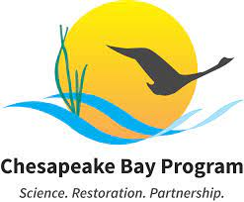

Diversity Workgroup Meeting Minutes
March 1, 2022 – WebEx Meeting

Meeting Objectives

- By the end of the session, DWG members and stakeholders will be able to identify strategies to engage people with prior justice system experience within their own organizations and/or as part of the Diversity Workgroup’s efforts that can be included as part of the 2022-2023 Logic and Action Plan.
- Today’s participants will also have an opportunity for networking and receiving updates from the Diversity workgroup

- Green Jobs Webinar
  - We streamed the webinar during the meeting. If you missed it, you can watch it here: https://www.youtube.com/watch?v=2vXDBStkc00
  - Panelists (Contact information located in the PowerPoint slides)
    - Wellington Ashe, BeKura Shabazz & Alex Smith
  - Takeaways from Panelists
    - When they pay their debt why do we continue to punish them (Wellington)
    - Not about asking for a seat at the table but building table yourself (Alex)
      - Don’t have to ask for permission to apart of society
    - Organizations of color need to be extremely supported so they don’t experience burn out and can get the work done. (Bekura)
    - Their capacity and capabilities are regularly questioned. Answer is “pay me and sit back and watch” (Alex)
    - Even if you bring your own chair to the table, you still have to be accepted by the table. (Alex)
    - People in the prison system are extremely brilliant and we lose a lot by excluding them (Bekura)
    - it so important to provide support to fix the issues (reduce crime). People who have livable jobs, high self-esteem and can support themselves are not going to commit crime (Bekura)
    - Federal govt needs to talk about how to streamline grants and then orgs who are successful should start subgranting
    - Give rights back in full, let them participate fully and don’t be afraid of the success they’re going to have (Wellington)
    - Your zipcode can be a form of incarceration (Alex)
    - We want to give people jobs that change their lives- they won’t want to go back to what they were doing before (Alex)
    - Tired, every time we make some headway, society pushes us back. We need resources directed at real problems. (Wellington)
- Welcome, and Meet and Greet with the Panelists/Transition to DWG Meeting
  - Comments & Questions for Panelists from DWG
    - What has been the impact of "Ban the Box" laws of effectuating greater Equal Employment Opportunity (EEO) for Persons with criminal conviction backgrounds?
    - What are some of the barriers you are noticing with bidding for state and federal contracts?
      - Bekura mentioned they don’t even attend to apply because don’t meet the material. Experience with grant writing
    - Federal government had a bonding program they inquire about in Job Centers
    - Training doesn’t always lead to jobs
    - I appreciate the panelists input on the MD DNR program with Civic Works. People need referral into our workforce after successfully completing the program
    - I would love to know more about what a social enterprise is and if it would be beneficial to encourage grants to be pushed to these types of businesses
- Breakout Room Discussion
  - Questions
    - Which specific populations are you reaching out to for the work that you do? Why?
    - Would you consider engaging with formerly incarcerated people?
    - Do you know of any other programs engaging formerly incarcerated people?
    - What is one action that we can take as the diversity workgroup to include and engage people with prior just system experience?
    - Do you know of any other programs engaging formerly incarcerated people?
    - Have you learned something from the panelists or from each other today that surprised you?

- Regroup and Share in the Chat- Facilitated Discussion
  - Summaries from Break Out Rooms
    - Kirsten J is working in Maryland Education, on teaching equitably across the state. Wants to include environmental concepts in fine arts, nutrition, ELA, and math
    - Max is taking the year to finish up some trainings to do this kind of work. May want to connect his brother with Wellington. He is not working now.
    - Colleen- we would consider reaching out to formerly incarcerated people. We’re currently engaging with youth programs that work in marginalized communities and is looking to make connections.
    - Brittany has a family connection with civic works. She is interested in 501(c)3 nonprofits, but is there way we can also partner with LLCs that benefit historically marginalized people?
    - Rev. Norris- initiative pushed by white house. We need to build our own network. Don’t take our ideas. Her program works with hiher-ups to white house faith based initiative.
    - Bekura- subgranting and supports is the best way to help. Ask yourself, who is the person leading the program for system involved people? It should be someone with prior experience in jail. We have to give them the space to lead it, build a partnership so people can see.
    - Encourage entrepreneurship because it helps navigate barriers around education or other employment barriers
    - Innovative collaborations new ways to create partnerships
    - Going in as minority contractors for state or local govt
    - There are institutions doing trades behind the wall HVAC, electrician,
    - Criminal record still presents barriers to hiring even when someone has all the training
    - Don’t want to steal anyones ideas. Encourage cross pollination but not take anyones property
    - Subgrating and supporting organizations run by formerly incarcerated people. Let them be in charge and let them own the work.
    - It’s time to work with grassroot groups stop giving grant funding to the same people, start giving money to new people with new ideas
    - With respective to innovative collab in Bay - I see there being a lot of potential in green infrastructure - e.g. native plant nurseries, living shoreline implementation - would also allow for entrepreneurship!
  - Other Orgs to Connect to
    - Bridging the gap in VA
    - Emily mentioned a state prison with forestry camp
    - Serenity Farms
    - Lorton Program
    - Southeast Baltimore Community Development Center
    - Rev Norris is helping returning women get access and funding
  - What can we do as a Workgroup
    - Support those who can lobby
    - Better knowing and supporting those
    - Knowing and promoting those partners where possible maybe something we do as diversity group?
    - it is time to work with grassroots organizations. Our sustainability and revitalization goals won’t be met without people of color.
- Diversity Workgroup Updates and Next Steps
  - New Meeting Format Satisfaction (see Mentimeter results below after the attendance list)
    - Most people were satisfied or very satisfied with the meeting format
    - In addition to the menti feedback, Rico, Charnell, and Circe said they liked the format. Bo said he accidentally put very unsatisfied but he actually liked it.
  - Kevin gave closing remarks
    - Our SRS discussion with the management board was one of the most engaged discussions they have had recently
    - Next Lunch and Learn will be in May on Mental Health
    - The communications team is hosting another webinar on March 29, 2022 in honor of Women’s History Month! They’ll be talking with three female anglers on fishing recreationally and commercially, and the business of aquaculture.
    - Briana Yancy accepted the role of DWG Coordinator and will start in April

Attendees & Organizations (* indicates steering committee member)
*Briana Yancy; Chesapeake Research Consortium (CRC) | *Brittany Hall, NPS Chesapeake
*Kevin Newman; DOEE | Marissa Sperry; Skeo
*Allison Ng; Environmental Protection Agency (EPA) | Jess Blackburn; Alliance for the Chesapeake Bay
*Bo Williams; EPA | Kathy Stecker; MDE
Bob Clegg; Justice Jobs | Cirse Gonzalez; Virginia Institute of Marine Science (VIMS)
Charnelle Hicks; CHPLanning | Rico Newman; Maryland Commission on Indian Affairs
Cindy Osorto; Maryland Department of the Environment (MDE) | Emily Hendrickson; PA DCNR
Amanda Knobloch; Morgan State | Edgar Freeman; MD DNR
Kirsten Jackson; MD Department of Education | *Ola-Imani Davis, Alliance for the Chesapeake Bay
Elder Jacqueline V Norris; Prince George’s Environmental Equity Community Collaborative | Kristin Saunders; UMCES
Randy Rowel; CRC | *Keisha Braunskill; DE Forest Service
*Gabrielle Roffe; Chesapeake Conservancy | Leah Franzluebbers; US Fish and Wildlife Service
Max Fairweather; Chesapeake College | *BeKura W. Shabazz; First Alliance Consulting
*Trystan Sill; Maryland Department of Natural Resources (DNR) | Clare Sevcik; DNREC
Wellington Ashe; Civicworks | Julie Mawhorter; US Forest Service
Julie Lawson; DOEE | Shannon Sprague; NOAA
Richard Allen; Maryland DNR | Phoebe Galione; Alliance for Aquatic Resource Monitoring (ALLARM)
Melissa Fagan; CRC | Colleen Norton; NPS Science in Parks Fellow

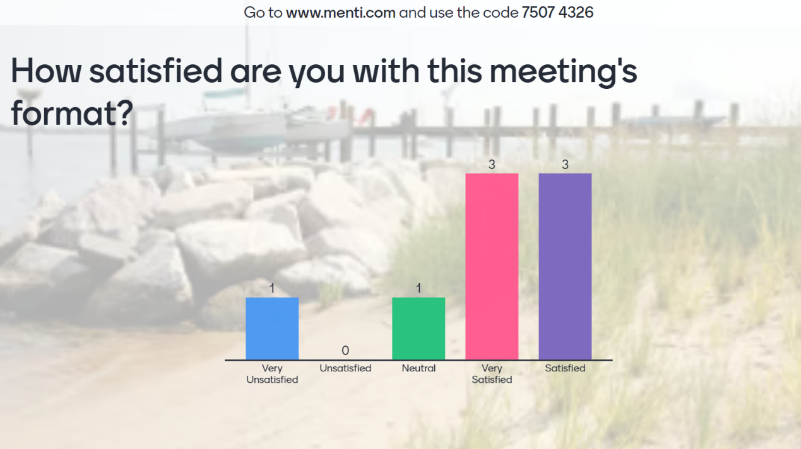
*One participant noted in the chat he clocked very unsatisfied by accident

SPEAKER INFORMATION

Wellington Bruce Ashe
washe@civicworks.com
(410) 929-6120
Civic Works: http://civicworks.com/

BeKura W. Shabazz
firstallianceconsulting@gmail.com
(423) 298-0342
First Alliance Consulting: https://firstalliance8.wixsite.com/consultant

Alex Smith
alexs@divisionstlandscaping.com
(443) 991-2154
Division Street Landscaping: https://www.divisionstlandscaping.com/

GENERAL INFORMATION
- Re-entry: https://www.prisonpolicy.org/research/recidivism_and_reentry/
- Best Practices in Green Re-entry by the Dream Corps: https://www.thedreamcorps.org/wp-content/uploads/2019/11/GFA-Reentry- Paper.pdf
- Chesapeake Bay Program Diversity Workgroup: https://www.chesapeakebay.net/who/group/diversity_workgroup

GREEN RE-ENTRY PROGRAMS AROUND THE USA
- The Dream Corps’ Green for All Program: https://www.thedreamcorps.org/our-programs/green-for-all/
- Inner-City Muslim Action Network 's Green Reentry program: https://www.imancentral.org/chicago/project-green-reentry/
- Sweet Beginnings: https://www.nlen.org/sweetbeginnings
- Hualapai Green Reentry Program: https://hualapai-nsn.gov/government/juvenile-detention-and- rehabilitation-center/hualapai-green-reentry-program/

PRISON POLICY
- Collateral Consequences Resource Center Annual Report: https://ccresourcecenter.org/wp- content/uploads/2022/01/2022_CCRC_Annual-Report.pdf
- Office of Disease Prevention and Health Promotion Social Determinants of Health—Incarceration: https://www.healthypeople.gov/2020/topics-objectives/topic/social-determinants-health/interventions- resources/incarceration
- Pre-Employment Inquiries and Arrest & Conviction: https://www.eeoc.gov/pre-employment-inquiries- and-arrest-conviction

