DRAFT Proposed Practice Life and Credit Duration for Forestry BMPs
in the Chesapeake Bay Model

Definitions
Practice Life-- The length of time a practice is expected to persist. This is primarily used to analyze annualized cost-benefit. The longer the practice life, the lower the cost of establishment/year as the cost is more spread out.
Credit Duration-- The length of time a practice can be credited in the model (CAST) before it needs to be verified. This is important for planning and administering work to assure the validity of CAST.
Back Out-- A process by which, after a prescribed amount of time, the CB Land Use model incorporates a land conversion BMP and that practice is taken off NEIEN at that time.

Forest and Tree Establishment

Once established, forests can grow indefinitely with little maintenance-- even in the event of a natural disaster (flooding, ice storms, etc.) -- as they are the natural land cover for this region. Some practices have a consistently higher standard of planning, implementation, maintenance, and regeneration (natural regeneration can be part of forest plantings per Verification protocol).

Both forest and tree planting survival depend on site characteristics, quality of planting stock, species selected for planting, early maintenance, and weather. The primary reason that the practice life for trees/forests is not indefinite, is due to changes in site management – something that is true for all practices. As information on good planting practices and “right tree, right place” is shared and heeded, the practice life will continue to be extended. Most urban tree planting occurs on lawns and community space, less often along streets. Less is known about the life span of these “lawn” plantings.

Basis for Extending Practice Life

1) A forest established after 15 years, is unlikely to be converted (compared to a grass buffer or single tree). Multiple landowner surveys have shown that 80-88% of landowners intend to keep their new forest buffer indefinitely (English and Hyberg 2019, Cooper 2005, Fesco 1982).
2) Forests are naturally regenerative.
3) Urban environs are harsher than agricultural ones. Small or narrow plantings are not as resilient as larger ones.
4) After a 15-year establishment period some grazing can occur without impacting buffer function. The 2018 Farm Bill, for instance, now permits grazing in some buffers. [Definition for Buffer with Fencing may need to be updated to reflect this.]
Forestry BMPs  (Pink= forest buffers  Blue-=tree plantings) | Practice Life Span (time that a Practice is expected to persist; used primarily for cost-benefit calculations) |  | Credit Duration (time that a Practice is held in CAST before being needing reverification) |  | Back Out (process by which a Practice is “counted” in the Land Use Model in place of NEIEN in order to prevent double-counting)
Forestry BMPs  (Pink= forest buffers  Blue-=tree plantings) | Current | Proposed | Current | Proposed
Ag Forest Buffer (w/o fencing- crop) | 40 years¹ | 70 years | 10 years¹ | 15 years | 15 years²
Ag Forest Buffer (w/ fencing- pasture) | 30 years¹ | 70 years | 10 years¹ | 15 years | 15 years²
Urban Forest Buffer | 40 years¹ | No change | 10 years¹ | 15 years | 15 years²
Ag Tree Planting | 40 years¹ | No change | 10 years | 15 years, then modeled as Land Use | 15 years
Narrow forest buffers (w/o fencing) | 40 years¹ | No change | 10 years | 15 years, then modeled as Land Use | 15 years
Narrow forest buffers (w/ fencing) | 25 years¹ | 40 years | 10 years | 15 years, then modeled as Land Use | 15 years
Urban tree planting | 40 years¹ | No change | 10 years | 15 years, then modeled as Land Use | 15 years
(Urban) Forest Planting | 28 years¹ | 40 years | 15 years | No change | 15 years
Forest Harvesting BMPs | 1 year | 3 years | 3 years then reverts to Forest Land Use | No change | n/a
¹Determined without consultation with the Forestry Workgroup.
²Back Out for Buffer Practices is only for the land use conversion portion of the credit. If verified, buffers can continue to receive the upslope efficiency portion of the credit.

Basis for Credit Durations

MD DNR and the FWG have been comparing shapefiles of trees planted 5-15 years ago to the Bay high-resolution imagery to determine the average number of years when the imagery reliably captures these plantings. We have learned that it is much more likely that the imagery will capture a 15 year-old planting as forest then a 10 year-old planting as demonstrated in the image below. The Expert Panel report was a placeholder, but the new analysis using actual CBP data is more reliable. We are therefore proposing that the credit life and backout period for all forestry BMPs is extended from 10 to 15 years.
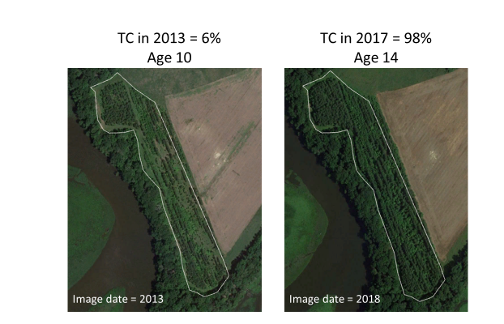
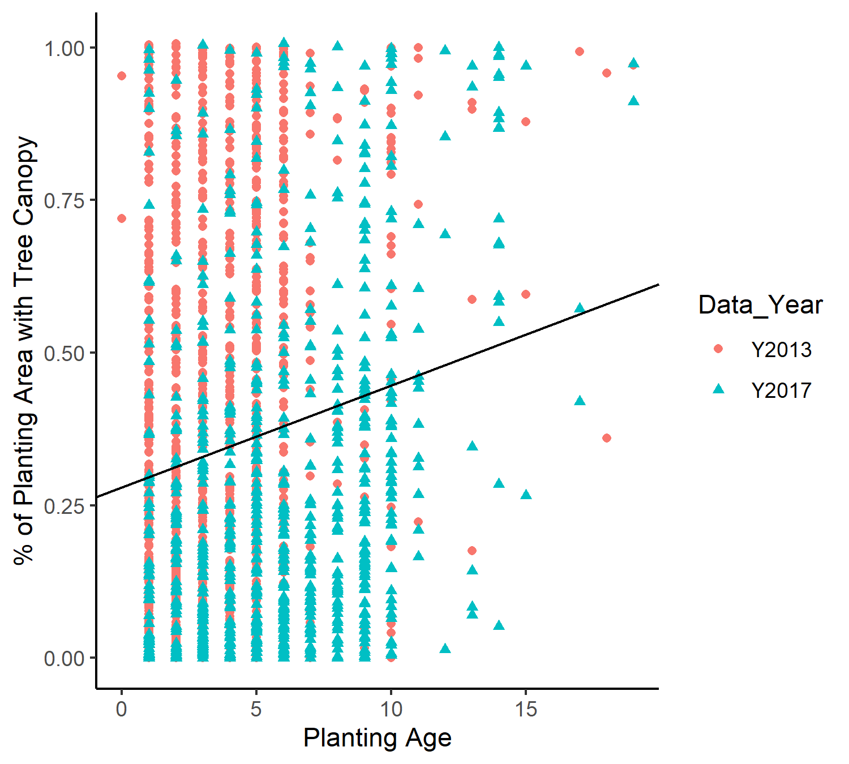
Forest Buffer Practices
For buffers, the 15-year credit duration is further supported based on:
- Contract length (The majority of CREP forest buffers have 15 year contract commitment which includes required maintenance and oversight by USDA. Contracts can be extended another 15 years, after the initial contract period.)
- Landowner investment— considerable investment is involved in establishing a forest and the landowner is unlikely to convert after establishment (see Practice Life discussion above).
- Consultation with forester—forest plantings have a higher bar for planning, implementation and establishment and are therefore more likely to persist.
After 15 years, new buffers will need to be verified to maintain the upslope efficiency in NEIEN. The FWG proposes that, if verified, buffers can continue to receive upslope efficiencies but not land use conversion credit after 15 years. Preliminary feedback from Bay Program experts is that the separation of the upslope efficiency and the land use credits can occur and be tracked in NEIEN. Non-buffer forestry practice credits will be picked up in the Land Use Model and will not need to be Verified at the end of their Credit Duration.

Supporting documentation from Expert Panel reports
The Riparian Forest Buffer Expert Panel (2014) debated whether to delay the assignation of credit until the planting was older but decided against it. The following was excerpted from their report: “Some forest buffer functions are realized quickly following planting and increase as forest soil and canopy functions are rebuilt… the recommended efficiencies for forest buffers are sufficiently conservative to address any lower efficiency experienced when buffers are new.” For the first year of a buffer planting, it functions as a grass buffer which receives 70% the efficiency of a forest buffer. The first 1-4 years of establishment, the forest planting looks and functions much like a mixed-open land use, which loads slightly more than forest in CAST (i.e., for nitrogen, forest loads around 1.5 #/acre/yr and Mixed Open loads around 1.8 - 2.0#/acre/yr).
The 2016 Tree Canopy Expert Panel (Cappiella et al.) researched the question of when planted trees are expected to be picked up in the land cover data:
Recommendation 1: Decision Rule for Tree Canopy as a BMP and as a Land Use
The high resolution imagery used by the Partnership to develop the Phase 6 CBWM land use distribution has a minimum mapping unit for tree canopy land uses of 97-ft2 in area (Chesapeake Bay Image Interpretation and Mapping Standards, Chesapeake Conservancy, and pers. comm., J. O’Neil-Dunne, University of Vermont, 1/21/2016). In review of the Forecast results, a tree will, on average, meet the 97 sq. ft. threshold 10 years after planting (assuming a DBH of 1” at planting with an assumed mortality of 5%). Therefore, the recommended decision rule be that trees will require a minimum of 10 years growth after planting to reach an area necessary to be captured by high resolution imagery and mapped as a land use. Based on this decision rule, trees planted for BMP credit in 2016 and onward will continue to be tracked as a BMP through 2025.
Recommendation 2: Lifespan of Annual BMP Credit (Credit Duration)
The lifespan of the BMP credit is based on the time period until it is mapped as a land use based on the high resolution imagery analysis completed by the Partnership and i-Tree Forecast results (i.e., minimum of 10 years of growth after planting). This BMP would not be eligible for renewal in the NEIEN once it is classified as a land use to avoid double counting of tree canopy acreage.
References
Belt et al. Recommendations of the Expert Panel to Reassess Removal Rates of Riparian Forest Buffers and Riparian Grass Buffer BMPs. October 2014. https://www.chesapeakebay.net/documents/Riparian_BMP_Panel_Report_FINAL_October_2014.pdf
Cappiella et al. 2016. Recommendations of the Expert Panel to Define BMP Effectiveness for Urban Tree Canopy Expansion. Approved by WQGIT September 2016.
Cooper, E.R. 2005. The Attitudes and Opinions of Pennsylvania Conservation Reserve Enhancement Program (CREP) Participants Towards Riparian Buffers and Conservation Easements. A Thesis in Forest Resources Submitted in Partial Fulfillment of the Requirements for the Degree of Master of Science, The Pennsylvania State University. State College. PA.

English, D. and S. Hyberg 2019. Retaining conservation investment: An examination of Chesapeake Bay CREP riparian buffers. Submitted to Chesapeake Bay and for publication. https://www.chesapeakebay.net/channel_files/24880/landowner_survey_preliminary_results.pdf.
Fesco, R.X., H.F. Kaiser, J.P. Royer and M.Wiedenhamer. 1982. Management practices and reforestation decisions for harvested southern pinelands. Staff Report No. AGES5821230. Washington DC.: USDA, Statistical Reporting Service.

