DRAFT

Rappahannock Tributary Report:
A summary of trends in tidal water quality and associated factors, 1985-2018.

June, 2022

Contents
1. Purpose and Scope 2
2. Location 2
2.1 Watershed Physiography 2
2.2 Land Use 2
2.3 Tidal Waters and Stations 2
3. Tidal Water Quality Status 2
3.1 Water Quality Criteria Attainment Error! Bookmark not defined.
4. Tidal Water Quality Trends 2
4.1 Surface Total Nitrogen 2
4.2 Surface Total Phosphorus 2
4.3 Surface Chlorophyll a: Spring (March-May) 2
4.4 Surface Chlorophyll a: Summer (July-Sept) Error! Bookmark not defined.
4.5 Secchi Disk Depth 2
4.6 Summer Bottom Dissolved Oxygen 2
5. Factors Affecting Trends 2
5.1 Watershed Factors 2
5.1.1. Effects of Physical Setting 2
5.1.2. Estimated Nutrient and Sediment Loads 2
5.1.3. Expected Effects of Changing Watershed Conditions Error! Bookmark not defined.
5.1.4. Best Management Practices (BMP) Implementation 2
5.2 Tidal Factors 2
5.3 Insights on Change in the Rappahannock Error! Bookmark not defined.
6. Summary Error! Bookmark not defined.
References 2
Appendix 2

1. Purpose and Scope

This report summarizes long term changes in a suite of water quality parameters and associated potential drivers of those trends at stations monitored in the tidal portion of the Rappahannock River for the period 1985 through 2018. Comparisons are made to connect the observed trends in water quality and potential natural and anthropogenic drivers of change in the Rappahannock River watershed based on our current understanding of the relationships between these drivers and water quality conditions. Water quality parameters described below include surface total nitrogen (TN), surface total phosphorus (TP), spring and summer surface chlorophyll a, summer bottom dissolved oxygen (DO) concentrations, and Secchi disk depth (a measure of water clarity). Results for annual surface water temperature, bottom TP, bottom TN, surface ortho-phosphate (PO4), surface dissolved inorganic nitrogen (DIN), surface total suspended solids (TSS), and summer surface DO concentrations are provided in an Appendix. Drivers discussed include physiographic watershed characteristics, changes in N, P, and sediment loads from the watershed to tidal waters, expected effects of changing land use, and implementation of nutrient management and natural resource conservation practices. Factors internal to estuarine waters that also play a role as drivers are described including biogeochemical processes, physical forces such as wind-driven mixing of the water column, and biological factors such as phytoplankton biomass and the presence of submersed aquatic vegetation. Continued monitoring and evaluation of both water quality parameters and the drivers that influence them are essential tools for the long-term environmental management goals for the Rappahannock River.

2. Location
The Rappahannock River is the third largest watershed in terms of area, and the fourth largest tributary to Chesapeake Bay in terms of nutrient loads. Its watershed spans approximately 7,370 km² (1,821,167 acres), and accounts for seven percent of the area of the state of Virginia. Major tributaries to the Rappahannock River include the Rapidan, Robinson, and Corrotoman rivers. Approximately 56% of the Rappahannock River watershed is located above the fall-line at Fredericksburg, VA.

2.1 Watershed Physiography
The Rappahannock River watershed stretches across four major physiographic regions: the Blue Ridge, Mesozoic Lowland, Piedmont, and Coastal Plain (Figure 1). The Coastal Plain physiography covers lowland, dissected upland, and undissected upland areas. Implications of these physiographies for nutrient and sediment transport are summarized in Section 4.1.
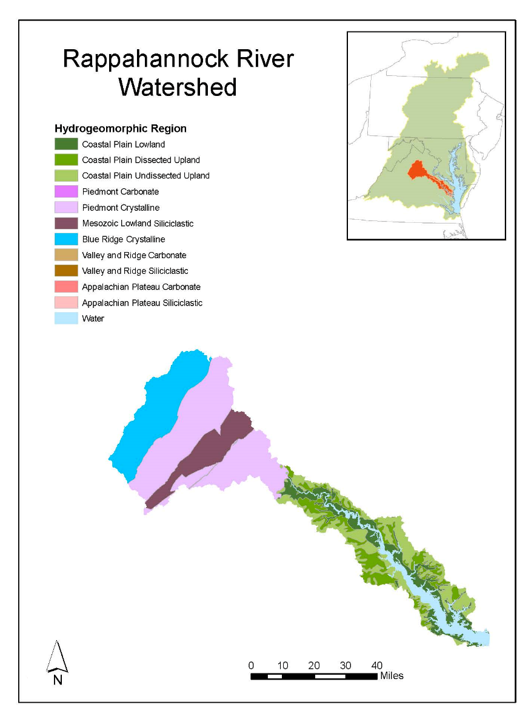
Figure 1. Distribution of physiography in the Rappahannock River watershed. Base map credit Chesapeake Bay Program, www.chesapeakebay.net, North American Datum 1983.

2.2 Land Use
Land use in the Rappahannock watershed is dominated (66%) by natural areas. Urban and suburban land areas have increased by 319 square kilometers since 1985, agricultural lands have decreased by 209 square kilometers, and natural lands have decreased by 109 square kilometers. Correspondingly, the proportion of urban land in this watershed has increased from 6% in 1985 to 11% in 2020 (Figure X). In general, developed lands in the 1970s were more concentrated. Since then, developed lands have expanded to regions both further upstream into the watershed and further downstream into the tidal areas (Figure X). The impacts of land development differ depending on the use from which the land is converted (Keisman et al., 2019; Ator et al., 2019). Implications of changing land use for nutrient and sediment transport are summarized in Section 5.1.3.

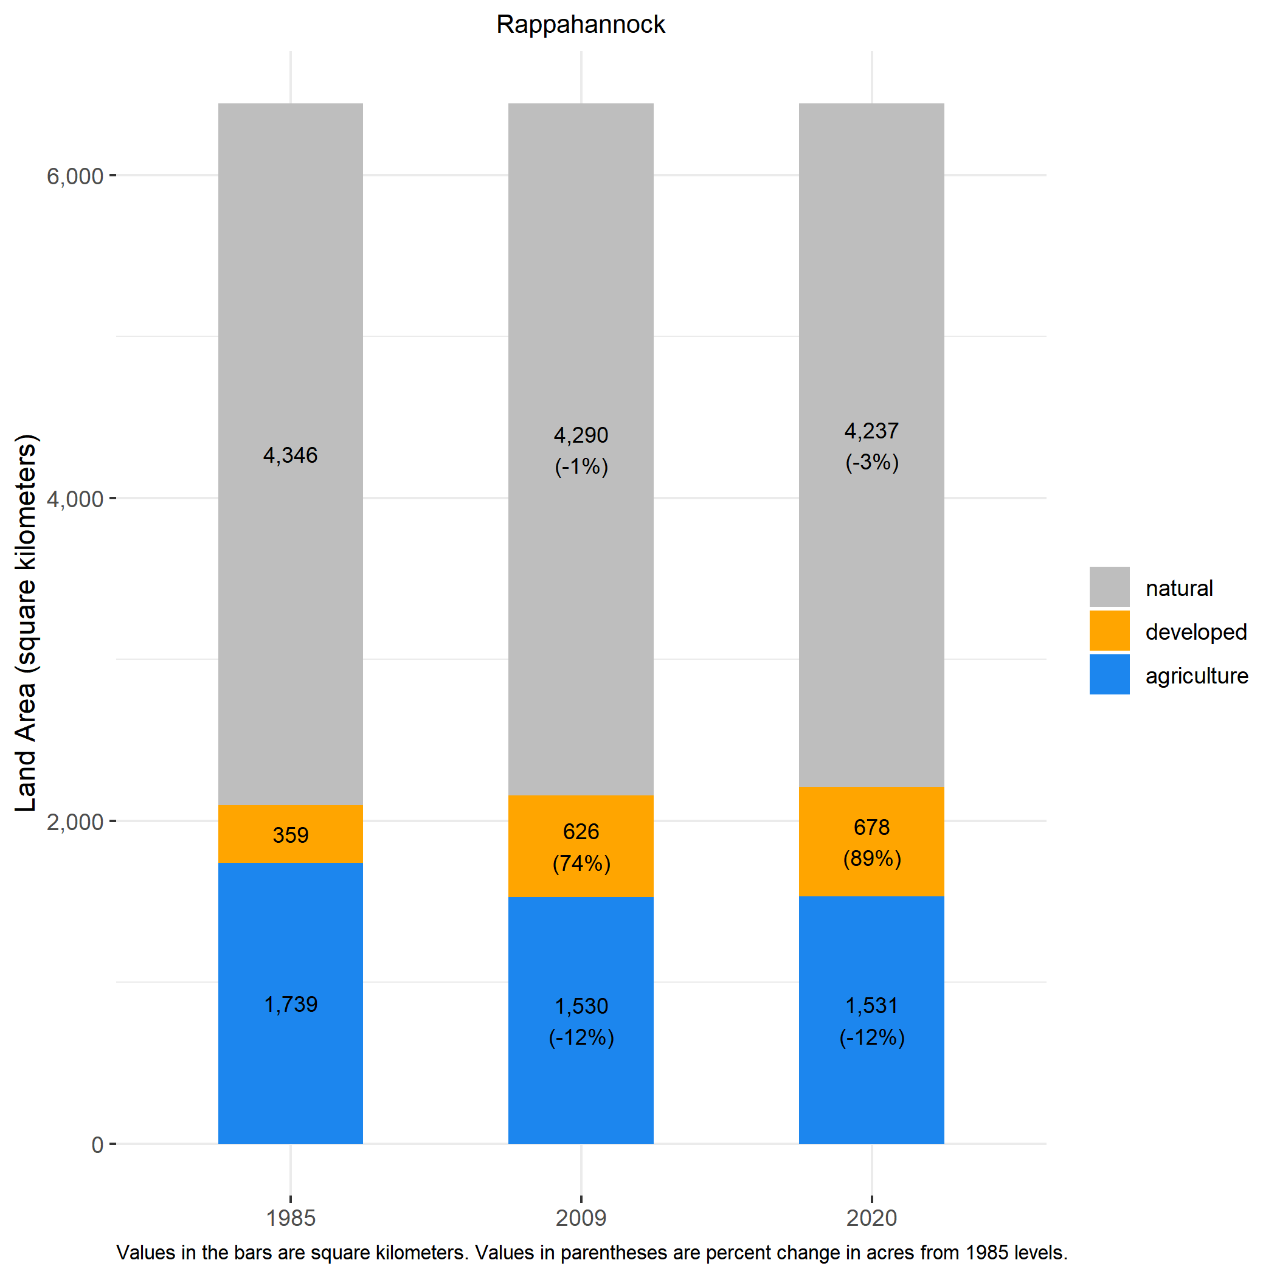
Figure 2. Land use distribution in the Rappahannock River watershed and percent change between 1985 and 2020.

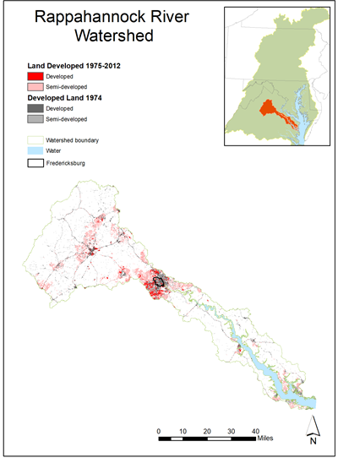
Figure 3. Change in developed and semi-developed land between 1974 and 2012 in the Rappahannock River watershed. Derived from Falcone (2015). Base map credit Chesapeake Bay Program, www.chesapeakebay.net, North American Datum 1983.

2.3 Tidal Waters and Stations
For the purposes of water quality standards assessment and reporting, the tidal waters associated with the Rappahannock River were divided into four segments: The tidal fresh (RPPTF), oligohaline (RPPOH), and mesohaline (RPPMH) portions of the Rappahannock River proper, and the Corrotoman River (CRRMH), a tributary of the Rappahannock, located on its northern banks about 13 km from the mouth of the river (Figure 4).

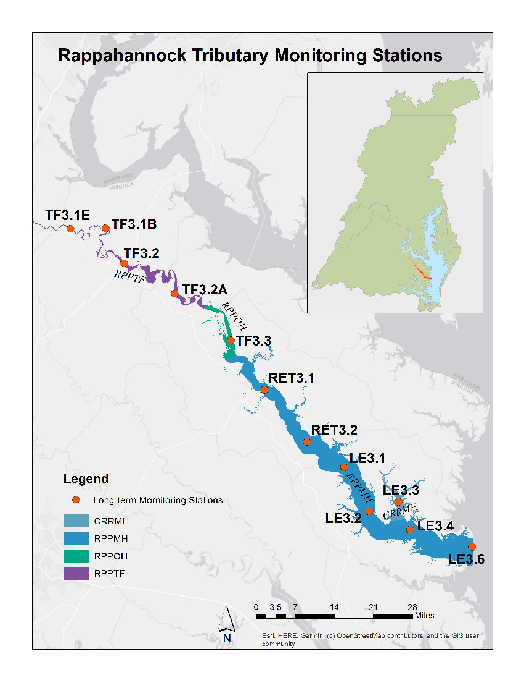
Figure 4. Map of tidal Rappahannock River segments and long-term monitoring stations. Base map credit Esri, HERE, Garmin, (c) OpenStreetMap contributors, and the GIS user community, World Geodetic System 1984.
Water quality data used to evaluate long term trends were collected by the Virginia Department of Environmental Quality (VADEQ) and Old Dominion University (ODU) at 12 stations stretching from the tidal freshwater portion of the estuary (station TF3.1E) located near the fall line at Fredericksburg to station LE3.6 at the mouth of the Rappahannock where it empties into Chesapeake Bay (Figure 4). Water quality data collected at these stations along with those collected by the VADEQ shallow-water monitoring program (not shown in Figure 4) were used to assess attainment of dissolved oxygen (DO) water quality criteria.

3. Water Quality Criteria and Management Goals

The Rappahannock River provides a direct example of the relevance of long-term water quality monitoring and the evaluation long term trends relative to environmental management goals. Multiple water quality standards were developed for the tidal Rappahannock and Chesapeake Bay in general to protect aquatic living resources (U.S. Environmental Protection Agency, 2003; Tango and Batiuk, 2013). These standards include specific criteria for dissolved oxygen (DO) and water clarity/underwater bay grasses. For the purposes of this report, a record of the evaluation results indicating whether different Rappahannock segments have attained Open Water (OW), Deep Water (DW), and Deep Channel (DC) DO criteria over time (Zhang et al., 2018a; Hernandez Cordero et al., 2020) are shown below (Figure 5). While analysis of water quality standards attainment was not the focus of this report, the results over time from the evaluation of these three DO criteria for the applicable Rappahannock River segments are included here to provide context for the importance of understanding water quality trends and the underlying drivers that control them. More specifically, trends in the water quality parameters summarized in this report directly affect environmental management goals implemented by interested stakeholders within the watershed. For more information on water quality standards, criteria, and standards attainment, visit the CBP’s “Chesapeake Progress” website at www.chesapeakeprogress.com.

Attainment deficit for the OW criteria was at or near zero from the start of monitoring to the most recent assessment period covered by this report (2018-2020) in all segments except CRRMH. In this segment attainment deficit showed a high degree of variability with an initial stable period above -5% followed by fluctuations that assumed a pattern of roughly alternating periods of increase and decline for 3 to 5 assessment periods such that the average attainment deficit was at or near -10-15% with the attainment deficit of the current assessment period at -15%. The DW attainment deficit was assessed only for segment RPPMH, where it typically remained at levels at or near -5% but fell below -10% during some assessment periods. The DC attainment deficit was assessed only for segment RPPMH, where it was above -20% during most assessment periods but fell to -23% in the current assessment period (2018-2020). Results of a Mann-Kendall trend test indicated no significant trends in any of the attainment deficit estimates for any segments (Figure 5).

Comparing trends in station-level DO concentrations to the computed DO criterion status for a recent assessment period can reveal valuable information, such as whether progress is being made towards attainment in a segment that is not meeting the water quality criteria, or conversely whether conditions are degrading even if the criteria are currently being met. To illustrate this, the 2016-2018 attainment status for the OW and DC DO criteria shown in Figure 5 are overlain with the 1985-2018 trend in summer surface DO concentration and the 1985-2018 trend in bottom summer DO concentrations, respectively (Figure 6). The 30-day mean OW summer DO criterion was met in one of the four segments for the 2016-2018 period. Surface oxygen is increasing in the segment that met the OW criterion and in the mesohaline segments but decreasing in the tidal fresh segment where the OW criterion was not met. Bottom oxygen is decreasing in the Rappahannock River mesohaline segment where the DC water quality criterion was not met. This example shows the importance of establishing criteria and monitoring of water quality conditions relative to established goals for those criteria. It also demonstrates the relevance of trend results in relation to criteria assessments.

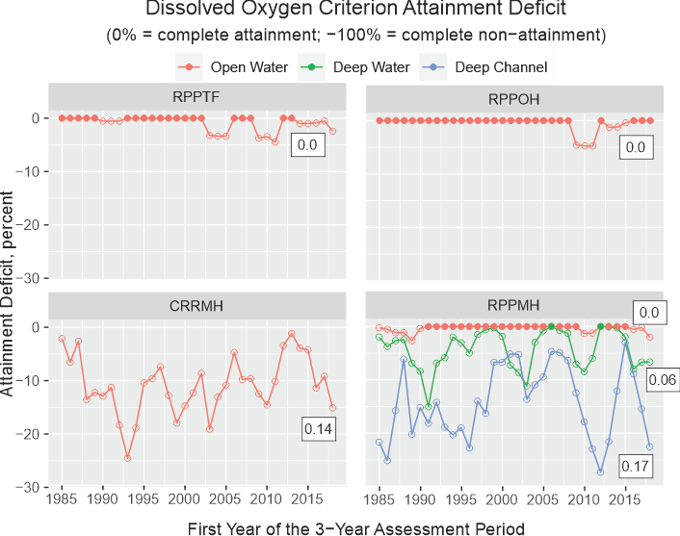

Figure 5. Attainment deficient for Summer Deep Water (30-day mean June-September), Deep Channel (Instantaneous) and Open Water (30-day mean June-September) dissolved oxygen criteria for three-year assessment periods from the start of monitoring through the current (2018-2020) assessment period. A value of 0% indicates full attainment for a given criterion while negative values indicate percent non-attainment (deficit) for the segment and criterion being plotted. Numbers associated with a given line are the Sen Slope estimates. Trends significant at p < 0.05 are indicated by ** or at p < 0.1 by *.

Figure 5. Deep Water summer DO (30-day mean June-September), Deep Channel (Instantaneous) and Open Water summer DO (30-day mean June-September) criteria evaluation results. Green lines indicate the criterion was met. All gaps indicate a violation of the criterion listed.

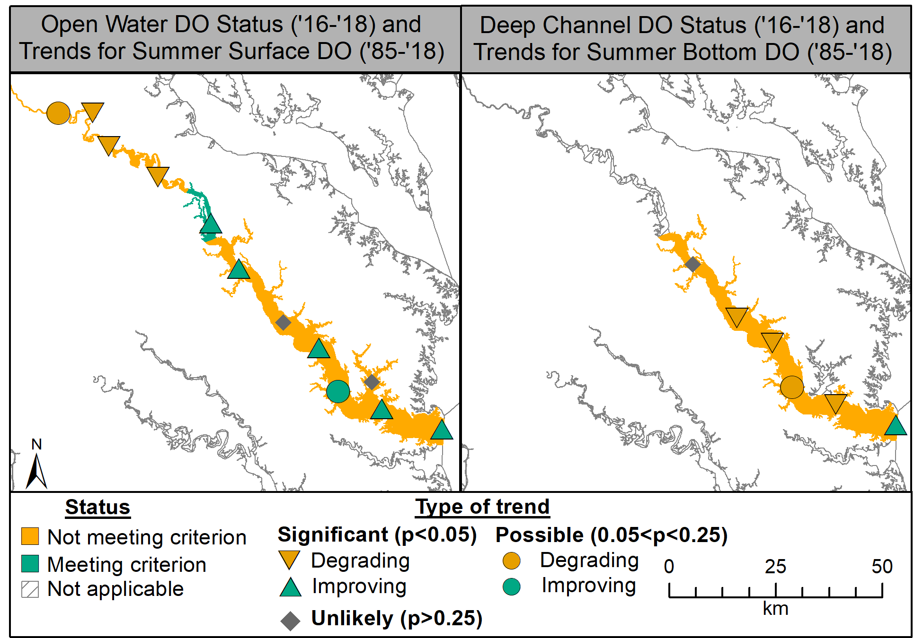
Figure 6. Criterion status for 30-day Open Water summer DO (2016-2018) and Deep Water Channel instantaneous DO along with long-term trends in surface and bottom DO concentrations (1985-2018). Base map credit Chesapeake Bay Program, www.chesapeakebay.net, North American Datum 1983.

4. Tidal Water Quality Trends

Trend analysis was conducted by fitting generalized additive models (GAMs) to water quality observations collected at the 12 tidal stations (Figure 4) by VADEQ and ODU. For more details on the GAM implementation that is applied each year for these stations in collaboration with the Chesapeake Bay Program and Maryland analysts, see Murphy et al. (2019).
Results shown below in each set of maps (e.g., Figure 6) include those generated using two different GAM model approaches applied to each station-parameter combination. The first approach involves fitting a GAM to the raw observations to generate a mean estimate of change over time, as observed in the estuary. The second approach involves including river flow or in situ salinity (as an aggregated measure of multiple river flows) in the GAM to explain some of the variation in the water quality parameter. From the results of this second approach, it is possible to estimate the flow independent change over time, which gives a mean estimate of what the water quality parameter trend would have been if river flow had been averaged over the period of record. Results of the flow or salinity adjusted results are typically used to help investigators determine whether natural variability or anthropogenic stressors such as point and non-point loads are responsible for change in water quality concentrations. Note that depending on the location in the Rappahannock River, adjustment may be carried out using either gaged river flow at the fall-line or salinity at the station, but for the purposes of simplicity and clarity all such results are referred to as “flow-adjusted”.
To determine if there has been a change over time (i.e., a trend) at a particular station for a given parameter, we compute a percent change between the estimates at beginning and end of a period of interest from the GAM fit. Parameter specific maps of statistically significant (p ≤ 0.05) and possible trends (0.05≤p≤0.25) were created to allow a comprehensive evaluation of long-term changes in the river for each parameter and identify locations where incipient trends may be developing (Murphy et al., 2019). Plots of observed and mean annual or seasonal annual predictions from the first set (no flow adjustment) of GAM model were plotted to examine the overall shape of the trend and general validity of the fit (e.g., Figure 8).

4.1 Surface Total Nitrogen
Although tidal monitoring program in the Rappahannock River began in 1985, changes in methodology used to estimate TN resulted in step trends in the data that make clear evaluations using data prior to 1994 for most but not all stations difficult. As a result, trends for TN are for 1994-2018, except for station LE3.6, which are for 1985-2018.
Annual total nitrogen concentrations have decreased (improved) at nearly all the mesohaline Rappahannock tidal stations over both the long-term and short-term, using both observed results and flow-adjusted protocols (Figure 7). Improving trends were also detected at the uppermost tidal fresh station, but in general the tidal freshwater and oligohaline portions of the estuary showed no change in this parameter.
Slight decreases are apparent over the long-term at many stations in both the data and the non-flow-adjusted mean annual GAM estimates (Figure 8). Most stations seem to exhibit a roughly decadal cycle of increasing and decreasing concentration as indicated by the plots of predicted values that appear to be similar within a given salinity regime (Figure 8). An upswing in 2018 is clear in many of these graphs as well and appears to be independent of river flows as indicated by the persistence of trends in flow adjusted trends (Figure 8).

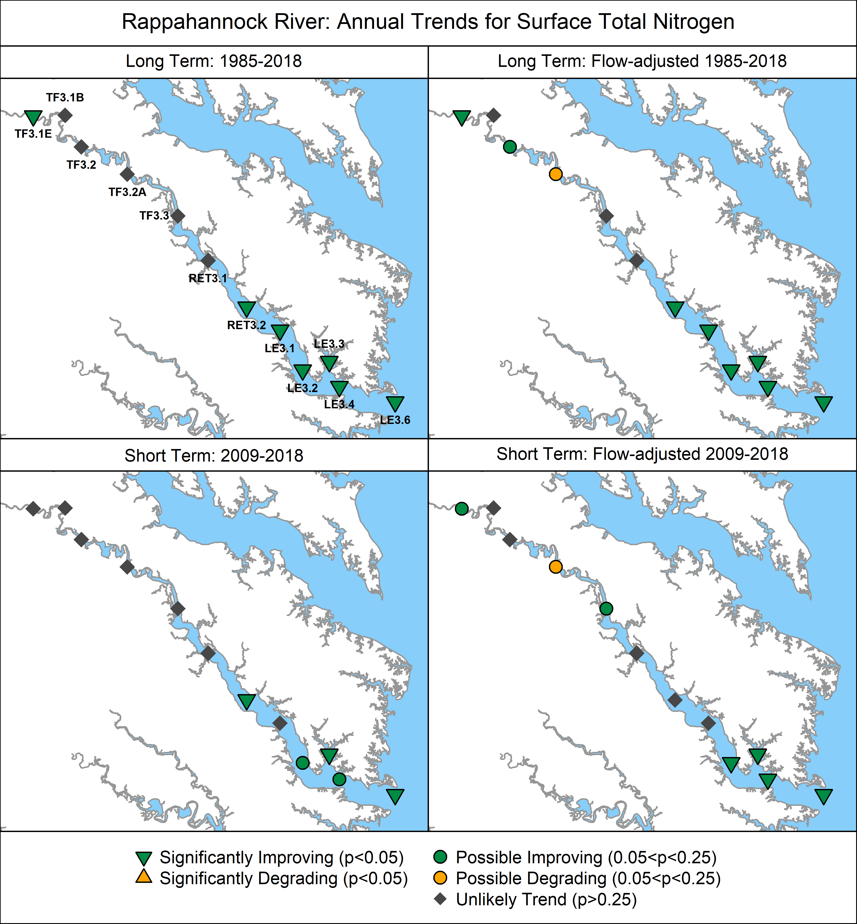

Figure 7. Surface trends in total nitrogen concentrations (1994-2018, except for LE3.6, see Figure 4) for non-adjusted (left panels) and flow-adjusted data (right panels). Basse map credit Chesapeake Bay Program, www.chesapeakebay.net, North American Datum 1983.

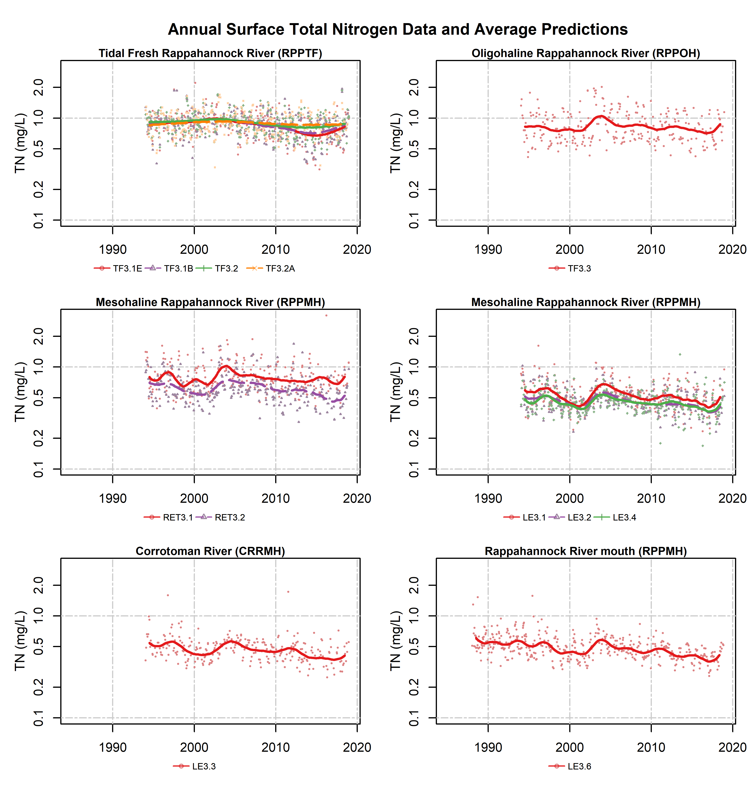
Figure 8. Surface TN data (dots) and the mean long-term pattern generated from non-flow adjusted GAMs, by station. Colored dots represent data corresponding to the monitoring station shown indicated in the legend; colored lines represent mean annual GAM estimates for the noted monitoring stations.

4.2 Surface Total Phosphorus
Total phophorus (TP) is monitored to assess the supply of this important nutrient to the phytoplankton community. When TP is in excess, it helps to fuel and overabundance of phytoplankton which if not consumed by higher trophic levels, will decay and lead to oxygen depletion. The trends in TP are mixed in the Rappahannock with improving trends in the tidal fresh, but a lack of improvement in the lower estuary. Surface total phosphorus trends decreased (improved) consistently over the long term at most stations in of the tidal fresh portion of Rappahannock River before and after accounting for the effects of flow (Figure 9). Short term trends in upper portion of the tributary were also improving but at fewer stations (Figure 9). The middle portion of Rappahannock River showed a degrading trend that persisted regardless of flow effects (Figure 9) while most stations in the lower portions of the tributary show little in the way of significant long- or short-term trends regardless of the effect of flow (Figure 9). GAM predictions of total phosphorus showed little to no change, with concentrations fluctuating roughly between 0.05 to 0.15 mg/L at most stations. The only exceptions were stations TF3.1E and TF3.1B where predicted concentrations showed evidence of an appreciable decline (Figure 10) consistent with the observed trends (Figure 9).
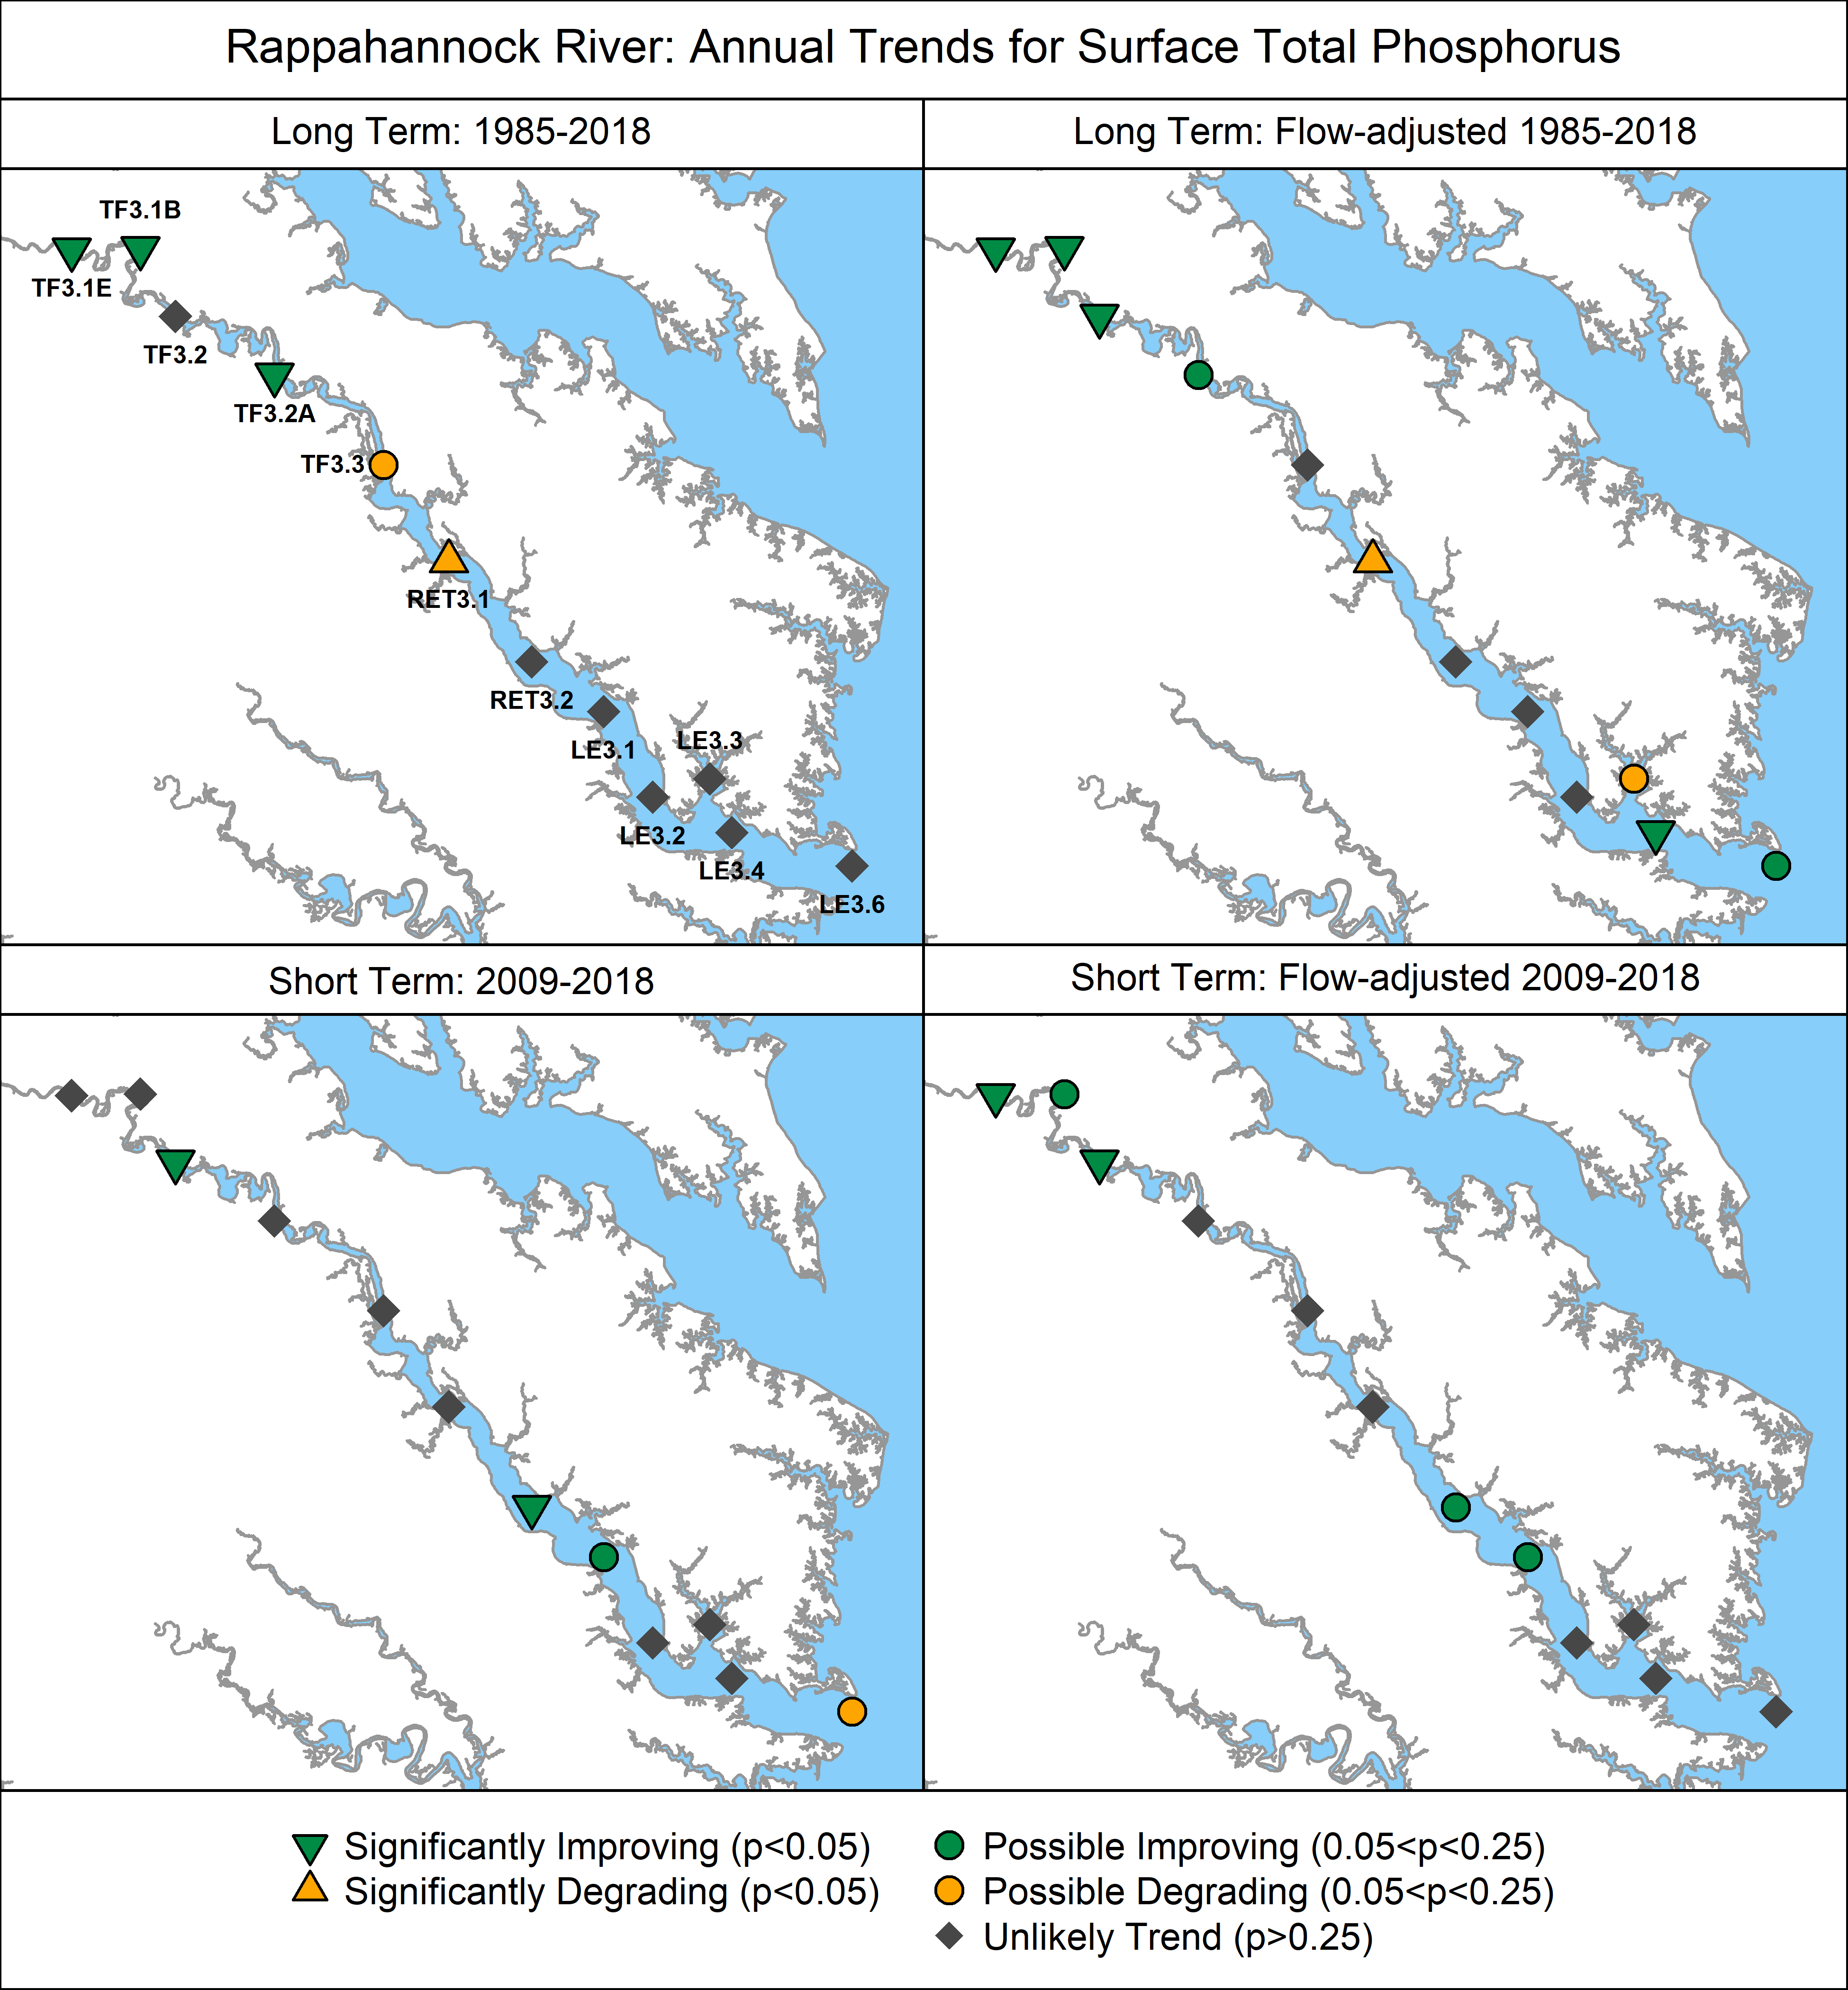
Figure 9. Surface trends in total phosphorus concentrations. Base map credit Chesapeake Bay Program, www.chesapeakebay.net, North American Datum 1983.
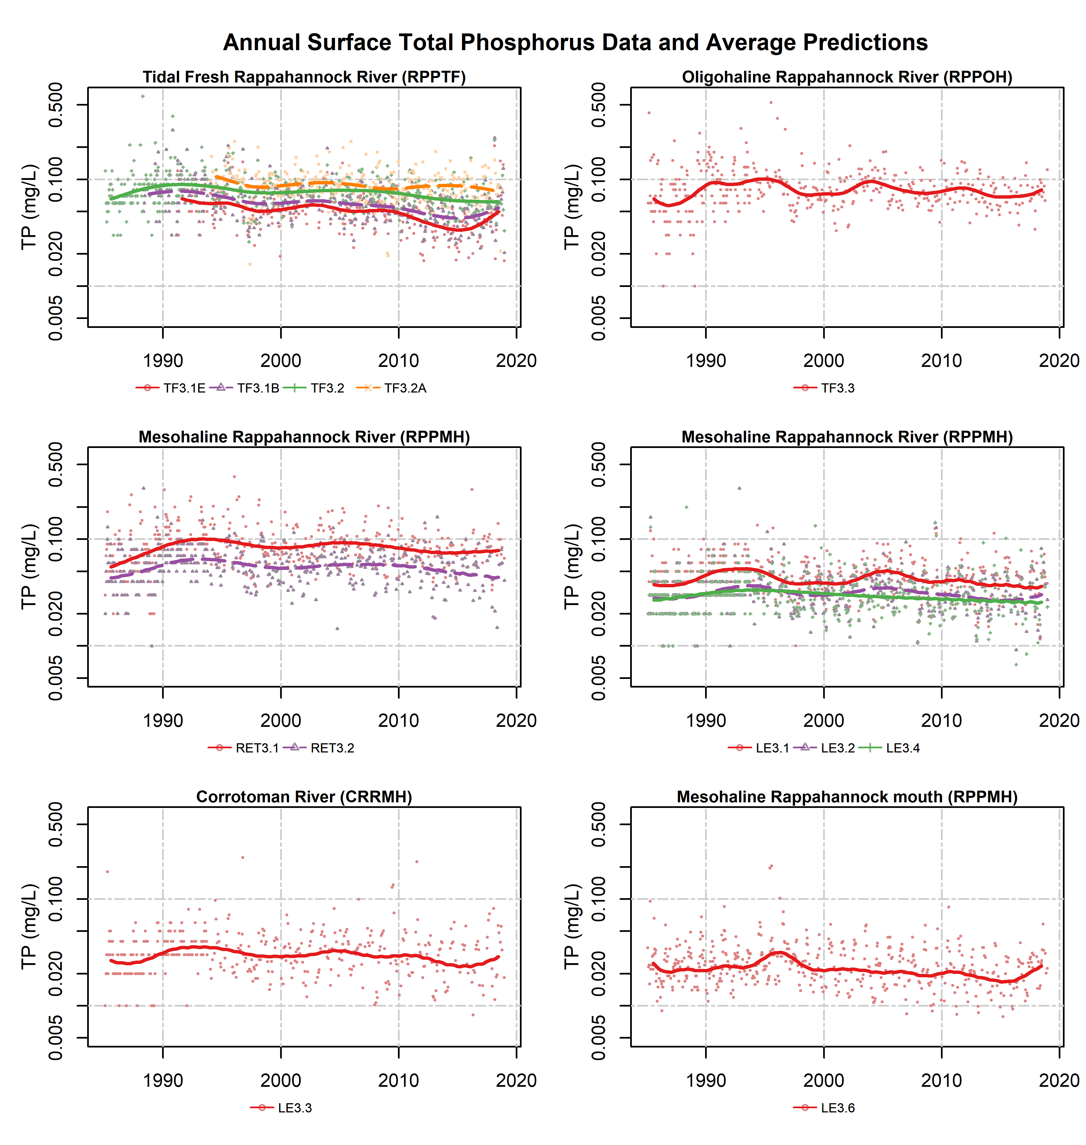
Figure 10. Surface total phosphorus (dots) and mean long-term pattern generated from GAMs of the observed data, by station. Colored dots represent data corresponding to the monitoring station shown indicated in the legend; colored lines represent mean annual GAM estimates for the noted monitoring stations.

4.3 Surface Chlorophyll a: Spring (March-May)

Chlorophyll a is monitored as an indicator of phytoplankton abundance and high levels of chlorophyll a are considered an indicator of eutrophication. Like the results for total phosphorus, chlorophyll a trends in the Rappahannock were mixed. Near the fall line and near the mouth of the estuary, there was evidence of improvement while in the middle estuary there were clear signs of degradation. Trends for chlorophyll a were split into spring and summer to analyze chlorophyll a during the two seasons when phytoplankton blooms are commonly observed in different parts of Chesapeake Bay (Smith and Kemp, 1995; Harding and Perry, 1997).

4.3.1. Spring (March-May)

Spring trends (Figure 11) show significant degradations in the middle tributary stations over the long-term, and improvements in the tidal fresh and mesohaline. Possible improvements in the tidal fresh spring chlorophyll a persisted in the short-term while possible degrading or no trends were found at other stations. Spring observed and predicted mean values are highly variable over the long-term at many stations and is likely reflective of the dynamics of local phytoplankton populations (Figure 12). Plots of the predicted mean spring chlorophyll show clear increases at stations TF3.3 and RET3.1 (Figure 12).

4.3.2. Summer (July-September)

Summer long-term chlorophyll a trends show a distinct spatial pattern (Figure 13), with more degrading or potentially degrading trends than in the spring. The three most upstream tidal fresh stations are improving in over both the short- and long-term, with and without flow-adjustment. Stations in the lower tidal fresh to upper mesohaline portion (stations TF3.2A, TF3.3, and RET3.1) exhibited degrading trends over the long-term but most of these trends were not detected in the short-term regardless of flow adjustment (Figure 13). The remaining stations in the lower mesohaline Rappahannock River and Corrotoman River exhibit degrading or potentially degrading long-term and short-term trends with a higher number of potentially degrading trends found in the flow-adjusted results. This indicates that freshwater inputs may have mediated increasing summer chlorophyll a concentrations in the lower portions of the tributary.
Comparing the time-series views (compare Figures 12 and 14) for spring and summer, it is clear that the magnitude of the summer tidal fresh chlorophyll a concentrations is much higher than it is in spring. Chlorophyll a mean concentrations are more similar between spring and summer at downstream stations, but trends reverse to increases at the more downstream stations, especially at TF3.3 and RET3.1 which rose from approximately 10.0 µg/L to roughly 20 µg/L from the start of monitoring to 2018 (Figure 14).

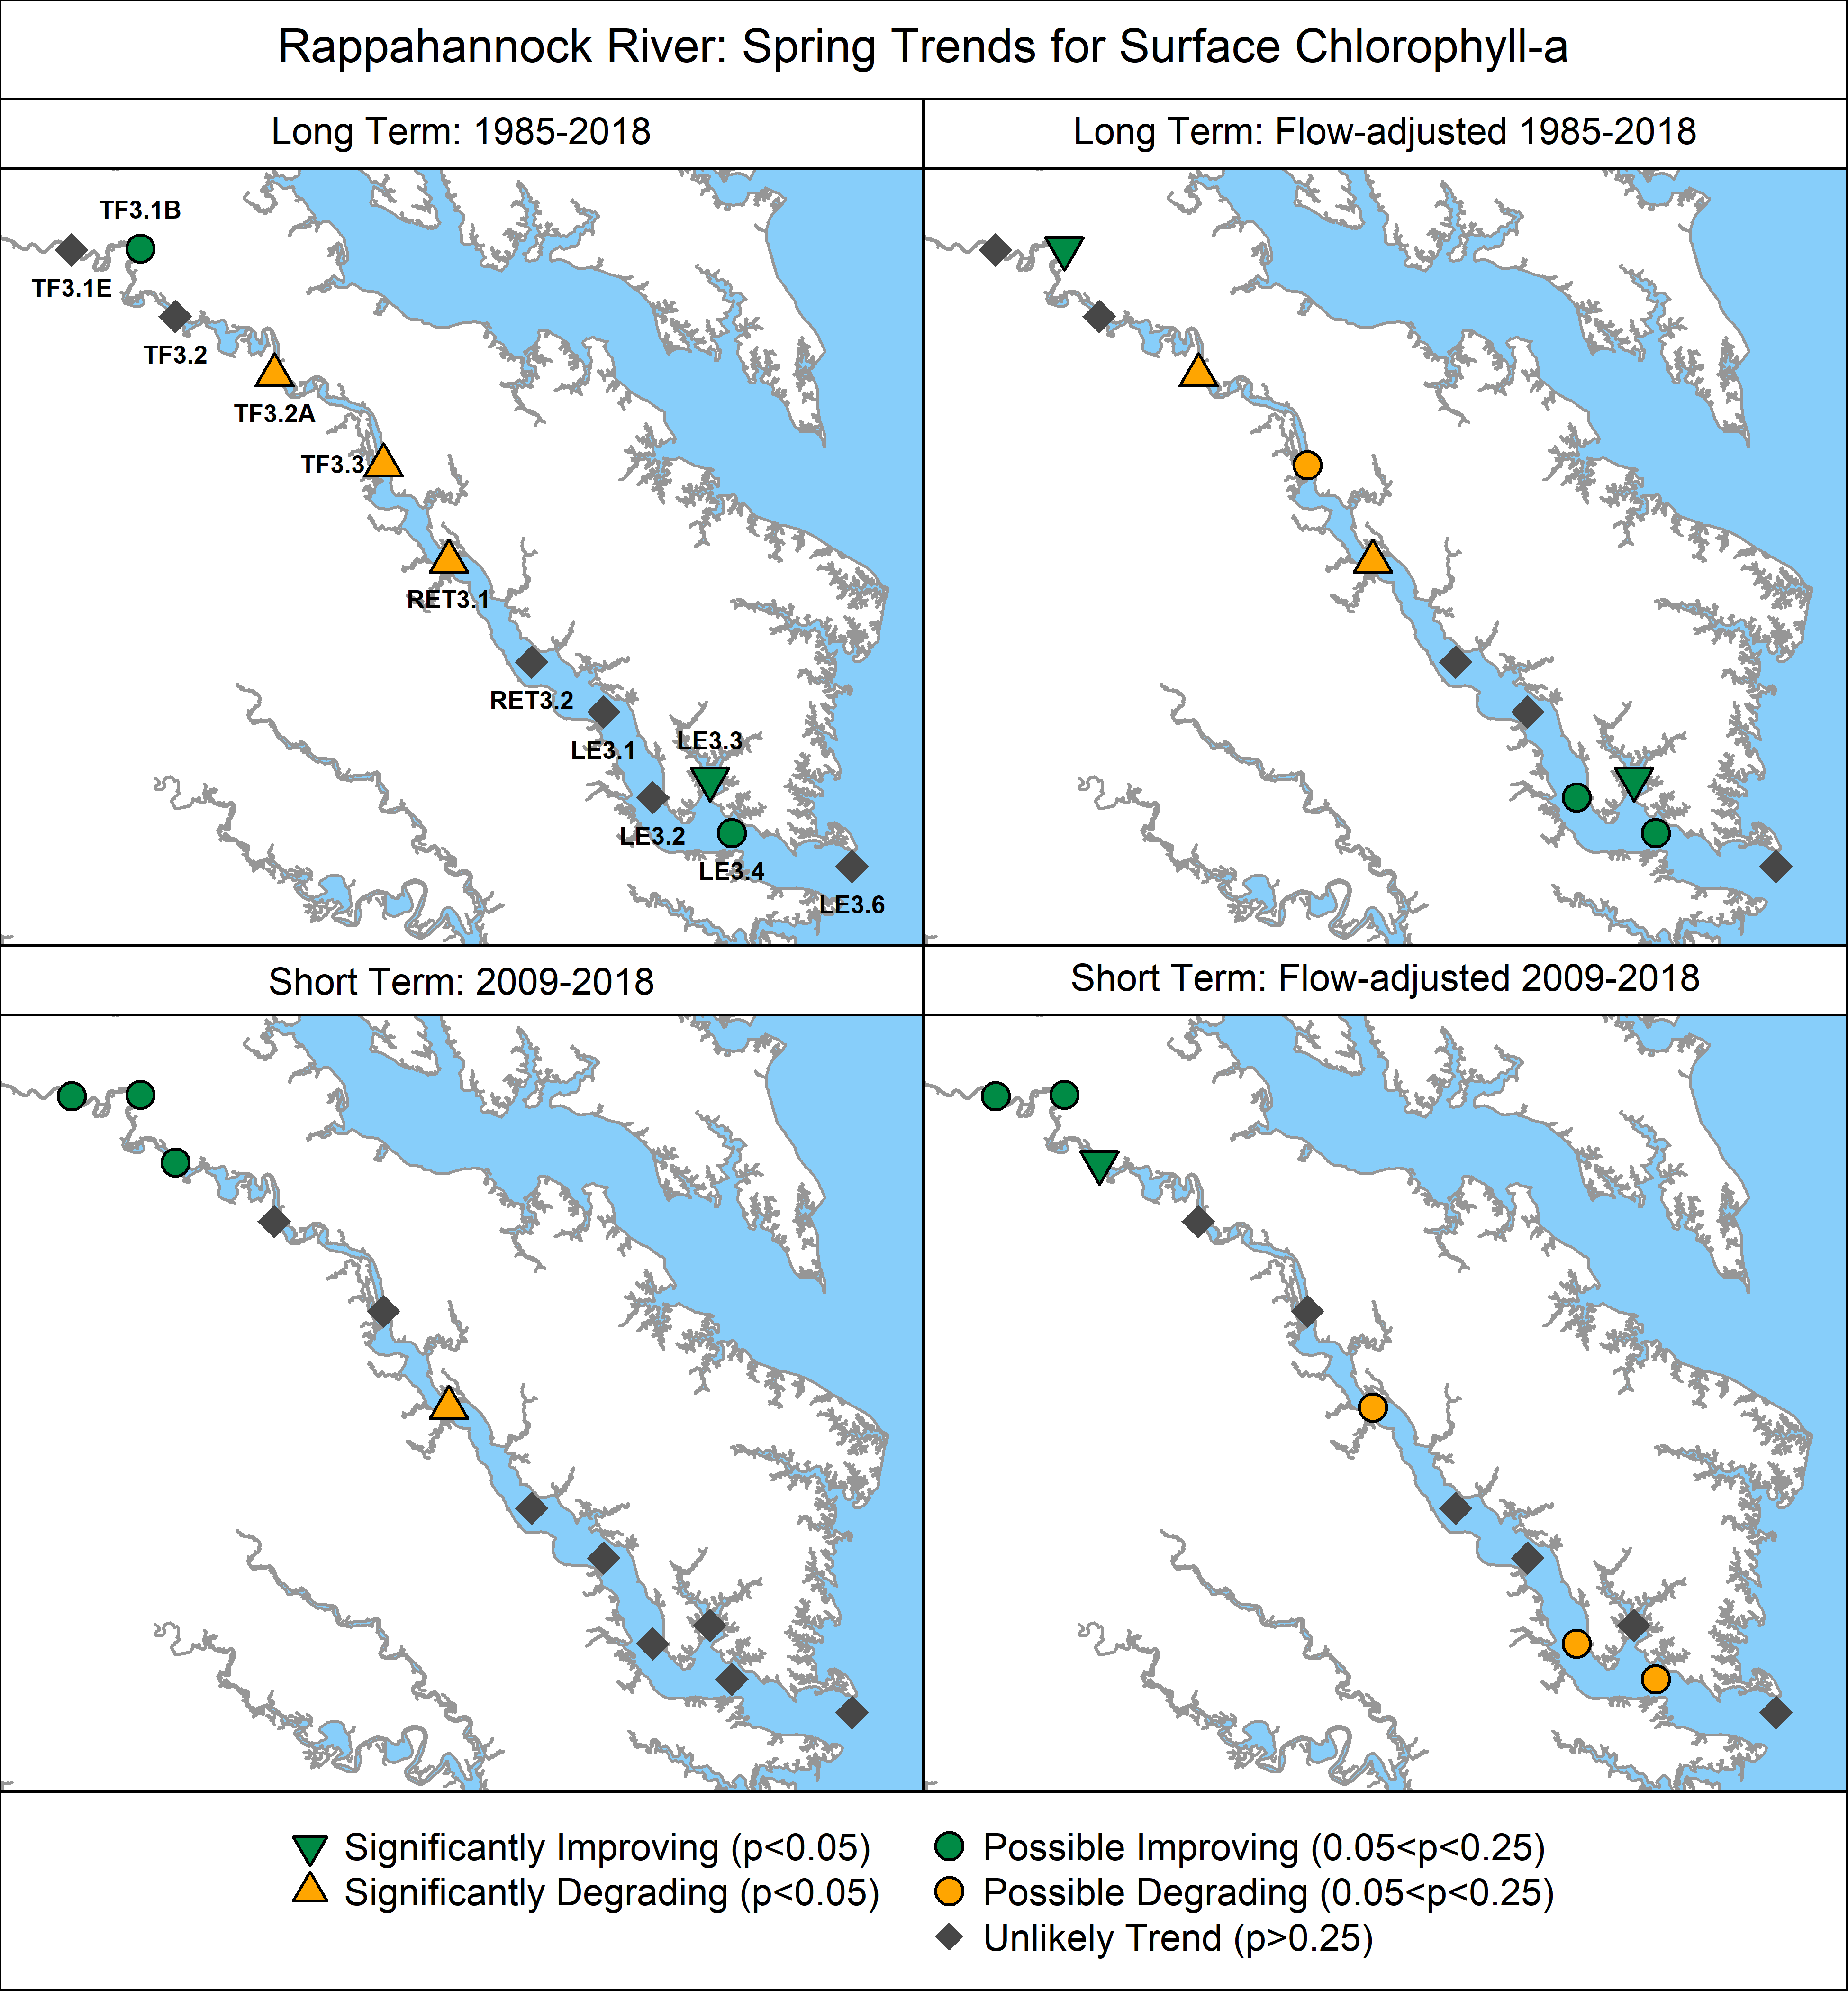
Figure 11. Surface spring (March-May) chlorophyll a trends. Base map credit Chesapeake Bay Program, www.chesapeakebay.net, North American Datum 1983.
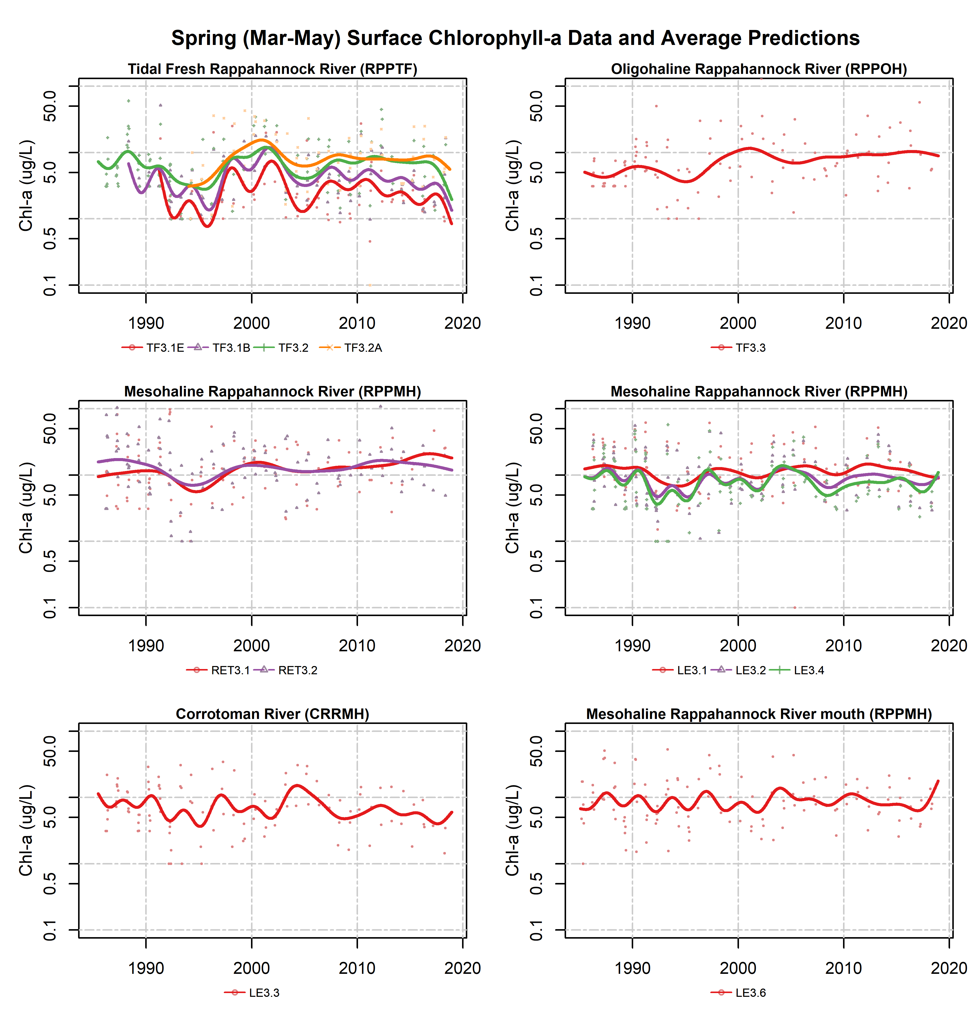
Figure 12. Surface spring Chlorophyll a data (dots) and mean long-term pattern generated from GAMs of the observed data, by station. Colored dots represent March-May data corresponding to the monitoring station shown indicated in the legend; colored lines represent mean spring GAM estimates for the noted monitoring stations.
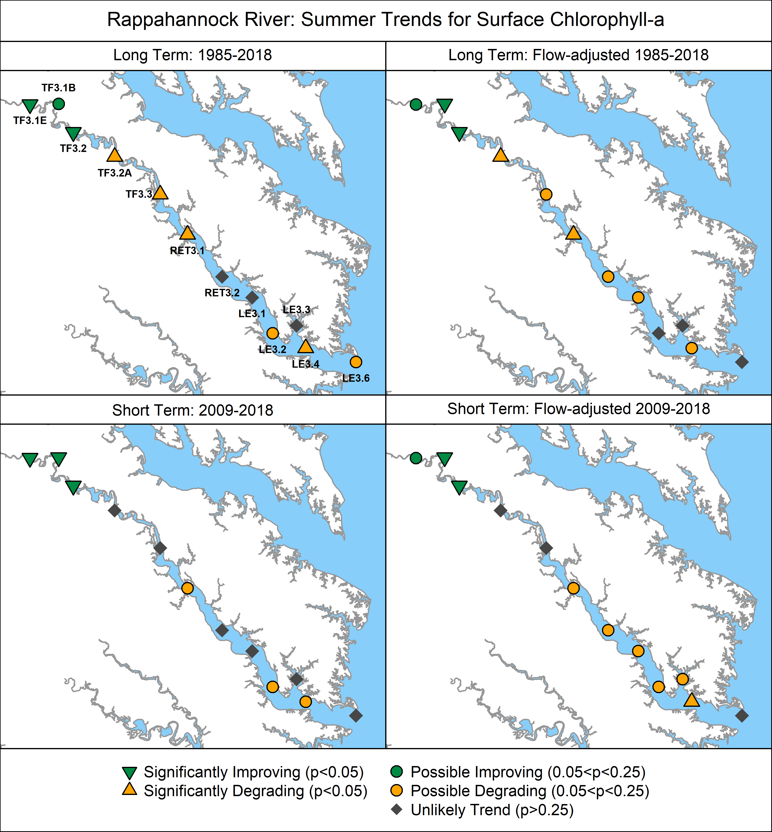
Figure 13. Surface summer (July-September) chlorophyll a trends. Base map credit Chesapeake Bay Program, www.chesapeakebay.net, North American Datum 1983.
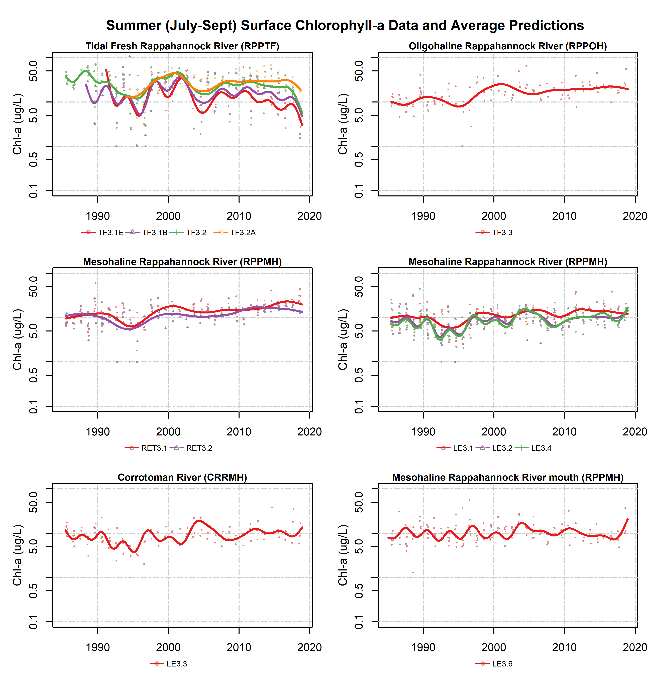
Figure 14. Surface summer chlorophyll a data (dots) and mean long-term pattern generated from GAMs of the observed data, by station. Colored dots represent July-September data corresponding to the monitoring station shown indicated in the legend; colored lines represent mean summer GAM estimates for the noted monitoring stations.

4.4 Secchi Disk Depth
Trends in Secchi depth exhibit a clear longitudinal pattern that is similar to chlorophyll a. Improving or potentially improving trends in the tidal freshwater stations contrasted with degrading trends at the oligohaline and mesohaline stations TF3.3 and RET3.1. Trends were generally consistent over the long- and short-term independent of flow adjustment (Figure 15). Only station TF3.3 exhibited a degrading trend in the short-term (Figure 15). Degrading trends in Secchi at stations TF3.3 and RET3.1 generally paralleled those of summer chlorophyll a regardless of time period assessed and flow adjustment suggesting excess phytoplankton production may be a main cause of lower water clarity. Degrading or potentially degrading trends in Secchi depth were observed at nearly all the stations in the mesohaline portion of the Rappahannock River over the long-term which appear to have been related in part to flow effects (Figure 15). Mesohaline water clarity tends to improve in drought years and degrade in high flow years. None of these trends were observed in the short-term (Figure 15).
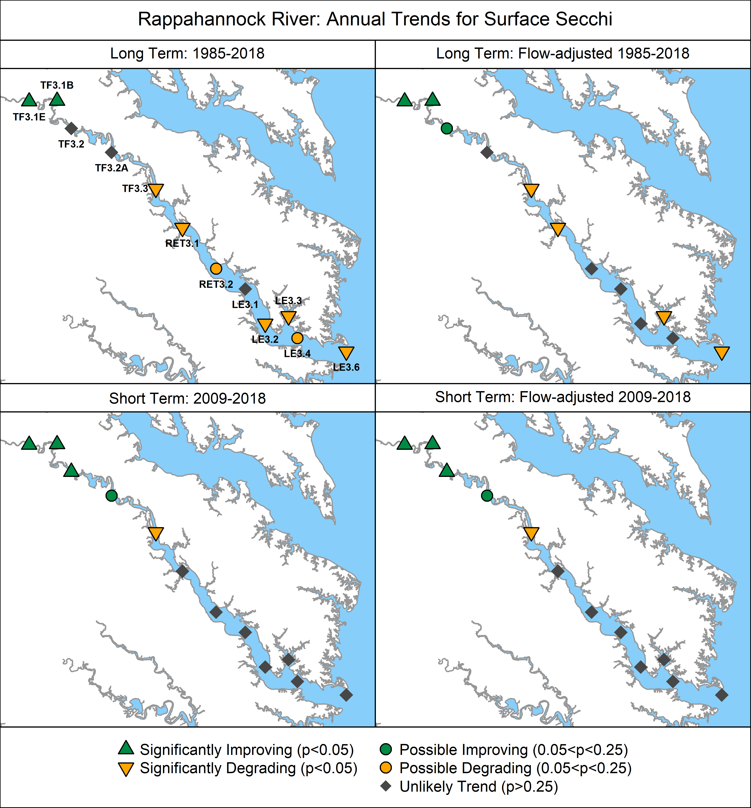
Figure 15. Annual Secchi depth trends. Base map credit Chesapeake Bay Program, www.chesapeakebay.net, North American Datum 1983.
Secchi depth is consistently higher at the mesohaline stations than at the tidal fresh or oligohaline stations in the Rappahannock River (Figure 16), a characteristic typical of estuaries that have a turbidity maximum zone at the interface of tidal fresh and saltwater region. Plots of the observed and GAM predicted values clearly reflect the observed long-term trends with improving clarity in the tidal freshwater and degrading clarity at the oligohaline and mesohaline stations (Figure 16). Many of the mesohaline stations show variability in Secchi depth that seems similar to that shown by chlorophyll a concentrations. This provides additional indirect evidence for a potential connection between long-term patterns in Secchi and chlorophyll a concentrations in the Rappahannock River.
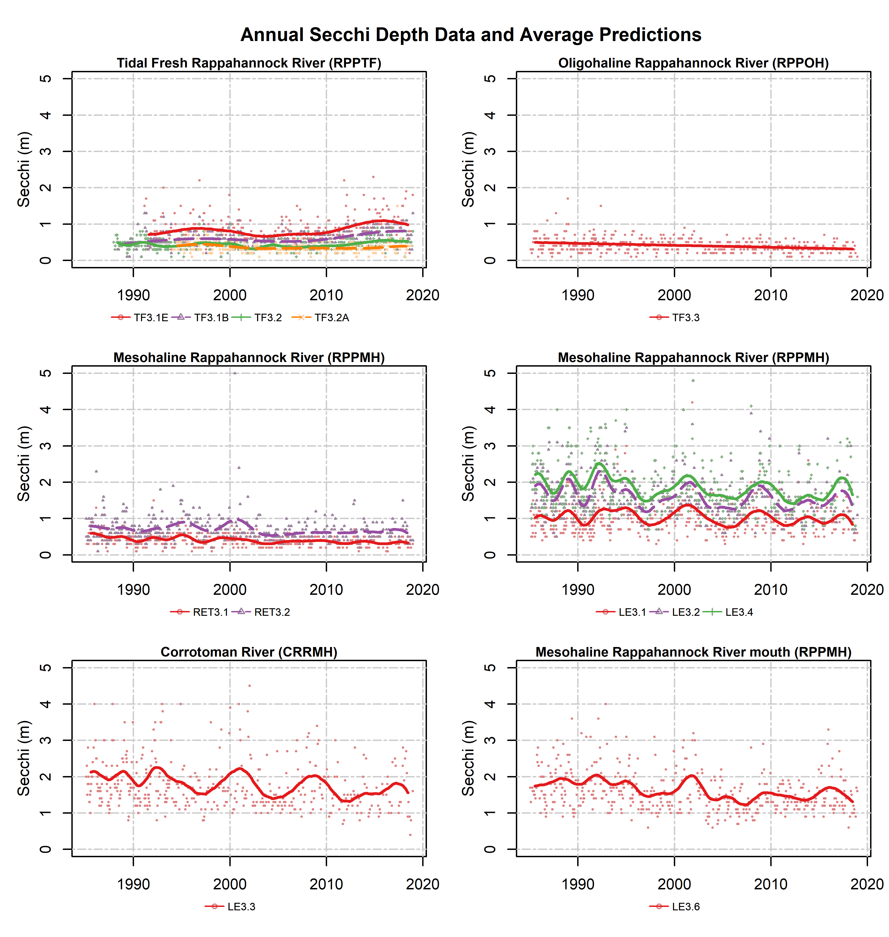
Figure 16. Annual Secchi depth data (dots) and mean long-term pattern generated from observed GAMs. Col0ored dots represent data corresponding to the monitoring station shown indicated in the legend; colored lines represent mean annual GAM estimates for the noted monitoring stations.

4.5 Summer Bottom Dissolved Oxygen
Degrading or potentially degrading long-term trends in summer dissolved oxygen concentrations were observed at most stations in the Rappahannock River and do not appear to be related to flow effects (Figure 16). An improving long-term trend was observed at station LE3.6 in the mouth of the Rappahannock which does appear to be tied to freshwater flow effects (Figure 17). In the short-term, there were only degrading and potentially degrading trends at the lower mesohaline stations many of which appear due to flow effects (Figure 17).

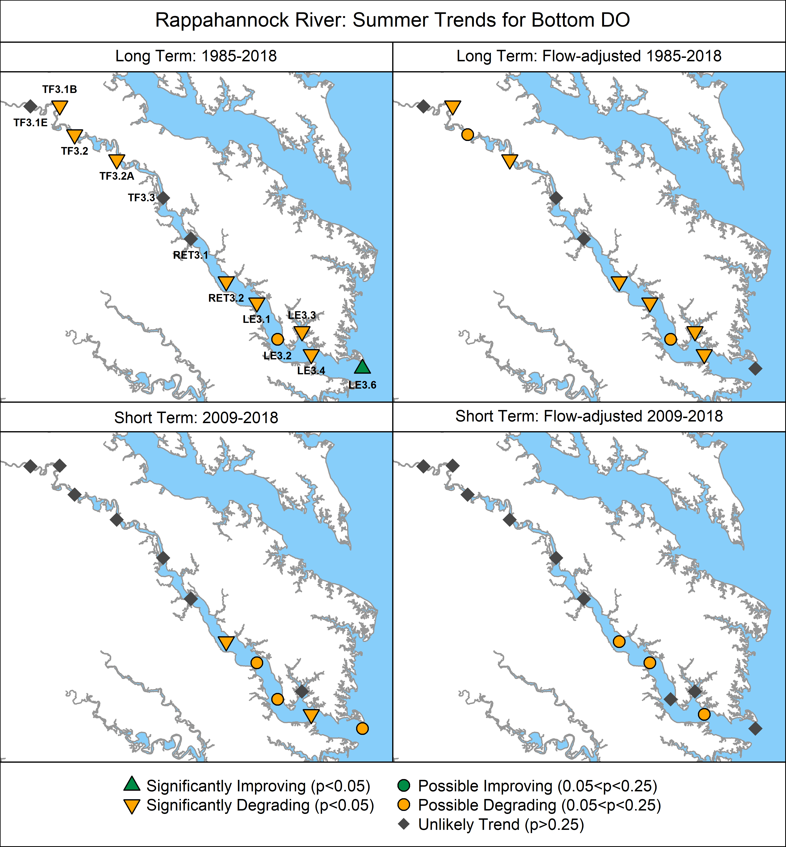
Figure 17. Summer (June-September) bottom DO trends. Base map credit Chesapeake Bay Program, www.chesapeakebay.net, North American Datum 1983.

Summer data and mean summer GAM predicted values reflect the spatial variability in concentrations and the long-term trends observed (Figure 17). Concentrations in the tidal fresh and middle Rappahannock were higher than the lower estuary, but the tidal fresh concentrations are declining and periodically go below the 5 mg/L summer Open Water mean criterion. Concentrations at some mesohaline stations go below the Deep Channel criterion of 1 mg/L during the summer and trends at many of these stations are degrading (Figures 17-18).
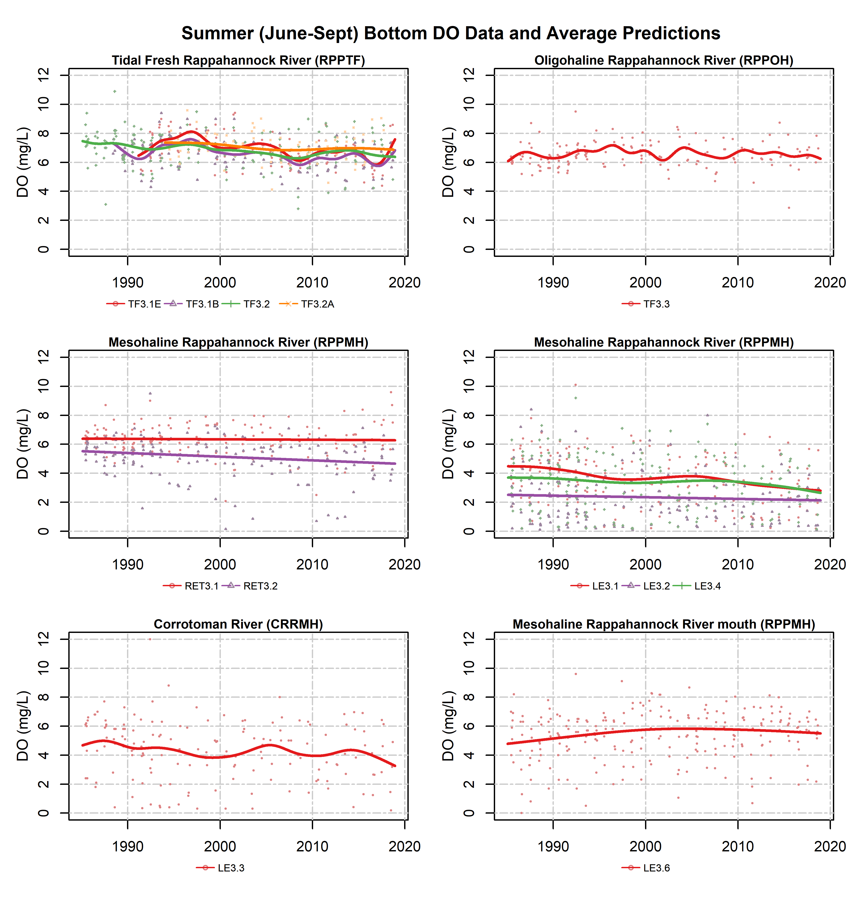
Figure 18. Summer (June-September) bottom DO data (dots) and mean long-term seasonal pattern generated from non-flow adjusted GAMs. Colored dots represent data corresponding to the monitoring station shown indicated in the legend; colored lines represent mean summer GAM estimates for the noted monitoring stations.

5. Factors Affecting Water Quality Trends

5.1 Watershed Factors

5.1.1. Effects of Physical Setting
The geology of the Rappahannock River watershed and its associated land use affects the quantity and transmissivity of nitrogen, phosphorus, and sediment delivered to non-tidal and tidal streams. (Brakebill et al., 2010; Ator et al., 2011; Ator et al., 2019; Ator et al., 2020; Noe et al., 2020).
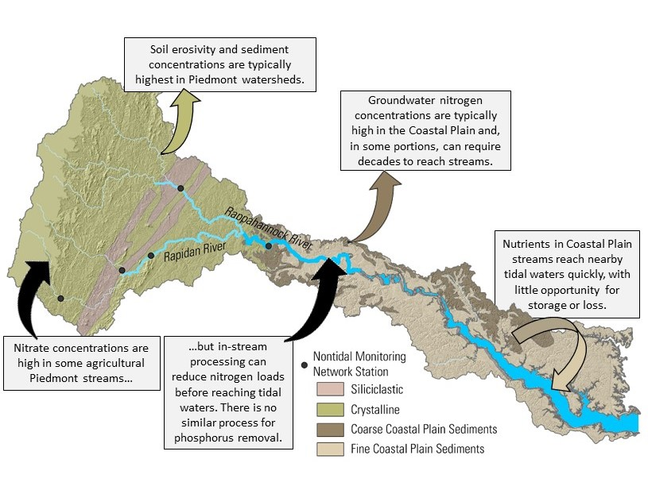
Figure 19: Effects of watershed hydrogeomorphology on nutrient transport to freshwater streams and tidal waters. Base map modified from King and Biekman, 1974 and Ator et al., others, 2005, North American Datum 1983
Nitrogen
Groundwater is the primary delivery pathway of nitrogen to most streams in the Chesapeake Bay watershed (Ator and Denver, 2012; Lizarraga, 1997). The proportion of nitrogen in groundwater that reaches freshwater streams and/or tidal waters is heavily dependent on location in the watershed (Figure 19). Groundwater nitrate concentrations in the Rappahannock River watershed are highest in streams above the fall line that drain Piedmont soils (Greene et al., 2005; Terziotti et al., 2017). Crystalline rocks in the above fall line portion of the Rappahannock river watershed contain large amounts of oxic groundwater, which promotes nitrate transport (Tesoriero et al., 2015), but their low porosity limits the amount of surface water infiltration (Lindsey et al., 2003). The typical residence time of groundwater delivered to streams in the Chesapeake Bay watershed is about 10 years, but ages vary from less than one year to greater than 50 years based on bedrock structure, groundwater flow paths, and aquifer depths (Lindsey et al., 2003). A similar range of water ages (0–33 years) has been measured from Piedmont crystalline springs (Phillips et al., 1999). Groundwater represents about 50% of streamflow in most Chesapeake Bay streams, with the other half composed of soil moisture and surface runoff, which have residence times of months to days (Phillips, 2007).
Sediment
The delivery of sediment from upland soil erosion, streambank erosion, and tributary loading varies throughout the Rappahannock River watershed, but in-stream concentrations are typically highest in streams above the fall line that drain Piedmont geology (Brakebill et al., 2010). The erosivity of Piedmont soils results from its unique topography and from the prevalence of agricultural and urban land uses in these areas (Trimble 1975, Gellis et al. 2005, Brakebill et al. 2010). Factors affecting streambank erosion are highly variable throughout this watershed and include drainage area (Gellis and others, 2015; Gellis and Noe, 2013; Gillespie and others, 2018; Hopkins and others, 2018), bank sediment density (Wynn and Mostaghimi, 2006), vegetation (Wynn and Mostaghimi, 2006), stream valley geomorphology (Hopkins et al., 2018), and developed land uses (Brakebill et al., 2010).
Phosphorus
Phosphorus binds to soil particles and most phosphorus delivered to the Bay is attached to sediment (Zhang et al., 2015); however, once fully phosphorus saturated, soils will not retain new applications and export of dissolved phosphorus to streams, from shallow soils and groundwater, will increase (Staver and Brinsfield, 2001). Phosphorus sorption capacity varies based on soil particle chemical composition and physical structure with clays typically having the greatest number of sorption sites and highest average phosphorus concentrations (Sharpley, 1980). The highest soil phosphorus concentrations occur in the headwaters of the Rappahannock River watershed where inputs of manure and fertilizer applied to agricultural fields exceed crop needs. Reducing soil phosphorus concentrations can take a decade or more (Kleinman et al., 2011) and, until this occurs, watershed phosphorus loads may be unresponsive to management practices (Jarvie et al., 2013; Sharpley et al., 2013).
Delivery to tidal waters from the non-tidal watershed
The delivery of nitrogen, phosphorus, and sediment in non-tidal streams to tidal waters in the Rappahannock River watershed varies based on physical and chemical factors that affect in-stream retention, loss, or storage. In general, nutrient and sediment loads in tidal waters are most strongly influenced by conditions in proximal non-tidal streams that have less opportunity for denitrification and floodplain trapping of sediment associated phosphorus. In-stream denitrification rates vary spatially with soil moisture and temperature (Pilegaard Kim, 2013) and are typically higher in the Rappahannock River watershed than in more northern Bay regions because of a warmer climate. More than half of the nitrogen in the uppermost reaches of the Rappahannock River is removed via denitrification before reaching tidal waters (Ator et al., 2011). There are no natural chemical processes that remove phosphorus from streams, but sediment, and associated phosphorus, can be trapped in floodplains before reaching tidal waters. High rates of sediment trapping by Coastal Plain nontidal floodplains and head-of-tide tidal freshwater wetlands creates a sediment shadow in many tidal rivers and limits sediment delivery to the bay (Ensign et al., 2014; Noe and Hupp, 2009). The average age of sediment stored in-channel is typically assumed to be less than a year (Gellis et a., 2017), but delivery to tidal waters can be exponentially longer as sediment moves in and out of different storage zones during downstream transport.

5.1.2. Estimated Nutrient and Sediment Loads

Estimated loads to tidal portions of Chesapeake Bay tributaries are a combination of monitored fluxes from U.S. Geological Survey (USGS) River Input Monitoring (RIM) stations located at the nontidal-tidal interface and below-RIM simulated loads from the Chesapeake Bay Program Watershed Model. Nitrogen and suspended sediment loads to the tidal Rappahannock were primarily from the below-RIM areas, whereas phosphorus loads were primarily from the RIM areas (Figure 19). Over the period of 1985-2018, 0.14, 0.016, and 21 million tons of nitrogen, phosphorus, and suspended sediment loads were exported through the Rappahannock River watershed, with 47%, 68%, and 40% of those loads from the RIM areas, respectively. Mann-Kendall trends and Sen’s slope estimates are summarized for each loading source in Table 4.
Nitrogen
Estimated TN loads showed an overall increase of 12 ton/yr in the period between 1985 and 2018, although it is not statistically significant (p = 0.70) (Table 1). This increase reflects a combination of increases in RIM loads (4.5 ton/yr; p = 0.73) and below-RIM loads (6.7 ton/yr; p = 0.55) (Table1). The below-RIM increase is driven by below-RIM nonpoint sources (13 ton/yr, p = 0.30). In contrast, long-term reductions were observed with the below-RIM point sources (-2.5 ton/yr, p < 0.01) and the atmospheric deposition to tidal waters (-2.0 ton/yr, p < 0.05) (Table1). The significant below-RIM point source reductions in TN are a result of substantial efforts to reduce nitrogen loads from major wastewater treatment facilities by implementing biological nutrient removal (Lyerly et al., 2014). The significant decline in atmospheric deposition of TN to the tidal waters is consistent with findings that atmospheric deposition of nitrogen has decreased due to benefits from the Clean Air Act implementation (Eshleman et al., 2013; Lyerly et al., 2014).
Phosphorus
Estimated TP loads showed an overall increase of 5.4 ton/yr in the period between 1985 and 2018, although it is not statistically significant (p = 0.15). This increase in TP is largely driven by the RIM loads (5.0 ton/yr, p = 0.12) ) (Table1) ) (Table1). Within the below-RIM load, nonpoint sources showed a statistically significant increase (1.4 ton/yr, p < 0.05) (Table1), whereas point sources showed a statistically significant decline (-0.58 ton/yr; p < 0.01) (Table1). This TP point source load reduction has also been attributed to significant efforts to reduce phosphorus in wastewater discharge through the phosphorus detergent ban in the early part of this record, as well as technology upgrades at wastewater treatment facilities (Lyerly et al., 2014).
Sediment
Estimated suspended sediment (SS) loads showed an overall increase of 4,158 ton/yr in the period between 1985 and 2018, although it is not statistically significant (p = 0.18) (Table1). Both the RIM and below-RIM loads showed increases, but both are not statistically significant. Like TP and TN, the below-RIM point source load of SS showed a statistically significant decline in this period (-4.0 ton/yr; p < 0.01) (Table1).
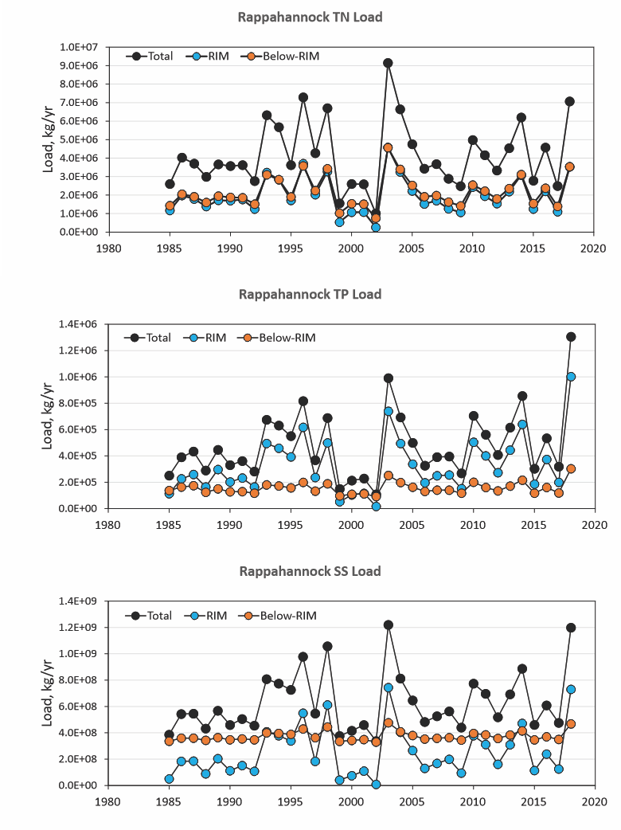
Figure 20. Estimated total loads (sum of RIM and Below-RIM) of nitrogen (TN), phosphorus (TP), and suspended sediment (SS) from the RIM and below-RIM areas of the Rappahannock River. RIM refers to the USGS River Input Monitoring site located just above the head of tide of this tributary, which includes upstream point source loads. Below-RIM estimates are a combination of simulated non-point and reported point-source loads.
Table 1. Summary of Mann-Kendall trends for the period of 1985-2018 for total nitrogen (TN), total phosphorus (TP), and suspended sediment (SS) loads from the Rappahannock River watershed.
Variable | Trend, metric ton/yr | Trend p-value
TN
Total watershed | 12 | 0.70
RIM watershed ¹ | 4.5 | 0.73
Below-RIM watershed ² | 6.7 | 0.55
Below-RIM point source | -2.5 | < 0.01
Below-RIM nonpoint source ³ | 13 | 0.30
Below-RIM tidal deposition | -2.0 | < 0.05
TP
Total watershed | 5.4 | 0.15
RIM watershed | 5.0 | 0.12
Below-RIM watershed | 0.51 | 0.50
Below-RIM point source | -0.58 | < 0.01
Below-RIM nonpoint source | 1.4 | < 0.05
SS
Total watershed | 4,158 | 0.18
RIM watershed | 3,484 | 0.21
Below-RIM watershed | 680 | 0.19
Below-RIM point source | -4.0 | < 0.01
Below-RIM nonpoint source | 678 | 0.19
¹ Loads for the RIM watershed were estimated loads at the USGS RIM station 01668000 (Rappahannock River near Fredericksburg, Va.; https://cbrim.er.usgs.gov/loads_query.html).
² Loads for the below-RIM watershed were obtained from the Chesapeake Bay Program Watershed Model (https://cast.chesapeakebay.net/).
³ Below-RIM nonpoint source loads were obtained from the Chesapeake Bay Program Watershed Model’s progress runs specific to each year from 1985 and 2018, which were adjusted to reflect actual hydrology using the method of the Chesapeake Bay Program’s Loads to the Bay indicator (see https://www.chesapeakeprogress.com/clean-water/water-quality).

5.1.3. Flow-Normalized Watershed Nutrient and Sediment Loads

Flow-adjusted or flow normalized nitrogen, phosphorus, and/or sediment trends in load have been measured between 2007 – 2018 at four stations throughout the watershed and show a mixture of improving and degrading conditions (Moyer et al., 2019; Table 2). These trends resulted from variability in nutrient applications, the delivery from the landscape to streams, and from processes that affect in-stream loss or retention of nutrients and sediment.

Table 2. Percent change (2009 – 2018) in flow normalized loads for total nitrogen (TN), total phosphorus (TP), and suspended sediment (SS) for nontidal network monitoring locations in the Rappahannock River watershed. Values shown were generated using the Weighted Regression on Time, Discharge, and Season (WRTDS) approach (Moyer et al., 2019).
USGS Station ID | USGS Station Location | TN | TP | SS
1668000¹ | Rappahannock River near Fredericksburg | 6.3% | 27.9% | 28.3&
1664000² | Rappahannock River at Remington | 15.4% | - | -
1667500³ | Rapidan River near Culpeper | -8.9% | -6.8% | -7.1%
1665500³ | Rapidan River near Ruckersville | -5.1% | - | -
Decreasing trends are listed in green, increasing trends in orange, results reported as no trend listed in black. TN=Total nitrogen, TP= Total phosphorus, SS=Suspended sediment. A “-“ indicates no available data.(?)
¹This station located at Rappahannock River fall-line.
²Lower Rapidan River station above Rappahannock fall-line.
³Rappidan is a tributary of the Rappahannock and stations are located above the fall-line.

5.1.4 Expected effects of changing watershed conditions

According to the Chesapeake Bay Program's Watershed Model known as the Chesapeake Assessment Scenario Tool (CAST; https://cast.chesapeakebay.net/About/UpgradeHistory, version Phase 6 - 7.1.0), changes in population size, land use, and pollution management controls between 1985 and 2020 would be expected to change long-term average nitrogen, phosphorus, and sediment loads to the tidal Rappahannock River by -13%, -33%, and -13%, respectively (Figure X). In contrast to the annual loads analysis above, CAST loads are based on changes in management only and do not include annual fluctuations in weather. CAST loads are calculated without lag times for delivery of pollutants or lags related to BMPs becoming fully effective after installation. In 1985, agriculture and natural were the two largest sources of nitrogen loads. By 2020, agriculture remained the largest nitrogen source; however, natural nitrogen loads had changed by -7% and the developed sector had taken its place as the second largest nitrogen source. Overall, decreasing nitrogen loads from agriculture (-28%), natural (-7%), stream bed and bank (-12%), and wastewater (-24%) sources were partially counteracted by increases from developed (79%) and septic (66%) sources.

The two largest sources of phosphorus loads as of 2020 were the agriculture and developed sectors. Overall, expected declines from agriculture (-51%), natural (-7%), stream bed and bank (-33%), and wastewater (-76%) sources were partially counteracted by increases from developed (96%) sources.

For sediment, the largest sources are shoreline and stream bed and bank areas: these two sources changed by -1% and -25%, respectively between 1985 and 2020. Sediment loads from the agriculture sector changed by -58%, whereas sediment load from developed areas changed by 40%.Overall, changing watershed conditions are expected to result in the agriculture, natural, stream bed and bank, and wastewater sectors achieving reductions in nitrogen, phosphorus, and sediment loads between 1985 and 2020, whereas the developed sectors are expected to increase in nitrogen, phosphorus, and sediment loads.

5.1.5. Best Management Practices (BMPs) Implementation
Data on reported BMP implementation are available for download from CAST (https://cast.chesapeakebay.net, version CAST-19). Reported BMP implementations on the ground as of 1985, 2009, and 2019 are compared to planned 2025 implementation levels in Figure 23 for a subset of major BMP groups measured in acres. As of 2019, tillage, cover crops, pasture management, forest buffer and tree planting, stormwater management, agricultural nutrient management, and urban nutrient management were credited for 142, 37, 47, 0.1, 13, 280, and 4.1 thousand acres, respectively. Implementation levels for some practices are already close to achieving their planned 2025 levels: for example, 102% of planned acres for tillage had been achieved as of 2019. In contrast, about 42% of planned commodity & cover crops implementation had been achieved as of 2019.
Stream restoration and animal waste management are two important BMPs that cannot be compared directly with those above because they are measured in different units. However, progress towards implementation goals can still be documented. Stream restoration (agricultural and urban) had increased from 0 feet in 1985 to 14,666 feet in 2019. Over the same period, animal waste management systems treated 0 animal units in 1985 and 1,887 animal units in 2019 (one animal unit represents 1,000 pounds of live animal). These levels represent 25% and 6% of their respective planned 2025 implementation levels.
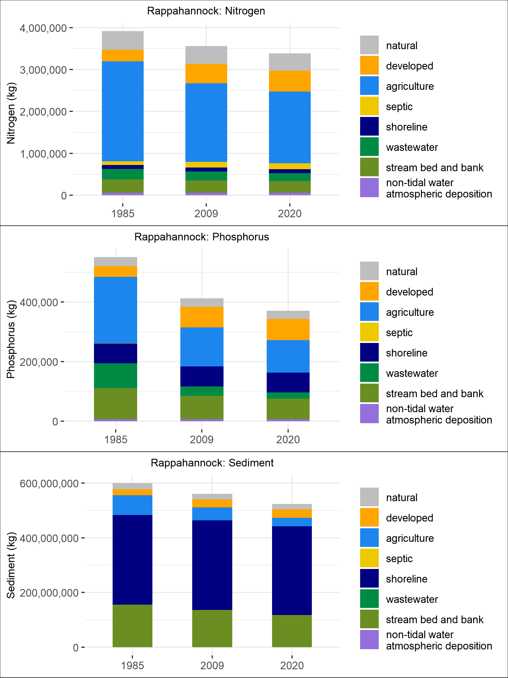

Figure 21. Expected changes in nitrogen, phosphorus, and sediment loads from different sources to the tidal Rappahannock, as obtained from the Chesapeake Assessment Scenario Tool (CAST-17d). Data shown are time-average delivered loads over the average hydrology of 1991-2000, once the steady state is reached for the conditions on the ground, as obtained from the 1985, 2009, and 2018 progress (management) scenarios.

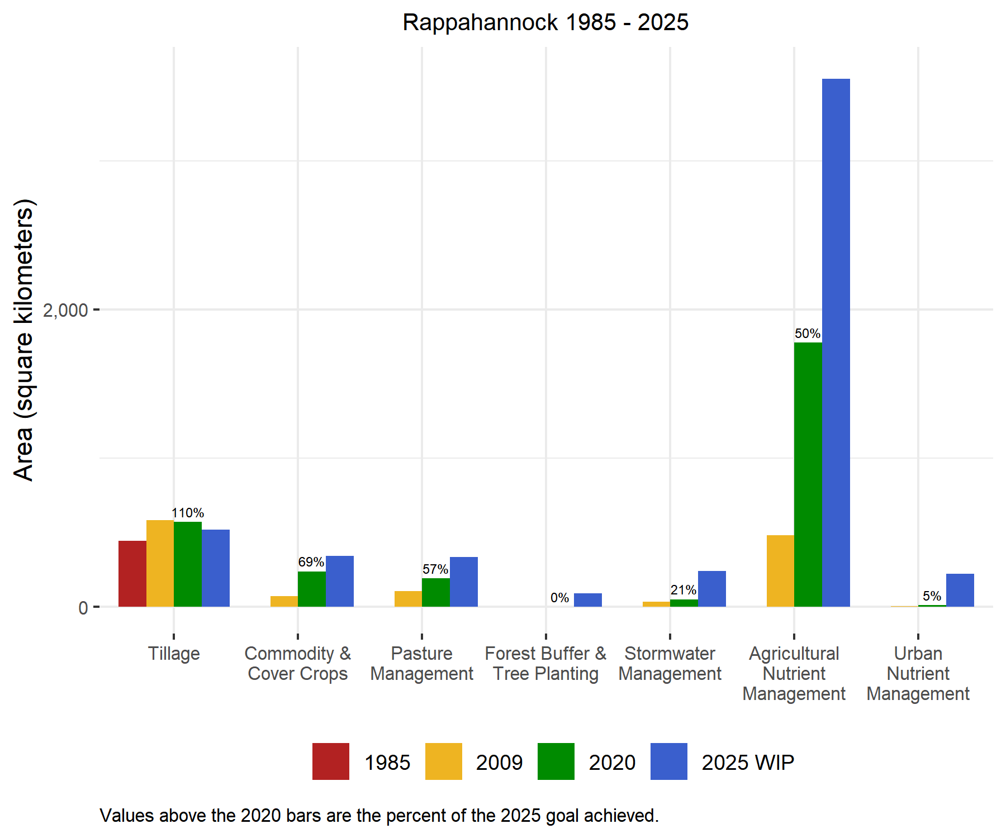
Figure 22. BMP implementation in the Rappahannock watershed.

5.2 Tidal Effects

5.2.1 Volume and Area Impacts
High nutrient loads relative to tidal river size are indicative of areas that are more susceptible to eutrophication (Bricker et al., 2003; Ferreira et al., 2007). The relationship between watershed area and tidal river size may also be an important indicator of eutrophication potential, however there are competing effects. A large watershed relative to the volume of receiving water would likely correlate with higher nutrient loads, however it would also correlate with a higher flow rate and decreased flushing time (Bricker et al., 2008). Figure 23 is a comparison of watershed area versus estuarine volume for all estuaries and sub-estuaries identified in the CBP monitoring segment scheme. Larger estuaries will contain multiple monitoring segments and, in many cases, sub-estuaries. For example, the Potomac River contains monitoring segments in the tidal fresh, oligohaline, and mesohaline sections of the river as well as the entire Anacostia River and other sub-estuaries. Figures 24 and 25 are comparisons of estimated annual average nitrogen and phosphorus loads, respectively, for the 2018 progress scenario in CAST versus the estuarine volume for the same set of estuaries and sub-estuaries.
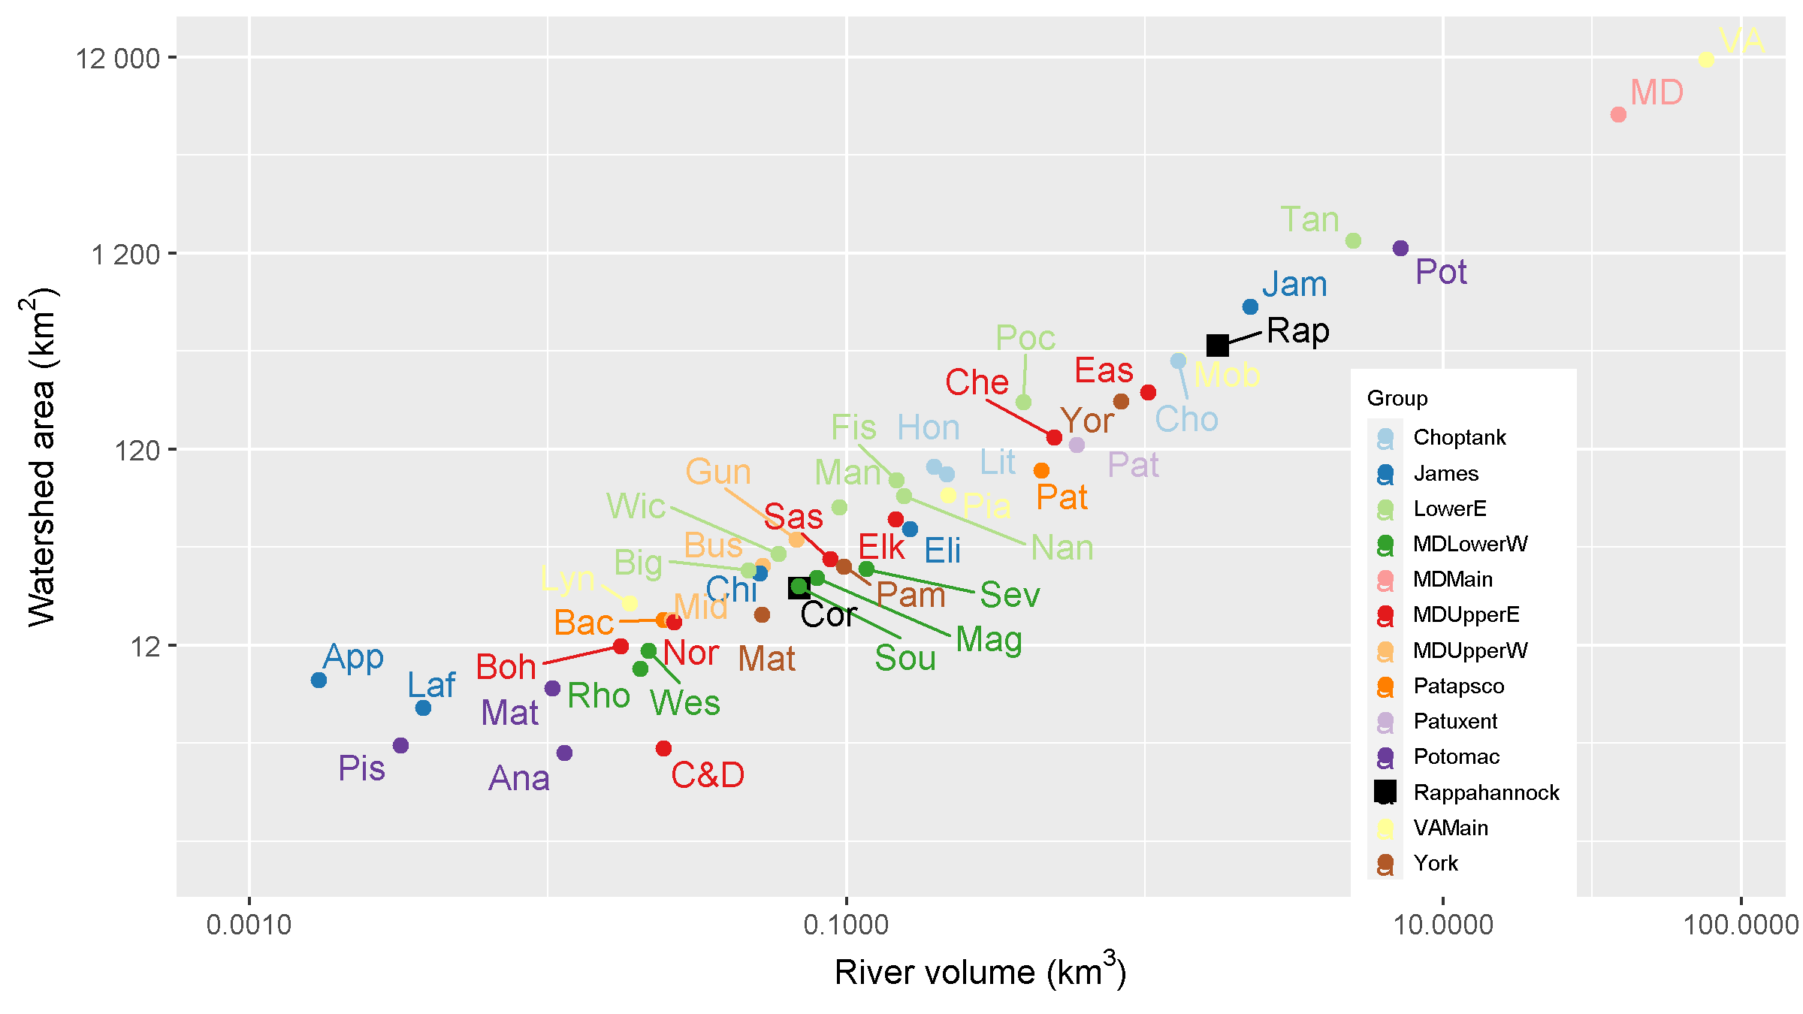
Figure 23. Watershed area vs estuarine volume.
Abbreviated tributary name | Full tributary name | Abbreviated tributary name | Full tributary name
Ana | Anacostia River | Mat | Mattaponi River
App | Appomattox River | MD | MD MAINSTEM
Bac | Back River | Mid | Middle River
Big | Big Annemessex River | Mob | Mobjack Bay
Boh | Bohemia River | Nan | Nanticoke River
Bus | Bush River | Nor | Northeast River
C&D | C&D Canal | Pam | Pamunkey River
Che | Chester River | Pat | Patapsco River
Chi | Chickahominy River | Pat | Patuxent River
Cho | Choptank River | Pia | Piankatank River
Cor | Corrotoman River | Pis | Piscataway Creek
Eas | Eastern Bay | Poc | Pocomoke River
Eli | Elizabeth River | Pot | Potomac River
Elk | Elk River | Rap | Rappahannock River
Fis | Fishing Bay | Rho | Rhode River
Gun | Gunpowder River | Sas | Sassafras River
Hon | Honga River | Sev | Severn River
Jam | James River | Sou | South River
Laf | Lafayette River | Tan | Tangier Sound
Lit | Little Choptank River | VA | VA MAINSTEM
Lyn | Lynnhaven River | Wes | West River
Mag | Magothy River | Wes | Western Branch (Patuxent River)
Man | Manokin River | Wic | Wicomico River
Mat | Mattawoman Creek | Yor | York River

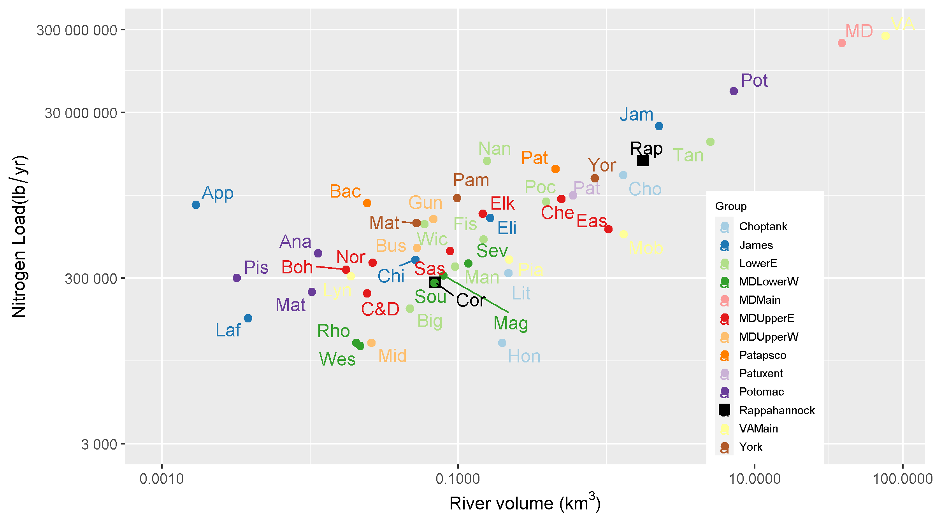
Figure 24. Annual mean expected nitrogen loads versus estuarine volume. Nitrogen loads are from the 2018 progress scenarios in CAST (Chesapeake Bay Program, 2020), which is an estimate of nitrogen loads under long-term average hydrology given land use and reported management as of 2018.
5.2.2. Long-term Changes in Water Quality Longitudinal Profiles
This section presents a series of longitudinal profiles of five water quality parameters across all Rappahannock River stations. The profiles are generated from the results of gam models estimated for each station. Cluster analyses is used to group years on the average GAM predicted values for the following surface water quality parameters: total nitrogen (TN), total phosphorus (TP), Chlorophyll a (Chl a), water clarity as measured by Secchi depth (Secchi), and bottom dissolved oxygen (DO). Figure 23A-E shows the longitudinal profile plots for each of these five parameters. The profiles of the same color represent groups of similar years across all the stations in the Rappahannock River for a given parameter and allow for comparisons of conditions across both time and space for individual parameters and between different parameters.
Total nitrogen shows consistency with respect to its spatial profile but variability in its response over time and in relation to annual flow conditions in the watershed. Typically, concentrations of TN are higher in the upper or tidal freshwater portion of the river and decline mid river in the oligohaline at station RET3.2 reaching minimum concentrations at the lower estuarine or mesohaline portion of the river (stations LE3.1 through LE3.7). Concentrations were generally lowest at the tidal freshwater stations (TF3.1E to TF3.2) of the river during more recent (2013-2017) high flow years (Figure 1F) and highest at these stations during low flow years of 1999 through 2001 (Figure 23A). At the oligohaline and mesohaline stations (TF3.3 to LE3.7) the lowest concentrations occurred during a low flow period (1999-2001) while the highest concentrations occurred during a higher flow period (red group Figure 23A).
The spatial profile of total phosphorus (TP) is similar to TN although TP increases from the tidal freshwater to oligohaline reaching a maximum at station RET3.2 declining thereafter into the lower mesohaline portion of the estuary (Figure 23B). Because TP is associated with particles, it is expected that TP will reach a maximum in the turbidty maximum of the estuary. Highest concentrations at all stations occurred during a three-year period (1994-1997) that was preceded by a period of relative low flow (Figure 23B). Lowest concentrations of this parameter occurred at most stations during a four-year period (2013-2016) of mixed flow conditions. The remainder of the period of record characterized by mid-range concentrations of TP coupled to a wide range of flow conditions. Results suggest that accumulation of total phosphorus occurs within the watershed during periods of both low to normal flow conditions but higher than normal concentrations of TP occur when a threshold of freshwater input is reached. Beyond this threshold, accumulated TP is flushed from watershed soil or groundwater reservoirs perhaps associated with suspended sediments.
Chlorophyll-a had lower concentrations at stations in the tidal freshwater portion of the river and increased slightly in the oligohaline and then declined to levels similar to those in the tidal fresh in the lower portion of the estuary (Figure 1C). On a temporal scale, concentrations of Chl a were highest in the tidal freshwater portion of the Rappahannock River during a series of years with relatively low flow (Figure 1C, red). In the oligohaline, Chl-a was highest in the years 2012-2017 (Figure 23C, green) which coincides with a relatively low TN and TP concentrations. In tidal freshwater, Chl-a was lowest in periods of high flow (Figure 23C, brown and purple). Within the lower mesohaline portions of the estuary, Chl a reaches its highest concentrations during years with higher flows (Figure 23C, purple). An exception is the early above average flow period of 1994-1995 which has relatively low Chl-a in the mesohaline. These results suggest that flow regime regulates chlorophyll a concentrations along the entire estuarine gradient in the Rappahannock River. Low flows allow for the accumulation of higher concentrations upstream but during higher flow periods those concentrations are pushed downstream into the mesohaline portions of the estuary to increase levels of Chl-a there. In addition, there is evidence that in above average flow conditions, Chl-a is higher in the most recent decade than in the mid 1990’s.
Water clarity as measured by Secchi depth shows decreasing trend into the turbidity maximum and then a steep increasing pattern into the mesohaline. (Figure 23D). Over time, clarity is more consistent in the tidal fresh and transition zone and more variable in the mesohaline. Secchi depth was lower during low flow years upstream and higher during low flow years downstream (Figure 23D, red). In high flow years, the converse is true (Figure 23D, green). Results suggest that high flow helps to increase tidal freshwater clarity by flushing suspended solids and excess phytoplankton biomass downstream where they decrease water clarity.
Bottom dissolved oxygen shows a spatial pattern of higher concentrations in the tidal freshwater and olighaline portions of the river with lower concentrations at mesohaline stations (Figure 23E). There is a consistent pattern of degrading bottom dissolved oxygen over time (decreasing) however temporal groupings do not appear to be uniformly related to flow regime. In the lower estuary, there is some evidence of improved bottom DO in the high flow years of 2003-2006 (Figure 23E) however the last three years 2018-2020 (green group Figure 23E) were also associated with higher flows and this group has the lowest DO concentrations in the lower portion of the estuary. This period of poor DO does correspond to periods in the lower estuary with high chlorophyll a and poor water clarity described above.

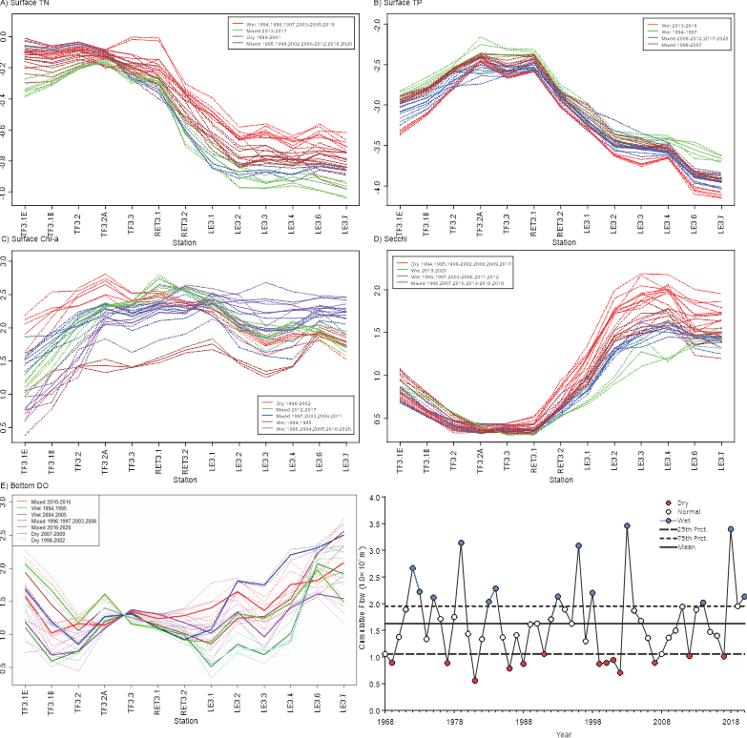
Figure 23. Long term changes in longitudinal profiles for: A. Surface Total Nitrogen; B. Surface Total Phosphorus; C. Chlorophyll a; D. Secchi Depth and E. Bottom Dissolved Oxygen along with the long-term change in cumulative freshwater flow at the fall-line in the Rappahannock River. Unless otherwise indicated on the figures year groups are identified in the table below.

5.2.3. Phytoplankton Communities
Phytoplankton communities respond rapidly to changes in water column nutrient concentrations and light availability. Excessive phytoplankton production can adversely affect the structure of ecosystem food webs and lead to low dissolved levels at the sediment-water interface. Algal blooms of toxic species can adversely affect both humans and aquatic living resource communities. As a result, phytoplankton communities have been monitored at three stations (TF3.3, RET3.1 and LE3.6) in the Rappahannock River since the mid-1980s. Status of phytoplankton communities was assessed using the phytoplankton index of biotic integrity or P-IBI (Buchanan, et al., 2005). Long-term changes in phytoplankton community health were assessed using GAM analyses similar to those conducted on the water quality using abundance levels of several important phytoplankton taxonomic groups (see Table 5).
Status of phytoplankton communities based on the phytoplankton IBI was degraded or severely degraded at all stations in the Rappahannock although community condition was somewhat better at station LE3.6 in the mesohaline portion of the river (Figure 25). Results of the GAM analyses indicate significant increases in the predicted mean abundance of multiple taxonomic groups at all the monitoring stations in the Rappahannock River. The largest increases were concentrated primarily at stations TF3.3 and RET3.1, which both saw significant (p ≤0.05) or potentially significant increases in cyanobacteria and chlorophytes (Table 5). Station LE3.6 and also had a significant (p ≤0.05) significant increases in dinoflagellates while a significant increase in diatoms was observed at station TF3.3. The only significant decline in predicted abundance observed was for diatoms at station LE3.6.

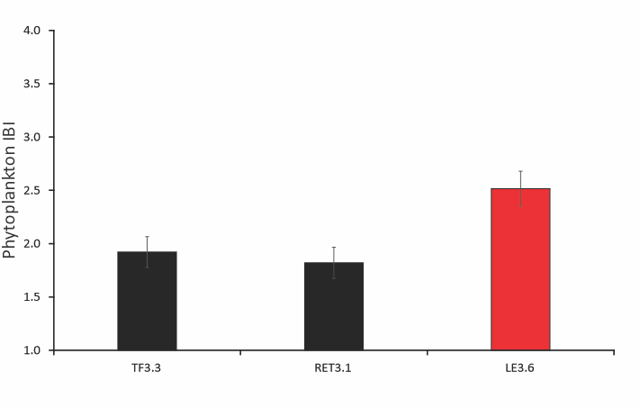
Figure 24. Status of phytoplankton communities at stations in the Rappahannock River for the period of 2017 through 2019 based on the P-IBI (Buchanan et al.,). Shown are mean values for the assessment period ± one standard error.
Table 5. Long term change in mean counts of taxonomic groups at stations in the Rappahannock River.
 |  | Long term Change in Mean
Station | Taxonomic Group | Percent |  | Absolute (#/L) | p Value
TF3.3 |  |  | 95 | 734504 | 0.013
RET3.1 | Diatoms |  | 6 | 69348 | 0.834
LE3.6 |  |  | -79 | -1686737 | <0.001
TF3.3 |  |  | 530 | 14377 | 0.104
RET3.1 | Dinoflagellates |  | -59 | -92646 | 0.372
LE3.6 |  |  | 111 | 135109 | 0.032
TF3.3 | Cyanobacteria |  | 286 | 732114 | 0.033
RET3.1 | Cyanobacteria |  | 269 | 238463 | 0.136
LE3.6 |  |  | 44 | 54 | 0.777
TF3.3 |  |  | 918 | 468736 | <0.001
RET3.1 | Chlorophytes |  | 3889 | 281404 | <0.001
LE3.6 |  |  | 523 | 5304 | 0.109

Plots of the observed data and model predictions for these groups the reflect the generalized trend directions observed as well as a high degree of seasonality and in many cases increasing variability in the seasonality over time (Figure 25-27). Model results indicated significant seasonal and/or seasonal interaction effects for each group analyzed with many groups exhibiting increasing variability in later years. The long-term pattern in several of the groups, in particular dinoflagellates and chlorophytes, either alone or perhaps in combination appear to mirror that of the chlorophyll a observed at the same stations however the match is not necessarily exact. The results indicate that phytoplankton production is generally increasing, highly variable, and that the variability is increasing. The long-term patterns for some groups (e.g chlorophytes at station TF3.3) seem to correspond roughly to changes in nutrients (i.e. total phosphorus) suggesting nutrient inputs are at least in part responsible for the increased phytoplankton counts. The reduced suspended sediment loads mentioned above could reduce light limitation which in turn would allow for the increase in phytoplankton production and the reduction in Secchi depths observed – an effect referred to as the Organic Fog (Turner et al., 2021). Finally, the increased variability observed could be the result of increased temperatures associated with climate change or seasonal variability in nutrient inputs or some combination of each of the effects listed. Whatever the source, phytoplankton communities show poor general status and an indication of increased eutrophication which could be linked to the low dissolved oxygen levels described above.
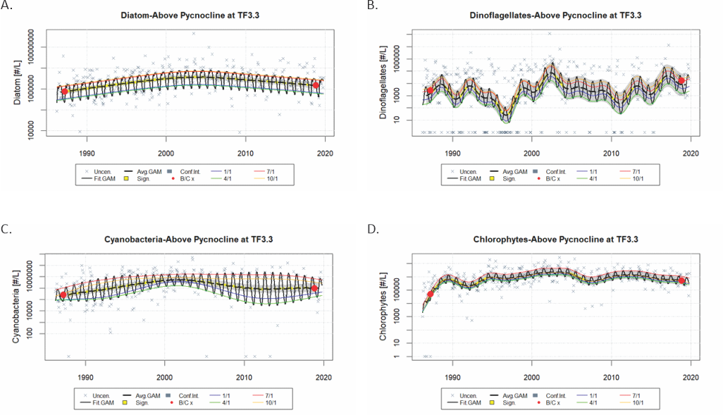
Figure 25. Long term changes in A. Diatom, B. Dinoflagellate, C. Cyanobacteria, and D. Chlorophyte counts (#/L) based on the GAM model output for station TF3.3 in the oligohaline Rappahannock River for the period of 1986 through 2019. Plots show the annual average predicted value and confidence interval, the full model and seasonal predictions for each of the taxonomic groups shown. Yellow lines on the plot indicate periods of significant change in direction. Red circles are the baseline and current mean values based on model predictions.

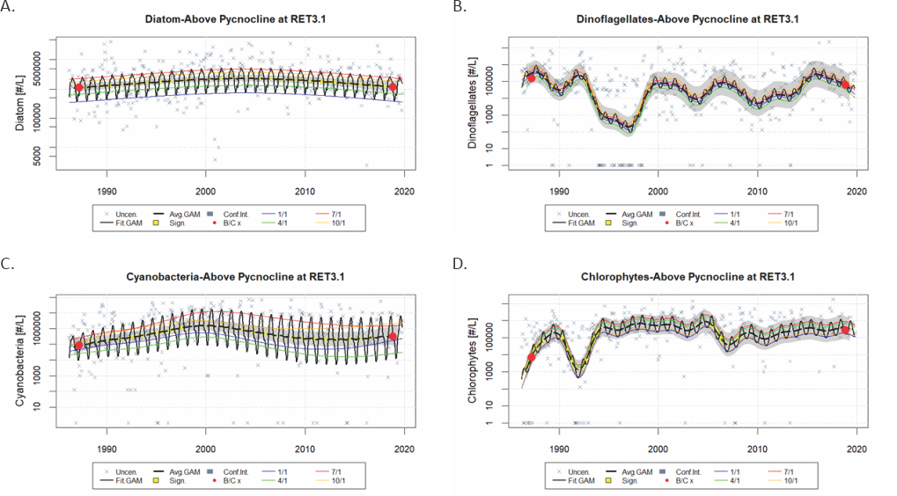
Figure 26. Long term changes in A. Diatom, B. Dinoflagellate, C. Cyanobacteria, and D. Chlorophyte counts (#/L) based on the GAM model output for station RET3.1 in the low mesohaline Rappahannock River for the period of 1986 through 2019. See Figure 25 for details.
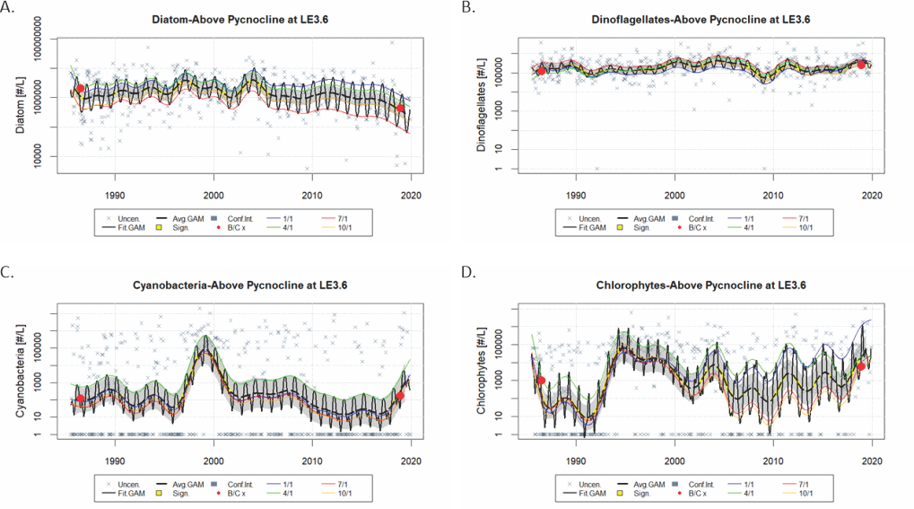
Figure 27. Long term changes in A. Diatom, B. Dinoflagellate, C. Cyanobacteria, and D. Chlorophyte counts (#/L) based on the GAM model output for station TF3.3 in the low mesohaline Rappahannock River for the period of 1986 through 2019. See Figure 25 for details.

5.2.4. Submerged Aquatic Vegetation
Submerged aquatic vegetation (SAV) monitoring has enabled the region’s state agencies and research community to collaborate on quantifying change over time in these important biological communities. Members of the Chesapeake SAV research community recently engaged in an effort to summarize changes over time in SAV abundance across all Chesapeake tidal regions. Their findings are available from at https://www.vims.edu/research/units/programs/sav/. Historically, the shoal areas of the lower Rappahannock and the Corrotoman rivers were dominated by dense beds of eelgrass and widgeongrass. As in other areas of the Chesapeake, these beds reached peak biomass in the drought years of the 1960s and declined sharply after Tropical Storm Agnes in 1972. There is no evidence of SAV beds in the tidal fresh and oligohaline portions of the Rappahannock River prior to 1978. Little SAV was observed through the 1980s, after which SAV abundance in the area has experienced a series of fluctuations.
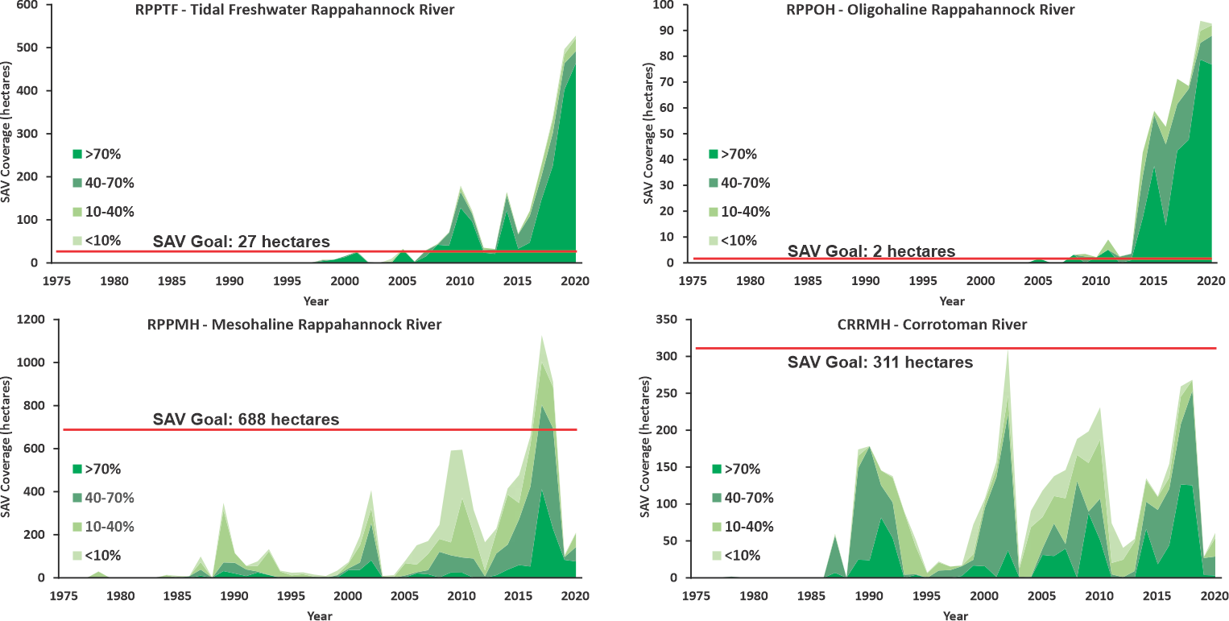
Figure 28. Long term change (1985-2020) and current status relative to Chesapeake Bay Program goals of submerged aquatic vegetation (SAV) in the Rappahannock River by segment. SAV coverages are provided in hectares with densities expressed as hectares in percent coverage from very sparse (<10%), to sparse (10-40%), dense (40-70%) or very dense (70-100%) SAV coverage for each segment of the Rappahannock River. Solid lines indicate established areal goals for a given segment in hectares (Note: there is no established goal for segment RPPOH). Modified from figures provided at https://www.vims.edu/research/units/programs/sav/.
Chesapeake Bay wide aerial SAV surveys expanded to include the upper and middle Rappahannock beginning in 1998. Since that time, SAV beds in the tidal fresh region have expanded and contracted depending on water quality conditions. SAV has populated the tidal wetland area formed by the meandering river channel, the tributary creeks and the large, shallow shoals found along the main river channel. The tidal fresh segment has regularly exceeded its SAV restoration goal of 66 acres, although this goal is likely artificially low due to limited historical coverage data. In the middle Rappahannock, SAV was not observed again until 2005, and its abundance remained low until 2014 when coverage suddenly increased. Almost all the SAV in this segment of the Rappahannock River is located inside the tributaries and small creeks entering the mainstem river or in and around marshes, all of which provide protection from the high-energy environment characteristic of the mainstem.
The Chesapeake Bay Program has established regional goals for SAV restoration in each of the major segments of the Rappahannock River. In 2020, both the tidal freshwater Rappahannock River (RPPTF) and the oligohaline Rappahannock River (RPPOH) currently and substantially exceed these goals (Figure 28A-B). SAV areal coverage and density have been slowly increasing in the last two decades in both segments (Figure 28A-B) in response to the reductions in loads mentioned above and concomitant improvements in nutrient concentrations and water clarity. The remaining segments have shown similar albeit smaller and/or more unstable responses that have either not attained the SAV goals (segment RPPMH; Figure 28C) or briefly attained them only to precipitously decline thereafter (segment CRRMH; Figure 28D). The dynamics observed particularly in the mesohaline segments of the river may be the result of a change in the dominant seagrass species Ruppia martitima which could alternatively respond positively to increasing temperature associated with climate change and negatively to increases in chlorophyll a, and/or water clarity and negatively to fluctuations in salinity (Richardson, et al., 2018; Moore et al., 2014). Future studies within the river should examine potential interactions between SAV coverage and the stressors mentioned above.

5.2.5 Benthos

Benthic invertebrates are an important part of food webs for aquatic and avian species, have relatively long lifespans and limited mobility, and respond to multiple natural and anthropogenic stressors. As a result, they are ideal communities for monitoring and assessing the level of impairment of the habitats in which they live. Benthic monitoring began in the Rappahannock River in 1985, with the establishment of four fixed point monitoring stations each corresponding to an existing water quality station (TF3.3, RET3.1, LE3.2, LE3.4; see Figure 4). Status and long-term trends in benthic community health were assessed for these stations using the Benthic Index of Biotic Integrity (B-IBI; Weisberg et al., 1997). In 1996, 25 probability-based stations were added to the Rappahannock River to supplement data collected at fixed-point stations and allow a tributary-wide assessment of community health and progress towards restoration goals based on the B-IBI (Ranasinghe et al., 1994; Weisberg et al., 1997; Alden et al., 2002; Llanso et al.,2009).
Station TF3.3 in the oligohaline portion of the Rappahannock River was the only fixed-point station that met the B-IBI restoration goals (Figure 29). The remaining stations were degraded or severely degrading with a minimum value at station LE3.2 in the mesohaline portion of the estuary (Figure 29A). Probability-based data used to assess impairment at the scale of the segment showed a similar degrading downstream trend. Benthic communities meet restoration goals in the tidal freshwater portion of the river (segment RPPTF) but were generally impaired in mesohaline reaches of the estuary (Figure 29B).
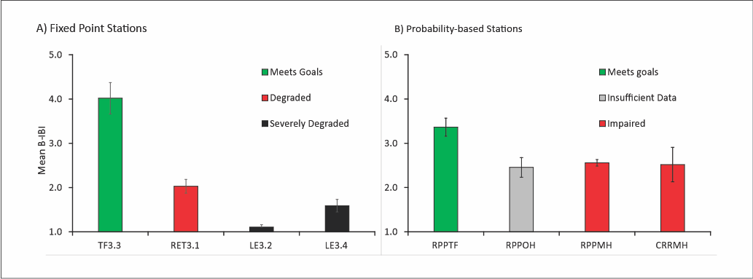
Figure 29. Status of benthic communities at A. Fixed Point Stations for the period of 2018 through 2020 and B) Probability-based Stations in the Rappahannock River for the period of 2016 through 2020. Shown are station and segment B-IBI means ± one standard error. Impairment for probability-based samples was assessed using methods described in Llanso et al., 2009.
A series of GAM analyses was conducted on the B-IBI and some of its component metrics to identify long-term patterns of change in benthic community conditions. Potential relationships between these the B-IBI and its component metrics to water column stressors including measures of dissolved oxygen, freshwater flow, salinity, and temperature were conducted. This text provides only a brief synopsis of the important results rather than a complete summary of all analytical results. When discussed below, a significant relationship refers to the prediction resulting from a generalized additive model (GAM) between a response variable (the B-IBI or its component metrics) and a predictor (time or the stressors listed above), for which at least one term of the model (linear or smoother) was statistically significant (p ≤ 0.05). For the sake of brevity, results of significance tests, R² and other statistical test criteria presented are provided in the appendices rather than referenced in the text.
Benthic condition as measured by the B-IBI fluctuated substantially over time at station TF3.3 ranging from below 2 to well above 4. There was a significant trend of improving community condition in this portion of the river in the last 15 years (Figure 30A). A significant relationship between the B-IBI and freshwater flow was detected at this station and the predicted values from the model appear to track the observed fluctuations in the B-IBI as do annual mean values of Spring/Summer flow (Figure 30B). The B-IBI declines below the restoration goal during periods of low flow but peaks above it when freshwater inputs rise above levels of 1500-2000 m³/sec (Figure 30B). These results suggest that flow acts as a mediating factor for maintaining benthic community conditions at levels above the restoration goals (B-IBI≥3.0) at station TF3.3.
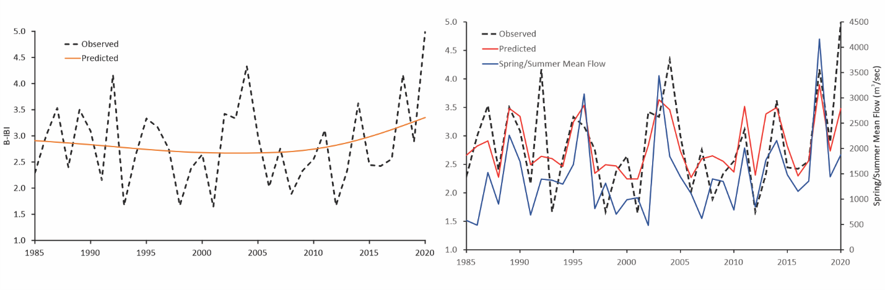
Figure 30. Change in the B-IBI at Station TF3.3 in the oligohaline Rappahannock River A. over time in years and B. over time in relation to change in flow. Plot A shows the observed data (dashed line) and prediction due to time while Plot B shows the change in observed B-IBI values (dashed line) and values predicted by a significant relationship to Spring/Summer mean annual flow (red line) in combination with the predictor variable (blue line) over time.
Although the B-IBI met the restoration goals at the start of monitoring, community condition at station RET3.1 has generally declined to degraded levels and is continuing worsened over time (Figure 31A). A significant relationship between the B-IBI and bottom summer temperature indicates that the decline in benthic community condition may be due to an increase in water temperature over the long-term (Figure 31B.). Plots of predicted values due to temperature show a steady decline that parallels although does not completely overlap that of the observed values while summer temperatures show a steady increase (Figure 31B). Temperature may directly or indirectly apply adverse pressure on the component metrics of the B-IBI which in combination could cause the observed degrading patterns.
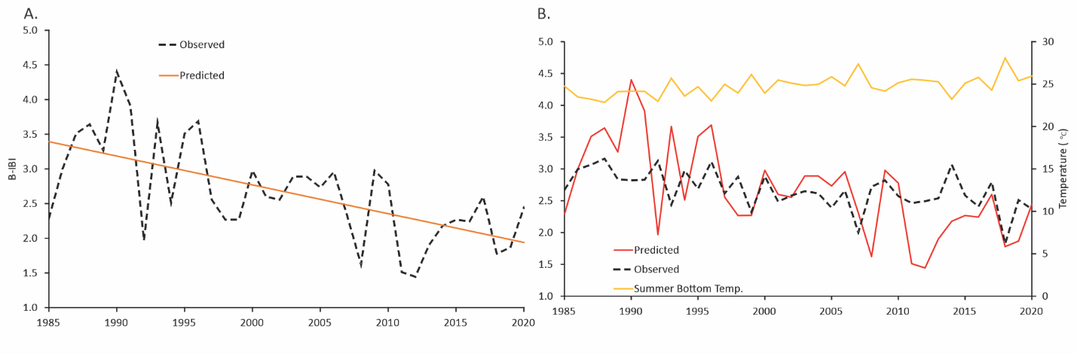
Figure 31. Change in the B-IBI at Station RET3.1 in the oligohaline Rappahannock River A. over time and B. over time in relation to change in summer mean temperature. Plot A shows the observed data (dashed line) and prediction due to time while Plot B shows the change in observed B-IBI values (dashed line) and values predicted by a significant relationship to Summer mean annual temperature(red line) in combination with the predictor variable (yellow line).

For example, increased temperature could increase water column stratification, bacterial respiration rates or phytoplankton production inputs any of which could lead to reduced dissolved oxygen and therefore impacts on the benthos. Alternatively, temperature increases could induce changes in the overall species composition of the community as different taxa will exhibit different temperature tolerances. The data reveal evidence of both of these potential effects.
There was a significant positive relationship between in-situ (collected with benthic samples) dissolved oxygen and Shannon-Weiner diversity and plots of the predicted values of this metric show a long-term decline that closely parallels both the observed data and in-situ dissolved oxygen (Figure 32). The observed relationship indicated that values of dissolved oxygen somewhere between 5-6 mg/L result in diversity values that lower metric scores for the B-IBI to levels indicative of degraded conditions (Figure 32). Changes in B-IBI can also be explained by examining changes in the composition of various taxonomic groups over time relative to the metric thresholds for total abundance. If total community abundance falls outsided the upper (6,000 per m²) and lower (500 per m²) thresholds, benthic communities are considered degraded with respect to this metric. From the start of monitoring through the 1990s and most of the early 2000s, total abundance remained within the bounds of these threshold (Figure 33) and the community was comprised of a mixture of bivalves, infaunal crustaceans and tubificid oligochaetes all typical of low mesohaline habitats (Figure 33). Beginning in the mid 2000s total abundance began to climb above the upper criterion indicative of degraded conditions as the result of increasing abundance of several groups including tubificid oligochaetes, spionid polycheates, the capitellid Mediomastus ambiseta, and the Pilargid polychaete Hermundura sp. A a recent migrant species from the Gulf Coast (Figure 33). These changes were accompanied by reductions in abundance in both bivalves and infaunal crustacean (Figure 33). Increases in the opportunistic taxa listed could be the result of trends in either temperature, dissolved oxygen, or increased phytoplankton production (chlorophyll a) observed in the water quality data. Loss of bivalve and crustacea both in termsof abundance and numbers of species are likely a response to reductions in dissolved oxygen.
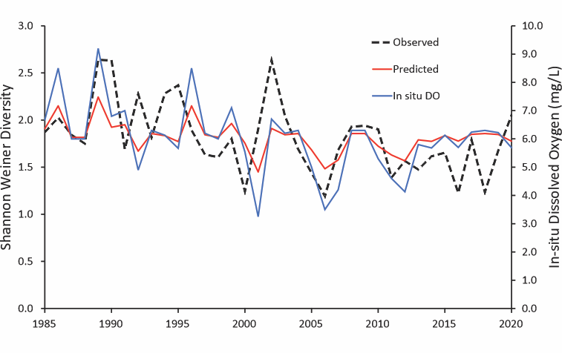
Figure 32. Change over time in diversity at Station RET3.1 in the oligohaline Rappahannock River and in relation to in-situ dissolved oxygen. Shown are observed data (dashed line) and prediction due to dissolved oxygen (red line) in combinaton with the predictor variable, in-situ dissolved oxygen (blue line).
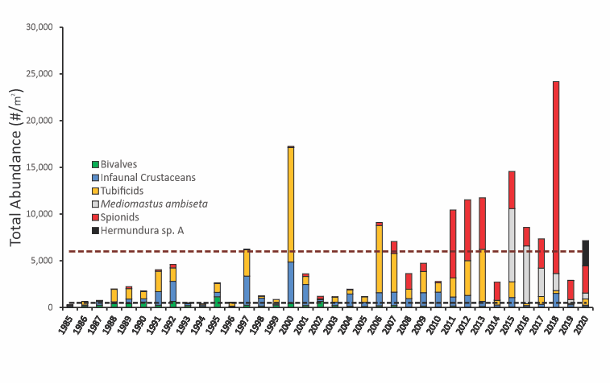
Figure 33. Change in total abundance and abundances of dominant taxa at Station RET3.1 in the oligohaline Rappahannock River. Dashed lines indicate the upper and lower criterion values indicative of degraded levels for total abundance per m² in low mesohaline habitats.
`

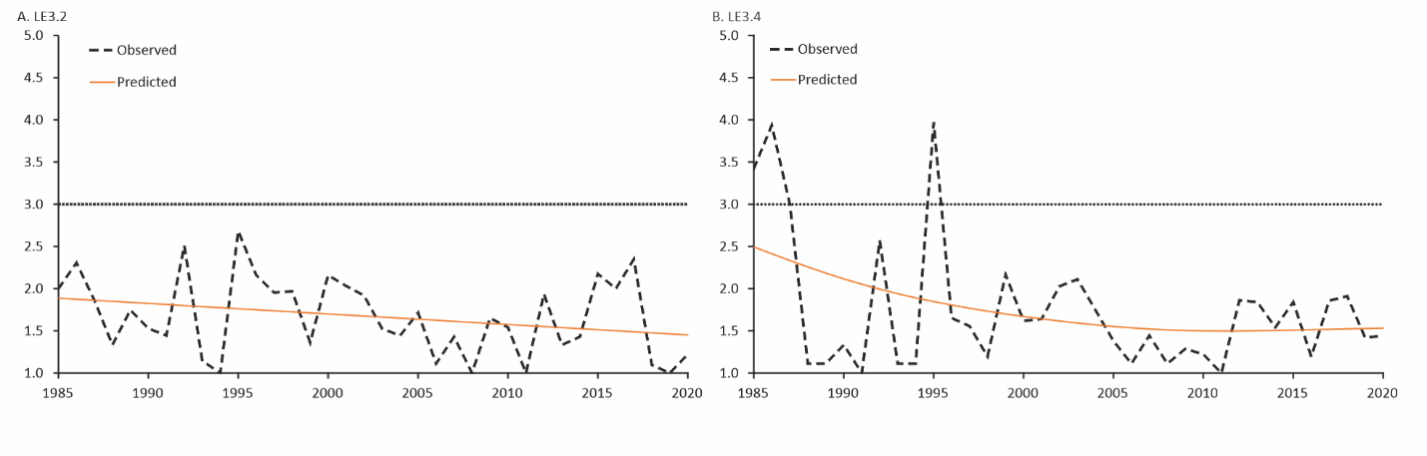Figure 34. Long-term change in the B-IBI at station A. LE3.2 and station B. LE3.4 in the Rappahannock River from the start of monitoring through 2020. Shown are the observed data and predicted values of a generalized additive model between the B-IBI and time in years.
The B-IBI at both stations LE3.2 and LE3.4 in the lower mesohaline portion of the river nearly always remained below the restoration goal and appears in both cases to be continuing to decline as indicated by the GAM analyses (Figure 34). Benthic communities at these two stations are chronically degraded likely due to low dissolved oxygen events triggered by increasing inputs of phytoplankton production. Benthic communities are likely to remain degraded at these two stations as there is either an indication continued decline in dissolved oxygen concentrations or no improvement. Although there is no direct evidence of temperature induced effects on community structure, the upward change in both temperature and phytoplankton production observed will likely continue to exacerbate dissolved oxygen problems at these two stations.

6. Summary and Insights on Change
At first glance, the results of this study seem somewhat at odds with established conceptual models of estuarine eutrophication. Once pollutants reach tidal waters, multiple environmental factors interact with them to affect key habitat indicators such as algal biomass, DO concentrations, water clarity, SAV abundance, and fish populations (Testa et al. 2017; Figure 35). For example, phytoplankton growth

Figure 35. Conceptual diagram illustrating how hypoxia is driven by eutrophication and physical forcing, while affecting sediment biogeochemistry and living resources. From Testa et al. (2017).
depends not just on nitrogen and phosphorus, but also on light and water temperature (Buchanan 2020, Buchanan et al. 2005). In general, the more saline waters of an estuary will tend to be more transparent than tidal-fresh regions (Testa et al. 2019), and waters closer to nutrient inputs are more affected by them than more distant regions. Plant and bacterial respiration and the decomposition of phytoplankton are the primary drivers of dissolved oxygen depletion, but it can also be negatively affected by salinity and temperature stratification of the water column. Conversely, wind-driven and flow advected mixing can positively influence dissolved oxygen concentrations. When anoxia occurs at the water-sediment interface, nitrogen and phosphorus stored in the sediments can be released through anaerobic chemical reactions further increasing phytoplankton production (Testa and Kemp 2012). When low-oxygen water and sediment burial suffocate benthic plant and animal communities, their nutrient consumption and water filtration services are lost. Conversely, when conditions improve enough to support abundant SAV and benthic communities, their functions can sustain and even advance progress towards a healthier ecosystem (Gurbisz and Kemp 2014, Phelps 1994, Cloern 1982).
Overall, the results of this study indicate that the Rappahannock River has experienced some improvements in nutrients concentrations and probably due to point source management strategies and other factors within the non-tidal portion of the watershed (Murphy et al., In Press). Despite these apparent improvements in nutrients, increased phytoplankton production was evidenced in the form of both increases in both chlorophyll a concentrations and abundances of several dominant phytoplankton taxa at multiple stations. Previous studies suggest that there is a “saturation limit” for phytoplankton use of nutrients (Buchanan et al., 2005; Fisher and Gustafson, 2003). If dissolved concentrations are above this limit, then phytoplankton become limited by some other resource such as light and the nutrients are in such excess that the phytoplankton cannot use them all. Phytoplankton abundance will not respond to nutrient reductions unless the dissolved nitrogen or phosphorus concentrations cross under their saturation limits. Spring dissolved inorganic nitrogen concentrations have remained well above the saturation limit for nitrogen, but spring phosphate concentrations have dipped below the saturation limit in recent years (see Appendices). This may partially explain the improving spring chlorophyll a concentrations, a measure of phytoplankton abundance, and Secchi depths at the tidal fresh Rappahannock stations. Interestingly, depending on which estimate are assessed phosphorus loads from the watershed may or may not have declined, over the same period. Other factors may influence phytoplankton production within the estuary. Declining sediment loads may increase light availability allowing for increased plankton production while still accounting for the decreasing Secchi depth as per the Organic Fog effect (Turner et al., 2021).
The excess phytoplankton production in combination with and possibly exacerbated by increasing temperatures are likely adversely affecting both SAV and benthic communities in multiple areas of the estuary. At least for the benthos and possibly for the SAV, freshwater flow may be ameliorating the adverse effects of increased production in the tidal freshwater portions of the estuary. Freshwater flow did not seem to have the same beneficial effects on the benthos in the lower portions of the river that it had in the tidal fresh. This may occur because the Rappahannock widens and meanders substantially, reducing flow velocity and perhaps lessening any of its ameliorating effects. An examination of water column stratification and/or continuous monitoring data (if available) could provide additional insight.

7. References

Alden III, R.A., Dauer, D.M., Ranasinghe, J.A., Scott, L.C., Llansó, R.J., 2002. Statistical verification of the Chesapeake Bay benthic index of biotic integrity. Environmetrics 13, 473–498.
Ator, S.W., A.M. Garcia, G.E. Schwarz, J.D. Blomquist, and A.J. Sekellick. 2019. “Toward Explaining Nitrogen and Phosphorus Trends in Chesapeake Bay Tributaries, 1992–2012.” Journal of the American Water Resources Association 1–20. https://doi.org/10.1111/1752-1688.12756.
Ator, S.W., Brakebill, J.W., and Blomquist, J.D., 2011, Sources, fate, and transport of nitrogen and phosphorus in the Chesapeake Bay watershed: An empirical model: U.S. Geological Survey Scientific Investigations Report 2011–5167, p. 27.
Ator, S.W., and Denver, J.M., 2012, Estimating Contributions of Nitrate and Herbicides From Groundwater to Headwater Streams, Northern Atlantic Coastal Plain, United States1: JAWRA Journal of the American Water Resources Association, v. 48, no. 6, p. 1075–1090.
Boynton, W.R., Hodgkins, C.L.S., O’Leary, C.A., Bailey, E.M., Bayard, A.R., Wainger, L.A., 2014. Multi-decade Responses of a Tidal Creek System to Nutrient Load Reductions: Mattawoman Creek, Maryland USA. Estuaries and Coasts 37(1) 111-127. 10.1007/s12237-013-9690-4.
Brakebill, J.W., Ator, S.W., and Schwarz, G.E., 2010, Sources of Suspended-Sediment Flux in Streams of the Chesapeake Bay Watershed: A Regional Application of the SPARROW Model ¹: S ources of S uspended -S ediment F lux in S treams of the C hesapeake B ay W atershed : A R egional A pplication of the SPARROW M odel: JAWRA Journal of the American Water Resources Association, v. 46, no. 4, p. 757–776.
Buchanan, C. 2020. A water quality binning method to infer phytoplankton community structure and function. Estuaries and Coasts accepted; not assigned to an issue yet. DOI: 10.1007/s12237-020-00714-3.
Buchanan, C., Lacouture, R.V., Marshall, H.G., Olson, M., Johnson, J.M., 2005. Phytoplankton reference communities for Chesapeake Bay and its tidal tributaries. Estuaries 28(1) 138-159. 10.1007/BF02732760.
Cloern, J. 1982. Does the benthos control phytoplankton biomass in south San Francisco Bay? Marine Ecology Progress Series 9:191–202.
Devereux, Olivia H. and J.R. Rigelman. 2014. CAST: An Online Tool for Facilitating Local Involvement in Watershed Implementation Plans for the Chesapeake Bay Total Maximum Daily Load. Journal of Water Management Modeling. Computational Hydraulics International. https://doi.org/10.14796%2Fjwmm.c364.
Ding, H., Elmore, A.J., 2015. Spatio-temporal patterns in water surface temperature from Landsat time series data in the Chesapeake Bay, U.S.A. Remote Sensing of Environment 168 335-348. https://doi.org/10.1016/j.rse.2015.07.009.
Ensign, S.H., Hupp, C.R., Noe, G.B., Krauss, K.W., and Stagg, C.L., 2014, Sediment Accretion in Tidal Freshwater Forests and Oligohaline Marshes of the Waccamaw and Savannah Rivers, USA Estuaries and Coasts, v. 37, no. 5, p. 1107–1119.
Falcone, J.A., 2015, U.S. conterminous wall-to-wall anthropogenic land use trends (NWALT), 1974–2012: U.S. Geological Survey Data Series 948, 33 p. plus appendixes 3–6 as separate files, http://dx.doi.org/10.3133/ds948
Fisher, T.R., Gustafson, A.B., 2003. Nutrient-addition bio- assays in Chesapeake Bay to assess resources limiting algal growth. Progress report: August 1990-December 2002. Cambridge, Maryland. Prepared for Maryland Department of Natural Resources, Chesapeake Bay Water Quality Monitoring Program.
Gellis, A.C., Myers, M.K., Noe, G.B., Hupp, C.R., Schenk, E.R., and Myers, L., 2017, Storms, channel changes, and a sediment budget for an urban-suburban stream, Difficult Run, Virginia, USA: Geomorphology, v. 278, p. 128–148.
Gellis, A.C., and Noe, G.B., 2013, Sediment source analysis in the Linganore Creek watershed, Maryland, USA, using the sediment fingerprinting approach: 2008 to 2010: Journal of Soils and Sediments, v. 13, no. 10, p. 1735–1753.
Gellis, A.C., Noe, G.B., Clune, J.W., Myers, M.K., Hupp, C.R., Schenk, E.R., and Schwarz, G.E., 2015, Sources of fine-grained sediment in the Linganore Creek watershed, Frederick and Carroll Counties, Maryland, 2008–10: U.S. Geological Survey Scientific Investigations Report 2014–5147, p. 56.
Gillespie, J.L., Noe, G.B., Hupp, C.R., Gellis, A.C., and Schenk, E.R., 2018, Floodplain Trapping and Cycling Compared to Streambank Erosion of Sediment and Nutrients in an Agricultural Watershed: JAWRA Journal of the American Water Resources Association, v. 54, no. 2, p. 565–582.
Greene, E.A., LaMotte, A.E., and Cullinan, K.-A., 2005, Ground-water vulnerability to nitrate contamination at multiple thresholds in the Mid-Atlantic region using spatial probability models: U.S. Geological Survey Scientific Investigations Report 2004-5118, p. 24.
Gurbisz, C. and Kemp, W.M. Unexpected resurgence of a large submersed plant bed in Chesapeake Bay: Analysis of time series data. Limnology and Oceanography 59(2): 482-494.
Hopkins, K.G., Noe, G.B., Franco, F., Pindilli, E.J., Gordon, S., Metes, M.J., Claggett, P.R., Gellis, A.C., Hupp, C.R., and Hogan, D.M., 2018, A method to quantify and value floodplain sediment and nutrient retention ecosystem services: Journal of Environmental Management, v. 220, p. 65–76.
Jarvie, H.P., Sharpley, A.N., Spears, B., Buda, A.R., May, L., and Kleinman, P.J.A., 2013, Water Quality Remediation Faces Unprecedented Challenges from “Legacy Phosphorus”: Environmental Science & Technology, v. 47, no. 16, p. 8997–8998.
Keisman, J.L.D., Devereux, O.H., LaMotte, A.E., Sekellick, A.J., and Blomquist, J.D., 2018, Manure and fertilizer inputs to land in the Chesapeake Bay watershed, 1950–2012: U.S. Geological Survey Scientific Investigations Report 2018–5022, 37 p., https://doi.org/10.3133/sir20185022.
Kleinman, P.J.A., Sharpley, A.N., Buda, A.R., McDowell, R.W., and Allen, A.L., 2011, Soil controls of phosphorus in runoff: Management barriers and opportunities: Canadian Journal of Soil Science, v. 91, no. 3, p. 329–338.
Lindsey, B.D., Phillips, S., Donnelly, C.A., Speiran, G.K., Plummer, N., Bohlke, J.K., Focazio, M.J., Burton, W.C., and Busenberg, E., 2003, Residence times and nitrate transport in ground water discharging to streams in the Chesapeake Bay Watershed: Water-Resources Investigations Report 2003–4035, accessed at http://pubs.er.usgs.gov/publication/wri034035.
Lindsey, B.D., Phillips, S.W., Donnelly, C.A., Speiran, G.K., Plummer, L.N., Böhlke, J.-K., Focazio, M.J., Burton, W.C., and Busenberg, E. Residence Times and Nitrate Transport in Ground Water Discharging to Streams in the Chesapeake Bay Watershed: p. 215.
Lizarraga, J., 1997, Estimation and analysis of nutrient and suspended- sediment loads at selected sites in the Potomac River Basin, 1993-95: U.S. Geological Survey Water-Resources Investigations Report 97-4154, p. 23.
Llansó, R.J. D.M. Dauer, J.H. Vølstad, 2009. Assessing ecological integrity for impaired waters decisions in Chesapeake Bay, USA. Marine Pollution Bulletin. 59:48-53.
Moyer, D.L., Langland, M.J., Blomquist, J.D., and Yang, Guoxiang, 2017, Nitrogen, phosphorus, and suspended-sediment loads and trends measured at the Chesapeake Bay Nontidal Network stations: Water years 1985-2016, U.S. Geological Survey data release, https://doi.org/10.5066/F7RR1X68.
Noe, G.B., and Hupp, C.R., 2009, Retention of Riverine Sediment and Nutrient Loads by Coastal Plain Floodplains: Ecosystems, v. 12, no. 5, p. 728–746.
Pennino, M.J., Kaushal, S.S., Murthy, S.N., Blomquist, J.D., Cornwell, J.C., Harris, L.A., 2016. Sources and transformations of anthropogenic nitrogen along an urban river–estuarine continuum. Biogeosciences 13(22) 6211-6228. 10.5194/bg-13-6211-2016.
Phelps, H.L., 1994. The asiatic clam (Corbicula fluminea) invasion and system-level ecological change in the Potomac River Estuary near Washington, D.C. Estuaries 17(3) 614-621. 10.2307/1352409.
Phillips, S.W., ed., 2007, Synthesis of U.S. Geological Survey Science for the Chesapeake Bay Ecosystem and Implications for Environmental Management: U.S. Geological Survey Circular 1316, p. 63.
Pilegaard Kim, 2013, Processes regulating nitric oxide emissions from soils: Philosophical Transactions of the Royal Society B: Biological Sciences, v. 368, no. 1621, p. 20130126.
Preston, B.L. 2004. Observed winter warming of the Chesapeake Bay estuary (1949–2002): implications for ecosystem management. Environmental Management 34: 125–139.
Ranasinghe, J.A., Weisberg, S.B., Dauer, D.M., Schaffner, L.C., Diaz, R.J., Frithsen, J.B., 1994. Chesapeake Bay Benthic Community Restoration Goals. Report prepared for the USEPA Chesapeake Bay Program Office, the Governor’s Council on Chesapeake Bay Research Fund, and the Maryland Department of Natural Resources by Versar Inc., Columbia, Maryland.
Richardson, J.P., J. S. Lefcheck, R. J. Orth 2018. Warming temperatures alter the relative abundance and distribution of two co-occurring foundational seagrasses in Chesapeake Bay, USA Marine Ecology Progress Series 599: 65–74.
Ruhl, H.A., Rybicki, N.B., 2010. Long-term reductions in anthropogenic nutrients link to improvements in Chesapeake Bay habitat. Proceedings of the National Academy of Sciences 107(38) 16566.
Sharpley, A.N., 1980, The Enrichment of Soil Phosphorus in Runoff Sediments1: Journal of Environmental Quality, v. 9, no. 3, p. 521–526.
Sharpley, A., Jarvie, H.P., Buda, A., May, L., Spears, B., and Kleinman, P., 2013, Phosphorus legacy: overcoming the effects of past management practices to mitigate future water quality impairment: Journal of Environmental Quality, v. 42, no. 5, p. 1308–1326.
Staver, K.W., and Brinsfield, R.B., 2001, Agriculture and Water Quality on the Maryland Eastern Shore: Where Do We Go from Here?Long-term solutions to accelerated eutrophication must provide mechanisms for redistributing nutrients flowing into concentrated animal-producing regions: BioScience, v. 51, no. 10, p. 859–868.
Terziotti, S., Capel, P., Tesoriero, A., Hopple, J., and Kronholm, S., 2017, Estimates of nitrate loads and yields from groundwater to streams in the Chesapeake Bay watershed based on land use and geology: U.S. Geological Survey Scientific Investigations Report 2017–5160, p. 20.
Tesoriero, A.J., Terziotti, S., and Abrams, D.B., 2015, Predicting Redox Conditions in Groundwater at a Regional Scale: Environmental Science & Technology, v. 49, no. 16, p. 9657–9664.
Testa, J.M., Clark, J.B., Dennison, W.C., Donovan, E.C., Fisher, A.W., Ni, W., Parker, M., Scavia, D., Spitzer, S.E., Waldrop, A.M., Vargas, V.M.D., Ziegler, G. Ecological forecasting and the science of hypoxia in Chesapeake Bay. Bioscience 67(7): 614-626. doi:10.1093/biosci/bix048
Testa JM, Kemp WM. 2012. Hypoxia-induced shifts in nitrogen and phosphorus cycling in Chesapeake Bay. Limnology and Oceanography 57: 835–850.
Turner, J.S., P. St-Laurent, M.A.M. Friedrichs, and C.T. Friedrichs, 2021. Effects of reduced shoreline erosion on Chesapeake Bay water clarity. Science of the Total Environment 769:145157
Weisberg, S.B., Ranasinghe, J.A., Dauer, D.M., Schaffner, L.C., Diaz, R.J., Frithsen, J.B., 1997. An estuarine benthic index of biotic integrity (B-IBI) for Chesapeake Bay. Estuaries 20, 149–158.
Wynn, T., and Mostaghimi, S., 2006, THE EFFECTS OF VEGETATION AND SOIL TYPE ON STREAMBANK EROSION, SOUTHWESTERN VIRGINIA, USA1: JAWRA Journal of the American Water Resources Association, v. 42, no. 1, p. 69–82.
Zhang, Q., Brady, D.C., Boynton, W.R., and Ball, W.P., 2015, Long-Term Trends of Nutrients and Sediment from the Nontidal Chesapeake Watershed: An Assessment of Progress by River and Season: JAWRA Journal of the American Water Resources Association, v. 51, no. 6, p. 1534–1555.

Appendix
This will be a separate document, but a map and panel plot each for:
- Surface PO4
- Surface DIN
- Surface TSS
- Surface DO
- Surface Temperature
- And bottom for all applicable parameters too?

Appendix X. Glossary of Terms

Anoxic ‐ condition in which the water column is characterized by a complete absence of oxygen. Anoxic conditions typically result from excessive decomposition of organic material by bacteria, high respiration
by phytoplankton, stratification of the water column due to salinity or temperature effects or a combination of these factors. Anoxic conditions can result in fish kills or localized extinction of benthic communities.

Anthropogenic ‐ resulting from or generated by human activities.

Benthos ‐ refers to organisms that dwell on or within the bottom. Includes both hard substratum habitats (e.g. oyster reefs) and sedimentary habitats (sand and mud bottoms).

B‐IBI ‐ the benthic index of biotic integrity of Weisberg et al. (1997). The B‐IBI is a multi‐metric index that
compares the condition of a benthic community to reference conditions.

Biological Nutrient Removal (BNR) ‐ A temperature dependent process in which the ammonia nitrogen
present in wastewater is converted by bacteria first to nitrate nitrogen and then to nitrogen gas. This
technique is used to reduce the concentration of nitrogen in sewage treatment plant effluents.

Biomass ‐ a quantitative estimate of the total mass of organisms for a particular population or community within a given area at a given time. Biomass for phytoplankton is measured as the total carbon within a liter of water. Biomass for the benthos is measured as the total ash‐free dry weight per square meter of sediment habitat.

Chlorophyll a ‐ a green pigment found in plant cells that functions as the receptor for energy in the form of sunlight. This energy is used in the production of cellular materials for growth and reproduction in plants. Chlorophyll a concentrations are measured in μg/L and are used as estimate of the total biomass of phytoplankton cells in the water column. In general, high levels of chlorophyll a concentrations are believed to be indicative of excessive growth of phytoplankton resulting from excess nutrients such as nitrogen and phosphorus in the water column.

Chlorophytes ‐ algae belonging to the division Chlorophyta often referred to as true “green algae.”
Chlorophytes occur in unicellular, colonial and filamentous forms and are generally more common in tidal freshwater and oligohaline portions of estuaries.

Cryptomonads ‐algae belonging to the division Cryptophyta that have accessory pigments in addition to
chlorophyll a which give these small flagellated cells a red, brown or yellow color.

Cyanophytes ‐ algae belonging to the division Cyanophycea that are procaryotic and that occur in single-celled, filamentous and colonial forms. In general, high concentrations of cyanobacteria are considered to be indicative of poor water quality.

Diatoms ‐ algae belonging to the division Bacillariophyta that have a cell wall that is composed primarily of silica and that consists of two separate halves. Most diatoms are single‐celled but some are colonial and filamentous forms. Diatoms are generally considered to be indicative of good water quality and are
considered to be appropriate food for many zooplankton.

Dinoflagellates ‐ biflagellated, predominately unicellular protists that are capable of performing photosynthesis. Many dinoflagellates are covered with cellulose plates or with a series of membranes. Some dinoflagellates periodically reproduce in large numbers causing blooms that are often referred to as “red tides.” Certain species produce toxins and blooms of these forms have been implicated in fish kills.
High concentrations of dinoflagellates are generally considered to be indicative of poor water quality.

Dissolved oxygen (DO) ‐ the concentration of oxygen in solution in the water column, measured in mg/L.
Most organisms rely on oxygen for cellular metabolism and as a result low levels of dissolved oxygen
adversely affect important living resources such as fish and the benthos. In general, dissolved oxygen levels decrease with increasing pollution.

Dissolved inorganic nitrogen (DIN) ‐ the concentration of inorganic nitrogen compounds including ammonia (NH4), nitrates (NO3) and nitrites (NO2) in the water column measured in mg/L. These dissolved inorganic forms of nitrogen are directly available for uptake by phytoplankton by diffusion without first undergoing the process of decomposition. High concentrations of dissolved inorganic nitrogen can result in excessive growth of phytoplankton which in turn can adversely effect other living resources.

Dissolved inorganic phosphorus (PO4F) ‐ the concentration of inorganic phosphorus compounds consisting primarily of orthophosphates (PO4), The dissolved inorganic forms of phosphorus are directly available for uptake by phytoplankton by diffusion without first undergoing the process of decomposition. High concentrations of dissolved inorganic phosphorus can result in excessive growth of phytoplankton which in turn can adversely effect other living resources.

Estuary ‐ A semi‐enclosed body of water that has a free connection with the open sea and within which
seawater is diluted measurably with freshwater derived from land drainage.

Eucaryote ‐ organisms the cells of which have discrete organelles and a nucleus separated from the
cytoplasm by a membrane.

Fall‐line ‐ location of the maximum upstream extent of tidal influence in an estuary typically characterized
by a waterfall.

Fixed Point Stations ‐ stations for long‐term trend analysis whose location is unchanged over time.

Flow adjusted concentration (FAC) ‐ concentration value which has been recalculated to remove the
variation caused by freshwater flow into a stream. By removing variation caused by flow, the effects of other factors such as nutrient management strategies can be assessed.

Habitat ‐ a local environment that has a community distinct from other such habitat types. For the B‐IBI of Chesapeake Bay, seven habitat types were defined as combinations of salinity and sedimentary types ‐ tidal freshwater, oligohaline, low mesohaline, high mesohaline sand, high mesohaline mud, polyhaline sand and polyhaline mud.

Hypoxic ‐ condition in which the water column is characterized by dissolved oxygen concentrations less than 2 mg/L but greater than 0 mg/L. Hypoxic conditions typically result from excessive decomposition of organic material by bacteria, high respiration by phytoplankton, stratification of the water column due to salinity or temperature effects or a combination of these factors. Hypoxic conditions can result in fish kills or localized extinction of benthic communities.

Light attenuation (KD) ‐ Absorption, scattering, or reflection of light by dissolved or suspended material in the water column expressed as the change in light extinction per meter of depth. Light attenuation reduces the amount of light available to submerged aquatic vegetation.

Loading ‐ the total mass of contaminant or nutrient added to a stream or river generally expressed in kg/yr or lbs/yr.

Macrobenthos ‐ a size category of benthic organisms that are retained on a mesh of 0.5 mm.

Mesohaline ‐ refers to waters with salinity values ranging between 0.5 and 18.0 ppt.

Metric ‐ a parameter or measurement of community structure (e.g., abundance, biomass, species diversity).

Non‐point source ‐ a source of pollution that is distributed widely across the landscape surrounding a water body instead of being at a fixed location (e.g. run‐off from residential and agricultural land).

Oligohaline ‐ refers to waters with salinity values ranging between 0.5 and 5.0 ppt.

Percent of light at the leaf surface (PLL) ‐ the percentage of light at the surface of the water column that
reaches the surface of the leaves of submerged aquatic vegetation generally estimated for depths of 0.5 m and 1.0 m. Without sufficient light at the leaf surface, submerged aquatic plants cannot perform
photosynthesis and hence cannot grow or reproduce.

Phytoplankton ‐ that portion of the plankton capable of producing its own food by photosynthesis. Typical
members of the phytoplankton include diatoms, dinoflagellates and chlorophytes.

P‐IBI ‐ the phytoplankton index of biotic integrity (Buchanan et al., 2005; Lacouture et al., 2006). The P‐IBI is a multi‐metric index that compares the condition of a phytoplankton community to reference conditions.

Picoplankton ‐ phytoplankton with a diameter between 0.2 and 2.0 μm in diameter. Picoplankton consists
primarily of cyanobacteria and high concentrations of picoplankton are generally considered to be indicative of poor water quality conditions.

Pielou’s evenness ‐ an estimate of the distribution of proportional abundances of individual species within
a community. Evenness (J) is calculated as follows: J=H’/lnS where H’ is the Shannon ‐ Weiner diversity index and S is the number of species.

Plankton ‐ aquatic organisms that drift within and that are incapable of movement against water currents.
Some plankton have limited locomotor ability that allows them to change their vertical position in the water column.

Point source ‐ a source of pollution that is concentrated at a specific location such as the outfall of a sewage treatment plant or factory.

Polyhaline ‐ refers to waters with salinity values ranging between 18.0 and 30 ppt.

Primary productivity ‐ the rate of production of living material through the process of photosynthesis that
for phytoplankton is typically expressed in grams of carbon per liter of water per hour. High rates of primary productivity are generally considered to be related to excessive concentrations of nutrients such as nitrogen and phosphorus in the water column.

Probability based sampling ‐ all locations within a stratum have an equal chance of being sampled. Allows
estimation of the percent of the stratum meeting or failing the benthic restoration goals.

Procaryote ‐ organisms the cells of which do not have discrete organelles or a nucleus (e.g. Cyanobacteria).

Pycnocline ‐ a rapid change in salinity in the water column indicating stratification of water with depth
resulting from either changes in salinity or water temperature.

Random Station ‐ a station selected randomly within a stratum. In every succeeding sampling event new
random locations are selected.

Recruitment ‐ The successful dispersal settlement and development of larval forms of plants or animal to
a reproducing adult.

Reference condition ‐ the structure of benthic communities at reference sites.

Reference sites ‐ sites determined to be minimally impacted by anthropogenic stress. Conditions at theses
sites are considered to represent goals for restoration of impacted benthic communities. Reference sites
were selected by Weisberg et al. (1997) as those outside highly developed watersheds, distant from any
point‐source discharge, with no sediment contaminant effect, with no low dissolved oxygen effect and with a low level of organic matter in the sediment.

Restoration Goal ‐ refers to obtaining an average B‐IBI value of 3.0 for a benthic community indicating that values for metrics approximate the reference condition.

Riparian Buffer ‐ An area of trees and shrubs a minium of 100 feet wide located up gradient, adjacent, and parallel to the edge of a water feature which serves to: 1) reduce excess amounts of sediment, organic
matter, nutrients, and other pollutants in surface runoff, 2) reduce soluble pollutants in shallow ground
water flow, 3) create shade along water bodies to lower aquatic temperatures, 4) provide a source of
detritus and large woody debris aquatic organisms, 5) provide riparian habitat and corridors for wildlife, and 6) reduce erosion of streambanks and shorelines.

Salinity ‐ the concentration of dissolved salts in the water column measured in mg/L, ppt or psu. The
composition and distribution of plant and animal communities is directly affected by salinity in estuarine
systems. The effects of salinity on living resources must be taken into consideration when interpreting the
potential effects of human activities on living resources.

Secchi depth ‐ the depth of light penetration expressed in meters as measured using a secchi disk. Light
penetration depth directly affects the growth and recruitment of submerge aquatic vegetation.

Shannon Weiner diversity index ‐ a measure of the number of species within a community and the relative abundances of each species. The Shannon Weiner index is calculated as follows:

Stratum ‐ a geographic region of unique ecological condition or managerial interest.

Submerged aquatic vegetation (SAV) ‐ rooted vascular plants (e.g. eelgrass, widgeon grass, sago pondweed) that grow in shallow water areas . SAV are important in marine environments because they serve as major food source, provide refuge for juvenile crabs and fish, stabilize sediments preventing shoreline erosion and excessive suspended materials in the water column, and produce oxygen in the water column.

Threshold ‐ a value of a metric that determines the B‐IBI scoring. For all metrics except abundance and
biomass, two thresholds are used ‐ the lower 5th percentile and the 50th percentile (median) of the distribution of values at reference sites. Samples with metric values less than the lower 5th percentile are
scored as a 1. Samples with values between the 5th and 50th metrics are scored as 3 and values greater than the 50th percentile are scored as 5. For abundance and biomass, values below the 5th and above the 95th percentile are scored as 1, values between the 5th and 25th and the 75th and 95th percentiles are scored as 3 and values between the 25th and 75th percentiles are scored as 5.

Tidal freshwater ‐ refers to waters with salinity values ranging between 0 and 0.5 ppt which are located in the upper reaches of the estuary at or just below the maximum upstream extent of tidal influence.

Total nitrogen (TN) ‐ the concentration of both inorganic and organic compounds in the water column which contain nitrogen measured in mg/L. Nitrogen is a required nutrient for protein synthesis. Inorganic forms of nitrogen are directly available for uptake by phytoplankton while organic compounds must first be decomposed by bacteria prior to being available for use for other organisms. High levels of total nitrogen are considered to be detrimental to living resources either as a source of nutrients for excessive
phytoplankton growth or as a source of excessive bacterial decomposition that can increase the incidence
and extent of anoxic or hypoxic events.

Total phosphorus (TP) ‐ the concentration of both inorganic and organic compounds in the water column
which contain phosphorus measured in mg/L. Phosphorus is a required nutrient for cellular metabolism and for the production of cell membranes. Inorganic forms of phosphorus are directly available for uptake by phytoplankton while organic compounds must first be decomposed by bacteria prior to being available for use for other organisms. High levels of total nitrogen are considered to be detrimental to living resources either as a source of nutrients for excessive phytoplankton growth or as a source of excessive bacterial decomposition that can increase the incidence and extent of anoxic or hypoxic events.

Total suspended solids (TSS) ‐ the concentration of suspended particles in the water column, measured in mg/L. The composition of total suspended solids includes both inorganic (fixed) and organic (volatile)
compounds. The fixed suspended solids component is comprised of sediment particles while the volatile
suspended solids component is comprised of detrital particles and planktonic organisms. The concentration of total suspended solids directly affects water clarity which in turn affects the development and growth of submerged aquatic vegetation.

