Environmental Literacy Planning Outcome
Management Strategy
v.2

Introduction
It has been 20 years since the Chesapeake Executive Council adopted Directive 98-1 formally recognizing the importance of education to the Chesapeake Bay Program partnership. Since then, states, local school districts, and partners have made tremendous progress in establishing curriculum, policies, and model programs that advance environmental literacy. Recognizing that that a committed youth will help to determine the ultimate success of our protection and restoration efforts and that there is still work to be done, the 2014 Chesapeake Bay Watershed Agreement elevated the significance of environmental literacy and included a focus on policy and planning.

With the past 20 years as our guide, the work is now shifting to directing and supporting systemic implementation of environmental literacy programming at the school district level, including student Meaningful Watershed Educational Experiences and sustainable schools efforts. It involves embedding environmental issues and outdoor learning into the K-12 curriculum for entire grades of students and adopting supportive operating practices at schools to ensure that every student has equitable access to this powerful approach to teaching and learning. It requires school districts to ensure that teachers receive high quality professional development to provide them with the content knowledge and pedagogical skills for using the outdoors as a context and approach for learning. This sort of school district curriculum-based approach takes advantage of the broadest possible distribution network (our public schools) whose mission is already to serve all students and develop the structures to disseminate and support new approaches to teaching and learning.

Because State Departments of Education set expectations, encourage innovation, and oversee accountability for school districts and schools, the Chesapeake Bay Program partnership cannot achieve this vision without their leadership and support.

Goal, Outcome and Baseline
This management strategy identifies approaches for achieving the following goal and outcome:

Environmental Literacy Goal
Enable every student in the region to graduate with the knowledge and skills to act responsibly to protect and restore their local watershed.

Environmental Literacy Planning Outcome
Each participating Bay jurisdiction should develop a comprehensive and systemic approach to environmental literacy for all students in the region that includes policies, practices and voluntary metrics that support the environmental literacy Goals and Outcomes of this Agreement.

Baseline and Current Condition
The Chesapeake Bay Watershed Environmental Literacy Indicator Tool (ELIT) was developed to monitor the capacity and progress of public school districts toward meeting the environmental literacy goal stated in the 2014 Chesapeake Bay Watershed Agreement. To assess each school district’s current capacity to implement a comprehensive and systemic approach to environmental education, respondents considered the following six elements and self-reported for each whether it was: Not in place, Partially in place, or Fully in place.
- An established program leader for environmental education (providing effective, sustained, and system leadership)
- An integrated program infusing environmental concepts into appropriate curricular areas
- Regular communication among staff responsible for environmental education curriculum and program implementation.
- A support system in place that enables teachers and administrators to engage in high quality professional development in content knowledge, instructional materials, and methodology related to environmental education.
- A plan to ensure opportunities for all students to engage in MWEEs at the elementary, middle and high school levels.
- Established community partnerships for delivery of environmental education, including implementation of MWEEs

​Responding LEAs rated how fully their district has implemented six indicators of planning and infrastructure for high quality environmental education. Total preparedness scores were grouped into three levels of preparedness:
- Well Prepared: scores from 9-12
- Somewhat Prepared: scores from 4-8
- Not Prepared: scores from 0-3
The results show that the majority of responding LEAs in the watershed are “somewhat prepared” to implement high quality environmental education. ​Preparedness varied between the states. Nearly all of the well prepared districts were in Maryland, with others coming from Virginia. Pennsylvania had the highest rate of responding districts that were unprepared (low response rates in PA and DE limits generalizability of these data).
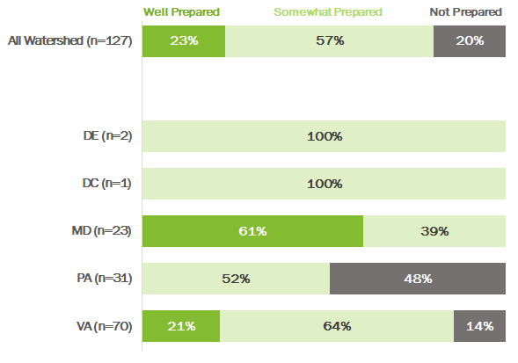

​The most common planning and infrastructure elements fully in place within LEAs are having established district leader and community partnerships for EE delivery. These data suggest that one of the most challenging preparedness elements to fully implement is an integrated program that infuses environmental topics across the curriculum. However, it is the element that received the strongest reports of districts at least making efforts in this direction, even if they have not yet been able to fully implement.

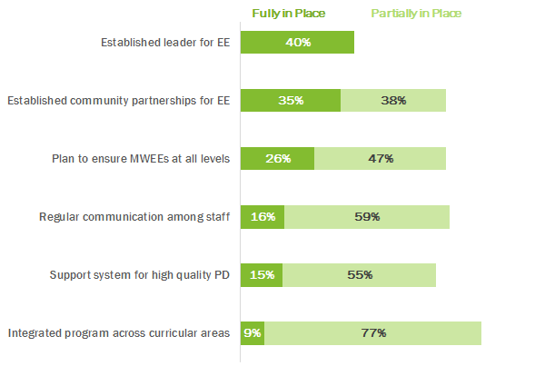

Participating Partners
The following partners have participated in the development of this strategy:

Chesapeake Bay Watershed Agreement Signatories
- State of Delaware
- District of Columbia
- State of Maryland
- Commonwealth of Pennsylvania
- Commonwealth of Virginia
- Chesapeake Bay Commission
- U.S. Environmental Protection Agency (EPA)

Other Key Participants
- National Oceanic and Atmospheric Administration (NOAA)
- U.S. Fish and Wildlife Service (USFWS)
- U.S Geological Survey (USGS)
- National Park Service (NPS)
- U.S. Forest Service (USFS)
- Nongovernmental Organizations (e.g. Chesapeake Bay Foundation, National Wildlife Federation, NAAEE state affiliates, and many local and regional organization)

Local Engagement
While states have the primary responsibility to advance the Chesapeake Bay Program’s environmental literacy efforts, this work is done in partnership with school districts who are responsible for defining their own curriculums and implementation strategies to support state standards and priorities.

Factors Influencing Success
The following are natural and human factors that influence the Chesapeake Bay Program’s ability to attain this outcome:

- State Education Agency Leadership: High level support for environmental literacy from state departments of education that is communicated to school districts is critical to establish environmental literacy as an educational priority. These agencies are also important in adopting standards of learning, accountability mechanisms, policies, and practices that are supportive of environmental literacy, and identifying funding streams that can be used to support the development of programs and training of teachers.
- Legislation and Policy: The establishment of formal graduation requirements or incentives, funding programs, and/or teacher certification/re-certification guidelines have been powerful in advancing environmental literacy. These guiding policies can be established by state legislatures, boards of education, or agencies. Stakeholder groups are often instrumental to advancing state legislative and policy initiatives.
- School District Implementation: Education is primarily controlled by local school districts (600+ in the region), each with their own leadership and management structure. With the exception of state laws and regulations, education priorities are largely determined at the local level and may not mirror state priorities.
- State agency and partner coordination: High quality environmental literacy programming requires the support of many state and local partners who often are the educators conducting teacher professional development and supporting student programming.
- School community (teachers, principals, staff) awareness and readiness: Ultimately the success of these efforts depends on the ability of educators to understand the essential elements and be comfortable delivering them and the permission and support of principals and the school community.
- Funding: A major limiting factor is funding, including support for sustainable school initiatives, student projects, teacher professional development, and transportation.

Current Efforts and Gaps
Current regional efforts include:
- Convening state leaders to focus on formal education on an ad hoc basis
- Collecting comprehensive data from each state using the Environmental Literacy Indicator Tool (ELIT) survey to better understand school district gaps and needs
- Working with state agencies to identify existing state funding that could advance MWEE implementation
- Maintaining interagency state workgroups
- Developing, improving, and expanding partnerships as well as opportunities for professional development to increase MWEE implementation across jurisdictions
- Promoting the adoption of state policies that advance key goals within the formal education systems
- Working with states towards cross-agency “Collective Impact” efforts that include appropriate leadership and organization, metrics, and support (analysis as follows with green checks indicating fully in place and yellow checks partially in place)
- Coordinating critical funding to support model programs through the NOAA Bay Watershed Education & Training (B-WET) Program, the NOAA Environmental Literacy Grant Program, the EPA Environmental Education grant program, the Chesapeake Bay Trust, and various state funding programs.

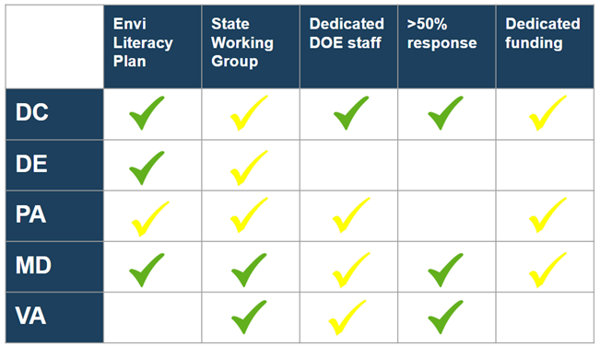

Specific efforts within the jurisdictions include:
- DC continues to support the use of teacher-developed MWEE resources and provide training for nonformal educators. A multi-faceted approach that involves our partners to increase understanding of MWEEs will encourage more targeted implementation efforts.
- Delaware is working to increase professional development opportunities to support the implementation of MWEEs in classrooms. State agencies also plan to increase the visibility and show how MWEES support the Next Generation Science Standards and local curriculum.
- Maryland is integrally involved in the regional effort to develop an online course to support educators develop and implement MWEEs. In addition, Maryland is developing a syllabus to be used as guidance for workshops around the state that could be used in conjunction with the online course and serve as a means of consistent messaging across all educational systems.
- Pennsylvania agencies are offering professional development workshops incorporating the “WET in the City” curriculum with an additional component specific to Stormwater management. They are also offering workshops as part of the Keystone Energy Education Program (KEEP). In addition, Pennsylvania is encouraging the adoption of MWEEs through the PA DEP quarterly newsletter “Teaching Green”, and web-pages and social media outlets.
- Virginia agencies offer professional development opportunities, both individually and collaboratively, to support the instruction of environmental concepts that are embedded within the Virginia Science Standards of Learning. The Virginia Resource Education Use Council (VRUEC) was initially formed to allow state agencies to communicate their efforts with environmental education. Membership in the organization has expanded to include environmental organizations and is currently working collaboratively to provide resources for both formal and non-formal educators.

Identified gaps for the effort:
- There is no formal way within the Chesapeake Bay Program to engage state leaders around environmental literacy issues and no defined structure for Management Board and Principals Staff Committee to engage education agencies.
- Staffing levels and interagency coordination to drive MWEE implementation at departments of education and natural resource agencies vary across states. Where these resources do not exist, implementation is inconsistent.
- States and many local school districts do not have a funding strategy for student MWEEs and sustainable school efforts. Much of the work is supported by individual grants without a strong plan for sustainability beyond grant period.
- With the exception of DC, Maryland, and Virginia, the ELIT survey for the 2016-2017 school year did not have an adequate response rate to provide reliable statewide findings.

Management Approaches
The Chesapeake Bay Program will work together to carry out the following actions and strategies to achieve the Environmental Literacy Goal and Outcomes. These approaches seek to address the factors affecting our ability to meet the goal and the gaps identified above. Work will be coordinated through the Education Workgroup of the Chesapeake Bay Program, which provides a forum for cross- jurisdictional coordination and support on all aspects of environmental education. These groups will work towards shared priorities as follows:

Management Approach 1: Support school district efforts to embed locally appropriate environmental practices, content, and learning opportunities into curriculum and operations.

Management Approach 2: Use available data and information to strategically and equitably focus resources to support school district level environmental literacy planning and implementation

Management Approach 3: Ensure broad understanding at the state and regional level of the progress, gaps, and opportunities related to the Environmental Literacy Goal and promote and share policies between jurisdictions that advance the goals.

Cross Outcome Collaboration and Multiple Benefits
An engaged and informed citizenry is the key to accomplishing and maintaining many of the Bay program goals. The environmental literacy outcomes seek to leverage the mutual goals of the Bay Program and formal education systems and the extensive reach of school systems to build a knowledgeable population. Future work for this management strategy will include coordination with all related goals and outcomes, including Water Quality, Public Access, Citizen Stewardship, and the Employment and Professional Engagement Workgroup under the Diversity Action Team. The resulting work will be captured in action plans.

Monitoring Progress
The Chesapeake Bay Program maintains a Environmental Literacy Planning indicator that tracks school district preparedness to support environmental literacy activities for their students. It is based on the Chesapeake Bay Watershed ELIT survey, which was developed to monitor the capacity and progress of public school districts toward meeting the environmental literacy goal stated in the 2014 Chesapeake Bay Watershed Agreement. ELIT is administered biennially to all school districts in six jurisdictions: the District of Columbia, Delaware, Maryland, Pennsylvania, Virginia, and West Virginia. The survey collects self-reported data from school district staff and, therefore, some elements are subjective in nature.

The survey was administered in 2015 and again in 2017. The Chesapeake Bay Program manages data collection for the survey and collates and reports data at the watershed and state levels. While the survey is voluntary, the 2017 ELIT data collected data from 39% of school districts (DC-100%, MD-96%, VA-74%, DE-25%, PA-16%, WV-0%) representing 76% of all students in the watershed portions of these jurisdictions.

In addition, the state of Maryland requires school districts to certify to the State Superintendent of Schools that the instructional program meets state-mandated requirements related to the environmental literacy graduation requirement and integrated program. In 2015, the Bay Program worked with the Maryland State Department of Education to use ELIT to collect this information to increase efficiency of the related data collection efforts. This partnership should continue in the future.

Progress for achieving the environmental literacy planning outcome is available at
http://www.chesapeakeprogress.com/engaged-communities/environmental-literacy-planning

Assessing Progress
Data from the 2015 ELIT survey established a baseline for the Environmental Literacy Planning indicator. While no numeric goals have been established for this indicator, the Workgroup anticipates that the number of “well prepared” districts will continue to increase and that we will see a trend of districts moving from “not prepared” to “somewhat well prepared” to “fully prepared.” From 2015 to 2017 the number of districts that fell into the “somewhat prepared” category increased from 51% to 57% while districts deemed “not prepared” decreased from 31% to 20%. To better communicate the anticipated pace of progress, the Workgroup will explore the feasibility of establishing numeric progress indicators.

Adaptively Managing
The Leadership Team of the Education Workgroup is co-chaired by NOAA and the Chesapeake Bay Foundation and includes federal representatives from the U.S. Forest Service and the Environmental Protection Agency along with appropriate state representatives (generally from state departments of education and natural resource agencies) and key partner organizations. The group convenes monthly to discuss priorities and progress towards meeting the Environmental Literacy Goal and Outcomes. The full Education Workgroup, which includes broader representation from federal agencies, state agencies, nonprofits, local education agencies, and others, meets several times a year. The group also convenes an Environmental Literacy Forum every two years around specific issues or priorities, which include outside experts and constituents. These convenings serve as good opportunities to re-assess where the group is in achieving the outcomes of the agreement and adjusting strategies as appropriate.

In addition, the Principals Staffing Committee of the Chesapeake Bay Program plans to convene high-level leaders from throughout the Bay Partnership to discuss progress towards meeting the Environmental Literacy goal and outcomes. These meetings will include State Superintendents of Education as well as leaders from state natural resource agencies, U.S. Department of Education, NOAA, U.S. EPA, national and regional nonprofit organizations, institutions of higher education, local education agencies, Chesapeake Bay Commission, and the Chesapeake Bay Program Education Workgroup. The Management Board will be responsible for tracking the agreements and commitments generated by these meetings.

States have also committed to maintaining state working groups to advance this work at the state and local level.

Biennial Workplan
A 2018-2019 biennial workplan is available that outlines work towards this outcome. Where appropriate, State-specific commitments are listed as performance targets.

