Management Strategy
Student Meaningful Watershed Educational Experience (MWEE) Outcome
Management Strategy
v.2

Introduction
The future well-being of the Chesapeake Bay and its 64,000 square miles of watershed will soon rest in the hands of its youth. We have a duty to impart to these young people—almost three million strong in kindergarten through 12th grade—a sense of individual responsibility and the skills to become stewards of the natural world. It has been 20 years since the Chesapeake Executive Council adopted Directive 98-1 formally recognizing the importance of education to the partnership, and the 2014 Chesapeake Bay Watershed Agreement elevated the significance of environmental literacy, acknowledging that a committed youth will help to determine the ultimate success of our protection and restoration efforts.

The Meaningful Watershed Educational Experience (MWEE) is the cornerstone of student environmental education about and in the Chesapeake Bay watershed. MWEEs seek to seamlessly connect standards-based classroom learning with outdoor field investigations to create a deeper understanding of the natural environment. Specifically, MWEEs ask students to explore local environmental issues through sustained, teacher supported programming that includes, but is not limited to, issue definition, outdoor field experiences, action projects, and sharing student-developed synthesis and conclusions with the school and community.

MWEEs are built on the best practices in environmental education and track closely with the current trend of education towards more inquiry-based, hands-on learning practices. Student MWEEs should not be viewed as an extra requirement for teachers, but rather as a way to teach existing curriculum standards in a thought provoking and engaging way.

States, local school districts, and partners have made tremendous progress in recent years in establishing curriculum, policies, and model programs that advance student MWEEs. Our focus must now expand to direct and support the systemic implementation of these experiences within areas of the Chesapeake Bay watershed that have yet to fully institute them to ensure that every student has equitable access to this powerful approach to teaching and learning. This sort of school district curriculum-based approach takes advantage of the broadest possible distribution network (our public schools) whose mission is already to serve all students and develop the structures to disseminate and support new approaches to teaching and learning. Systemic implementation involves embedding student MWEEs into the K-12 curriculum for entire grades of students. It requires school districts to ensure that teachers receive high quality professional development to provide them with the content knowledge and pedagogical skills for using the outdoors as a context and approach for learning.

Because State Departments of Education set expectations, encourage innovation, and oversee accountability for school districts and schools, the Chesapeake Bay Program partnership cannot achieve this vision without their leadership and support.

Goal, Outcome, and Baseline
This management strategy identifies approaches for achieving the following goal and outcomes:

Environmental Literacy Goal: Enable every student in the region to graduate with the knowledge and skills to act responsibly to protect and restore their local watershed.

Student Outcome: Continually increase students’ age-appropriate understanding of the watershed through participation in teacher-supported, meaningful watershed educational experiences and rigorous, inquiry-based instruction, with a target of at least one meaningful watershed educational experience in each grade band -- elementary, middle and high school -- depending on available resources.

Baseline and Current Condition
The Chesapeake Bay Watershed Environmental Literacy Indicator Tool (ELIT) was developed to monitor the capacity and progress of public school districts toward meeting the environmental literacy goal stated in the 2014 Chesapeake Bay Watershed Agreement. To assess the level of student participation in MWEEs within each school district, respondents were asked to assess the presence of MWEEs within curricular offerings within each grade level (K-12), considering if they were system-wide or isolated to schools or classes. The responses were grouped into one of three levels within each grade band:
- At least one system-wide MWEE provided in the grade band;
- Some MWEE programming in the grade band, but not system-wide;
- No MWEE programming provided in the grade band.

41% of responding LEAs in the watershed have a system-wide MWEE in place at the elementary grade levels.
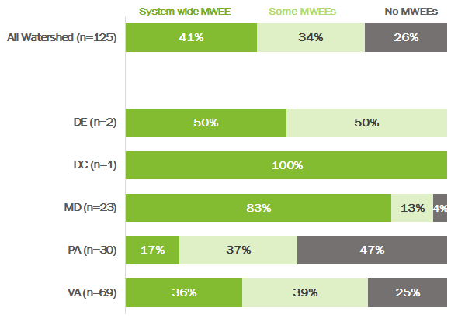

43% of responding LEAs in the watershed have a system-wide MWEE in place at the middle school grade levels.
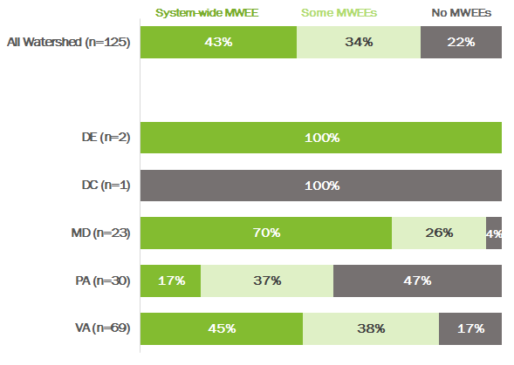

32% of responding LEAs in the watershed have a system-wide MWEE in place within required high school courses.
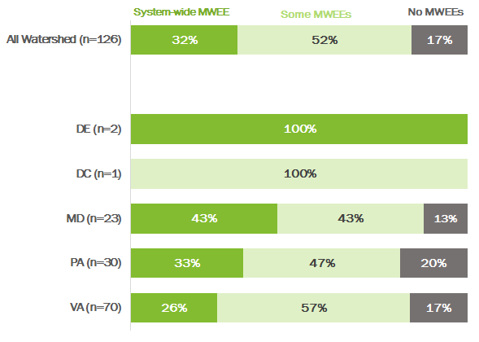

Participating Partners
The following partners have participated in the development of this strategy:

Chesapeake Bay Watershed Agreement Signatories
- State of Delaware
- District of Columbia
- State of Maryland
- Commonwealth of Pennsylvania
- Commonwealth of Virginia
- Chesapeake Bay Commission
- U.S. Environmental Protection Agency (EPA)

Other Key Participants
- National Oceanic and Atmospheric Administration (NOAA)
- U.S. Fish and Wildlife Service (USFWS)
- U.S Geological Survey (USGS)
- National Park Service (NPS)
- U.S. Forest Service (USFS)
- Nongovernmental Organizations (e.g. Chesapeake Bay Foundation, National Wildlife Federation, NAAEE state affiliates, and many local and regional organization)

Local Engagement
While states have the primary responsibility to advance the Chesapeake Bay Program’s environmental literacy efforts, this work is done in partnership with school districts who are responsible for defining their own curricula and implementation strategies to support state academic standards and priorities.

Factors Influencing Success
The following are natural and human factors that influence the Chesapeake Bay Program’s ability to attain this outcome:
- State Education Agency Leadership: High level support for environmental literacy from state departments of education that is communicated to school districts is critical to establish environmental literacy as an educational priority. These agencies are also important in adopting standards of learning, accountability mechanisms, policies, and practices that are supportive of environmental literacy, and identifying funding streams that can be used to support the development of programs and training of teachers.
- Legislation and Policy: The establishment of formal graduation requirements or incentives, funding programs, and/or teacher certification/re-certification guidelines have been powerful in advancing environmental literacy. These guiding policies can be established by state legislatures, boards of education, or agencies. Stakeholder groups are often instrumental to advancing state legislative and policy initiatives.
- Local Education Agency Implementation of MWEEs: Education in most of the states in the Chesapeake Bay watershed is controlled by local education agencies (600+ in the region), each with their own leadership and management structure that often does not include staffing for environmental literacy. With the exception of state laws and regulations, education priorities are largely determined at the local level and may not mirror state priorities, leaving a critical gap for policy and readiness at the local level. In addition, some policies for field trips, transportation, etc. may not be supportive of the MWEE model. MWEEs are often left out of established accountability mechanisms between state and local education agencies.
- Education Reform/Curriculum Alignment: While national education reform efforts including STEM, Common Core, and Next Generation Science Standards lend themselves to using the environment as an integrating context for learning, the extensive efforts to support and implement the necessary shifts in teaching and learning required by these reforms pose ongoing challenges to systemic approaches to environmental education.
- Funding: A major limiting factor is funding, including for teacher professional development and transportation.
- State agency and partner coordination: MWEE implementation requires the support of many state and local partners who often are the educators conducting teacher professional development and supporting student programming.
- School community (teachers, principals, staff) awareness and readiness: Ultimately the success of MWEEs depends on the ability of educators to understand the essential elements and be comfortable delivering them and the permission and support of principals and the school community.

Current Efforts and Gaps
Current regional efforts include:
- Working at the State level to put in place policy drivers to encourage and advance student MWEEs
- Using the Environmental Literacy Indicator Tool (ELIT) to track MWEEs and the needs of school districts
- Working with states and school districts to integrate MWEEs into curriculum to reduce perceived burden on educators
- Pursuing private and innovative funding to support regional and local efforts
- Creating and deploying effective online and in-person trainings to build a cadre of MWEE Ambassadors and to support teacher’s comfort with environmental education both in the classroom and in the field
- Some states are beginning to engage Institutions of Higher Education and Higher Education Commissions who set priorities for teacher professional learning
- Maintaining educational resources on Bay Backpack
- Coordinating critical funding to support model programs through the NOAA Bay Watershed Education & Training (B-WET) Program, the NOAA Environmental Literacy Grant Program, the EPA Environmental Education grant program, the Chesapeake Bay Trust, and various state funding programs.

Specific efforts within the jurisdictions include:
- DC strives to increase capacity for MWEE efforts, building upon current activities to integrate implementation into teaching practices. Continued partnership and collaboration between OSSE and DOEE will better serve students and nonprofit education providers, leading to assurance of the sustainability of MWEE programs.
- Delaware supports school district plans to make use of out-of-school learning experiences in support of STEM learning goals (which include environmental) and build their capacity to take advantage of those experiences. They also plan to share the DE environmental literacy plan with the Delaware Science Coalition, and work with the DE Science Coalition on ways to use data and information to help implement the environmental literacy goals.
- Maryland continues to support school district efforts through encouraging and facilitating partnerships, providing technical assistance and participating in grant funded initiatives designed to support increased capacity in MWEE planning and implementation. The ELIT data is routinely used to inform more focused efforts in areas of highest need.
- Pennsylvania received a NOAA Bay Watershed Education and Training (B-WET) Program grant for a collaborative effort collaborative effort between the Department of Environmental Protection, the Department of Conservation and Natural Resources, the Department of Education, and the Stroud Water Research Center to increase capacity the plan for and deliver environmental literacy programming in the state. This effort is being used as a vehicle to increase visibility and adoption of MWEEs within Pennsylvania. In addition, the state Department of Education also plans to fill a vacant Environmental Education Coordinator position this summer through shared funding from DEP, DCNR, PDE, and Department of Agriculture. This position is designed to coordinate environmental education throughout Pennsylvania
- Virginia received a NOAA B-WET grant to offer cohorts of teachers and administrators a two year sustained professional development in the development and implementation of environmental literacy plans. The grant is a collaborative effort between the Department of Education, the Department of Game and Inland Fisheries, the Department of Forestry, the Chesapeake Bay Foundation, and the Chesapeake Bay National Estuarine Resource Reserve. A result of the trainings will be exemplar environmental literacy plans and lessons to be shared with other school districts in the Commonwealth. Virginia has also adopted an Environmental Science course that students may take for graduation credit in science; statewide professional development is being conducted to assist teachers in teaching the course.
- West Virginia is executing a NOAA B-WET grant to make MWEE systemic in the eight counties of the Potomac Basin, however, the effort was hampered by the legislatively mandated closure of the Regional Education Service Area Eight. Environmental educators continue to provide watershed education in individual classes but a systemic, approach throughout the counties has been challenging in the absence of a coordinating body for the local school districts. Cacapon Institute, Experience Learning, and other partners continue to work towards comprehensive MWEE offerings for all 4th grade students through Chesapeake Bay Program approved best management practices, including rain gardens, tree plantings, rain barrel & cistern installation, and public education & outreach campaigns by students.

Identified gaps for the effort:
- Staffing levels and interagency coordination to drive MWEE implementation at departments of education and natural resource agencies vary across states. Where these resources do not exist, implementation is inconsistent.
- States and many local school districts do not have a funding strategy for student MWEEs. Much of the work is supported by individual grants without a strong plan for sustainability beyond grant period.
- With the exception of DC, Maryland, and Virginia, the ELIT survey for the 2016-2017 school year did not have an adequate response rate to provide reliable statewide findings.
- Many teachers do not have the confidence and support they need to implement inquiry-based learning, especially outdoors.
- Given competing priorities (principals and teachers need to be responsive to testing, new standards, 21st century skills, etc.), student MWEEs are often seen as an additional task that is hard to resource, versus a means to achieve requirements in multiple areas.

Management Approaches
The Chesapeake Bay Program will work together to carry out the following actions and strategies to achieve the Environmental Literacy Goal and Outcomes. These approaches seek to address the factors affecting our ability to meet the goal and the gaps identified above. Work will be coordinated through the Education Workgroup of the Chesapeake Bay Program, which provides a forum for cross- jurisdictional coordination and support on all aspects of environmental education. These groups will work towards shared priorities as follows:

Management Approach 1: Increase professional development opportunities for educators (pre-service, teachers, and non-formal) to support the development and implementation of MWEEs

Management Approach 2: Increase the visibility and adoption of MWEEs as an educational best practice that supports and contributes to Environmental Literacy programs at the state and local levels

Cross Outcome Collaboration and Multiple Benefits
An engaged and informed citizenry is the key to accomplishing and maintaining most of the Bay program goals for all topics. The environmental literacy outcomes seek to leverage the mutual goals of the Bay Program and formal education systems, and use the extensive reach of school systems to build a knowledgeable population. Future work for this management strategy will include coordination with all related goals and outcomes, including Water Quality, Public Access, Citizen Stewardship, and the Employment and Professional Engagement Workgroup under the Diversity Action Team. The resulting work will be captured in action plans.

Monitoring Progress
The Chesapeake Bay Program maintains a Student MWEE indicator that tracks progress towards MWEE implementation at the elementary, middle, and high school level. It is based on the Chesapeake Bay Watershed ELIT survey, which was developed to monitor the capacity and progress of public school districts toward meeting the environmental literacy goal stated in the 2014 Chesapeake Bay Watershed Agreement. ELIT is administered biennially to all school districts in six jurisdictions: the District of Columbia, Delaware, Maryland, Pennsylvania, Virginia, and West Virginia. The survey collects self-reported data from school district staff and, therefore, some elements are subjective in nature.

The survey was administered in 2015 and again in 2017. The Chesapeake Bay Program manages data collection for the survey and collates and reports data at the watershed and state levels. While the survey is voluntary, the 2017 ELIT survey collected data from 39% of school districts (DC-100%, MD-96%, VA-74%, DE-25%, PA-16%, WV-0%) representing 76% of all students in the watershed portions of these jurisdictions.

In addition, the state of Maryland requires school districts to report every 5 years on how they are meeting the state-mandated requirements related to an environmental literacy graduation requirement and integrated program for environmental literacy across all grades. In 2015, the Bay Program worked with the Maryland State Department of Education to use ELIT to collect this information to increase efficiency of the related data collection efforts. This partnership should continue in the future.

Progress for achieving the student MWEE outcome is available at
http://www.chesapeakeprogress.com/engaged-communities/student

Assessing Progress
Data from the 2015 ELIT survey established a baseline for the student outcome. Prevalence of system-wide MWEEs remained relatively steady between 2015 and 2017. Elementary school results showed a slight increase (37% to 41%), which was largely attributable to increases in Maryland. Results from 2017 middle school and high school were within 1% of the 2015 results. While no numeric goals have been established for this indicator, the Workgroup anticipates that the number of students participating in MWEEs will continue to increase. To better communicate the anticipated pace of progress, the Workgroup will explore the feasibility of establishing numeric progress indicators.

Adaptively Managing
The Leadership Team of the Education Workgroup is co-chaired by NOAA and the Chesapeake Bay Foundation and includes federal representatives from the U.S. Forest Service and the Environmental Protection Agency along with appropriate state representatives (generally from state departments of education and natural resource agencies) and key partner organizations. The group convenes monthly to discuss priorities and progress towards meeting the Environmental Literacy Goal and Outcomes. The full Education Workgroup, which includes broader representation from federal agencies, state agencies, nonprofits, local education agencies, and others, meets several times a year. The group also convenes an Environmental Literacy Forum every two years around specific issues or priorities, which include outside experts and constituents. These convenings serve as good opportunities to re-assess where the group is in achieving the outcomes of the agreement and adjusting strategies as appropriate.

In addition, the Principals Staffing Committee of the Chesapeake Bay Program plans to convene high-level leaders from throughout the Bay Partnership to discuss progress towards meeting the Environmental Literacy goal and outcomes. These meetings will include State Superintendents of Education as well as leaders from state natural resource agencies, U.S. Department of Education, NOAA, U.S. EPA, national and regional nonprofit organizations, institutions of higher education, local education agencies, Chesapeake Bay Commission, and the Chesapeake Bay Program Education Workgroup. The Management Board will be responsible for tracking the agreements and commitments generated by these meetings.

States have also committed to maintaining state working groups to advance this work at the state and local level.

Biennial Workplan
A 2018-2019 biennial workplan is available that outlines work towards this outcome. Where appropriate, State-specific commitments are listed as performance targets.

