Sustainable Schools Outcome
Management Strategy
v.2

Introduction
Twenty years ago the Chesapeake Executive Council adopted Directive 98-1, which formally recognized the importance of K-12 education to the Chesapeake Bay Program partnership. Early work focused primarily on student experiences and teacher professional development. With the 2014 Chesapeake Bay Watershed Agreement, the partnership recognized for the first time the importance of creating sustainable school buildings and grounds. School buildings occupy hundreds of thousands of acres in the Chesapeake Bay Watershed and their buildings enclose millions of square feet; these properties provide a backdrop for real world learning opportunities for students and teachers. This presents a significant opportunity for partners to work with school districts to use best management practices to meet water quality and other restoration goals.

The Chesapeake Bay Program recognizes the guiding principles of the U.S. Department of Education Green Ribbon Schools Program as the foundation for its work:
- Reducing environmental impact and costs;
- Improving the health and wellness of schools, students, and staff; and
- Providing effective environmental and sustainability education.
To accomplish this vision, many organizations in the Chesapeake Bay watershed are involved in Sustainable Schools efforts. State and national level operating in the region, including the U.S. Green Ribbon Schools Program, the National Wildlife Federation EcoSchools Program, Maryland Green Schools, Pennsylvania Green and Healthy Schools, and Virginia Naturally recognize exemplar sustainable schools and school districts. The Chesapeake Bay Program acknowledges the important role that these partners play in this work and its strategy attempts to leverage these resources towards the broad objective in establishing more and better sustainable schools, while, in fact, using the school building, grounds, and its community as a real-world space for students to put their environmental literacy learning into practice.

Goal, Outcome and Baseline
This management strategy identifies approaches for achieving the following goal and outcome:

Environmental Literacy Goal:
Enable every student in the region to graduate with the knowledge and skills to act responsibly to protect and restore their local watershed.

Sustainable Schools Outcome
Continually increase the number of schools in the region that reduce the impact of their buildings and grounds on their local watershed, environment and human health through best practices, including student-led protection and restoration projects.

Baseline and Current Condition
To assess the number of schools achieving this outcome, the Chesapeake Bay Program works with sustainable schools certification providers to track the number of public and charter schools within the Chesapeake Bay watershed that have been recognized as sustainable by the following programs: U.S. Green Ribbon Schools Program, the National Wildlife Federation EcoSchools Program, Maryland Green Schools, Pennsylvania Green and Healthy Schools, and Virginia Naturally. Each of these certification programs requires that schools meet objectives from two or more of the three pillars of U.S. Green Ribbon Schools, and require that students take an active role in the conservation and restoration activities occurring at their schools.

In the 2017 data collection, 610 public and charter schools in the watershed were recognized as sustainable by one of these programs. This represents 14% of all public and charter schools in the watershed. At 82 percent of the total (503 schools), Maryland has the largest percentage of certified sustainable schools in the watershed. Seventeen percent of the sustainable schools in the watershed are located in Virginia, with one additional school located in Pennsylvania and four additional schools located in Washington, D.C. While the state of Delaware has schools that have been certified sustainable, none of these schools are located within the watershed.

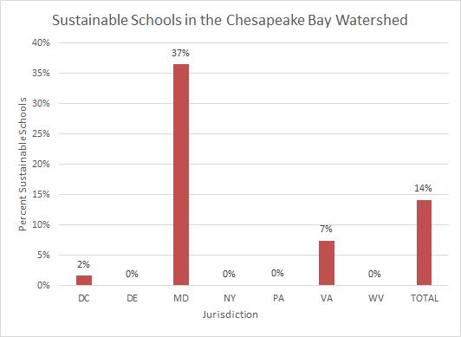

In addition, the Chesapeake Bay Program works with states to administer the Environmental Literacy Indicator Tool (ELIT), which monitors the capacity and progress of public school districts toward meeting the environmental literacy goal and outcomes from the 2014 Chesapeake Bay Watershed Agreement. ELIT asks school districts a series of questions about sustainable schools best practices as shown in the graphic below.

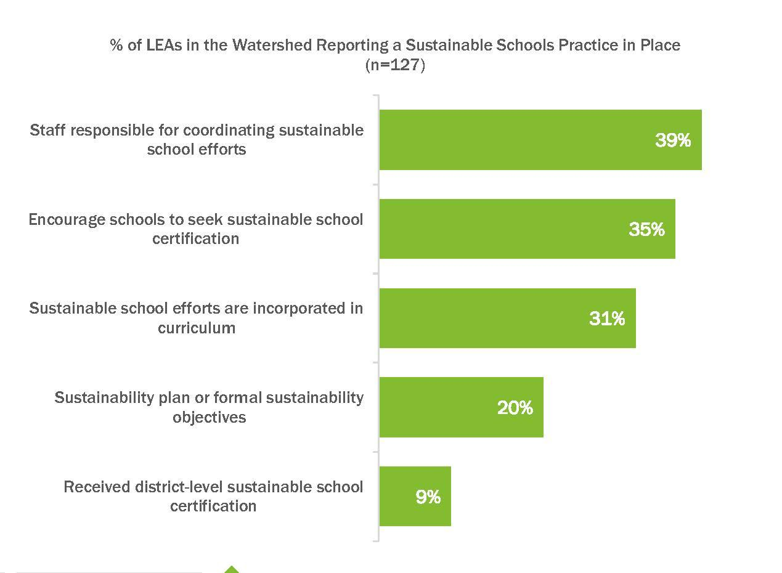

Participating Partners
The following partners have participated in the development of this strategy:

Chesapeake Bay Watershed Agreement Signatories
● State of Delaware
● District of Columbia
● State of Maryland
● Commonwealth of Pennsylvania
● Commonwealth of Virginia
● Chesapeake Bay Commission
● U.S. Environmental Protection Agency (EPA)

Other Key Participants
● National Oceanic and Atmospheric Administration (NOAA)
● U.S. Fish and Wildlife Service (USFWS)
● U.S. Forest Service (USFS)
● National Wildlife Federation
● Maryland Association for Environmental and Outdoor Education

Local Engagement
While states have the primary responsibility to advance the Chesapeake Bay Program’s environmental literacy efforts, this work is done in partnership with school districts who are responsible for defining their own curricula and implementation strategies to support state standards and priorities.

Factors Influencing Success
The following are natural and human factors that influence the Chesapeake Bay Program’s ability to attain this outcome:

- State Education Agency Leadership: High level support for environmental literacy from state departments of education that is communicated to school districts is critical to establish sustainable schools as a priority. These agencies are also important for establishing supportive policies and identifying funding streams.
- State agency and partner coordination: Sustainable schools implementation requires the support of many state and local partners who often are the professionals working to identify and install best management practices, conduct teacher professional development, and support student programming.
- School District Implementation: Education is primarily controlled by local school districts (600+ in the region), each with their own leadership and management structure. With the exception of state laws and regulations, education priorities are largely determined at the local level and may not mirror state priorities.
- National Leadership: The U.S. Department of Education Green Ribbon Schools Program has organized the thinking and incentivized the development of sustainable schools across the region.
- Funding: A major limiting factor is funding, including support for best management practices, student projects, and teacher professional development.

Current Efforts and Gaps
Current regional efforts include:
- Maintaining an Action Team for Sustainable Schools under the Education Workgroup to help guide this work.
- Encouraging state-level promotion and coordination of the U.S. Green Ribbon Schools Program
- Supporting the coordination of school certification programs from various partner organization
- Developing training materials about sustainable schools implementation
- Working with watershed jurisdictions to better understand and coordinate sustainable school efforts in the region with a particular focus on Healthy Schools.
- Providing technical support to plan and implement habitat projects on school grounds and at environmental education centers.
- Coordinating critical funding to support model programs through the U.S. Environmental Protection Agency’s (EPA) Environmental Education grant program, the NOAA Bay Watershed Education & Training (B-WET) Program, the U.S. Forest Service Project Learning Tree GreenSchools Program, the Chesapeake Bay Trust environmental education grant program, and various state funding programs.

Specific efforts within the jurisdictions include:
- The State of Delaware Department of Education and Department of Natural Resources and Environmental Control, partners with Green Build United and Delaware Nature Society to hold sustainable school workshops, conduct outreach and recognition ceremonies. Green Build United and the Delaware Sustainable Energy Utility to promote Delaware’s Pathways to Green Schools.
- In 2010, the Council of the District of Columbia signed into law the Healthy Schools Act of 2010, which sets up requirements to help the D.C. school system go green. It establishes an environmental programs within the Department of General Services, which will: run recycling, energy reduction, and integrated pest management programs at DCPS schools; test drinking water for lead; make sure schools comply with EPA standards for indoor air quality and lead removal; encourage more environmentally-friendly practices in building construction, school meals, and school cleaning procedures. The Healthy Schools Act requires that the District 1. Establish an environmental literacy plan for DCPS and public charter schools. 2. Establish a School Gardens Program within OSSE and assist schools in receiving certification as U.S. Department of Education Green Ribbon Schools. 3. Meet LEED Gold Level certification for school buildings whenever possible, new and renovated buildings should be green, according to LEED. The District accomplishes many of these goals via collaboration with partner organizations.
- Much of the Sustainable Schools work in Maryland is accomplished by the Maryland Association for Environmental and Outdoor Education (MAEOE) in collaboration with partners throughout the state. MAEOE administers the Maryland Green Schools program and Green Centers in which over 500 Maryland schools participate. They also partner and with and recognize the National Wildlife Federation Eco-Schools. The statewide Project Green Classrooms Initiative includes sustainable schools support among its many actions.
- Pennsylvania has a collaborative sustainable school effort which brings together partners from around the state to transform their schools launched on April 22, 2015 and known as the Pennsylvania Green and Healthy Schools Partnership (PGHSP). The Partnership hosts the State Annual Green Ribbon Schools awards and promotes NWF Eco-Schools as a pathway to green schools. The Green Ribbon Schools Awards program is managed by the Pennsylvania Department of Education with support from the Pennsylvania Department of Natural Resources and the Department of Environmental Protection.
- The Virginia Resource-Use Education Council (VRUEC) and state agencies were charged via State Executive Order 42 (Governor Terry McAuliffe, April 2015), to develop recognition programs for school-based conservation and environmental stewardship efforts and achievements. In addition, the Virginia Department of Education coordinates the Green Ribbon Award promotion and application process. The Virginia Naturally Recognition Program recognizes schools for incorporating the environment into their curriculum, conducting energy and water audits, and establishing an outdoor classroom. The Virginia School Board Association Green Schools Challenge is a friendly competition designed to encourage implementation of specific environmental policies and practical actions that reduce the carbon emissions generated by both the local school division and the broader community. School Divisions can become a certified "Green School Division." Many of these actions can save local school divisions money. In the Green Schools Challenge the USGBC Greater Virginia chapter challenges K-12 schools across the Washington, D.C., Maryland and Virginia regions to develop and implement the most creative, effective, no or low cost sustainable practices for their schools. Schools are matched with volunteer mentors to help guide project development and implementation resulting in greater environmental understanding for students and reducing operating costs.
- The WV Department of Education (WVDE) administers the WV Sustainable Schools award program and promotion and participation in the federal Green Ribbon Schools program. WV Sustainable Schools is a recognition program for schools that exemplify a commitment to sustainable practices in the facilities as well as integrate those practices into the curriculum and community. All public and private schools in West Virginia will be invited to apply for this state and national recognition. Cacapon Institute and Experience Learning are leading an effort to expand school participation in WV Sustainable School. Working with WVDE, we are developing a “tiered system of recognition.” The current US ED Green Ribbon Award may be too high a standard for schools since there can only be one award winner statewide. We believe that offering “best in class” or “best in grade” awards to WV schools will encourage more participation and activity. In addition to the possible recognition by the US ED award, schools can be awarded state-level and regional awards at the grade level (elementary, middle, high) and in “classes” of sustainable school projects (e.g., recycling, energy saving, water conservation).

Identified gaps for the effort:
- States and many local school districts do not have a funding strategy for sustainable school efforts. Much of the work is supported by individual grants without a strong plan for sustainability beyond grant period.
- Participation in the U.S. Department of Education Green Ribbon Schools Program is waning, providing less incentive for schools to engage in this type of work.
- State sustainable schools programs are often understaffed and unable to strategically advance state and local efforts.

Management Approaches
The Chesapeake Bay Program will work together to carry out the following actions and strategies to achieve the Environmental Literacy Goal and Outcomes. These approaches seek to address the factors affecting our ability to meet the goal and the gaps identified above. Work will be coordinated through the Education Workgroup of the Chesapeake Bay Program, which provides a forum for cross- jurisdictional coordination and support on all aspects of environmental education. For Sustainable Schools, a team has formed working under the auspices of the Education Workgroup to engage a broader group of stakeholders, explore areas of regional collaboration, and identify specific actions the Bay Program can take to achieve this outcome. The team is led by staff from the U.S. Environmental Protection Agency (EPA). It includes individuals from state agencies, local education agencies, and non-profit organizations.
These teams will work towards shared priorities as follows:

Management Approach 1: Strengthen and coordinate sustainable school state certification and recognition programs consistent with high-quality, recognized criteria such as the U.S. Department of Education Green Ribbon School program.

Management Approach 2: Broaden stakeholder engagement beyond environmental literacy constituents to broaden awareness, build partnerships, and increase support.

Management Approach 3: Identify and disseminate sustainable schools information and resources to school districts and schools.

Cross Outcome Collaboration and Multiple Benefits
Future work for this management strategy will include coordination with all related goals and outcomes, including Water Quality and the Diversity Action Team. The resulting work will be captured in the action plans.

Monitoring Progress
The Chesapeake Bay Program works with identified certification programs to collect data on the number of schools that maintain a sustainable schools certification. In addition, the Chesapeake Bay Program administers the Environmental Literacy Indicator Tool (ELIT), which asks a series of questions about school district sustainability efforts. The survey was administered in 2015 and again in 2017. The Chesapeake Bay Program manages data collection for the survey and collates and reports data at the watershed and state levels. While the survey is voluntary, the 2017 ELIT survey collected data from 39% of school districts (DC-100%, MD-96%, VA-74%, DE-25%, PA-16%, WV-0%) representing 76% of all students in the watershed portions of these jurisdictions.

Progress for achieving the sustainable schools outcome is available at http://www.chesapeakeprogress.com/engaged-communities/sustainable-schools

Assessing Progress
The Chesapeake Bay Program established a baseline in 2015. From 2015-2017, increase of 109 sustainable schools (from 501 to 610). While no numeric goals have been established for this indicator, the Workgroup anticipates that the number of sustainable schools will continue to increase. To better communicate the anticipated pace of progress, the Workgroup will explore the feasibility of establishing numeric progress indicators.

Adaptively Managing
The Leadership Team of the Education Workgroup is co-chaired by NOAA and the Chesapeake Bay Foundation and includes federal representatives from the U.S. Forest Service and the Environmental Protection Agency along with appropriate state representatives (generally from state departments of education and natural resource agencies) and key partner organizations. The group convenes monthly to discuss priorities and progress towards meeting the Environmental Literacy Goal and Outcomes. The full Education Workgroup, which includes broader representation from federal agencies, state agencies, nonprofits, local education agencies, and others, meets several times a year. The group also convenes an Environmental Literacy Forum every two years around specific issues or priorities, which include outside experts and constituents. These convenings serve as good opportunities to re-assess where the group is in achieving the outcomes of the agreement and adjusting strategies as appropriate.

In addition, the Principals Staffing Committee of the Chesapeake Bay Program plans to convene high-level leaders from throughout the Bay Partnership to discuss progress towards meeting the Environmental Literacy goal and outcomes. These meetings will include State Superintendents of Education as well as leaders from state natural resource agencies, U.S. Department of Education, NOAA, U.S. EPA, national and regional nonprofit organizations, institutions of higher education, local education agencies, Chesapeake Bay Commission, and the Chesapeake Bay Program Education Workgroup. The Management Board will be responsible for tracking the agreements and commitments generated by these meetings.

States have also committed to maintaining state working groups to advance this work at the state and local level.

Biennial Workplan
A 2018-2019 biennial workplan is available that outlines work towards this outcome where appropriate, state-specific commitments are listed as performance targets.

