Phase II: Preliminary Ecological Risk Assessment
Conceptual Model for Striped Bass Exposure to Microplastics

Overview

A series of draft conceptual models were developed as the first step to frame the ecological risk assessment of microplastics in the 0-2 year age class of Striped Bass (Morone saxatilis) in the tidal Potomac River. The goal of this second phase is to highlight potential biological endpoints and pathways from food and water that could lead to uptake of microplastics by Striped Bass. The current phase incorporates microplastics literature that identifies measurement of microplastics in these pathways/food sources. The studies will be used in the next step to develop initial quantitative estimates of microplastic exposure in striped bass.

A search of primary and gray literature was conducted to identify prey items consumed by Striped Bass and studies that measured microplastics in potential food sources or trophic pathways. The search emphasized data collected from the tidal Potomac River and Chesapeake Bay, and supplemented with information from east coast estuaries and other geographical locations, as appropriate. Literature from the Chesapeake Bay area primarily informed the food web models while other geographic regions were readily included for studies that measured microplastic uptake in species of interest. Prey items for the 0-2 year age class were emphasized in the draft diagrams, but information related to older age classes and prey organisms not found in the Chesapeake Bay were retained for future reference. Relative contribution of prey items to Striped Bass diet was quantified where possible.

This memo provides three sets of models: 1) biological endpoints of potential interest; 2) qualitative food web interactions that could lead to microplastic intake by Striped Bass, and 3) semi-quantitative food web interaction scenarios for Striped Bass living in different salinity regimes.

Methods

A literature search was initiated following the methodology approved under the quality assurance project plan (QAPP) developed using EPA guidance. The compiled literature was examined for Potomac River relevant data on resident age-classes of Striped Bass, including food web interactions and potential assessment endpoints (Figure 1). Resident age-classes were defined as including: all young-of-the-year (YOY) stages (both larval and post-metamorphosis juvenile), and ages 1 through 3 fish. Though the 0-2 age class was the original focus, age-3 fish were included in the analysis because evidence suggests the majority of age-3 males remain resident in Chesapeake Bay (Secor and Piccoli 2007), indicating that primary exposure to microplastics for males of that age class is still limited to the geographic area of interest. Diet data reported in several key studies were used to develop initial prey networks linking dominant primary producers at the base of the food web, Markle and Grant (1970), Boynton et al. (1981), Walter III and Austin (2003) 458-710 mm size classes only, Muffelman (2006), and Ihde et al. (2015). These regional studies were conducted in the Potomac River (Boynton et al. 1981), adjacent Virginia tributaries (Markle and Grant 1970, Muffelman 2006), and the Chesapeake Bay mainstem (Walter III and Austin 2003, Ihde et al. 2015). One study did note the direct consumption of microplastics by older Striped Bass, although it was ion a reservoir system (Baldwin et al. 2020).

Prey importance was determined using % diet composition by biomass or volume (if biomass was not reported). Dominant prey species were assigned individual categories (e.g., Bay Anchovy Anchoa mitchilli, Atlantic Menhaden Brevoortia tyrannus). Where prey groups were reported as lower taxonomic resolution aggregates, these aggregate prey taxa were maintained (e.g., polychaetes, insects) or were further aggregated to reflect diverse functional groups of taxonomically similar prey that contributed relatively little to diet individually but could be important together (e.g., other crustaceans, other fish). For this second phase report, trophic networks were constructed using the igraph package in the R environment. The igraph package is a specialized network visualization package (Csárdi and Nepusz 2006). Additional network software packages that provided additional visual or analytical capacity will be explored for future drafts (e.g., network, Butts (2008)).

Draft trophic networks linking prey groups to lower trophic position prey and, ultimately, to primary producers were based on compiled literature (e.g., Baird and Ulanowicz (1989)) and professional knowledge of the project PIs (Figure 2, Table 1). Prey trophic linkages will continue to be refined through the ongoing literature review to ensure the network structure is robust. Primary pools of bioavailable microplastics were identified as including settled (sediment) and suspended particles (water column). A literature search was conducted to identify publications that measured microplastics in prey and striped bass to provide information for the next phase to determine relative contribution of microplastics to striped bass diets.

Biological Endpoints

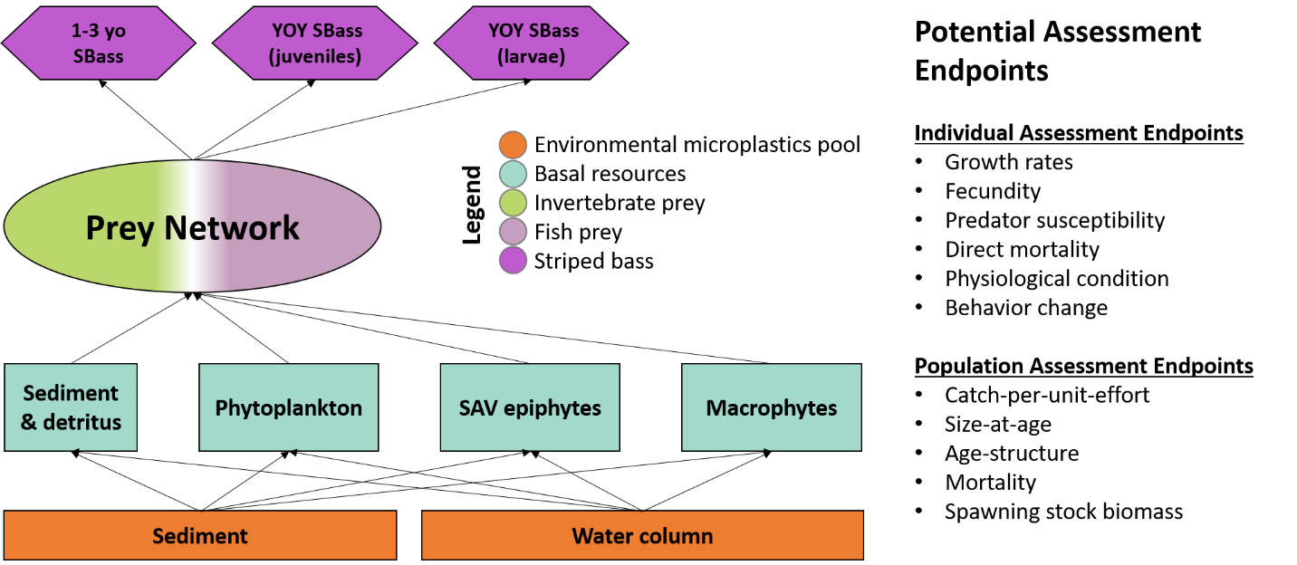
Fig. 1: This diagram shows a simplified conceptual model of expected environmental pools of microplastics and generalized uptake through the food chain to Striped Bass. The large oval labeled “Prey Network” is further expanded in the next figure. Measurable ecological endpoints quantifiable at the individual (ex. growth, fecundity, etc.) and community management-focused/population level (ex. catch-per-unit-effort, size at age, etc.) are highlighted as potential endpoints to evaluate the effects of microplastics. In many cases, it is expected that these represent data gaps without a known relationship to microplastic exposure and may not yet be quantifiable.

Qualitative Food Web Interactions

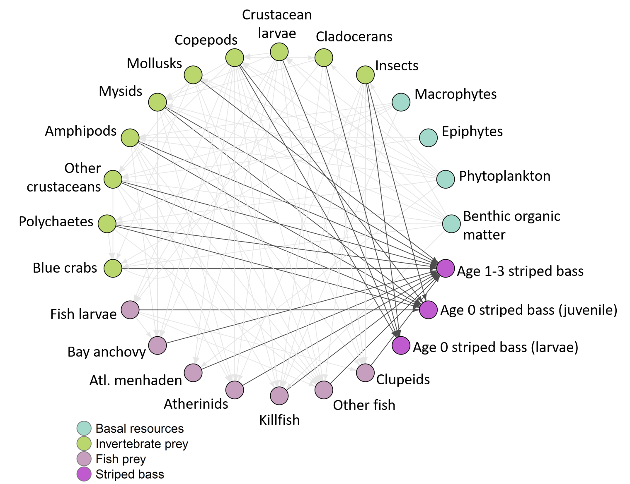
Fig. 2: This diagram shows potential pools of microplastics associated with basal trophic resources and a more detailed food web of prey items consumed by Striped Bass and organisms consumed by those prey items. Three age classes of Striped Bass (young of year [YOY] larvae, YOY juveniles, and 1-3-year-old) are shown with connections to their known prey items.

Table 1: Aggregated Striped Bass prey table identifying specific taxa included in aggregate groups and associated references.
Aggregate group | Included taxa | Reference
Other fish | Morone americana, Leiostomus xanthurus, Micropogonias undulatus, Urophycis regia, Notropis hudsonius, Lepomis gibbosus, Cynoscion regalis, Gobiosoma bosci | (Markle and Grant 1970, Walter III and Austin 2003, Ihde et al. 2015)
Insects (larvae and pupae) | Diptera (e.g., Muscidae, Chironomus sp., Chaoborus sp.), Hemiptera, Ephemeroptera | (Markle and Grant 1970, Boynton et al. 1981, Muffelman 2006)
Larval zooplankton | Cirripedia (barnacle larvae cirri), copepodites*, copepod nauplii* | (Markle and Grant 1970)
Other crustaceans | Mud crab, Palaemonidae (Palaemonetes sp.), sand shrimp (Crangon septemspinosa), mantis shrimp, isopods, xanthids, Ovalipes ocellatus; Mysid shrimp | (Markle and Grant 1970, Walter III and Austin 2003, Muffelman 2006, Ihde et al. 2015, Lehtiniemi et al. 2018)
*based on literature from other estuaries ((Hjorth 1988, Limburg et al. 1997) - Hudson River)

Semi-Quantitative Food Web Interactions

This series of diagrams (Figure 3-5) is based on the striped bass dietary studies conducted by Boynton et al. (1981) that described quantitative dietary preferences of YOY Striped Bass (25-99 mm) foraging in three Potomac River salinity regimes—mesohaline, oligohaline, and tidal freshwater. The dashed lines connecting Striped Bass to a prey item indicate the prevalence of that organism as a food item, with thicker lines indicating a greater contribution than thinner lines. These diagrams demonstrate that the diet of young of year Striped Bass varies in composition depending on foraging habitat. For example, mysids and polychaetes make up most of the diet in mesohaline habitats while fish larvae and insects are the most dominant dietary components in tidal freshwater habitats. Using a quantitative dietary approach could be helpful to weight the expected contributions of microplastics via prey items.

The differing dietary preferences associated with salinity-based habitats provide insights as well, especially as future studies focus on the fate and transport of microplastics within the Potomac River. As data gaps close for fate and transport and uptake by prey items, an ecological risk assessment can be tailored to specific habitats that might be disproportionately affected by different varieties of microplastics.

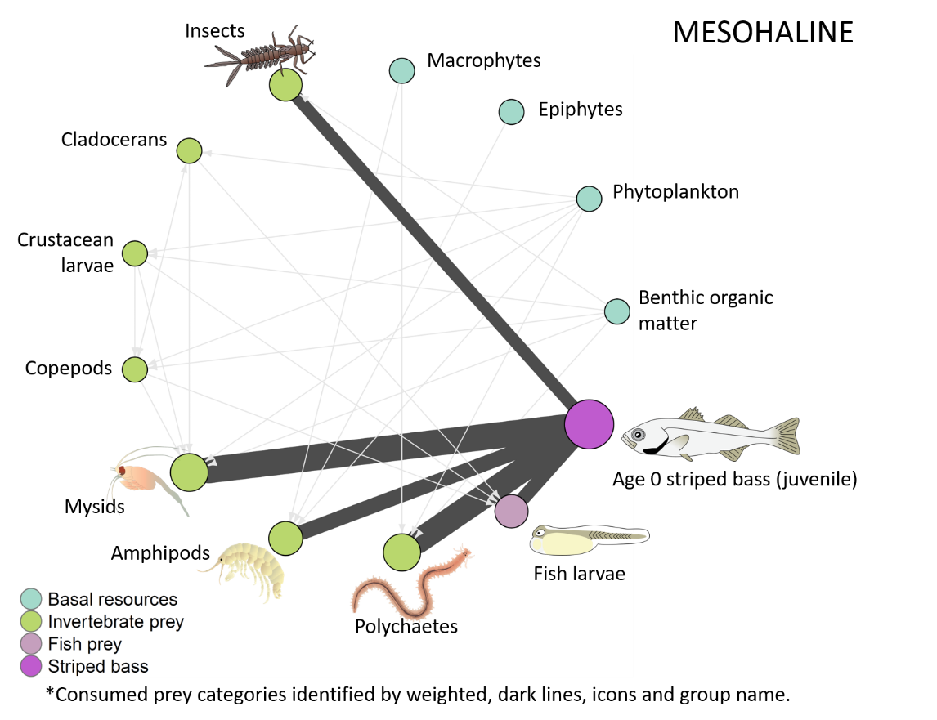

Fig. 3: Juvenile Striped Bass food web from mesohaline portion of Potomac River estuary (adapted from Boynton et al. (1981)). Dark vectors connecting prey through direct consumption provides biomass-weighted percent contribution to diet for each prey category.

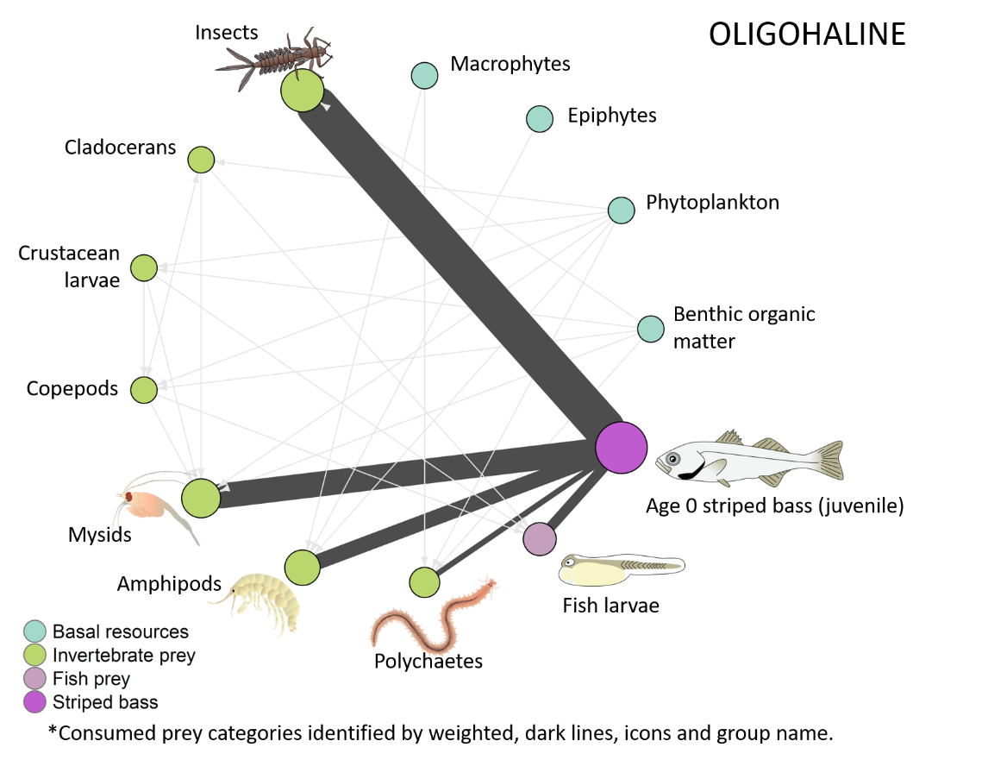

Fig. 4: Juvenile Striped Bass food web from oligohaline portion of Potomac River estuary (adapted from Boynton et al. (1981)). Dark vectors connecting prey through direct consumption provides biomass-weighted percent contribution to diet for each prey category.

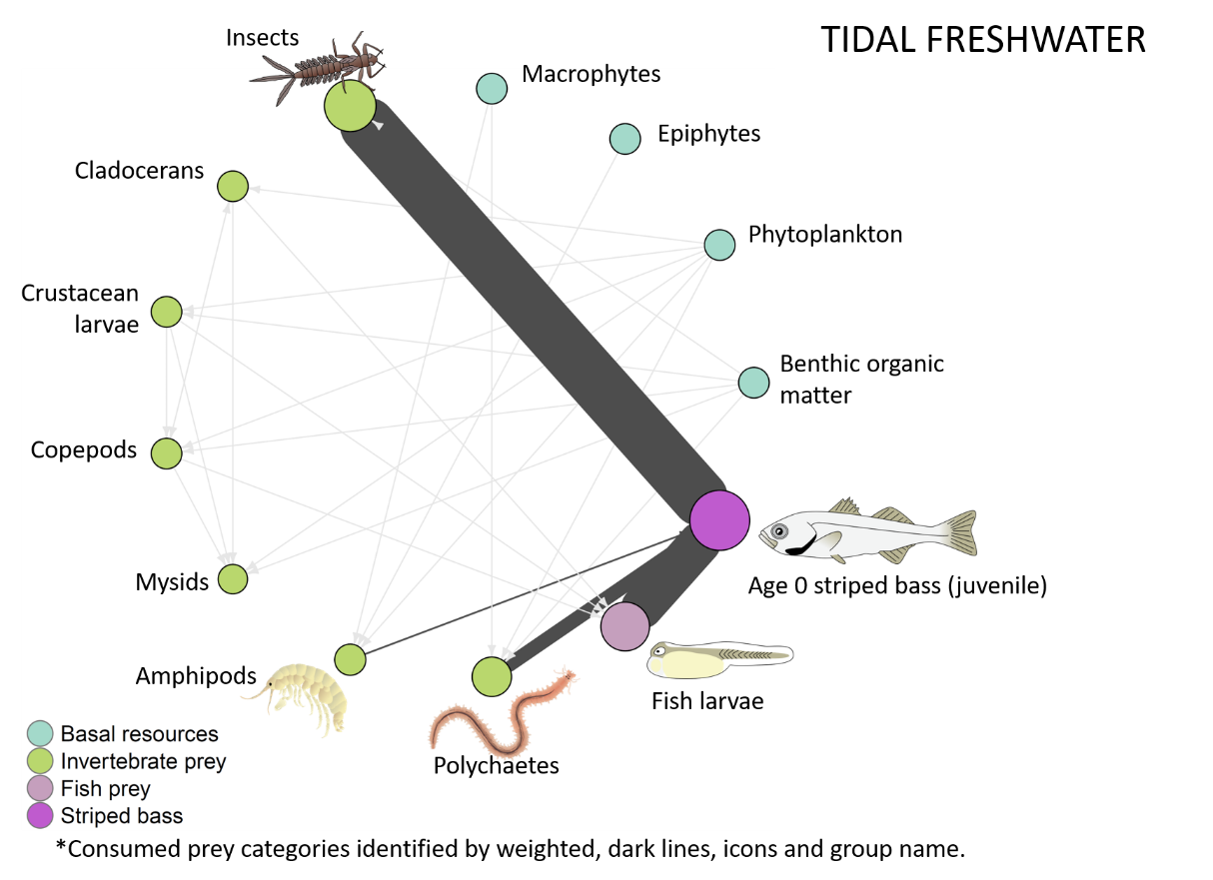

Fig. 5: Juvenile Striped Bass food web from tidal fresh portion of Potomac River estuary (adapted from Boynton et al. (1981)). Dark vectors connecting prey through direct consumption provides biomass-weighted percent contribution to diet for each prey category. Insects are primarily Diptera larvae (e.g., Muscidae).

Ages 1-2 Mainstem Chesapeake Bay

As previously noted, the literature review evaluated a number of studies on Striped Bass diets and those that focused on Potomac River populations (primarily Boynton et al. (1981)) were used to develop the juvenile models. However, few to no studies exist for older fish (1YO-2YO) from the Potomac River Ihde et al. (2015) reviewed striped bass diets along the entire mainstem of the Chesapeake Bay, from tidal fresh to polyhaline regions, that can be utilized as a proxy for the Potomac River estuary. Those findings were used to develop the models for ages 1 and 2 shown in Figure 6 and 7.

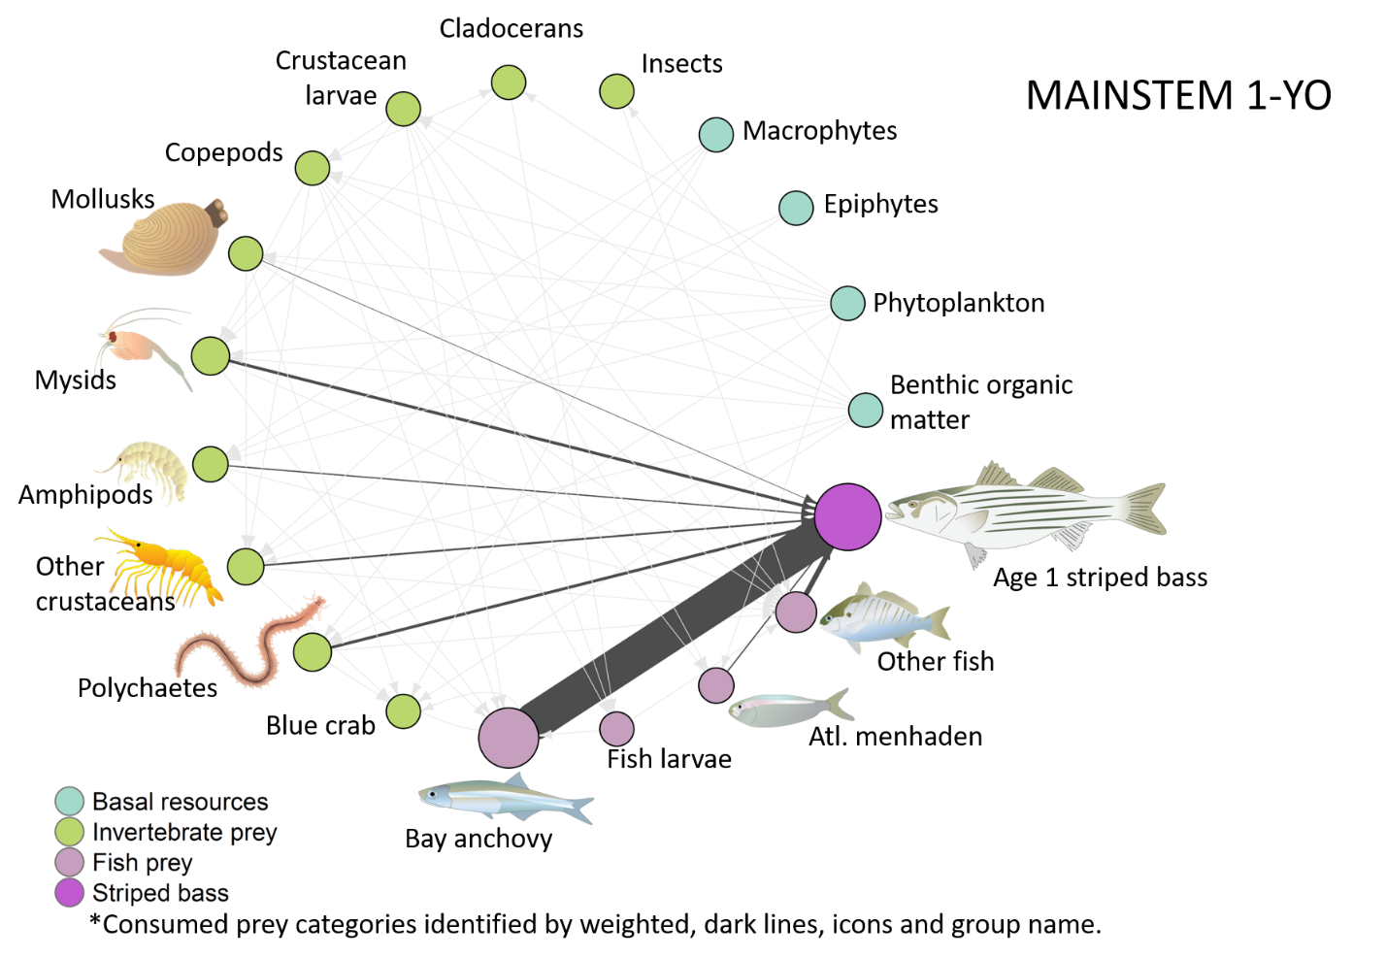

Fig. 6: Food web with Striped Bass 1YO endpoint. Dark vectors connecting prey through direct consumption provides biomass-weighted percent contribution to diet for each prey category as found in Ihde et al. (2015).
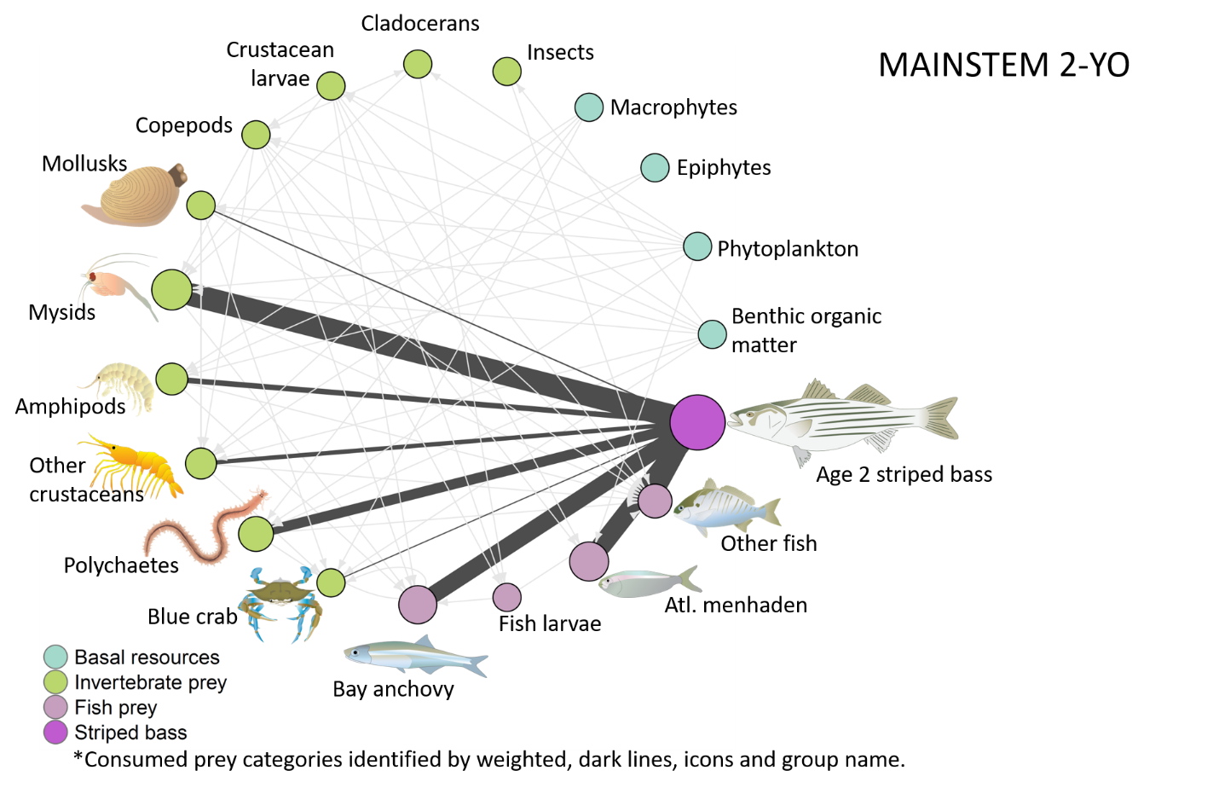

Fig. 7: Food web with Striped Bass 2YO endpoint. Dark vectors connecting prey through direct consumption provides biomass-weighted percent contribution to diet for each prey category as found in Ihde et al. (2015). Note the change in dominant dietary components from 1YO.

Next Steps

The current Phase II conceptual models focus heavily on predator-prey relationships of Striped Bass food webs. Additionally, it also includes estimating potential magnitude of uptake of microplastic by Striped Bass based on known vectors and estimated prey loads. Our literature review (Table 2) includes several instances where microplastics have been found either within the habitat or within the prey taxa, as well as one study that found Striped Bass directly ingesting In many cases, we identified studies that used similar species or taxa in other parts of the world. This is a step towards better understanding and enumerating the data gaps for the Potomac River and Chesapeake Bay.

It is also expected that environmental processes are likely to influence the availability of total microplastics along with specific sizes and polymer compositions, as conceptualized in Figure 8. Microplastics are carried from their source by wind and water to potential sinks (e.g. sediment and detritus, phytoplankton, SAV epiphytes, macrophytes) (Van Cauwenberghe et al. 2015, Ballent et al. 2016, Liu et al. 2019, Murphy 2020). Other environmental factors and processes that enhance or depress the dispersal or availability of microplastics will be included as the draft is expanded. Examples of these factors include tides, sunlight/photodegradation, seasonal changes, bacterial degradation, and storm events. These and other environmental factors are expected to influence the availability of microplastics in Striped Bass diets, but many unknowns exist surrounding transport and dispersion dynamics in the Potomac River.

The conceptual models shown in this memo will be refined, and two main end products will result—a simplistic overview of the microplastic risk assessment and a complex model with food web interactions and environmental factors. However, other models, including those showing food source variations in different salinity regimes will be useful, especially as more information about microplastic transport dynamics become available (e.g. Cohen et al. (2019)). It is possible that some sizes and polymer compositions are more or less prevalent in different locations in the tidal Potomac and larger Chesapeake Bay.

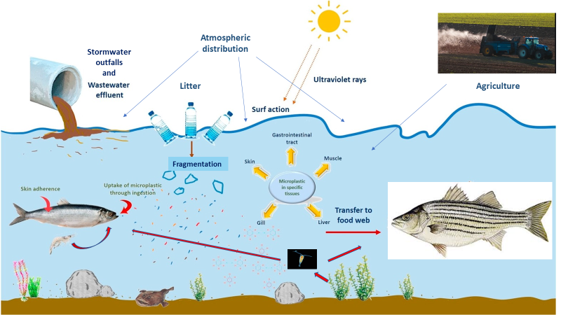
Fig. 8: Generalized pathways of abiotic/biotic relationships with microplastics in coastal systems. (adapted from (Abbasi et al. 2018))

Table 2: Known microplastic occurrences in habitat or taxa (or closely related taxa) included in the Potomac and Chesapeake food web models.

Major Taxa | Confirmed MP presence or consumption?  (Y/N) | Location | Citation | Notes
Habitat
Macrophytes (includes SAV and wetlands) | Y | (SAV) Caribbean; UK, Korea; Washington, DC; (wetlands)South Africa; multiple | (Goss et al. 2018, Reynolds and Ryan 2018, Murphy 2019, Townsend et al. 2019, Cozzolino et al. 2020, Huang et al. 2020, Jones et al. 2020) | Macrophytes include a combination of SAV and wetlands given similar roles for microplastic adherence
Epiphytes | Y | Caribbean; | (Goss et al. 2018, Seng et al. 2020) | Found in epiphytes on seagrass
Benthic organic matter | Y | St. Lawrence River; Washington DC; | (Castaneda et al. 2014, Murphy 2020)
Phytoplankton | Y | Laboratory; | (Long et al. 2015, Shiu et al. 2020) | Diatoms; aggregation of cells on MPs
Invertebrate Prey
Insects | Y
Crustacean larvae | Y | Laboratory | (Jemec et al. 2016, Gambardella et al. 2017, Woods et al. 2020) | Lobsters; barnacle nauplii;
Cladocerans | Y | Laboratory | (Martins and Guilhermino 2018, Jaikumar et al. 2019, Woods et al. 2020) | Freshwater regions
Copepods | Y | Laboratory; Pacific Ocean | (Cole et al. 2015, Desforges et al. 2015)
Amphipods | Y | Laboratory | (Jeong et al. 2017, Mateos Cárdenas et al. 2019) | Jeong et al proposed an adverse outcome pathway for microplastic exposure that covers molecular and individual levels.
Mysids | Y | Laboratory | (Setälä et al. 2014, Lehtiniemi et al. 2018, Wang et al. 2020)
Polychaetes | Y | Newfoundland; laboratory; Norway | (Mathalon and Hill 2014, Setälä et al. 2014, Knutsen et al. 2020)
Blue crab | Y | Murderkill and St. Jones Rivers, DE; Texas; | (Santana et al. 2017, Cohen 2020, Waddell et al. 2020) | Santana et al found little trophic cascade; Cohen’s work in similar systems to tidal Potomac;
Crustacea (other) | Y | Florida; North Sea | (Devriese et al. 2015, Waite et al. 2018) | Waite et al found MPs in Panopeus, a known prey item for striped bass; Devriese looked at Crangon shrimp, known prey ofr striped bass.
Molluscs | Y | Laboratory; | (Avio et al. 2015, Gutow et al. 2016) | Gutow looked at Littorina; Avio looked at mussels
Fish
Bay anchovy | Y | South Carolina; | (Gray et al. 2018, Parker et al. 2020) | Other literature available for proxies to bay anchovy
Atlantic menhaden | Y | South Carolina | (Parker et al. 2020)
Fish larvae | Y | Laboratory; Portugal | (Lonnstedt and Eklov 2016, Rodrigues et al. 2019) | Rodrigues looked at urbanized estuaries, multiple fish species;
Striped Bass
Striped Bass | Y | Lake Meade | (Baldwin et al. 2020) | Freshwater impoundment

Literature Reviewed
Abbasi, S., N. Soltani, B. Keshavarzi, F. Moore, A. Turner, and M. Hassanaghaei. 2018. Microplastics in different tissues of fish and prawn from the Musa Estuary, Persian Gulf. Chemosphere 205:80-87.
Avio, C. G., S. Gorbi, M. Milan, M. Benedetti, D. Fattorini, G. d'Errico, M. Pauletto, L. Bargelloni, and F. Regoli. 2015. Pollutants bioavailability and toxicological risk from microplastics to marine mussels. Environmental Pollution 198:211-222.
Baird, D., and R. E. Ulanowicz. 1989. The seasonal dynamics of the Chesapeake Bay ecosystem. Ecological Monographs 59:329-364.
Baldwin, A. K., A. R. Spanjer, M. R. RosenI, and T. Thom. 2020. Microplastics in Lake Mead National Recreation Area, USA: Occurrence and biological uptake. PloS one 15:1-20.
Ballent, A., P. L. Concoran, O. Madden, P. A. Helm, and F. J. Longstaffe. 2016. Sources and sinks of microplastics in Canadian Lake Ontario nearshore, tributary and beach sediments. Marine Pollution Bulletin 110:383-395.
Boynton, W. R., H. H. Zion, and T. T. Polgar. 1981. Importance of Juvenile Striped Bass Food Habits in the Potomac Estuary. Transactions of the American Fisheries Society 110:56-63.
Butts, C. T. 2008. network: A Package for Managing Relational Data in R. 2008 24:36.
Castaneda, R. A., S. Avlijas, M. A. Simard, and A. Ricciardi. 2014. Microplastic pollution in St. Lawrence River sediments. Canadian Journal of Fisheries and Aquatic Sciences 71:1767-1771.
Cohen, J. H. 2020. Microplastics in the Murderkill and St. Jones Rivers and their accumulation in blue crabs. University of Deleware, Lewes, DE.
Cohen, J. H., A. M. Internicola, R. A. Mason, and T. Kukulka. 2019. Observations and simulations of microplastic debris in a tide, wind, and freshwater-driven estuarine environment: The Delaware Bay. Environmental Science & Technology 53:14204-14211.
Cole, M., P. Lindeque, E. Fileman, C. Halsband, and T. S. Galloway. 2015. The Impact of Polystyrene Microplastics on Feeding, Function and Fecundity in the Marine Copepod Calanus helgolandicus. Environmental Science & Technology 49:1130-1137.
Cozzolino, L., K. R. Nicastro, G. I. Zardi, and C. B. de los Santos. 2020. Species-specific plastic accumulation in the sediment and canopy of coastal vegetated habitats. Science of the Total Environment 723:138018.
Csárdi, G., and T. Nepusz. 2006. The igraph software package for complex network research. Complex Systems, 1695.
Desforges, J.-P. W., M. Galbraith, and P. S. Ross. 2015. Ingestion of microplastics by zooplankton in the northeast Pacific Ocean. Archives of Environmental Contamination and Toxicology 69:320-330.
Devriese, L. I., M. D. van der Meulen, T. Maes, K. Bekaert, I. Paul-Pont, L. Frère, J. Robbens, and A. D. Vethaak. 2015. Microplastic contamination in brown shrimp (Crangon crangon, Linnaeus 1758) from coastal waters of the Southern North Sea and Channel area. Marine Pollution Bulletin 98:179-187.
Gambardella, C., S. Morgana, S. Ferrando, M. Bramini, V. Piazza, E. Costa, F. Garaventa, and M. Faimali. 2017. Effects of polystyrene microbeads in marine planktonic crustaceans. Ecotoxicology and Environmental Safety 145:250-257.
Goss, H., J. Jaskiel, and R. Rotjan. 2018. Thalassia testudinum as a potential vector for incorporating microplastics into benthic marine food webs. Marine Pollution Bulletin 135:1085-1089.
Gray, A. D., H. Wertz, R. R. Leads, and J. E. Weinstein. 2018. Microplastic in two South Carolina estuaries: Occurrence, distribution, and composition. Marine Pollution Bulletin 128:223-233.
Gutow, L., A. Eckerlebe, L. Giménez, and R. Saborowski. 2016. Experimental evaluation of seaweeds as a vector for microplastics into marine food webs. Environmental Science & Technology 50:915-923.
Hjorth, D. A. 1988. Feeding selection of larval striped bass and white perch in the Peekskill region of the Hudson River. Pages 134-147 in C. L. Smith, editor. Fisheries Research in the Hudson River. SUNY Press, New York, NY.
Huang, Y., X. Xiao, C. Xu, Y. D. Perianen, J. Hu, and M. Holmer. 2020. Seagrass beds acting as a trap of microplastics - Emerging hotspot in the coastal region? Environmental Pollution 257:113450.
Ihde, T. F., E. D. Houde, C. F. Bonzek, and E. Franke. 2015. Assessing the Chesapeake Bay Forage Base: Existing Data and Research Priorities. STAC Publication 15-005, The Scientific and Technical Advisory Committee, Edgewater, MD.
Jaikumar, G., N. R. Brun, M. G. Vijver, and T. Bosker. 2019. Reproductive toxicity of primary and secondary microplastics to three cladocerans during chronic exposure. Environmental Pollution 249:638-646.
Jemec, A., P. Horvat, U. Kunej, M. Bele, and A. Kržan. 2016. Uptake and effects of microplastic textile fibers on freshwater crustacean Daphnia magna. Environmental Pollution 219:201-209.
Jeong, C.-B., H.-M. Kang, M.-C. Lee, D.-H. Kim, J. Han, D.-S. Hwang, S. Souissi, S.-J. Lee, K.-H. Shin, H. G. Park, and J.-S. Lee. 2017. Adverse effects of microplastics and oxidative stress-induced MAPK/Nrf2 pathway-mediated defense mechanisms in the marine copepod Paracyclopina nana. Scientific Reports 7:41323.
Jones, K. L., M. G. J. Hartl, M. C. Bell, and A. Capper. 2020. Microplastic accumulation in a Zostera marina L. bed at Deerness Sound, Orkney, Scotland. Marine Pollution Bulletin 152:110883.
Knutsen, H., J. B. Cyvin, C. Totland, Ø. Lilleeng, E. J. Wade, V. Castro, A. Pettersen, J. Laugesen, T. Møskeland, and H. P. H. Arp. 2020. Microplastic accumulation by tube-dwelling, suspension feeding polychaetes from the sediment surface: A case study from the Norwegian Continental Shelf. Marine Environmental Research 161:105073.
Lehtiniemi, M., S. Hartikainen, P. Näkki, J. Engström-Öst, A. Koistinen, and O. Setälä. 2018. Size matters more than shape: Ingestion of primary and secondary microplastics by small predators. Food Webs 17:e00097.
Limburg, K. E., M. L. Pace, D. Fischer, and K. K. Arend. 1997. Consumption, Selectivity, and Use of Zooplankton by Larval Striped Bass and White Perch in a Seasonally Pulsed Estuary. Transactions of the American Fisheries Society 126:607-621.
Liu, K., X. Wang, T. Fang, P. Xu, L. Zhu, and D. Li. 2019. Source and potential risk assessment of suspended atmospheric microplastics in Shanghai. Science of the Total Environment 675:462-471.
Long, M., B. Moriceau, M. Gallinari, C. Lambert, A. Huvet, J. Raffray, and P. Soudant. 2015. Interactions between microplastics and phytoplankton aggregates: Impact on their respective fates. Marine Chemistry 175:39-46.
Lonnstedt, O. M., and P. Eklov. 2016. Environmentally relevant concentrations of microplastic particles influence larval fish ecology. Science 352:1213-1216.
Markle, D. F., and G. C. Grant. 1970. The summer food habits of young-of-the year striped bass in three Virginia rivers. Chesapeake Science 11:50-54.
Martins, A., and L. Guilhermino. 2018. Transgenerational effects and recovery of microplastics exposure in model populations of the freshwater cladoceran Daphnia magna Straus. Science of the Total Environment 631-632:421-428.
Mateos Cárdenas, A., D. Scott, S. Gulzara, N. A. M. Frank, J. O'Halloran, and M. Jansen. 2019. Polyethylene microplastics adhere to Lemna minor (L.), yet have no effects on plant growth or feeding by Gammarus duebeni (Lillj.). Science of the Total Environment 689.
Mathalon, A., and P. Hill. 2014. Microplastic fibers in the intertidal ecosystem surrounding Halifax Harbor, Nova Scotia. Marine Pollution Bulletin 81:69-79.
Muffelman, S. C. 2006. Diel and site-specific feeding of young striped bass in a heterogeneous nursery habitat. College of William & Mary, School of Marine Science, Gloucester Point, VA.
Murphy, R. 2020. Microplastic abundance in submerged aquatic vegetation beds in the Anacostia River, Washington, DC Tetra Tech, Owings Mills, MD.
Murphy, R. F. 2019. Microplastic Occurrence in Aquatic Vegetation Beds in Tidal Waters of Washington, D.C., Tetra Tech, Owings Mills, MD.
Parker, B. W., B. A. Beckingham, B. C. Ingram, J. C. Ballenger, J. E. Weinstein, and G. Sancho. 2020. Microplastic and tire wear particle occurrence in fishes from an urban estuary: Influence of feeding characteristics on exposure risk. Marine Pollution Bulletin 160:111539.
Reynolds, C., and P. G. Ryan. 2018. Micro-plastic ingestion by waterbirds from contaminated wetlands in South Africa. Marine Pollution Bulletin 126:330-333.
Rodrigues, S. M., C. M. R. Almeida, D. Silva, J. Cunha, C. Antunes, V. Freitas, and S. Ramos. 2019. Microplastic contamination in an urban estuary: Abundance and distribution of microplastics and fish larvae in the Douro estuary. Science of the Total Environment 659:1071-1081.
Santana, M. F. M., F. T. Moreira, and A. Turra. 2017. Trophic transference of microplastics under a low exposure scenario: Insights on the likelihood of particle cascading along marine food-webs. Marine Pollution Bulletin 121:154-159.
Secor, D. H., and P. M. Piccoli. 2007. Oceanic migration rates of Upper Chesapeake Bay striped bass (Morone saxatilis), determined by otolith microchemical analysis. Fishery Bulletin 105:62-73.
Seng, N., S. Lai, J. Fong, M. F. Saleh, C. Cheng, Z. Y. Cheok, and P. A. Todd. 2020. Early evidence of microplastics on seagrass and macroalgae. Marine and Freshwater Research 71:922-928.
Setälä, O., V. Fleming-Lehtinen, and M. Lehtiniemi. 2014. Ingestion and transfer of microplastics in the planktonic food web. Environmental Pollution 185:77-83.
Shiu, R.-F., C. I. Vazquez, C.-Y. Chiang, M.-H. Chiu, C.-S. Chen, C.-W. Ni, G.-C. Gong, A. Quigg, P. H. Santschi, and W.-C. Chin. 2020. Nano- and microplastics trigger secretion of protein-rich extracellular polymeric substances from phytoplankton. Science of the Total Environment 748:141469.
Townsend, K. R., H.-C. Lu, D. J. Sharley, and V. Pettigrove. 2019. Associations between microplastic pollution and land use in urban wetland sediments. Environmental Science and Pollution Research 26:22551-22561.
Van Cauwenberghe, L., L. Devriese, F. Galgani, J. Robbens, and C. R. Janssen. 2015. Microplastics in sediments: A review of techniques, occurrence and effects. Marine Environmental Research 111:5-17.
Waddell, E. N., N. Lascelles, and J. L. Conkle. 2020. Microplastic contamination in Corpus Christi Bay blue crabs, Callinectes sapidus. Limnology and Oceanography Letters 5:92-102.
Waite, H. R., M. J. Donnelly, and L. J. Walters. 2018. Quantity and types of microplastics in the organic tissues of the eastern oyster Crassostrea virginica and Atlantic mud crab Panopeus herbstii from a Florida estuary. Marine Pollution Bulletin 129:179-185.
Walter III, J. F., and H. M. Austin. 2003. Diet composition of large striped bass (Morone saxatilis) in Chesapeake Bay. Fishery Bulletin 101:414-423.
Wang, X., L. Liu, H. Zheng, M. Wang, Y. Fu, X. Luo, F. Li, and Z. Wang. 2020. Polystyrene microplastics impaired the feeding and swimming behavior of mysid shrimp Neomysis japonica. Marine Pollution Bulletin 150:110660.
Woods, M. N., T. J. Hong, D. Baughman, G. Andrews, D. M. Fields, and P. A. Matrai. 2020. Accumulation and effects of microplastic fibers in American lobster larvae (Homarus americanus). Marine Pollution Bulletin 157:111280.

