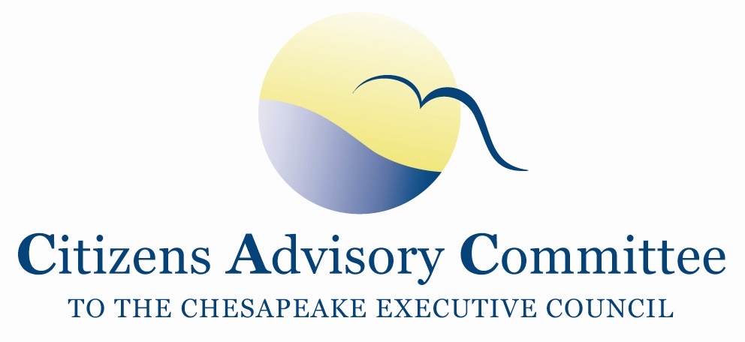
Citizens Advisory Committee
Meeting Agenda
February 19-20, 2015

_______________________________________________________________________________________________________________________________________

Stonewall Jackson Hotel
24 South Market Street
Staunton, VA 24401

“Good farmers, who take seriously their duties as stewards of Creation and of their land's inheritors, contribute to the welfare of society in more ways than society usually acknowledges, or even knows. These farmers produce valuable goods, of course; but they also conserve soil, they conserve water, they conserve wildlife, they conserve open space, they conserve scenery.”
― Wendell Berry, Bringing it to the Table: Writings on Farming and Food

Thursday, February 19- Salon C

11:00 a.m. Call to Order…………………………………………………………….…..Charlie Stek, Chair Welcome and Introductions of Members and Guests
Opening remarks about the theme and objectives of the meeting

11:05 a.m. Updates from Office of VA Natural Resources………………………………...…Russ Baxter,
Deputy Secretary of Natural Resources for the Chesapeake Bay
- What issues will the Office of Natural Resources exercise leadership of the Chesapeake Executive Council and Principals’ Staff Committee?
- What are Virginia’s priorities over the coming year related to the Chesapeake Watershed Agreement?
- What plans are there for Virginia to help close the gap on projected targets for Agriculture and Stormwater as we look to 2025?

12:00 p.m. Working Lunch- Colonnade Ballroom
CAC Priority- Stewardship: Local Restoration and Protection Efforts
Members are encouraged to sit with their jurisdiction colleagues.
Presentation: Local Stormwater Runoff Projects and Partnerships
Erik Curren, City of Staunton Councilman
Tom Yeago, Member, Lewis Creek Watershed Advisory Committee

1:15 p.m. CAC Priority- Agriculture and Water Quality
Understanding Agriculture in Virginia

Bobby Whitescarver, Whitescarver Natural Resource Management, LLC

- What are the demographics and trends of Virginia Agriculture?
- What is Virginia’s Agriculture Contribution of Nutrient and Sediment Pollution?
- What makes Virginia Agriculture unique from the other Chesapeake Bay Watershed States?
- How is the Regional Conservation Partnership Program different from the previous Farm Bill’s regional conservation programs?

- What are some of the priority issues and challenges for Virginia Agriculture?
- What are the best opportunities for mutual gain to farmers and water quality?
- What are the key elements of a Nutrient Management Plan?
- How do Resource Management Plans work in Virginia?

2:15 p.m. Panel Discussion with Local Farmers
Opening Remarks: Dale Gardner, CAC Member, WaterStewardship, Inc.

Each panelist takes 15 minutes for opening remarks to introduce themselves, talk about their farming operation, and share their insights on Nutrient Management Plans, Riparian Forest Buffers, and other Best Management Practices.
- Ray (Buff) Showalter Beef and Poultry farmer
- Kevin Phillips Dairy farmer
- Anthony Beery Dairy and Poultry farmer

3:45 p.m. Break

4:00 p.m. Updates from the Chesapeake Bay Program’s Agriculture Workgroup……………………...
Kristen Saacke Blunk, Field Liaison, HeadWaters, LLC, Ag Workgroup Co-Chair
Mark Dubin, Agricultural Technical Coordinator, U of MD, Ag Workgroup Coordinator

- Overview of Differences in Nutrient Management Plans in VA, MD and PA
- Recent Meeting Discussion and Decisions

4:30 p.m. Chesapeake Bay Program Updates…………………………………………...Nick DiPasquale,
Director, EPA Chesapeake Bay Program Office
Chesapeake Bay Barometer
- Brief Overview of General Findings of Annual Progress Report
Principals’ Staff Committee Meeting
- February 18, 2015 Meeting Decisions
- Looking Ahead for the Year
Accountability and Verification
- Independent Evaluation
- A brief update on issues in nutrient credit trading
- Report on progress of gaps in meeting the Watershed Implementation Plans?
  - Will there be EPA backstops? If so, What and When?
- What is EPA doing to work with the jurisdictions to strengthen the tracking, assessing and verification components outlined in the Bay Program’s guidance for developing the Management Strategies?

5:30 p.m. Meeting Recess

7:00 p.m. Dinner- on site: Colonnade Ballroom
Members will engage in informal discussion about Bay Restoration and Protection issues.

Friday, February 20- Salon C
A Breakfast buffet is served on-site for hotel guests at 24 Market Restaurant starting at 6:30am. Please tell them you are with the Citizens Advisory Committee so your breakfast will be covered on the master bill.

8:30 a.m. Call to Order……………………………...…………………………..Charlie Stek, CAC Chair

8:35 a.m. General Overview of the Management Strategies………………………..….…Carin Bisland,
EPA, Chesapeake Bay Program
Process
- Timeline
- Plans for Public Release
- Differences between the Management Strategies and Workplans
- Overall assessment of completeness of the strategies

Substance
- A closer look at the strategies of most interest to CAC
- Elements of accountability in those strategies

9:45 a.m. Break

10:00 a.m. CAC Business Meeting and Updates
- Approval of CAC November 2014 meeting minutes

- Staff Updates to CAC on Bay Program Goal Teams and Workgroups
  - Partnering and Leadership Goal Team- Governance Workgroup
  - Partnering and Leadership Goal Team- Independent Evaluator Workgroup
  - Diversity Outcome- Employment and Professional Development Workgroup
  - Bay Program Communications Workgroup
  - LGAC updates

- Debrief and Impressions on presentations and learning
  - What are the opportunities for CAC?
  - Is there follow-up by CAC members or staff?

- Staff Updates on new CAC/LGAC cooperative agreement with EPA
  - Elements of focus and new tasks in the Work Plan
  - What organizations and affiliations are you representing on CAC?
  - What are the expectations for CAC members’ participation?
  - Coordination call with NFWF on CAC priorities in the EPA Chesapeake Bay Small Watershed and Innovative Nutrient and Sediment Reduction Grants

- Updates from CAC Members and Subcommittee Chairs

10:45 a.m. CAC Priorities and Organizational Structure
- What level of participation do CAC members want to have for the Stewardship and Diversity Management Strategies?
- Are there other Goal Outcomes that CAC members want to follow?
- Is there a more efficient way to structure CAC subcommittees?
- Are there changes to the CAC By-Laws that should be made to reflect CAC’s work with the Chesapeake Bay Watershed Agreement?

12:00 p.m. Meeting Wrap Up
- Suggestions for CAC meeting agenda on May 21-22 in Harrisburg, PA
  - We will be having lunch with LGAC on Thursday, May 21 and meeting with them until 3:30pm that afternoon
  - Who is planning to attend the Choose Clean Water Coalition Conference?
- Action Items and Wrap Up

12:15 p.m. Adjourn

Upcoming Meetings:
Choose Clean Water Coalition Conference is May 19-20 in Harrisburg, PA
Next CAC meeting is May 21-22 in Harrisburg, PA. We will be meeting jointly with LGAC on May 21.

