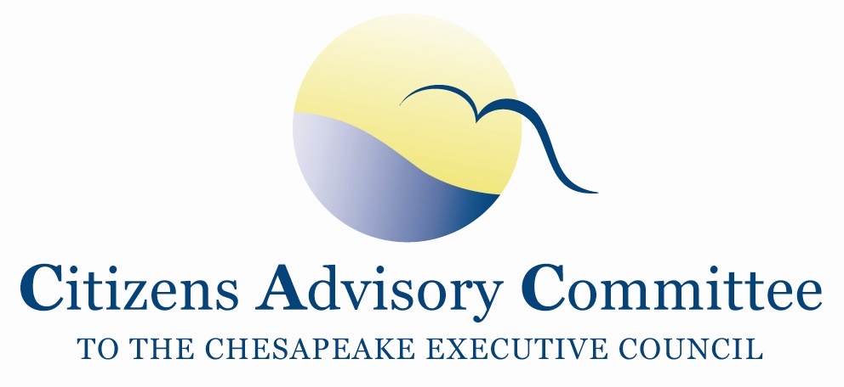
Citizens Advisory Committee
Meeting Agenda
February 20-21, 2020

______________________________________________________________________________________________________________________________________
The Country Inn of Berkeley Springs
110 S. Washington Street
Berkeley Springs, WV 25411

Meeting Goal: Members learn about the restoration efforts in WV and the perspectives of headwater state’s participation in the Bay TMDL and Chesapeake Watershed Agreement.

Thursday, February 20- Inn’s Meeting Room

11:00 a.m. Call to Order……………………………………….………………….…..Matt Ehrhart, Chair
- Introduction of Members and Guests

11:10 a.m. Welcome and Opening Remarks……………………..…………David Lillard, CAC Member
Matt Pennington, Eastern Panhandle Regional Planning and Development Council
- WV in Context: Rivers and Watershed, Population, Land Use, Pollution Challenges and Culture

11:30 a.m. Updates and Comments on Events since we last gathered………………………………..…All
- Debrief on the PSC Meeting
  - TMDL Enforcement
  - Conowingo Dam

12:00 p.m. Working Lunch- Continued Discussion

1:00 p.m. West Virginia’s approach to Phase III WIPs………………………….………Alana Hartman
Potomac Basin Coordinator
West Virginia Department of Environmental Protection

1:45 p.m. Eastern Panhandle Regional Planning and Development Council……….Matt Pennington
- Overview of the Council
- Environmental Programming for the Chesapeake Bay watershed
- His role as Chesapeake Bay Program’s Local Leadership Workgroup

2:30 p.m. West Virginia Rivers Coalition………………..……………Angie Rosser, Executive Director
- Issues of Focus, Opportunities and Challenges for 2020
- WV Topics in the Choose Clean Water Coalition
- Examples of successful programs that advance the WV Rivers Coalition’s Mission

3:15 p.m. Break

3:30 p.m. Snapshot of NY’s Approach to Non-point source implementation of Phase III WIPs
Mike Lovegreen, CAC Member
Upper Susquehanna Coalition

4:30 p.m. CAC Discussion

5:00 p.m. Meeting Recess

6:30 p.m. Dinner- Tari’s Premier Café and Inn
Members continue to discuss local river and Chesapeake Bay issues in an informal setting.

Friday, February 21- Inn’s Meeting Room
Breakfast buffet available in the meeting room starting at 8:00am.
(Please Check out of the hotel before the meeting begins.)

8:30 a.m. Call to Order and Business Meeting………………………...….…….…..Matt Ehrhart, Chair
- Approve November 2019 Meeting Minutes
- Reflections on the Previous Day
- CAC Staff Updates
  - Brief Introduction to Federal Rules and Regulatory Changes
- Member Updates and Announcements

9:15 a.m. Updates from the Chesapeake Bay Program…………………………..…………Jim Edward,
Deputy Director, EPA Chesapeake Bay Program Office
- Highlights of EPA’s Evaluation of the Phase III WIPs
- Update on BMP verification assessments
- Federal Agency Budget

10:15 a.m. Break

10:30 a.m. CAC Discussion, Final Thoughts and Action Items
- Reflections on the Meeting Topics
- Discuss Action Items and Next Steps
- Ideas for May 2020 CAC meeting agenda in Richmond, Virginia
  - Climate Change, Oysters as BMPs, Chesapeake Bay Commission

12:00 p.m. Adjourn

2020 CAC Meeting Dates:
May 21-22 in Richmond, VA following the Choose Clean Water Coalition Conference
September 17-18 in PA
December 3-4 in St. Mary’s, MD half day with LGAC

