Draft Preliminary Ecological Risk Assessment
Conceptual Model for Striped Bass Exposure to Microplastics

Overview

A series of draft conceptual models were developed as the first step to frame the ecological risk assessment of microplastics in the 0-2 year age class of Striped Bass (Morone saxatilis) in the tidal Potomac River. The goal of this first draft is to highlight potential biological endpoints and pathways from food and water that could lead to uptake of microplastics by Striped Bass. A search of primary and gray literature was conducted to identify prey items consumed by Striped Bass, with an emphasis on data collected from the tidal Potomac River and Chesapeake Bay, and supplemented with information from east coast estuaries and other geographical locations, as appropriate. Prey items for the 0-2 year age class were emphasized in the draft diagrams, but information related to older age classes and prey organisms not found in the Chesapeake Bay were retained for future reference. Relative contribution of prey items to Striped Bass diet was quantified where possible.

This memo provides three sets of models—1) biological endpoints of potential interest; 2) qualitative food web interactions that could lead to microplastic intake by Striped Bass, and 3) semi-quantitative food web interaction scenarios for Striped Bass living in different salinity regimes.

Methods

A literature search was initiated following the methodology approved under the quality assusance project plan (QAPP) developed using EPA guidance. The compiled literature was examined for Potomac River relevant data on resident age-classes of Striped Bass. Resident age-classes were defined as including: all young-of-the-year (YOY) stages (both larval and post-metamorphosis juvenile), and ages 1 through 3 fish. Though the 0-2 age class was the original focus, age-3 fish were included in the analysis because evidence suggests the majority of age-3 males remain resident in Chesapeake Bay (Secor and Piccoli 2007), indicating that primary exposure to microplastics for males of that age class is still limited to the geographic area of interest. Diet data reported in several key studies were used to develop initial prey networks linking dominant primary producers, including Markle and Grant (1970), Boynton et al. (1981), Walter and Austin (2003; 458-710 mm size-classes only), Muffelman (2006), and Ihde et al. (2015). These regional studies were conducted in the Potomac River (Boynton et al. 1981), adjacent Virginia tributaries (Markle and Grant 1970, Muffelman 2006), and the Chesapeake Bay mainstem (Walter and Austin 2003; Ihde et al. 2015).

Prey importance was determined using % diet composition by biomass or volume (if biomass was not reported). Dominant prey species were assigned individual categories (e.g., Bay Anchovy Anchoa mitchilli, Atlantic Menhaden Brevoortia tyrannus). Where prey groups were reported as lower taxonomic resolution aggregates, these aggregate prey taxa were maintained (e.g., polychaetes, insects) or were further aggregated to reflect diverse functional groups of taxonomically similar prey that contributed relatively little to diet individually but could be important together (e.g., other crustaceans, other fish). For this initial report, trophic networks were manually constructed but the process will eventually be automated through the use of specialized network software such as the network package in R (Butts 2008).

Draft trophic networks linking prey groups to lower trophic position prey and, ultimately, to primary producers were based on compiled literature (e.g., Baird and Ulanowicz 1989) and professional knowledge of the project PIs. Prey trophic linkages will continue to be refined through the ongoing literature review to ensure the network structure is robust. Primary pools of bioavailable microplastics were identified as including settled (sediment) and suspended particles (water column).

Biological Endpoints

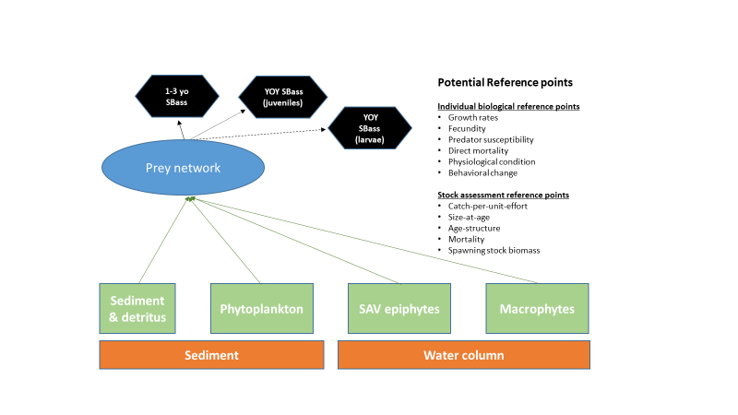
Fig. 1: This diagram shows a simplified conceptual model of expected environmental sinks of microplastics and generalized uptake through the food chain to Striped Bass. The blue oval labeled “Prey Network” is further expanded in the next figure. Measurable biological endpoints quantifiable at the individual (ex. growth, fecundity, etc.) and community management-focused level (ex. catch-per-unit-effort, size at age, etc.) are highlighted as potential endpoints to evaluate the effects of microplastics. In many cases, it is expected that these represent data gaps without a known relationship to microplastic exposure and may not yet be quantifiable.

Qualitative Food Web Interactions

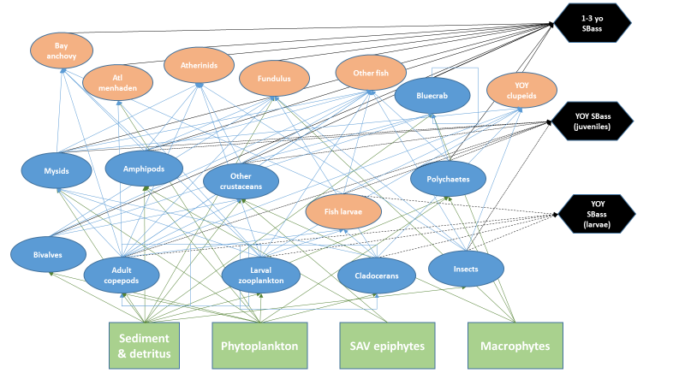
Fig. 2: This diagram shows potential sinks of microplastics and a more detailed food web of prey items consumed by Striped Bass and organisms consumed by those prey items. Three age classes of Striped Bass (young of year [YOY] larvae, YOY juveniles, and 1-3-year-old) are shown with connections to their known prey items.

Table 1: Aggregated Striped Bass prey table identifying specific taxa included in aggregate groups and associated references.
Aggregate group | Included taxa | Reference
Other fish | Morone americana, Leiostomus xanthurus, Micropogonias undulatus, Urophycis regia, Notropis hudsonius, Lepomis gibbosus, Cynoscion regalis, Gobiosoma bosci | Walter and Austin 2003, Markle and Grant 1970, Ihde et al. 2015
Insects (larvae and pupae) | Diptera (e.g., Muscidae, Chironomus sp., Chaoborus sp.), Hemiptera, Ephemeroptera | Markle and Grant 1970, Boynton et al. 1981, Muffelman 2006
Larval zooplankton | Cirripedia (barnacle larvae cirri), copepodites*, copepod nauplii* | Markle and Grant 1970
Other crustaceans | Mud crab, Palaemonidae (Palaemonetes sp.), sand shrimp (Crangon septemspinosa), mantis shrimp, isopods, xanthids, Ovalipes ocellatus | Muffelman 2006, Ihde et al. 2015, Markle and Grant 1970, Walter and Austin 2003
*based on literature from other estuaries (Limburg et al. 1997, Hjorth 1988 - Hudson River)
Semi-Quantitative Food Web Interactions

This series of diagrams is based on the striped bass dietary studies conducted by Boynton et al. (1981) that described quantitative dietary preferences of YOY Striped Bass (25-99 mm) foraging in three Potomac River salinity regimes—mesohaline, oligohaline, and tidal freshwater. The dashed lines connecting Striped Bass to a prey item indicate the prevalence of that organism as a food item, with thicker lines indicating a greater contribution than thinner lines. These diagrams demonstrate that the diet of young of year Striped Bass varies in composition depending on foraging habitat. For example, mysids and polychaetes make up most of the diet in mesohaline habitats while fish larvae and insects are the most dominant dietary components in tidal freshwater habitats. Using a quantitative dietary approach could be helpful to weight the expected contributions of microplastics via prey items.

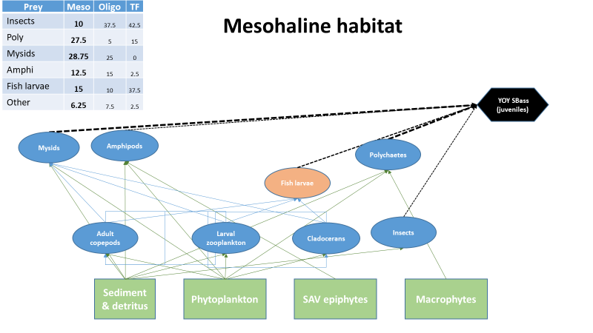
Fig. 3: Juvenile Striped Bass food web from mesohaline portion of Potomac River estuary (adapted from Boynton et al, 1981). Inset table provides biomass-weighted percent contribution to diet for each prey category.

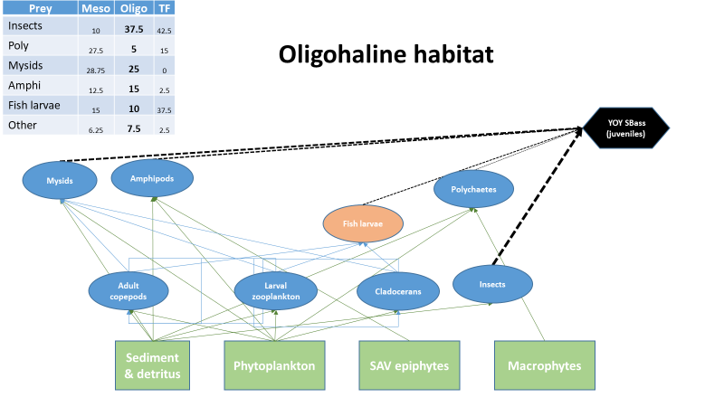
Fig. 4: Juvenile Striped Bass food web from oligohaline portion of Potomac River estuary (adapted from Boynton et al, 1981). Inset table provides biomass-weighted percent contribution to diet for each prey category.

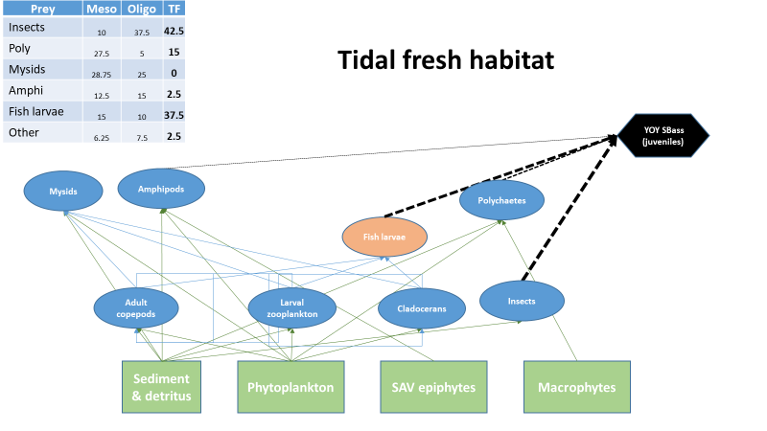
Fig. 5: Juvenile Striped Bass food web from tidal fresh portion of Potomac River estuary (adapted from Boynton et al, 1981). Inset table provides biomass-weighted percent contribution to diet for each prey category. Insects are primarily Diptera larvae (e.g., Muscidae).

The differing dietary preferences associated with salinity-based habitats provide insights as well, especially as future studies focus on the fate and transport of microplastics within the Potomac River. As data gaps close for fate and transport and uptake by prey items, an ecological risk assessment can be tailored to specific habitats that might be disproportionately affected by different varieties of microplastics.

Ages 1-2 Mainstem Chesapeake Bay

As previously noted, the literature review evaluated a number of studies on Striped Bass diets and those that focused on Potomac River populations (primarily Boynton et al, 1981) were used to develop the juvenile models. However, few to no studies exist for older fish (1YO-2YO) from the Potomac River. Ihde et al (2015) reviewed striped bass diets along the entire mainstem of the Chesapeake Bay, from tidal fresh to polyhaline regions, that can be utilized as a proxy for the Potomac River estuary. Those findings were used to develop the models for ages 1 and 2 shown below.

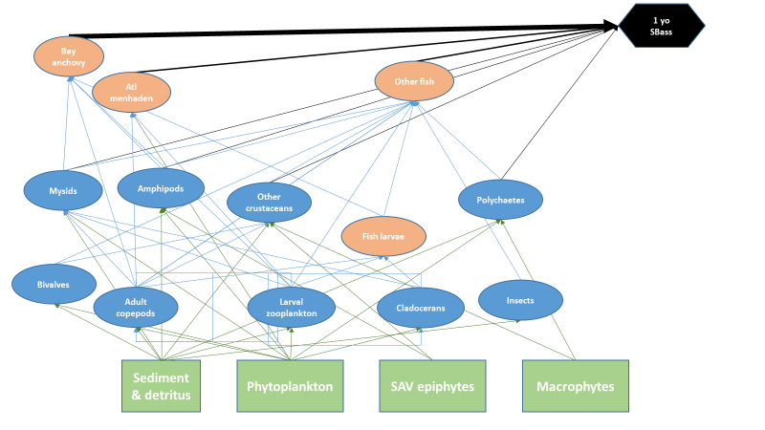
Fig. 6: Food web with Striped Bass 1YO endpoint. The relative thickness of black lines to striped bass indicate relative contribution to diet as found in Ihde et al 2015.
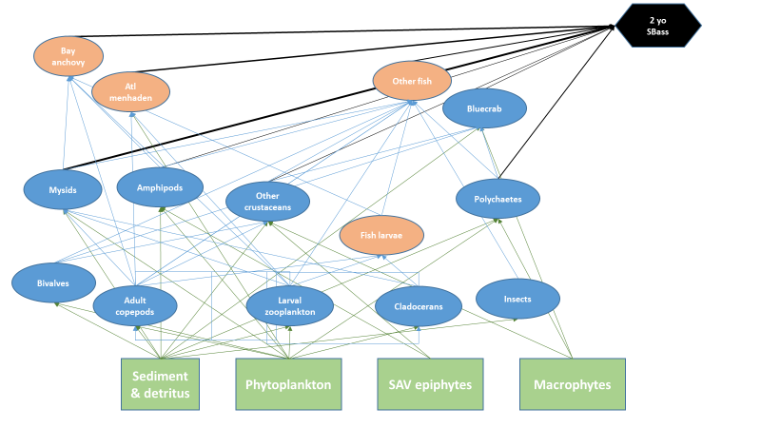
Fig. 7: Food web with Striped Bass 2YO endpoint. The relative thickness of black lines to Striped Bass indicate relative contribution to diet as found in Ihde et al 2015. Note the change in dominant dietary components from 1YO.

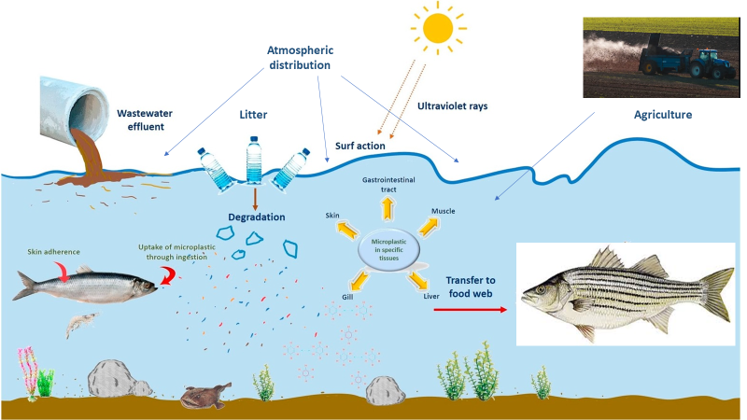
Fig. 8: Generalized pathways of abiotic/biotic relationships with microplastics in coastal systems. (adapted from Abbassi et al, 2018)
Next Steps

The current draft conceptual models focus heavily on predator-prey relationships of Striped Bass food webs. This sets up the framework for the next stage of the process—estimating potential magnitude of uptake of microplastic by Striped Bass. A literature search is underway to identify data that describe presence or absence of microplastics in species or genera relevant to the Potomac food web. In many cases, it is expected that data gaps will be identified and relationship to microplastic exposure may not yet be quantifiable for many species or genera.

It is also expected that environmental processes are likely to influence the availability of total microplastics along with specific sizes and polymer compositions. Microplastics are carried from their source by wind and water to potential sinks (sediment and detritus, phytoplankton, SAV epiphytes, macrophytes). Other environmental factors and processes that enhance or depress the dispersal or availability of microplastics will be included as the draft is expanded. Examples of these factors include tides, sunlight/photodegradation, seasonal changes, bacterial degradation, and storm events. These and other environmental factors are expected to influence the availability of microplastics in Striped Bass diets, but many unknowns exist surrounding transport and dispersion dynamics in the Potomac River.

The conceptual models shown in this memo will be refined, and two main end products will result—a simplistic overview of the microplastic risk assessment and a complex model with food web interactions and environmental factors. However, other models, including those showing food source variations in different salinity regimes will be useful, especially as more information about microplastic transport dynamics become available. It is possible that some sizes and polymer compositions are more or less prevalent in different locations in the tidal Potomac and larger Chesapeake Bay.

Literature Reviewed

Abbasi, S., N. Soltani, B. Keshavarzi, F. Moore, A. Turner, M. Hassanaghaei. (2018). “Microplastics in different tissues of fish and prawn from the Musa Estuary, Persian Gulf”. Chemosphere. 205: 80-87

Baird, D. and R. E. Ulanowicz. (1989). “The seasonal dynamics of the Chesapeake Bay Ecosystem” Ecological. Monographs. 59: 329–364.

Beaven, M., and J. Mihursky. (1980). “Food and feeding habits of larval striped bass: an analysis of larval striped bass stomachs from 1976 Potomac Estuary collections”. Rep. Maryland Univ.Chesapeake Biol. Lab. UMCEES 79-45-CBL, PPSP-PRFF 80-2. 27 PP.

Boynton, W. R., H. H. Zion, T. T. Polgar (1981). "Importance of Juvenile Striped Bass Food Habits in the Potomac Estuary." Transactions of the American Fisheries Society 110(1): 56-63.

Buchheister, A. & R. Latour. (2015). “Diets and trophic-guild structure of a diverse fish assemblage in Chesapeake Bay, USA”. Journal of Fish Biology. 86 (3): 967-992 10.1111/jfb.12621.

Butts, C. (2008). Network: A Package for Managing Relational Data in R. Journal of Statistical Software 24:2.

Fay, C. W., R. J. Neves, G. B. Pardue. (1983). “Species profiles: Life histories and environmental requirements of coastal fishes and invertebrates (Mid-Atlantic)-- Striped bass”. U.S. Fish & Wildlife Service, Division of Biological Services, FWS/OBS-82/11.8: 36.

Ferry, K. & M. E. Mather (2012) Spatial and temporal diet patterns of subadult and small adult striped bass in Massachusetts estuaries: Data, a synthesis, and trends across scales”. Marine and Coastal Fisheries 4(1): 30-45

Griffin, J. C. & Margraf, F. J. (2003). “The diet of Chesapeake Bay striped bass in the late 1950s”. Fisheries Management and Ecology 10, 323–328

Hartman, K. J. (2000). "The influence of size on striped bass foraging." Marine Ecology Progress Series 194: 263-268

Hartman, K.J. (2000) “Variability in daily ration estimates of Age-0 striped bass in the Chesapeake Bay”. Trans Am Fish Soc 129:1181-1186

Hartman, K. J. and S. B. Brandt. (1995). Trophic resource partitioning, diets, and growth of sympatricestuarine predators. Transactions of the American Fisheries Society. 124: 520–537.

Hjorth, D.A. (1988). Feeding selection of larval striped bass and white perch in the Peekskill region of the Hudson River. Fisheries Research in the Hudson River, pp.134-147.

Ihde, T.F., E.D. Houde, C.F. Bonzek, and E. Franke. (2015). “Assessing the Chesapeake Bay Forage Base: Existing Data and Research Priorities”. STAC Publication Number 15-005, Edgewater, MD. 198 pp.

Limburg, K. E., Pace, M. L. & Fischer, D. (1997). “Consumption, selectivity, and use of
zooplankton by larval striped bass and white perch in a seasonally pulsed estuary”. Transactions of the American Fisheries Society 126(4): 607-621

Markle, D.F., Grant, G.C. (1970) “The summer food habits of young-of-the year striped bass in three Virginia rivers”. Chesapeake Science 11: 50–54

Merriman, D. (1941). “Studies on the striped bass (Roccus saxatilis) of the Atlantic coast. U.S. Fish.Bull. 50: 1–77

Muffelman, S.C. (2006). “Diel and site-specific feeding of young striped bass in a heterogeneous nursery habitat” . M.S. Thesis. School of Marine Science, College of William & Mary, Gloucester Point, Virginia.

Overton, A. S., F. Margraf, E. B. May. (2009). "Spatial and temporal patterns in the diet of striped bass in Chesapeake Bay." Transactions of the American Fisheries Society 138(4): 915-926.

Pruell, R. J., Taplin, B. K. & Cicchelli, K. (2003). “Stable isotope ratios in archived striped
bass scales suggest changes in trophic structure”. Fisheries Management and Ecology 10:
329–336

Rudershausen, P. J., J. E. Tuomikoski, J. A. Buckel, J. E. Hightower. (2005) “Prey selectivity and diet of striped bass in western Albemarle Sound, North Carolina”. Transactions of the American Fisheries Society, 134(5): 1059-1074. DOI: 10.1577/T04-115.1

Secor, D.H. and P. M. Piccoli. (2007) Oceanic migration rates of upper Chesapeake Bay striped bass (Morone saxatilis), determined by otolith microchemical analysis. Fishery Bulletin, 105(1), pp.62-73.

Setzler-Hamilton, E. M., W. R. Boynton, J. Mihursky, T. T. Polgar. (1981). "Spatial and temporal distribution of striped bass eggs, larvae, and juveniles in the Potomac estuary." Transactions of the American Fisheries Society 110(1): 121-136.

Setzler-Hamilton, E. M., P. W. Jones, G. E. Drewry, F. D. Martin, K. L. Ripple, M. Beaven, and J. A. Mihursky. (1982). “A comparison of larval feeding habits among striped bass, white perch and Clupeidae in Potomac Estuary”. University of Maryland [UMCEES] CBL81-87. Chesapeake Biological Laboratory, Solomons, Maryland, USA

Shideler, A.C. (2011) “Patterns in distribution, growth, and trophodynamics of striped bass early life stages in the estuarine transition region of upper Chesapeake Bay”. Master's Thesis, University of Maryland, College Park, MD.

Uphoff, J., M. McGinty, A. Park, C. Hoover, M. Patton. (2018). Performance Report for Federal Aid Grant F-63-R, Segment 9. Marine and Estuarine Finfish Ecological and Habitat Investigations, Maryland Department of Natural Resources.

Walter, J.F. and Austin, H.M., 2003. Diet composition of large striped bass (Morone saxatilis) in Chesapeake Bay. Fishery Bulletin, 101(2), p.414.

Walter III, J. F., Overton, A.S., Ferry, K.H., Mather, M.E. (2003). "Atlantic coast feeding habits of Striped Bass: A synthesis supporting a coast-wide understanding of trophic biology " Fisheries Management and Ecology 10: 349-360.

Woodland, R., E. Houde, A. Buchheister, R. Latour, C. Lozano, M. Fabrizio, T. Tuckey, C. Sweetman, C. (2017). “Environmental, Spatial and Temporal Patterns in Chesapeake Bay Forage Population Distributions and Predator Consumption. Forage Patterns in Chesapeake Bay”. University of Maryland Center for Environmental Science. 119 pp.

