

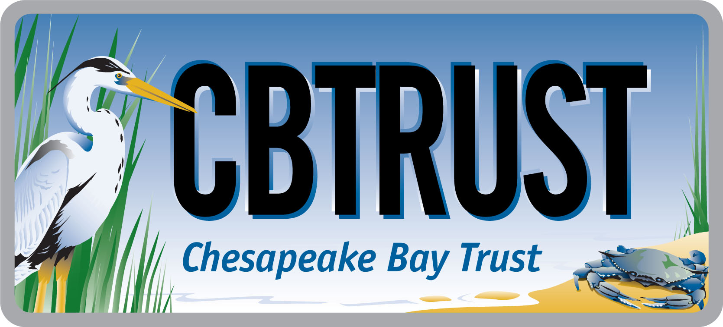
2017 Goal Implementation Team Projects Process for Project Funding and

Request for Ideas

This solicitation is focused on projects that remove barriers limiting accomplishment of management strategies/work plans. This funding is not intended to support implementation of restoration, protection, or stewardship projects; rather, it is intended to support tools or analyses that will make restoration, protection, and stewardship easier in the future.

Who is eligible to participate:
Members of Goal Implementation Teams (GITs) and work groups responsible for management strategies.

Deadline:
August 4, 2017

AT A GLANCE
I. Overview

The Environmental Protection Agency Chesapeake Bay Program Office (CBPO) has made funding available for key projects intended to accelerate accomplishment of the Management Strategies developed under the 2014 Chesapeake Watershed Agreement. The goal of these funds is to identify and remove key barriers that are hindering accomplishment of management strategies and work plans. Chesapeake Bay Program Goal Implementation Teams (GITs) and Workgroups responsible for management strategies are eligible to participate. For information on current and completed projects, please visit https://cbtrust.org/git/.

II. Project Selection Process

Any member of a GIT or GIT work group may submit a project idea, using Table 1 in Section VIII below, to GIT leadership. Each GIT leadership team is responsible for facilitating a process for prioritizing ideas generated within the GIT and reporting out the top three to four priority ideas using the criteria outlined in Section III below. Any projects that don’t make the top three to four priorities are candidates for alternative funding. These priority ideas will then undergo an external review process coordinated by the Chesapeake Bay Trust (the Trust) using the CBPO review criteria. The intent of this external review process is to provide scores and feedback that will support refining the scopes of work and help determine which projects will be included in the Request for Proposals (RFP) to seek bidders. The GIT Chairs will collaborate to form a consensus set of prioritized projects based on available funding levels and will submit that list to the CBPO Director for approval. For 2017, the total funding amount is $900,000. Selected projects will be assigned a GIT project lead, who will work with the Trust to ready the selected projects for the contracting phase and play a key role in seeing the project through to completion. This includes serving as a reviewer for all proposals submitted in response to their specific scope of work and approving all status reports submitted by the selected contractor, provided no conflicts of interest exist. All projects will be openly competed by the Trust to satisfy federal procurement guidelines.

III. Criteria

The following criteria will be used by GIT chairs and reviewers to rank project ideas. Projects:
- must support Chesapeake Bay Program goals, outcomes, management strategies, and work plans (required);
- must aim to remove a key existing barrier to implementation of work plan task(s) (required);
- must include deliverables that can serve as a catalyst for expanded action (required);
- must be unique projects that have not been previously undertaken (required);
- should meet more than one Chesapeake Bay Program outcome, particularly outcomes that fall under more than one GIT (preferred);
- should aim to complete all the components of an outcome’s decision framework (e.g., developing a monitoring plan or establishing criteria for measuring progress) (preferred).

IV. Eligible Project Cost and Types

Typically, project budgets are in the $25,000-$75,000 range. Example project categories include but are not limited to:
Metric Development and Tracking  - Support for science needed to develop metrics  - Metric/indicator development  - Performance measure development  - Monitoring/tracking program development  - Data collection program development  - Assessments of data to evaluate progress on metrics  - Modeling support | Work plan Implementation Projects  - Economic modeling  - Database development  - Policy research and recommendations  - Training  - Mapping, lands assessment  - Baseline analyses  - Environmental monitoring  - Environmental demonstration projects
V. Timeline

Determined by GIT Deadline for project ideas submitted to GIT leadership.
July 6, 2017 GIT Chairs, Coordinators and Staffers meet to discuss project ideas. After this meeting, teams should engage in internal review by CBPO Web Team, Creative Team, and Communications Workgroup to determine in-house capacity and refinements to project ideas.
August 4, 2017 Deadline for GIT leadership to submit top three project proposals from within each GIT.
August 11, 2017 External technical peer review comments are solicited on the top three proposals from each GIT for the purpose of strengthening the project designs. Internal review by CBP Web Team, Creative Team, and Communications Workgroup to determine in-house capacity and refinements to project ideas.
August 29, 2017 GIT Chairs, Coordinators and Staffers present and rank proposals. GIT Chairs select the finalists from the full suite of projects based on criteria in Section III, comments from the external review, and input from other Bay Program components.
September 5, 2017 GIT Chairs present a proposed final list of projects for funding to the CBPO Director for final approval & CBPO Director will notify Management Board and GIT Chairs of final approved project list.
September 29, 2017 GIT lead refines the scope of work and request for proposal (RFP) content (Table 2 in Section VIII below) and submits to the coordinator and staffer of Enhance Partnering, Leadership and Management GIT.
October 6, 2017 The Trust provides feedback to the GIT Leads on the draft RFP content and schedules conference calls to discuss as needed to develop a robust scope for the RFP.
October 2017 The Trust issues a RFP to seek bidders.
November 2017 Bids from contractors are due; the Trust releases bids for external peer review.
December 2017 The Trust compiles reviews, works with the GIT technical project leads to identify winning bidders, initiates sub-award contracts.
January 2018 GIT technical leads meet with awardees to commence projects.

VI. Role of a GIT Technical Project Lead

Each project selected for funding will have assigned a “GIT technical project lead” (GIT lead) by the GIT Chair. The GIT lead may be the individual who submitted a project idea in response to this solicitation or may be a different individual assigned by GIT leadership. The GIT lead will have several responsibilities over the course of the project:
- Providing a detailed scope of work for the project, with guidance from the Trust, to be used to procure a contractor;
- Helping to identify at least three potential bidders to accomplish the work outlined in the scope of work;
- Reviewing proposals as part of a review team; and
- Helping to monitor progress and the acceptability of deliverables of the winning contractor.

An individual named as a GIT lead is not permitted to have a conflict of interest with any organizations that respond to the Trust Request for Proposals. Should a GIT lead be conflicted with any bidders, he or she will be replaced at least for the duration of the bid phase.

VII. Idea Development Assistance

Interested parties are strongly encouraged to work with their GIT leadership (chairs, coordinators, and staffers) prior to completing the form in Section VIII. Additionally, contact:

Hannah Martin Greg Allen Emily Freeman
Chesapeake Bay Trust Environmental Protection Agency Chesapeake Research Consortium
(410) 974-2941 ext. 112 (410) 267-5746 (410) 267-5721
hmartin@cbtrust.org allen.greg@epa.gov freeman.emily@epa.gov

VIII. Project Idea Submission Form

Step 1 - Please fill out the following form and submit via email to your GIT Chair and coordinator (see http://www.chesapeakebay.net/about/organized for contact information).

Table 1: Project Description
Your Name:
Goal Implementation Team:
Project Title:
Project Type (See Section IV above):
Goal/Outcome:
Estimated Cost:
Justification: Provide a brief description of the work and why it is needed. It is recommended that you draw upon one or more work plans.
Methodology: Provide a 1-2 paragraph description of how the work is likely to be accomplished.
Cross-Goal Benefits: What other goals may be advanced through this work?
Are you willing to serve as GIT lead (see description of the role in Section VI above) If no, suggest other GIT lead (with contact information)

Step 2 - ONLY if your project idea is selected for funding and will be included in the RFP, you or the assigned GIT lead will be required to provide the following information (the Trust will send the RFP content guidance document to assist completing the Table 2 “Project Details.”):
Table 2: Project Details
GIT Lead Name:
Goal Implementation Team:
Project Title:
Refined Cost Estimate:
Estimated Project Duration:
Statement of Work: Provide a detailed scope of work to be accomplished by the contractor, including information on methods, stakeholder participants, deliverables, due dates and intended uses of the products.
List specific deliverables/products to be provided by the contractor:
QAP: Will environmental data be generated, and will a quality assurance plan be required?
Qualifications: List skills and experience required of winning bidder:
Bidders List: Due to federal procurement guidelines, project ideas MUST be open to competitive bidding. List at least three entities (with contract information) to include in the RFPs
Reviewers List: The Trust will use external review to evaluate bids. List at least 3 potential reviewers (with contact information) without a conflict of interest with likely bidders.

