

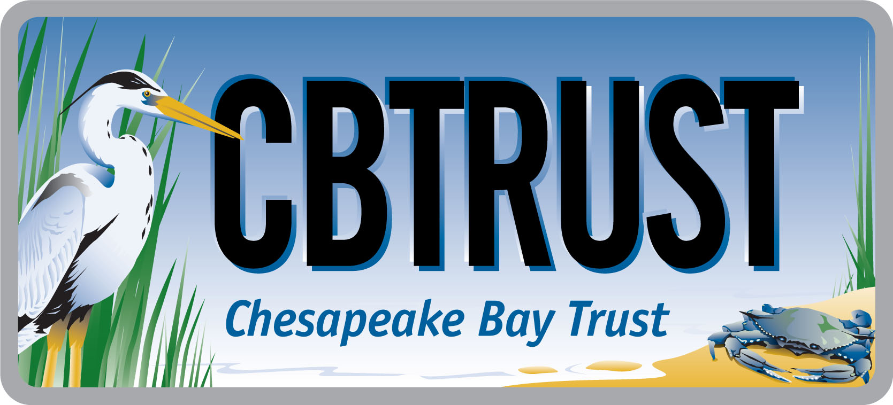
2016 Goal Implementation Team Projects Process for Project Funding and

Request for Ideas

This solicitation is focused on projects that remove barriers limiting accomplishment of Management Strategies/Work Plans. This funding is not intended to support implementation of large-scale restoration, protection, or stewardship projects; rather, it is intended to support tools or analyses that will make restoration, protection, and stewardship easier in the future.

Who is eligible to participate?
Members of Goal Implementation Teams (GITs) and GIT work groups

Deadline:
July 15, 2016

AT A GLANCE
I. Overview

The Environmental Protection Agency Chesapeake Bay Program Office (CBPO) has made funding available for key projects intended to accelerate accomplishment of the Management Strategies developed under the 2014 Chesapeake Watershed Agreement. Chesapeake Bay Program Goal Implementation Teams (GITs) and Workgroups are eligible to participate. The goal of these funds is to identify and remove key barriers that are hindering accomplishment of management strategies and work plans.

II. Project Selection Process

Any member of a GIT or GIT work group may submit a project idea, following the instructions in Section VIII below, to his or her GIT leadership. Each GIT leadership team is responsible for facilitating a process for prioritizing ideas generated within the GIT and reporting out a set of top three priority ideas using the criteria outlined in Section III below. The GIT Chairs will collaborate to form a consensus set of prioritized projects based on available funding levels and will submit that list to the CBPO Director for approval. For 2016, the approximate total amount available is $775,000. Selected project ideas will be assigned a GIT project lead, who will work with the Chesapeake Bay Trust (the Trust) to ready the selected project ideas for the contracting phase and play a key role in seeing the project through to completion. All projects will be openly competed by the Trust to satisfy federal procurement guidelines.

III. Criteria

The following criteria will be used by GIT chairs and reviewers to rank project ideas. Projects:
- must support Chesapeake Bay Program goals, outcomes, management strategies, and work plans (required);
- must aim to remove a key existing barrier to implementation of work plan task(s) (required);
- must include deliverables that can serve as a catalyst for expanded action (required);
- must be projects that have not been previously undertaken (i.e., must have unique deliverables);
- should meet more than one Bay Program outcome, particularly outcomes that fall under more than one GIT (preferred); and
- should aim to complete all the components of an outcome’s decision framework (examples: developing a monitoring plan or establishing criteria for measuring progress) (preferred).

IV. Eligible Project Size and Types

Typically, project budgets are in the $25,000-$75,000 range. Example project categories include but are not limited to:
Metric Development and Tracking  - Support for science needed to develop metrics  - Metric/indicator development  - Performance measure development  - Monitoring/tracking program development  - Data collection program development  - Assessments of data to evaluate progress on metrics  - Modeling support | Work plan Implementation Projects  - Economic modeling  - Database development  - Policy research and recommendations  - Training  - Mapping, lands assessment  - Baseline analyses  - Environmental monitoring  - Environmental demonstration projects
V. Timeline

June 30, 2016 Deadline for project idea submission to GIT leadership (Table 1 in Section VIII below).
July 15, 2016 Deadline for GIT leadership to submit top three project proposals from within each GIT.
July 30, 2016 External technical peer review comments are solicited on the top three proposals from each GIT for the purpose of strengthening the project designs.
Mid Aug, 2016 GIT Chairs select the finalists from the full suite of projects based on criteria in Section III, comments from the external review, and input from other Bay Program components.
Aug 15, 2016 GIT Chairs present a final list of projects for funding to the CBPO Director for final approval. CBPO Director will notify Management Board and GIT Chairs of final approved projects list.
Sept. 15, 2016 GIT leads finalize detailed scopes of work (Table 2 in Section VIII below).
Oct. 2016 The Trust issues a Request for Proposals to seek bidders.
Nov. 2016 Bids from contractors are due; the Trust releases bids for external peer review.
Dec. 2016 The Trust compiles reviews, works with the GIT technical project leads to identify winning bidders, initiates sub-award contracts.
Jan. 2017 GIT technical leads meet with awardees to commence projects.
.
VI. Role of a GIT Technical Project Lead

Each project selected for funding will have assigned a “GIT technical project lead” (GIT lead) by the GIT Chair. The GIT lead may be the individual who submitted a project idea in response to this solicitation or may be a different individual assigned by GIT leadership. The GIT lead will have several responsibilities over the course of the project:
- Providing a detailed scope of work for the project, with guidance from Chesapeake Bay Trust, to be used to procure a contractor
- Helping to identify at least three potential bidders to accomplish the work outlined in the scope of work
- Reviewing proposals as part of a review team;
- Helping to monitor progress and the acceptability of deliverables of the winning contractor.
An individual named as a GIT lead is not permitted to have a conflict of interest with any organizations that respond to the Trust Request for Proposals. Should a GIT lead be conflicted with any bidders, he or she will be replaced at least for the duration of the bid phase.

VII. Idea Development Assistance

Interested parties are strongly encouraged to work with their GIT leadership (chairs, coordinators, and staffers) prior to completing the form in Section VIII. Additionally, contact:

Hannah Martin Greg Allen
Chesapeake Bay Trust Environmental Protection Agency
(410) 974-2941 ext. 112 (410) 267-5746
hmartin@cbtrust.org allen.greg@epa.gov

VIII. Project Idea Submission Form
Please fill out the following form and submit via email to your GIT Chair and coordinator (see http://www.chesapeakebay.net/about/organized for contact information).

Table 1: Project Description
Your Name:
Goal Implementation Team:
Project Title:
Project Type (See Section IV above):
Goal/Outcome:
Estimated Cost:
Justification: Provide a 2 paragraph description of the work and why it is needed. It is recommended that you draw upon one or more work plans.
Methodology: Provide a 1-2 paragraph description of how the work is likely to be accomplished.
Cross-Goal Benefits: What other goals may be advanced through this work?
Are you willing to serve as GIT lead (see description of the role in Section VI above) If no, suggest other GIT lead

If your project idea is selected for funding, you or the assigned GIT lead will be required to provide the following information:

Table 2: Project Details
GIT Lead Name:
Goal Implementation Team:
Project Title:
Refined Cost Estimate:
Estimated Project Duration:
Statement of Work: Provide a detailed scope of work to be accomplished by the contractor, including information on methods, stakeholder participants, deliverables, due dates and intended uses of the products.
List specific deliverables/products to be provided by the contractor:
QAP: Will environmental data be generated, and will a quality assurance plan be required?
Qualifications: List skills and experience required of winning bidder:
Bidders List: Due to federal procurement guidelines, project ideas MUST be open to competitive bidding. List at least three entities to include in the request for proposals
Reviewers List: The Trust will use external review to evaluate bids. List at least 3 potential reviewers without a conflict of interest with likely bidders.

