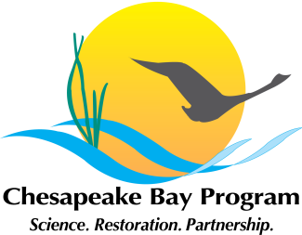
2014 Chesapeake Bay Watershed Agreement
Goals and Outcomes

Goal | Outcome
Sustainable Fisheries Goal
 | Blue Crab Abundance Outcome
 | Blue Crab Management Outcome
 | Oyster Outcome
 | Forage Fish Outcome
 | Fish Habitat Outcome
Vital Habitats Goal
 | Wetlands Outcome
 | Black Duck
 | Stream Health Outcome
 | Brook Trout
 | Fish Passage Outcome
 | Submerged Aquatic Vegetation Outcome
 | Forest Buffer Outcome
 | Tree Canopy Outcome
Water Quality Goal
 | 2017 Watershed Implementation Plans (WIP) Outcome
 | 2025 WIP Outcome
 | Water Quality Standards Attainment and Monitoring Outcome
Toxic Contaminants Goal
 | Toxic Contaminant Research Outcome
 | Toxic Contaminant Policy and Prevention Outcome
Healthy Watersheds Goal
 | Healthy Watersheds Outcome
Stewardship Goal
 | Citizen Stewardship Outcome
 | Local Leadership Outcome
 | Diversity Outcome
Land Conservation Goal
 | Protected Lands Outcome
 | Land Use Methods and Metrics Development Outcome
 | Land Use Options Evaluation Outcome
Public Access Goal
 | Public Access Site Development Outcome
Environmental Literacy
 | Student Outcome
 | Sustainable Schools Outcome
 | Environmental Literacy Planning Outcome
Climate Resiliency
 | Monitoring and Assessment Outcome
 | Adaptation Outcome

