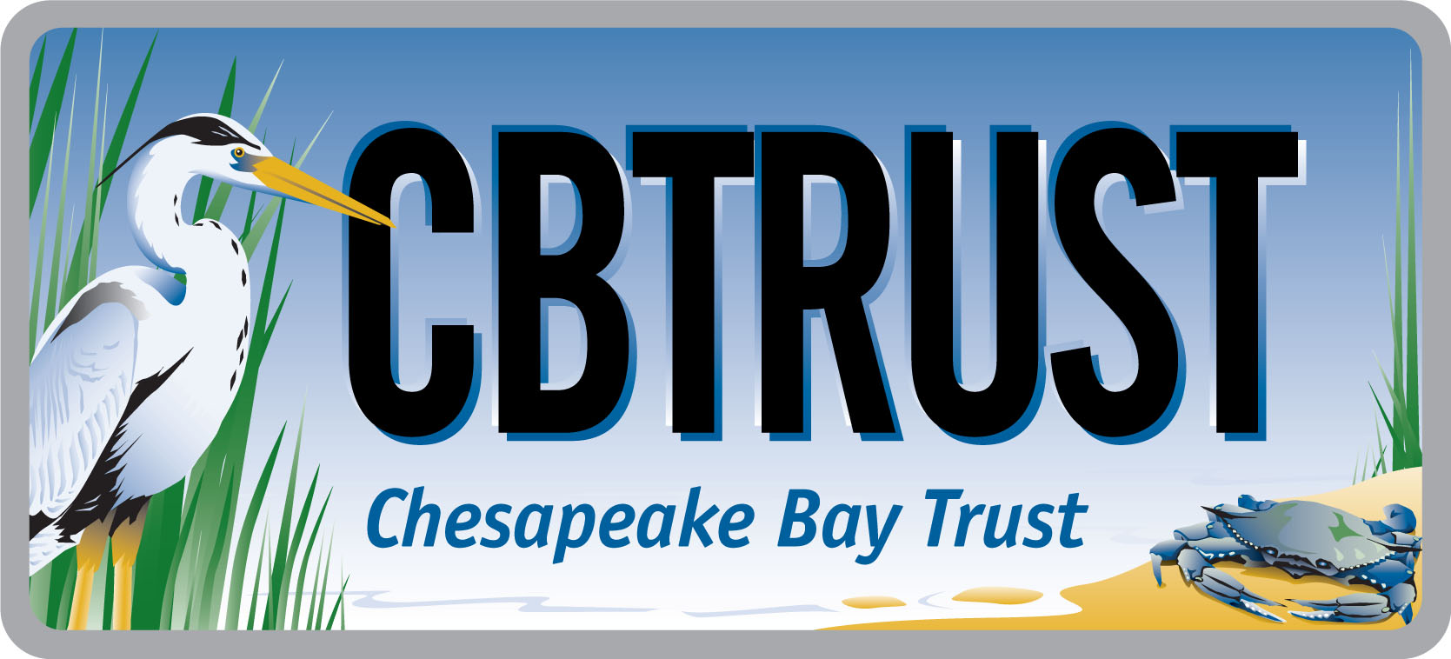



Guidance to Develop RFP Content for the

2016 Goal Implementation Team Projects

I. Overview
This solicitation is focused on projects that remove barriers limiting accomplishment of Management Strategies/Work Plans. This funding is not intended to support implementation of restoration, protection, or stewardship projects; rather, it is intended to support tools or analyses that will make restoration, protection, and stewardship easier in the future.

This document provides guidance to provide robust project details that will result in better responses to the RFP for your project.

Who is eligible to participate:
Members of Goal Implementation Teams (GITs) and GIT work groups

AT A GLANCE

The Environmental Protection Agency Chesapeake Bay Program Office (CBPO) has made funding available for key projects intended to accelerate accomplishment of the Management Strategies developed under the 2014 Chesapeake Watershed Agreement. The goal of these funds is to identify and remove key barriers that are hindering accomplishment of management strategies and work plans. Chesapeake Bay Program Goal Implementation Teams (GITs) and Workgroups are eligible to participate. Members of the GITs submitted their project ideas and the priority projects were identified to include in the 2016 Request for Proposals (RFPs). The next step is for the successful GIT project ideas to provide robust project details that will be used to solicit contractors. This document provides guidance for those project details that will result in better responses to the RFP for your project.

II. RFP Content Template (Table 2: Project Details)

The projects that will be included in the 2016 RFP each have a GIT Technical Lead. The GIT Technical Lead will work with the GITs to provide the requested project details that are listed in Table 2 (copied below) of the “2016 Goal Implementation Team Projects Process for Project Funding and Request for Ideas.” These project details are the basis for the content provided in the RFP and will be used to procure a contractor. The more specific and detailed the project details are, the more closely the responding entity can match their scope of work, data gathered, deliverables, timeline, etc. to meet your needs. The Chesapeake Bay Trust requests this detailed information in order to receive thorough proposals from potential contractors and deliver products that closely match the GIT’s request.

Table 2: Project Details (from the “2016 Goal Implementation Team Projects Process for Project Funding and Request for Ideas”)
GIT Lead Name:
Goal Implementation Team:
Project Title:
Refined Cost Estimate: Provide the level of funding needed to complete the scope of work.
Estimated Project Duration: Detail the project timeline, including the end date.
Statement of Work: Provide a detailed scope of work to be accomplished by the contractor, including information on methods, stakeholder participants, specific deliverables/products, due dates and intended uses of the products.
QAPP: Will environmental data be generated, and will a quality assurance plan be required?
Qualifications: List skills and experience required of winning bidder:
Bidders List: Due to federal procurement guidelines, project ideas MUST be open to competitive bidding. List at least three entities to include in the request for proposals
Reviewers List: The Trust will use external review to evaluate bids. List at least 3 potential reviewers without a conflict of interest with likely bidders.

III. Statement of Work

The statement of work should clearly define the expectations of the anticipated work for each project. The statement of work must outline exactly what this work is to accomplish, why the project is important, what methods should be used, how the work will be used, identify any common obstacles in the field, provide timeline and milestones, and detail the deliverables required. The table below provides the content to include in your statement of work. The table also includes guidance and examples to support those content pieces.

As you develop the statement of work, fully consider the project, the work needed to successfully complete the project, and the final product that will result from this effort. A review by a colleague not as familiar with the topic will identify areas where the scope of work may be vague to a contractor responding to the RFP. The Trust can serve as a reviewer for draft scopes of work, if needed. Finally, the most successful statements of work will clearly convey to the potential applicant what you need the work to accomplish in order for them to compile the appropriate team members to complete a scope of work with in the budget allotted and develop the deliverables you need.

Content | Guidance and Examples
Overview and purpose of the project | Explain the overview of the subject and purpose of the project. Be as detailed as possible.  Goals of the project – What do you want this project accomplish?  Background and importance of the work –Why is this work needed? How does this project relate to current GIT efforts? Has any sentinel work been completed that would support this effort or be a starting point for the responding team? If so, please provide references. Are there any known barriers or obstacles for the proposed work? If so, please provide these barriers or obstacles.  Anticipated Outcomes –What do you expect the awarded contractor to accomplish? What do you need to be provided to you as an outcome of the work? Detail how this product will be used by the GIT. Outline the appropriate scale of the project to assist the applicant to meet the project purpose and stay within the budget guidelines.
Methods | What methods do you want the contractor to use? Detail any standard operating procedures or best practices in the field that must be followed. Also, list any methods or data that should be avoided. This is where you detail what methods are known to work for the body of work needed.  How do you expect this project to be completed?  Detail the steps that will be needed to develop the deliverable(s). List any process methods (e.g., perform a literature review, conduct a workshop with experts in the field, develop the final recommendations) that should be included in the effort.  Will data be collected? If so, list what kind of data will be gathered and what type of protocols should be used for data compilation and analysis? Will this data gathering effort require a Quality Assurance Project Plan (QAPP) (see also Section V QAPP)? Consider requesting an experimental design to ensure that the applicant will measure and monitor the project in a scientifically valid manner that produces robust results. A QAPP may be required for your scope of work (see Section V QAPP for more details).  Examples:  - Stakeholder meetings will be used to vet the product and receive end user feedback for final product refinement  - Research will be conducted on rainfall patterns in the coastal zone  - Workshops will be held to bring experts in the field together and reach consensus on “X” issue  - Investigate abundance of fish for living shoreline practices compared to bulkheads over the last ten years. Deliver the raw data on a USB drive with the final report to the GIT
Stakeholder participants | Who do you think should be involved with the project? Who is the audience? Are there certain audiences that should be targeted for this effort?  Examples:  - Local governments  - Communities vulnerable to sea level rise  - Researchers that specialize in fish abundance of the Chesapeake Bay coastal zone  What outcomes will be developed with the stakeholder participants? List any anticipated or required stakeholder groups that should be included in the study.
Due Dates | Provide dates of requested deliverables and project end dates.  If you requested a final report as one of the deliverables, please account for time before the project end date for revisions between contractor and GIT, if you anticipate and want to provide comments that will be addressed and included in the deliverable(s).  Consider developing due dates based on any upcoming GIT meetings or any other internal milestones where this information could be used.  Please note that the Chesapeake Bay Trust requires contractors to submit status reports accompanied by invoices at least quarterly. All invoices require the GIT Technical Lead’s review and approval prior to reimbursement. This is a great way to stay up-to-date on the project progress and is a required role of the GIT Technical Lead.
Intended uses of the products | Why does the GIT need this product? How will the GIT use the final product? Provide the potential applicant with the background information that will help them understand why this information is requested and how it will be used. This background information will help the contractor refine their scope of work to better fit the final product you need.  Example: The final report will be presented to the Urban Stormwater Workgroup to support a future panel’s work on the floating wetlands studied.

IV. Deliverables

In the scope of work, list and explain any specific deliverables that are requested by the GIT. This is where you need to let the contractor know the deliverables required and what format this information should be delivered as a final product to the GIT at the project’s conclusion. In addition, the contractor needs to know what interaction and follow-up responses, if any, they will be required to have with the GIT during the development of the product. Finally, if data is generated, provide guidance on data delivery to the GIT.

Content | Guidance and Examples
Deliverables | What format is expected for the information to be delivered to the GITs? If you have a specific data requirement, state it so that the contractor is well aware of your needs and will develop their scope of work and budget to accommodate them.  Examples:  - Map of the sample sites and the GIS files associated with the map  - White paper with annotated bibliography  - Supporting research should be from the last 10 years only  - Presentation to the GIT on X date  - Final report  Do you want to see draft deliverables before the project end date? Do you want the contractor to respond to your feedback and update their deliverable(s) accordingly? If so, provide phased deliverables that the contractor can build into scope of work and timeline.  Examples:  - Phase I: Contractor provides draft recommendations from workshop convening coastal erosion experts  - Phase II: GIT responds to draft recommendations  - Phase III: Contractor revises and provides final recommendations in a presentation to the GIT and a final report  If the project collects data, do you want the data and what format would you like the data delivered? You may consider requesting an experimental design in the methods section to make sure that the applicant captures all the factors needed to answer the question posed. Consider if the project will use or collect data that will be required to develop a Quality Assurance Project Plan (QAPP). QAPPs are covered in the Section V. Finally, the experimental design, methods, data collected, and data analysis must be carefully considered and conducted to produce useful deliverables for your project.  Examples:  - Raw data is required with the final report  - Summary of data that was used for the findings is required with the final report submission  - Map of the study area including the sample sites and associated GIS files are required with the final deliverables

V. Quality Assurance Project Plan (QAPP)

Environmental data gathered (e.g., measurements of pollutants, land use, fish, etc.) used by the Chesapeake Bay scientists, researchers, and policy makers must be technically sound and scientifically defensible. Organizations funded by EPA that generate, compile, or use existing environmental data are required to establish and implement a quality system.

The QAPP is developed by the contractor and approved by the Quality Assurance Program at the CBPO. The QAPP describes the activities of environmental data operations for projects involved with acquisition of environmental information whether generated from direct measurements, collected from other sources, or compiled from computerized databases. The QAPP documents the results of the technical planning process in one place (i.e., the QAPP) to provide a clear and complete plan for the environmental data operation and the quality objectives. The QAPP provides project specific details that include project management, data sources and acquisition, assessment and oversight, and data review and usability. The QAPP provides up-front planning that is clearly communicated to all parties the specifications for implementation of the project to ensure the quality objectives are met.

The QAPP is an important tool. Consider if your project will use existing data or collect new data in the proposed scope of work. If so, the contractor should describe their quality systems in an approved QAPP. QAPPs must be approved prior to the start of the project’s data collection. If a QAPP is or may be required, this requirement should be stated in your scope of work in order for the contractor to add the time and budget necessary to develop and finalize the QAPP.

See the Chesapeake Bay Quality Assurance Program website for more QMP and QAPP details at http://www.chesapeakebay.net/about/programs/qa
.
VI. Qualifications
Provide the expertise and qualifications of the team of experts that will be needed to do this work. Describe the expertise that will be needed for the project. Determine and list the skills that are needed to successfully conduct the work.

Content | Guidance and Examples
Qualifications | List the qualifications needed by the project team to successfully complete the work. For example, if your scope of work requires understanding and using the Chesapeake Bay model, then the project team will require knowledge of the Chesapeake Bay model and a team with expertise in modeling.  Examples:  - Professional engineer is needed to review the data gathered and compile the final recommendations  - Project team must include one or more modeler(s) that are familiar with the CBPO Estuary Model  - Behavior change professional must conduct this work

VII. Bidders List
Please provide contact information for at least three (3) entities or groups that you think can do this work successfully. The Chesapeake Bay Trust will then provide the RFP to these groups. Per the federal procurement guidelines, the project ideas MUST be open to competitive bidding.

VIII. Reviewers List

Please provide contact information for at least three (3) potential reviewers beyond the GIT Technical Lead. These reviewers should be experts in the field. In addition, these reviewers should not have a conflict of interest with the potential bidders, such as a financial stake in the potential bidder company or be on the staff of a potential bidder. The Chesapeake Bay Trust will reach out to the reviewers to complete reviews in order to select the most qualified bidder.

