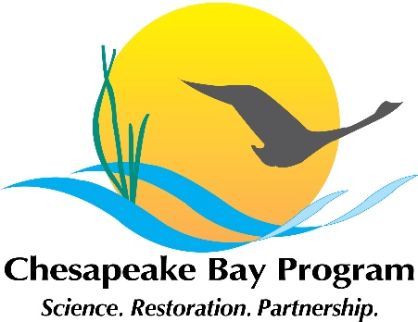
Habitat Goal Implementation Team Spring 2020 Meeting
May 6-7, 2020
Conference Call
*Please note that there are separate webinars for each day*
Before this meeting we request that you watch the following video (57:54) on community based social marketing strategies to set the stage for our discussions today. https://www.youtube.com/watch?v=McwWDxLiCu0&feature=youtu.be

Wednesday, May 6, 2020
Webinar: https://zoom.us/j/315729387?pwd=WWFHN2w0OWR0OFNpOGEzd0ZkTHJSUT09
Call in number: +1 929-205-6099
Meeting ID: 315-729-387 Password: 05062020
9:30 am | Welcome, Introductions, Expectations  Bill Jenkins (EPA) and Christine Conn (Maryland DNR)  - What are the impacts of the work we are trying to do? How can our programs be more impactful?  - What audiences have been engaged in the work we are doing? What lessons have we learned?  - How have the social sciences influenced the work we are trying to do?
9:45 | Social Science and the Bay Program Partnership  Amy Handen (EPA) & Genevieve LaRouche (USFWS)
10:15 | Update on Ecological Effects of Sea Level Rise Outreach  Nicole Carlozo (Maryland DNR)
11:00 | Break
11:10 am | Habitat Restoration on the Urban Elizabeth River – The use of collective impact and changing human behavior  Dave Koubsky (Elizabeth River Project)
11:55 am | Oyster Restoration and the Oyster Fishery in Virginia: Past and Present  Andrew Button (Virginia MRC)
12:35 pm | Wrap up and Discussion of How the Habitat GIT can Participate in the Chesapeake Bay Program’s Social Science Push
1:00 pm | Adjourn Day One
Thursday, May 7, 2020
Webinar: https://zoom.us/j/94995601353?pwd=S0VwUjN5S1pYZjVEQkZGalRkMmRzQT09
Call in number: +1 929-205-6099
Meeting ID: 949 9560 1353 Password: 05072020
1:00 pm | Setting the stage and discussion of yesterday’s meeting  Bill Jenkins and Christine Conn
1:30 pm | Black Duck Action Team’s Baseline and Progress Tracking  Ben Lewis (Virginia DGIF)
2:00 pm | Showcase of Updated Work Planned for the SAV Workgroup  Brooke Landry (Maryland DNR)
2:45 pm | Break
3:00 pm | Updates from the Wetlands Workgroup  Pam Mason (Virginia Institute of Marine Science)
3:45 pm | Wrap up and Discussion of How the Habitat GIT can Participate in the Chesapeake Bay Program’s Social Science Push
4:00 pm | Adjourn Meeting

