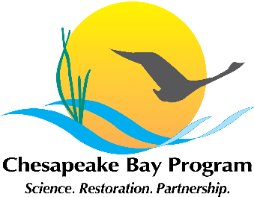
Chesapeake Executive Council Resolution- 2015 #2
Financing the Restoration of the Chesapeake Bay

Whereas, the significant cost of Chesapeake Bay restoration demands innovative financing methods to supplement current sources of federal, state, and local funds; and
Whereas, examples exist across the country and the world from the development of certified natural commodity markets, climate funds, land conservations, public/private partnerships, among others; each having particular requirements and relative amounts of risk and reward for private investors; and
Whereas, economic development opportunities exist through the economic activity associated with restoration activities and financing methods; and
Whereas, it is necessary to examine these methods and markets and determine their applicability to the jurisdictions in the Chesapeake Bay watershed.
Now, therefore be resolved,
That the Chesapeake Bay Program, under the leadership of the Principals’ Staff Committee conduct a symposium on environmental financing within the next 12 months and report any findings and recommendations at the next meeting of this council. That the symposium include representatives from federal, state and local governments, private capital firms, non-profit organizations, academic institutions and others.

