Indicators Framework
The Indicators Framework (Framework) is a conceptual model presented to the Management Board in November 2015 to align the Indicators Framework with the Chesapeake Bay Watershed Agreement (Agreement) and ensure it supports our adaptive management and communication needs.

Indicator Types

Each Agreement Outcome needs three information types to support and communicate progress towards the outcome and demonstrate the relationships between indicators and describe how they will be used. They are influencing factors, work plan and strategy outputs, and performance.

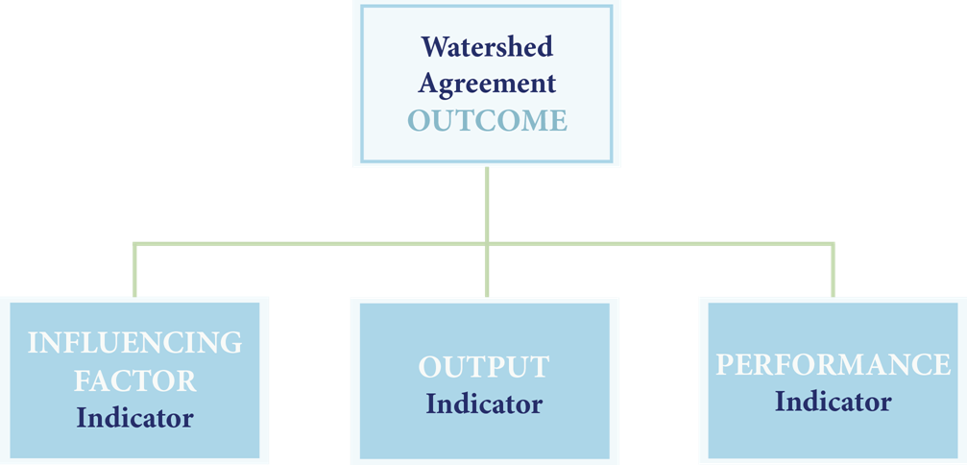

Indicator Development Progress
The Status and Trends Workgroup (under STAR) will work with the Goal Implementation Teams and STAC to identify indicator gaps for each outcome. A team under STAR (the Indicators Assessment Team) has begun the work of interviewing GIT management strategy leads to identify which outcomes currently have performance indicators. Early results show that
We have established indicators to track progress toward 9 outcomes:
  - Blue Crab Abundance and Blue Crab Management
  - Fish Passage, Submerged Aquatic Vegetation (SAV)
  - 2017 and 2025 Watershed Implementation Plans (WIPS), Water Quality Standards Attainment and Monitoring
  - Protected Lands
  - Public Access
We are developing indicators to track progress toward 13 outcomes:
  - Oysters
  - Brook Trout, Stream Health, Wetlands, Black Duck, Forest Buffer, Tree Canopy
  - Healthy Watersheds
  - Toxic Contaminants Policy and Prevention
  - Citizen Stewardship
  - Student, Sustainable Schools, Environmental Literacy
Another 9 outcomes are currently without any performance indicators:
  - Fish Habitat, Forage Fish
  - Toxic Contaminants Research
  - Local Leadership, Diversity
  - Land Use Methods and Metrics Development, Land Use Options Evaluation
  - Climate Monitoring and Assessment, Climate Adaptation
Work will continue to determine available indicators and gaps for the remaining Outcomes.

