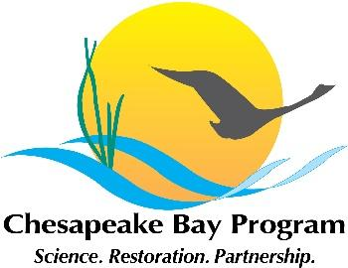

Joint Hampton Roads and Western Shore VA Oyster Team
Meeting Agenda
December 8, 2021 1:00 - 3:00pm

Google Meet Link:
meet.google.com/msh-coxy-xnq

Call in info:
Join by phone
(US) +1 617-675-4444‬ PIN: 660 426 107 3652‬#
Agenda

- Welcome, and note that this meeting is open to the public; notes will be posted here after the meeting.
- Thank you to the Corps Norfolk’s Alicia Logalbo for her service on the Team, and recognition of her new position.
- Updates on reef construction and general updates
- Bay Program Strategy Review System season is upon us. Report out on the presentation to Management Board- power point is here; next steps; STAR research agenda; for reference, see the Oyster Management Plan and the 2020-2021 oyster logic & action plan. What we need to do is update the logic & action plan for 2022-2023.
- -Review draft numbers for 2021 Annual Update document (see last year's VA version here for reference). Reminder that the annual oyster update presentation to the Sustainable Fisheries Goal Implementation Team is Jan 6 update- this is when we will first present these numbers, and hopefully the following week we can release the Annual Updates for MD, VA, and (new this year!) Bay-wide.
- -Reminder that the Bay Program Oyster Workgroups web page is a great resource; all our restoration plans, annual updates, meeting dates, agendas and notes, etc, are posted there.

