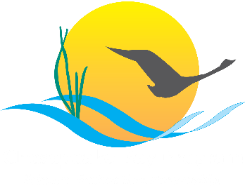

Land Use Methods & Metrics Development Outcome
Management Strategy
2015–2025, v.2

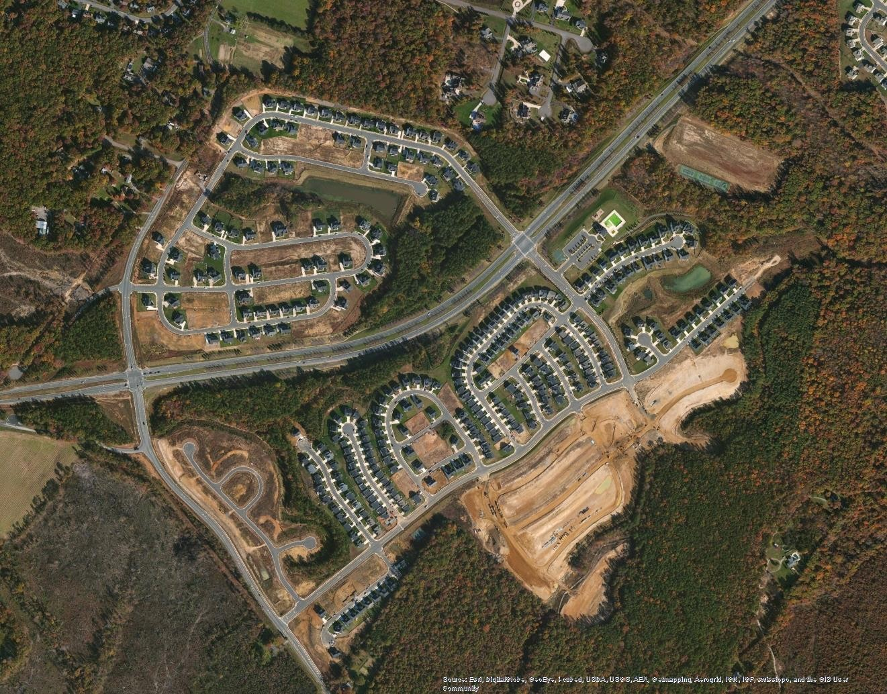
Photo Sources: Esri, DigitalGlobe, GeoEye, i-cubed, USDA, FSA, USGS, AEX, Getmapping, Aerogrid, IGN, IGP, swisstopo, and the GIS User Community

Introduction
To minimize the extent, and mitigate the effects of land conversion, local decision-makers and the land conservation community need to be informed about: 1) land cover and use changes that affect wildlife and stream habitats, watersheds, and human communities; and 2) policy options, incentives, and tools to reduce the rate and magnitude of land conversion. To address the first part of this strategy, the Land Use Methods and Metrics Development Outcome calls for monitoring and reporting on the rates of farmland, forest and wetland conversion and the rate of impervious surface change at a local scale relevant to land use decisions. The Metrics Outcome will help inform outreach efforts and products

developed as part of the Land Use Options Evaluation Outcome which will address the second part of this strategy.
The intent of the Metrics Outcome is to develop a method and metrics to monitor the conversion of valued natural and working landscapes, such as forests, wetlands and farms and to better understand the impacts of land conversion. Natural and working landscapes provide ecosystem services of value to the Chesapeake Bay and its population including water quality and quantity, habitat, recreation and food production.

Goal, Outcome and Baseline
This management strategy identifies approaches for achieving the following goal and outcome:


Goal
Conserve landscapes treasured by citizens in order to maintain water quality and habitat; sustain working forests, farms and maritime communities; and conserve lands of cultural, indigenous and community value.

Outcome
Continually improve the knowledge of land conversion and the associated impacts throughout the watershed. By 2016, develop a Chesapeake Bay watershed-wide methodology and local level metrics for characterizing the rate of farmland, forest and wetland conversion, measuring the extent and rate of change in impervious surface coverage and quantifying the potential impacts of land conversion to water quality, healthy watersheds and communities. Launch a public awareness campaign to share this information with citizens, local governments, elected officials and stakeholders.

Baseline and Current Condition
The temporal baseline for the outcome are the years 2013 (New York and Pennsylvania) and 2014 (District of Columbia, Delaware, Maryland, Virginia, and West Virginia) for which 1-meter resolution land cover and land use data exist for all counties intersecting the Bay Watershed. “Hot spots” of land change will be monitored every two years while complete wall-to-wall remapping of the watershed counties will occur every four years.
The economy, consumer preferences, and public investments influence the decisions of private developers and businesses which in turn influence the migration of people seeking jobs and amenities resulting in both commercial and residential growth. These factors, however, can be unpredictable and volatile as witnessed in the steep decline in new housing starts from 2006-2009 following the housing boom. Therefore, measured rates of land conversion should be interpreted in context, relative to measures of economic activity such as population growth due to migration and episodic large-scale infrastructure projects and relative to data on land protection and zoning.

Participating Partners
The following partners have pledged to help implement this strategy:
  - Chesapeake Bay Commission
  - Local Government Advisory Committee
  - Water Quality Goal Implementation Team
  - Habitat Goal Implementation Team
  - Healthy Watersheds Goal Implementation Team
  - Maryland Department of Planning
  - Pennsylvania Department of Community and Economic Development
  - U.S. Geological Survey
  - USGS National Geospatial Program
  - The Chesapeake Conservancy

Local Engagement
To assist in quantifying impacts on communities, the Land Use Workgroup will work with the Local Government Advisory Committee (LGAC) and the Local Leadership Workgroup to identify local governments interested in better understanding local rates of, and impacts from, land conversion, and in using new tools for better managing the rates and impacts from land conversion. Local government stakeholders are needed to advise the Chesapeake Bay Program on the development of the methodology and local level metrics, and in quantifying potential impacts.

Factors Influencing Success
The following are natural and human factors that influence the Bay Program’s ability to attain this outcome:
  - The CBP Management Board has interpreted the Outcome language as calling for the development of separate metrics for forest, farm, and wetland conversion in addition to measuring the rate of impervious surface change. For example, addressing this Outcome will require metrics that account for conversions from forests to farms and from farms to forests, in addition to conversions of both forests and farms to development.
  - Sustainability of long-term monitoring. This factor is a question of political will more than technological capabilities. Over the next six years, this is only a minor factor because in 2018, the CBP Partners awarded a six-year cooperative agreement to the Chesapeake Conservancy for geospatial support that includes mapping high-resolution land cover and land use for all watershed counties every four years.
  - Methodology for assessing landscape change with high-resolution data with sufficient precision to inform county-level decisions. Techniques to separate actual change in land cover from background noise and sources of confusion are rapidly advancing but are not sufficiently established to make this a non-issue. To accurately track change, updates to existing high-resolution land cover and land use datasets will be required during each 4-year remapping phase. This will ensure that the data for 2013/14 are consistent with and directly comparable to the data for 2017/18 and those for 2021/22.

  - Methodology to quantify impacts to communities and the environment. The quantification of impacts from land conversion to communities and the environment needs to be explored in more detail and with input from local governments. Quantification of impacts without sufficient context for interpreting those impacts may lead to false conclusions.

Current Efforts and Gaps
The term “land cover” refers to a wall-to-wall classification of land surface characteristics into categories such as impervious surfaces and tree canopy. Land cover classifications are derived from aerial and satellite spectral imagery collected from passive sensors. These classifications can be enhanced by
incorporating data from active sensors. Since the late 1990’s, the Bay Program has relied on 30m-resolution Landsat satellite derived land cover data to provide a spatially consistent representation of Chesapeake Bay watershed conditions to inform the suite of models used for management purposes and for tracking changes on the landscape. The U.S. Geological Survey (USGS) has recently produced annual 8-class land cover data derived from Landsat imagery for the Bay watershed for the period 1985 – 2017. In addition, the USGS has produced more detailed land cover classifications for the years 1984, 1992, 2001, 2006, and 2011 with 2013 and 2016 updates expected in January 2019. These data are invaluable for highlighting “hot spots” of change and for informing the Bay watershed model but they can largely miss the development of 2-lane roads and low-density residential areas. While these data have an overall accuracy above 80%, this is likely insufficient for monitoring change at the county-level every 3-5 years.
Throughout the 2000’s and present day, counties, states, and the United States Department of
Agriculture’s (USDA-FSA) Farm Service Agency have acquired high-resolution (<=2m) imagery to inform transportation, public works and natural resource decisions. Initially, these data were acquired as natural color images and used as pictures rather than analyzed as data. This practice has gradually evolved through the development of object-based feature extraction software, such as Feature Analyst, ENVI and eCognition as well as the acquisition of imagery with a near-infrared spectral band in addition to the three visible bands. The near-infrared band enhances the ability to distinguish vegetation from non-vegetated areas.
At present, USDA-FSA collects four-band leaf-on one-meter resolution ortho-imagery for each state as part of their National Agriculture Imagery Program (NAIP) every 1-3 years. Collection dates are cyclic and vary due to the availability of state cost-share funds and other factors. In addition, the Virginia Institute of Marine Science (VIMS) collects and manually classifies black and white aerial photographs along the near-shore areas of the Chesapeake and Coastal Bays to support their annual inventory of submerged aquatic vegetation (SAV) extent and density. Some states and localities acquire sub-meter leaf-off imagery every 3-5 years to support transportation and planning needs. Leaf-on imagery is better for detecting vegetation and leaf-off imagery is better for detecting impervious surfaces and water features which may be obscured by the canopy during the growing season. Leaf-off imagery is mostly collected during the spring, but the collection years often vary by state.

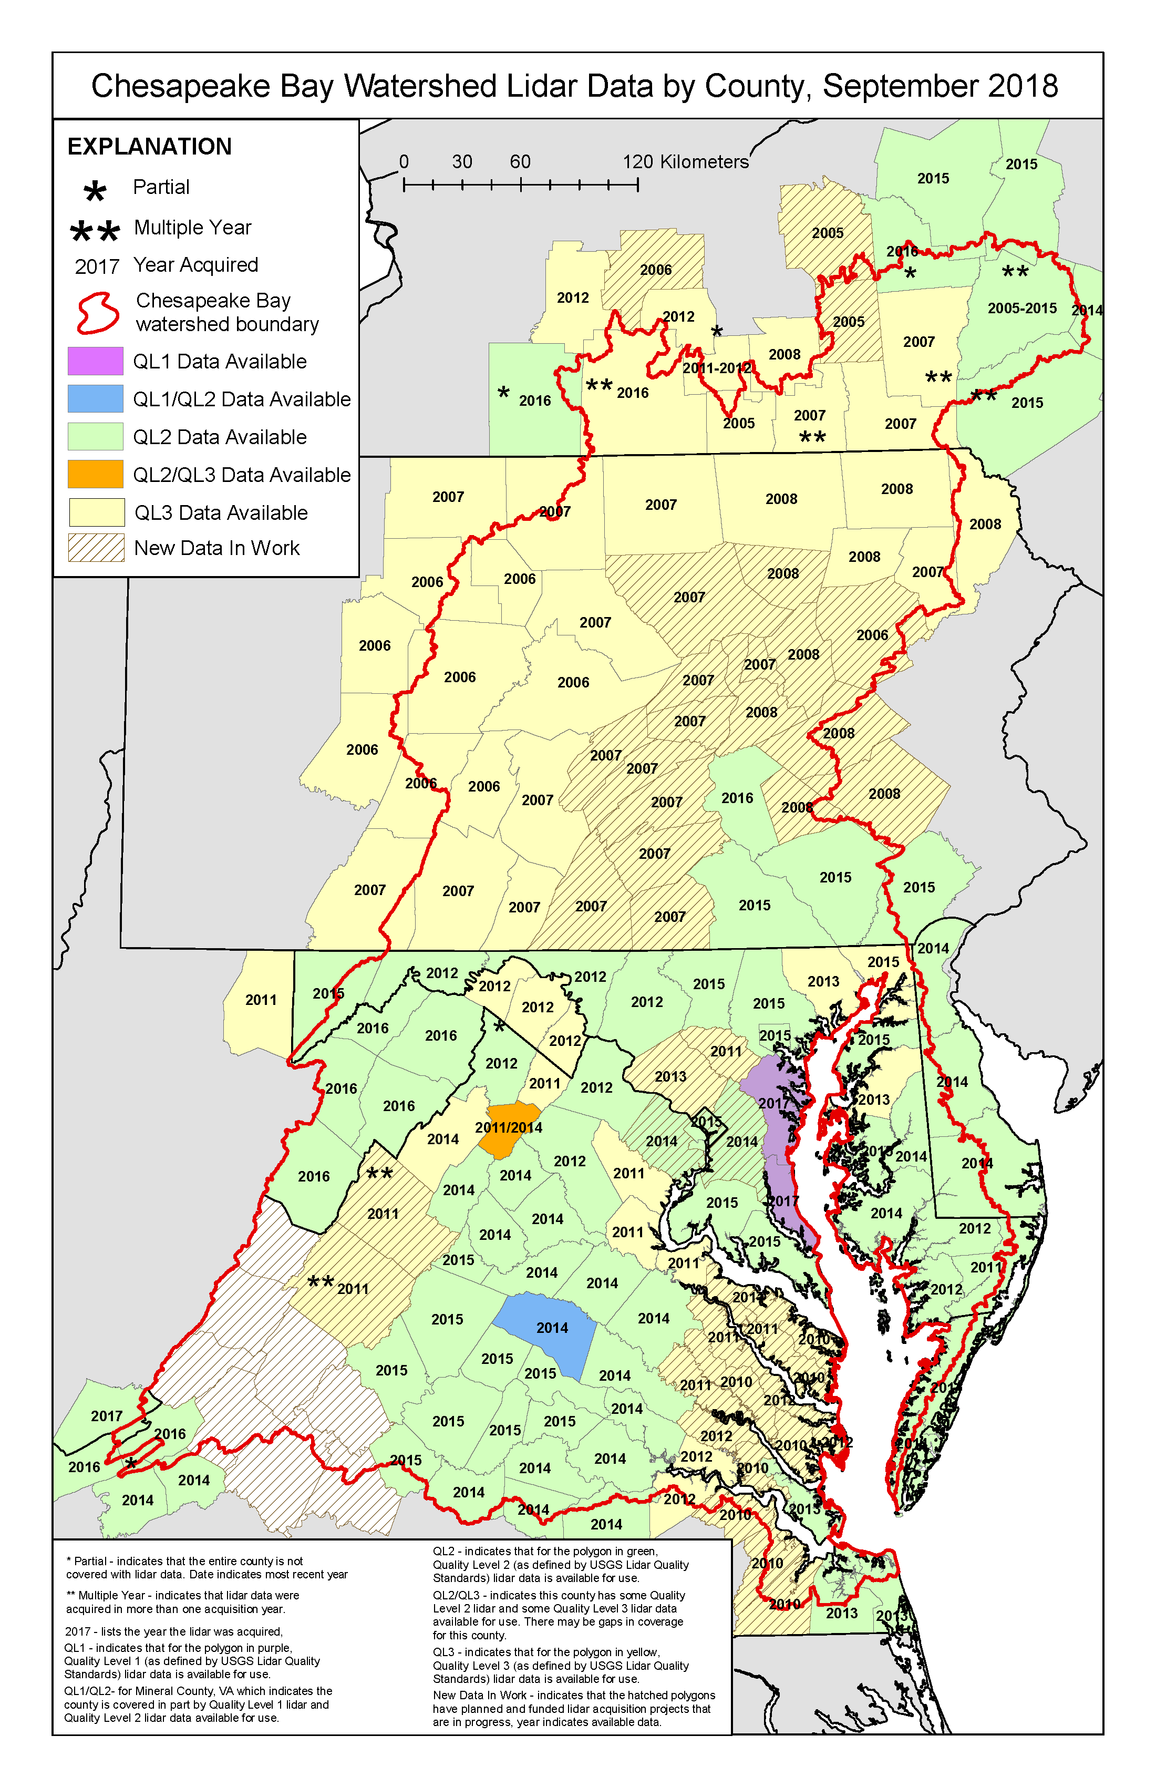
2018
Figure 1. Status of LiDAR data acquisitions in 2018. QL1-3 refer to data Quality Levels that influence the spatial resolution and accuracy of the final product. For an updated status map, see: http://gis.chesapeakebay.net/lidarstatus/. For more information on LiDAR specifications, see: https://pubs.usgs.gov/tm/11b4/pdf/tm11-B4.pdf

LiDAR (Light Detection and Ranging) refers to a high-resolution (<=2m) active airborne sensor that emits pulses of light in near-infrared (topographic LiDAR) and/or blue-green (topo/bathymetric LiDAR) wavelengths. These pulses are directed towards the ground, reflect off surfaces (i.e., buildings, leaves, branches, pavement, dirt), and return to the sensor. The time it takes for the pulses to be detected is recorded and correlated with the travel distance or “range” of each pulse. Because the exact location of the airplane in three-dimensional space is known, travel distances can be converted to elevations revealing a wealth of information about vegetation height, structure, biomass, and ground surface characteristics. As of 2015, LiDAR imagery had been collected on a county-by-county basis at least once (and seldom twice) for approximately three-quarters of the Bay watershed with dates varying from 2004 - 2014. By late 2019, LiDAR data will exist for all watershed counties (Figure 1).

There are different types of airborne LiDAR (e.g., waveform, discrete return, pulse width, and photon counting) which are not discussed here. The LiDAR data characteristics most relevant to the CBP needs are spatial accuracy, vertical accuracy, and penetration through water. Accuracies are influenced partly by the height and speed of the plane and frequency of pulses. The National Digital Elevation Program has developed a convention for characterizing the quality of elevation datasets. Most of the LiDAR elevation data currently available in the Chesapeake Bay watershed are classed as either Quality Level 2, “QL-2” (nominal pulse density of ≥ 2.0 pls/m²; 10 cm vertical RMSEz) or “QL-3” (nominal pulse density of ≥ 0.5 pls/m²; 20 cm vertical RMSEz). The QL-2 products have sufficient accuracy to produce a 1m resolution Digital Elevation Model (DEM) or Digital Surface Model (DSM) whereas the QL-3 products only support the production of a 2-3m resolution derivative products. Quality Level 1, “QL-1”, data are now available for three jurisdictions and have nominal pulse density of ≥ 8.0 pls/m²; 10 cm vertical RMSEz. These LiDAR products have mostly been collected using laser pulses with near-infrared wavelengths that cannot penetrate through water. Surface waters are depicted as flat, constant elevation surfaces similar to some building and pavement surfaces. Bathymetric and topo-bathy LiDAR instruments emit pulses in the blue-green wavelength that can penetrate water surfaces up to depths of 1- 10 meters depending on water clarity. Submerged surface elevations are also more accurate if the substrate is hardened (e.g., oyster bed) vs. soft (e.g., mud).

Coupling LiDAR data with high-resolution spectral imagery has proven very useful for improving the accuracy of semi-automated land cover classifications (e.g., differentiating buildings from parking lots and forests from scrub-shrub and herbaceous vegetation). The more data informing a classification (e.g., # of spectral bands, elevation and biomass data, parcels, and land use), the more automated the process can become to produce an accurate product. The costs of production are generally positively correlated with the degree of automation, yet all products require some level of manual editing to increase overall and individual class accuracies above 90%.

In 2015, 1-meter land cover data were produced for the entire Bay watershed (including all adjacent counties) using a combination of 2013/14 leaf-on NAIP, available state or county leaf-off imagery, and a Digital Surface Mata (1st return indicating the tops of surfaces) derived from LiDAR. In 2016, the land cover data was translated into 1m land use.
The Metrics Outcome calls for “continually improving the knowledge of land conversion” which requires attention towards monitoring land change rather than just mapping land cover once or multiple times. Assessing and mapping land use and cover change from high-resolution imagery is challenging but holds great promise for meeting the objectives of this outcome. Changes in spectral surface properties over multi-date images, however, introduce a lot of noise into interpretations of change. The sources noise might include variations in sun-angle, atmospheric conditions, vegetation phenology, and infrastructure materials and aggregates. Image properties can also vary from one image tile to another and from one year to another. These problems are largely absent when performing a change analysis on 30m-resolution Landsat satellite imagery which makes it ideal for “hot spot” change detection. High-resolution change analysis can be done, but for the above stated reasons, first-round automated results will likely be noisy and require modification to realize the accuracies needed to detect the average amount of change expected over a 2 to 4-year interval (~1% of the landscape).

Management Approaches
There are three elements to the Metrics Outcome:
- Monitor the rates of impervious surface change and conversion of forests, wetlands and farmland.
- Quantify the impacts of land conversion on:
  - Water quality
  - Healthy watersheds
  - Communities
- Communicate results to the public, elected officials and to the Bay Program.

The Bay Program will coordinate and solicit input on user requirements and technical specifications for this outcome. There are three basic technical approaches for monitoring land conversion every 2-4 years: 1) coarse, 30m-resolution wall-to-wall mapping of land cover change from Landsat satellite imagery; 2) high-resolution (<5m) wall-to-wall mapping of land cover change from aerial or satellite imagery; and 3) high-resolution (<5m) stratified random sampling. Each of these options has advantages and disadvantages related to cost, accuracy, spatial and temporal scale, flexibility for management use, adaptability to changing management objectives and educational value. These attributes were considered in developing recommendations for monitoring land change over time. Note that the above options are not necessarily mutually exclusive. For example, monitoring land change with Landsat satellite imagery can inform a stratified sampling framework using high-resolution imagery. Additional options may emerge in the future given rapidly advancing technologies and techniques.
While measuring current rates of land conversion will require use of existing imagery and data which varies in spatial resolution, accuracy and temporal currency, significant improvements in derived metrics and cost savings to local, state and federal government agencies could be achieved through a heavily coordinated effort to synchronize the acquisition of imagery and agree on a classification schema and change detection approach.
Quantifying the impacts of land conversion on water quality will be accomplished through close coordination with the Bay Program Modeling Workgroup and utilize the same sets of assumptions and data used to inform water quality decisions associated with the Chesapeake Bay Total Maximum Daily Load (TMDL). Quantifying impacts to healthy watersheds will be determined through close coordination with the Habitat and Healthy Watersheds Goal Implementation Teams (GITs) and may involve measures of vulnerability to urban development coupled with hydrologic impact measures associated with stream flow alteration. Assessing the impacts of land conversion to communities is one of the most complicated aspects of this outcome. Land conversion associated with residential and commercial development provides economic benefits to communities, but also involves costs that are not always evident at the time of development. Local participation will be sought to help identify and describe impacts to communities and to develop and implement the communication strategy as described below.

Approaches Targeted to Local Participation
Local participation in developing impact methodologies, particularly those used to assess impacts to communities, are needed to ensure the data are useful for informing local-level decisions. The Bay Program’s Land Use Workgroup will work with LGAC and the Local Leadership Workgroup to help develop a local engagement strategy that seeks to target outreach efforts and integrate and disseminate products from this outcome and those from the Land Use Options Evaluation outcome.

Cross-Outcome Collaboration and Multiple Benefits
Restoration and conservation efforts in the watershed will benefit from the availability of high- resolution land cover and elevation data produced every 2-4 years. The data will inform goals outlined by all of the Bay Program’s GITs and inform almost all of the outcomes specified in the
Chesapeake Bay Watershed Agreement—particularly the Vital Habitats, Healthy Watersheds, and Land Conservation Outcomes. Specific benefits include:
    - Characterizing, mapping, and tracking of wetlands, riparian forest buffers, forests and impervious surfaces;
    - Characterizing, mapping, and tracking habitat conditions;
    - Developing habitat suitability maps;
    - Prioritizing and targeting restoration, conservation, education and public access efforts;
    - Understanding the effects of management actions on water quality;
    - Verifying riparian buffer and urban tree canopy Best Management Practices;
    - Verifying the effects of Land Policy BMPs;
    - Assessing the vulnerability of watersheds and stream restoration BMPs to altered flow regimes;
    - Improving the accuracy of nutrient and sediment load estimates; and
    - Educating people on the value and location of high-functioning landscapes

Monitoring Progress
N/A

Assessing Progress
Progress in developing the methods and metrics will be assessed quarterly by the Land Use Workgroup and will be based on the feasibility and accuracy of the derived metrics and impact measures. Following development and approval of the metrics, they will be reassessed every 2-4 years corresponding to the receipt of updated land cover information.

Adaptively Manage
The utility of the metrics and impact assessments for informing Bay Program decisions will be evaluated at the end of each monitoring cycle and adjusted as needed to improve their utility for local decisions to accommodate changes in technology and programs.

Biennial Workplan
Biennial workplans for each management strategy will be developed by April 2016. The Land Use Methods and Metrics Development Workplan is expected to include the following information:
  - Key actions
  - Timeline for the action
  - Expected outcome
  - Partners responsible for each action
  - Estimated resources

https://chesapeakeconservancy.org/conservation-innovation-center/high-resolution-data/land-cover-data-project-2/
https://chesapeakeconservancy.org/conservation-innovation-center/high-resolution-data/land-use-data-project/

