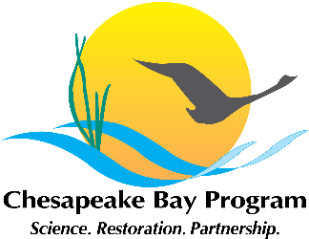

Local Leadership Management Strategy Discussion Meeting
Chesapeake Bay Program Office
Room
410 Severn Avenue
Annapolis, MD 21403

May __, 2015
?:00 p.m. – ?:00 p.m.

Conference Line:
Conference Code:
Web Access: https://epa.connectsolutions.com/git6/

Agenda

- Welcome, Introductions
Mike Foreman, VA DEQ
- Meeting objectives:
  - Review comments received during the public input period
  - Begin discussions on the development of the two year workplan

- Local Leadership Management Strategy Comment Review
Facilitator: Carin Bisland, EPA CBPO

- Review of Workplan Timeline and Discussion of First Steps
Facilitator: Carin Bisland, EPA CBPO

- Wrap Up and Next Steps
Mike Foreman, VA DEQ

