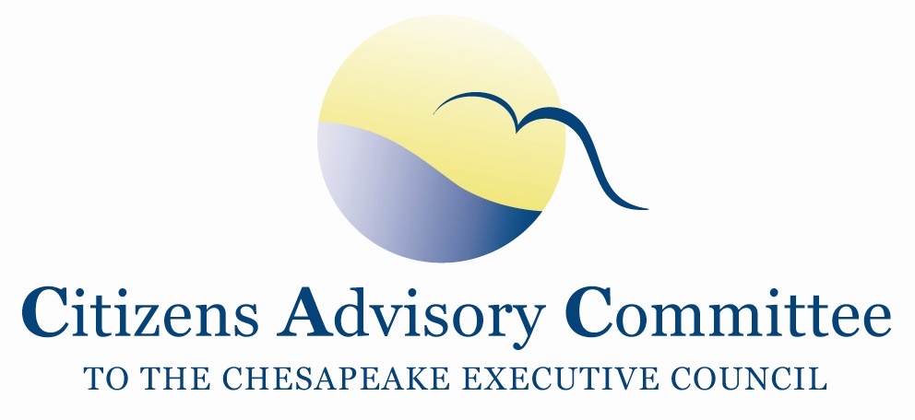
Citizens Advisory Committee
Meeting Agenda
May 23-24, 2018

______________________________________________________________________________________________________________________________________

Lancaster Marriott at Penn Square
25 S Queen Street
Lancaster, PA 17603

Meeting Goals:
(1) Discuss CAC Priority on Forest Buffers;
(2) Expand members’ learning on Diversity Equity and Inclusion;
(3) Select three topics for CAC’s Annual Report of Recommendation to the Executive Council.

Wednesday, May 23- Hickory Room

11:00 a.m. Call to Order………………………………………………………….…..Paula Jasinski, Chair
- Introduction of Members and Guests
- Opening Remarks about the meeting and objectives

11:10 a.m. Updates from PA DEP……………………………….....…………….………….….Nicki Kasi
Chesapeake Bay Program Manager,
PA Department of Environmental Protection
- Phase III Watershed Implementation Plan (WIP) outreach meetings on local planning goals
- Plans for Best Management Practice (BMP) verification in Phase III WIP

11:50 p.m. Lunch- Commonwealth Ballroom
Luncheon and Plenary Session with Choose Clean Water Conference
Topic: Diversity, Equity and Inclusion…………………………………….………Nicole Lee
1:00 p.m. Reconvene in Meeting Room
Reflections on lunch topic

1:15 p.m. Chesapeake Bay Program Updates……………………………………..………….Jim Edward
Acting Director, EPA Chesapeake Bay Program
- EPA Expectations for Phase III WIPs
- Topics for Annual Executive Council Meeting
- Next steps on BMP verification

2:00 p.m. Achieving Equity across the Chesapeake Bay Watershed
Join Choose Clean Water Conference Session……………….......………..Vernice Miller Travis

Choose Clean Water Coalition and the Chesapeake Bay Funders Network are collaborating on the development of a Diversity, Equity, and Inclusion Plan for the Chesapeake Bay community.
This session will reveal the self-assessment survey results of strengths and challenges from Coalition members, grant-makers and grantees. The talk will include how individual organizations, the Coalition, and the Funders Network as a whole should approach this important work.
3:30 p.m. Forest Buffers 101…………………..…………………………Matt Ehrhart, CAC Vice-Chair
Stroud Water Research Center
- Background and Goals
- Progress and Challenges
- Opportunities and Initiatives

4:45 p.m. CAC Member Discussion

5:00 p.m. Meeting Recess

6:30 p.m. Dinner and Reception hosted at Pat Levin’s House
Members continue to discuss local river and Chesapeake Bay issues in an informal setting

Thursday, May 24- Hickory Room
Breakfast will be served in the meeting room starting at 8:00am.

8:30 a.m. Working Breakfast
Call to Order…………………………………………………….…….…..Paula Jasinski, Chair
Business Meeting
- Approve February 2018 Meeting Minutes
- Review CAC’s actions since last meeting
- Review of CAC’s 2018 Priorities

9:00 a.m. Farm Bill, Chesapeake Bay Watershed, and Technical Assistance…………....Ann Swanson
Executive Director, Chesapeake Bay Commission

10:00 a.m. CAC Member Discussion
- Announcements
- CAC Member Updates
- Review of Past CAC Recommendations to Executive Council

10:45 a.m. Break

11:00 a.m. CAC Discussion: Annual Recommendations for the Executive Council

11:45 a.m. Wrap-up
What are the findings and action items for the discussion?
How can CAC engage on these topics after the meeting?
Ideas for September CAC Meeting Agenda in VA

12:00 p.m. Adjourn
Next CAC Meeting is September 5-6, 2018 in Virginia, location TBD.

