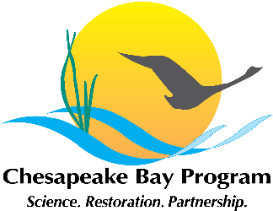

Actions and Decisions
Management Board Meeting
December 10, 2015

ORD Safe and Sustainable Resources Research Program
Action: Agreed to send a note to the MB and PSC about the December 16, 2016 webinar on “Ecosystem Services Approaches to Restoring a Sustainable Chesapeake Bay and its Tributary Watersheds.” The webinar is being hosted by EPA’s Office of Research and Development. Completed 12/11/15.

Department of Education Participation in the CBP
Action: CBP staff will draft a letter to go out under the EC chair’s signature to the US Department of Education Secretary requesting the Department to increase its participation in CBP related programs. CBP staff will work with the PSC chair to refine it. In progress.

Budget and Finance Workgroup
Decision: The Management Board tabled the proposal for creating a new budget and finance workgroup under the Partnering and Leadership and Goal Implementation Team and remanded it to GIT 6 to refine the scope and charge. MB members who would like to participate in the discussion should contact Samantha Watterson. The refined proposal should be ready for discussion at the January MB meeting. On January 14 agenda for further action.

Communication Strategy for Agreement Workplans
Action: Agreed to proactively send out the draft workplans to the Management Board in addition to targeted stakeholders. Will be sent by February 1.
Decision: Agreed to modify the targeted public input format to list only the management approach and the associated key actions (not the steps) for each, along with a comment box.
Decision: Agreed that for each key action in the workplans, we will identify the partners who are participating in that action and the goal teams will identify a lead for those actions where appropriate.
In progress.

Next meeting
Action: CBP staff will work with the authors of the EPA Office of Research and Development’s webinar on Ecosystem Services Approaches to Restoring a Sustainable Chesapeake Bay and its Tributary Watersheds (noted above). The presentation will discuss an EPA project that explored means of reducing the costs of meeting the TMDLs for nitrogen, phosphorus and sediment, while at the same time promoting the creation of restoration of “bonus” ecosystem services not related to water quality in the Bay. The presentation should be on the January or February 2016 meeting agenda. For a future meeting.

