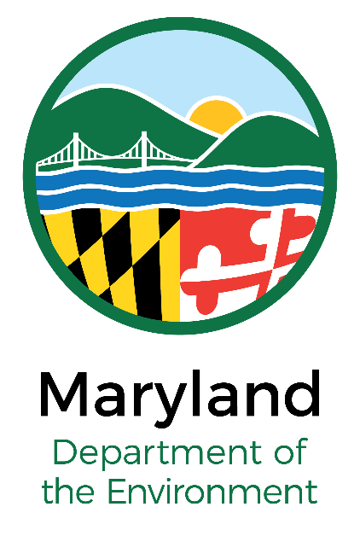

MS4/Chesapeake Bay TMDL/Trust Fund
Restoration Project
Wetlands & Waterways Permit Package Check List
Check One ___ Government Agency ___ Non-profit Partner
Other
(Cover To Be Printed on Green-Colored Paper)
Enhancement/Restoration Project Permit Checklist

- Application Submittal Date:

- Project Purpose (please check all that apply)

MS4 Permit Work WIP Implementation Trust Fund Project

- Restoration Activities (please check all that apply)

Stream Restoration Wetland Restoration Stormwater BMP

Other ________________

- Waiver of Alternatives Analysis:
For voluntary restoration projects associated with achieving local Municipal Separate Storm Sewer System (MS4) targets or Chesapeake Bay Total Maximum Daily Load (TMDL) goals, the alternatives analysis is waived based on the submission of watershed implementation plan (WIP) materials documenting the project location as a priority for restoration.

This submission includes relevant materials from the following document verifying that the project is an MS4/Chesapeake Bay TMDL-related restoration project:

Watershed Implementation Plan Comprehensive Watershed Assessment

Design Report Other__________________

- Demonstration of Functional Impairment of the site/aquatic resource(s):

The current conditions of streams, wetlands or other aquatic resources where restoration or enhancement projects are proposed must be assessed and meet degradation criteria for both the existing biological function-based parameter AND the existing geomorphology/hydraulic function-based parameter. Applicants must include documentation (e.g., photographs and data sheets from filed assessments) demonstrating that the following degradation criteria have been met:

Streams

- Perennial Streams:

1. Biological Function-Based Parameter: A Benthic Index of Biotic Integrity (BIBI) score of fair or worse (i.e., BIBI score of 50% or less); AND
2. Geomorphology/Hydraulic Function-Based Parameter: Documentation of existing stream conditions for at least one of the following:
a) Lateral Stability: Geomorphic evidence of active, widespread lateral erosion (e.g., Bank Erosion Hazard Index/Near Bank Stress score of Moderate/Moderate or higher or an annual bank erosion); OR
b) Floodplain Connectivity (Vertical Stability): Evidence of floodplain disconnection throughout the majority of the reach (e.g., bank height ratio, entrenchment ratio, stage/Q relationship, Hydrologic Engineering Center River Analysis System or other hydraulic model); OR

c) Other: Other appropriate, MDE-acceptable metric that demonstrates water quality impairment and stream stability degradation of the project reach.

- Intermittent Streams

1. Biological Function-Based Parameter: A Modified EPA Rapid Bioassessment Protocol Habitat Assessment score of marginal to poor AND
2. Geomorphology/Hydraulic Function-Based Parameter: Documentation of existing stream conditions for at least one of the following:
a) Lateral Stability: Geomorphic evidence of active, widespread lateral erosion (e.g., Bank Erosion Hazard Index/Near Bank Stress score of Moderate/Moderate or higher or an annual bank erosion rate of greater than 0.1 foot/year); OR
b) Floodplain Connectivity (Vertical Stability): Evidence of floodplain disconnection throughout the majority of the reach (e.g., bank height ratio, entrenchment ratio, stage/Q relationship, Hydrologic Engineering Center River Analysis System or other hydraulic model); OR
c) Other: Other appropriate, approved metric that demonstrates water quality impairment and stream stability degradation of the project reach.

Other Aquatic Resource(s)

1. Description of biological degradation of the resource(s) AND
2. Description of Geomorphology/Hydraulic Function degradation.

SUMMARY TABLE/DEGRADATION

Streams

Stream Perenniality: Perennial Intermittent

Function | Measure | Score | Impaired? (Y/N)
Biological
Geomorphological

Other Aquatic Resource(s)

Function | Measure | Description of Degradation
Biological
Geomorphological/Hydraulic

- Impacts/Conversions/Enhancements

MDE recognizes that functional uplift of aquatic resources at a restoration project site may involve some conversions of wetlands and/or streams to uplands, some conversions of wetland community types, some conversions of streams to open waters or wetlands, some conversion of forest cover, and/or some conversions of wetlands to other aquatic habitat type. Applicants must quantify, to the extent practicable, and document the nature and extent of expected conversions associated with the restoration project. In the permitting of these restoration projects, MDE will operate under the presumption that compensatory mitigation will not be required, provided that: (1) the applicant demonstrates (and MDE agrees) that there is a net increase in aquatic resource functions and/or services at the project site (i.e., environmental benefit); and, (2) any conversions that do occur will not exceed the Conversion Thresholds, as defined under the Corps of Engineers Bay TMDL RGP of July 1, 2015 and will not result in impacts to non tidal wetlands of special state concern, State or Federally listed Rare, Threatened or Endangered Species or ambient thermal regimes in temperature sensitive streams.

For situations where expected conversions associated with a MS4/Chesapeake Bay TMDL-related restoration project exceed the Corps Bay TMDL RGP conversion thresholds, MDE affirms that if the applicant is able to document (and MDE agrees) that there is a functional uplift to the aquatic resource at the project site between existing and proposed conditions, that such projects will not require mitigation PROVIDED that the applicant demonstrates (and MDE agrees) that there is no practicable option that achieves the same or substantially similar degree of functional uplift with a lesser degree of conversions. Absent such a demonstration, MDE will, on a case-by-case basis, consider the need for some level of Compensatory Mitigation.

Summarize impacts/conversions/enhancements below:

a. Summary of the amount and type of resource conversions:

Existing |  | Post-Restoration
Stream Length |  | Stream Length
Wetland Acreage |  | Wetland Acreage

b. Narrative and/or tabular description (summary form) of the expected functional uplift (environmental benefit) that is expected from the project (see case studies for examples of narrative summaries).

c. If conversions exceed Corps Thresholds in the July 1, 2015 TMDL RGP, describe whether there is a practicable option that achieves the same or substantially similar degree of functional uplift (environmental benefit) with a lesser degree of conversions and the basis for the applicant’s decision as to whether there is a practicable alternative.

If there is a practicable option with a lesser degree of conversions for the same or substantially similar degree of functional uplift, and the applicant is choosing not to adopt this option, the applicant may be required to submit a proposal for mitigation.

- Monitoring
The applicant recognizes the necessity of project monitoring for stability and commits to conducting project stability monitoring for a period of 5 years beyond the construction of the project, providing MDE with a report documenting the stability and/or adaptive management actions taken to ensure continued stability, on an annual basis.

Signature of applicant:

Date:

