MDHWA Menti Session Results

Summary:

Climate and riparian forests were the most popular topics submitted for candidate metrics. Members are interested in summarizing data at multiple scales, improving coordination between restoration and protection efforts.

What factors should we investigate as candidate health, vulnerability, and resiliency metrics in the MD HWA?

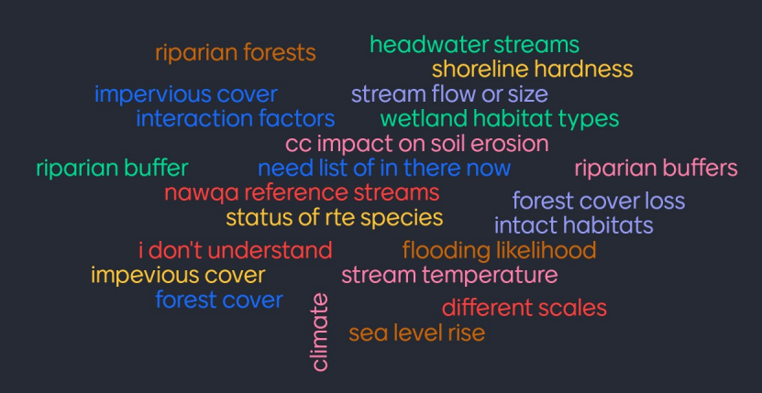

- Stream temperature
- Impervious cover
- Riparian forests
- Forest cover
- Status of RTE species
- Climate
- Riparian buffer
- Sea level rise
- Stream flow or size
- Headwater streams
- Riparian buffers
- Different scales
- Shoreline hardness
- Forest cover loss
- Wetland habitat types
- Flooding likelihood
- CC impact on soil erosion
- NAWQA reference streams
- Intact habitats
- Interaction factors

How could this assessment be customized for your jurisdiction? Provide examples.
- I would rather ask around my agency and other agencies. There are several opportunities for story boards for different purposes.
- Currently having trouble identifying public land to target for restoration or conservation through private donors
- improved coordination between restoration and protection efforts
- use of local/state funds (ballot measures)
- allow user to summarize the health watershed data by other boundaries such as counties
At what scale would this be most useful?
Choices | Votes
Chesapeake Bay Watershed Wide | 3
State/Commonwealth | 1
County | 4
NHD Catchment | 5
Other | 1

