Standardization of Terminology Recommendations for Microplastic Ecological Risk Assessments in the Chesapeake Bay and its Watershed

Tetra Tech
November 4, 2020

Introduction and Purpose
Plastic debris adversely affects aquatic and terrestrial organisms as a physical entanglement hazard, source of gastrointestinal blockage, and potential for toxicity/ adverse biological effects following uptake of smaller pieces through oral ingestion, inhalation/gills, or contact with external body surfaces. Signs of toxicity potentially occur following uptake of chemical ingredients associated with plastic degradation or via environmental chemicals like hydrophobic persistent, bioaccumulative, and toxic (PBT) chemicals that tend to sorb to plastic debris. EPA conceptualized a summary of these pathways and complexities regarding plastic exposure and potential adverse outcomes (Figure 1) in their Microplastics Expert Workshop Report (EPA 2017).
Plastic trash and its breakdown products are found in many terrestrial and aquatic habitats including fresh, estuarine, and marine waters. These plastics typically occur as the result of two broad sources-- primary and secondary microplastics. Primary microplastics are intentionally designed as small particles for use in industrial applications (ex.“nurdles”, small plastic pellets used as raw material to produce plastic goods) or consumer product ingredients (ex. abrasives in cosmetics, personal care products, and cleaners). Secondary microplastics occur as fragments or fibers from the breakdown of larger debris like water bottles, plastic bags, and single use food packaging.
The term “macrolitter” was first discussed in 2003 to describe plastic debris found in marine environments ranging in size from 63-500 µm (Gregory and Andrady 2003) and “microplastic” was introduced by Thompson et al. (2004) to describe the small pieces of plastic found in marine waters (Thompson et al. 2004). Subsequent efforts to consistently define microplastics have yet to result in a robust, specific definition, or method for consistently describing them. Plastics constitute a complex and diverse group of substances that vary in size, shape, color, composition, source, age, along with other physical or chemical factors. These variables further increase in natural ecosystems as plastics weather and degrade, where they potentially release chemicals like phthalates and bisphenol A, serve as an absorptive surface for chemical contaminants like PCBs, and develop colonies of biofilm that are consumed by aquatic organisms.
Microplastic research addresses a range of scenarios including many aquatic organisms or plastic types and the field is rapidly evolving. It is useful to consider meaningful ways to define, categorize, and measure it in order to interpret and compare study results. The purpose of this document is to describe and recommend a uniform size classification and concentration unit terminology for microplastics and apply it to the parallel effort to develop an environmental risk assessment (ERA) framework and eventual monitoring plan for microplastics in the tidal Potomac River. It is understood that classification of microplastics is very complex continuously evolving. Many researchers acknowledge the need to classify beyond only particle size. While this document briefly acknowledges other classification factors, it is not intended to serve as an exhaustive resource for microplastic classification based on multiple factors. Rather, the current focus is to provide context for size and concentration unit terminology used in the ERA framework, which will identify data gaps and serve as a basis for conducting future research on microplastics in the Chesapeake Bay and watershed. The proposed terminology is recommended to standardize monitoring and research efforts to inform future iterations of this ERA or ERAs focused on other endpoints.
This document provides the next steps to addressing urgent needs recommended by the STAC following the April 2019 workshop, Microplastics in the Chesapeake Bay and its Watershed: State of the Knowledge, Data Gaps, and Relationship to Management Goals--
The Scientific, Technical Assessment and Reporting Team should incorporate development of ERAs of microplastics into the CBP strategic science and research framework, and the Plastic Pollution Action Team should oversee the development of the Ecological Risk Assessments (ERAs) focused on assessment of microplastic pollution on multiple living resource endpoints.
STAC should undertake a technical review of terminology used in microplastic research, specifically size classification and concentration units, and recommend uniform terminology for the CBP partners to utilize in monitoring and studies focused on plastic pollution in the bay and watershed.

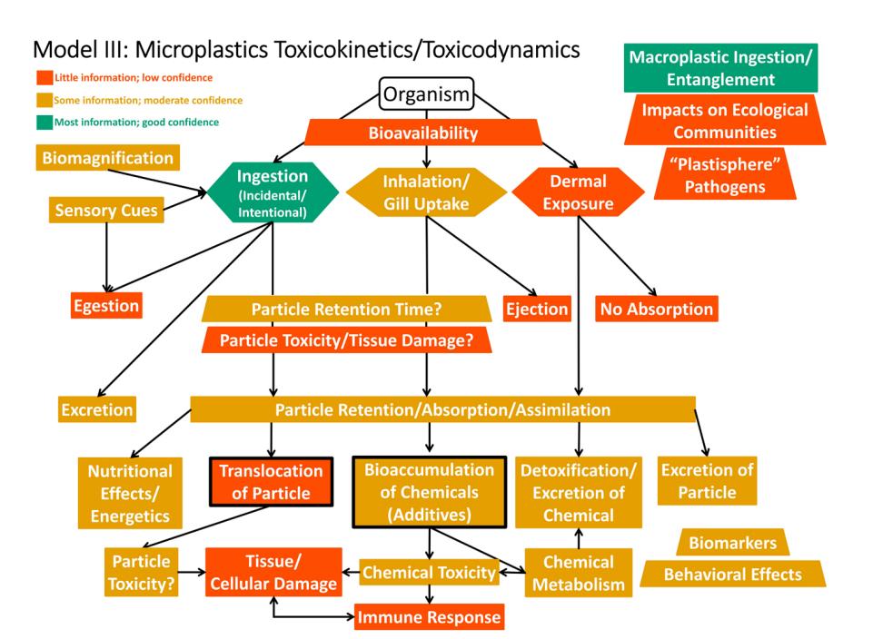
Figure 1. Conceptual model describing pathways and complexities regarding plastic exposure and potential outcomes (from EPA 2017)

Classification of Microplastics
Size, shape, density, composition, color, age, or a combination of several of these factors are frequent descriptors in the results of microplastics research. The purpose of this section is to describe current recommendations for size classifications of microplastics and briefly discuss other physical/chemical properties that may be important to consider in future ERA and monitoring efforts. Recent literature suggests that scrutiny of a single attribute is perhaps too simplistic of a view for drawing conclusions about the entire field of microplastics. However, size is expected to significantly influence the bioavailability of plastic fragments and dictate whether they are ingestible, inhalable/callable of interaction with gills, or able to cross cellular membranes. Thus, understanding implications of size and standardizing the terminology used to describe that parameter are important for moving forward with research that produces results that are comparable between studies. New studies are continually emerging, and evidence related to other individual attributes are building blocks that will improve future insight regarding ecological effects associated with the conglomeration of environmentally relevant mixtures of plastic particles.

Size
Grouping environmental plastics by size (at least in part) is one method to reduce complexity, understand exposure, and organize the universe of microplastics (Arthur et al. 2009, Hartmann et al. 2019). Particle size is one factor that determines environmental fate and ecological relevance of plastic fragments and serves as a logical method for regulatory agencies to implement guidelines, as in the Microbead-Free Waters Act of 2015 which provided a plan for phasing out microbeads in cosmetics and personal care products.
The terms most frequently used to describe size of environmental plastics include megaplastics, macroplastics, mesoplastics, microplastics, and nanoplastics. These group names and corresponding sizes are not consistently applied across all studies, as demonstrated in the review by Hartmann et al. (2019) (Figure 2). The use of ambiguous and potentially conflicting definitions causes challenges in the interpretation and comparison among studies. For example:
- Macroplastic sizes have been defined as 1-15 cm (10-150mm), >5mm and anywhere from 2.5 to 100 cm (25-1,000mm).
- Mesoplastics generally refer to a small range of sizes between 1-25mm.
- Microplastics have been defined as 67-500 µm, 1-5000 µm, 20-5000 µm, or more broadly as <5,000 µm (the definition supported by NOAA).
- Nanoplastics have included sizes ranging from an upper limit of <20 µm to as small as 1nm.
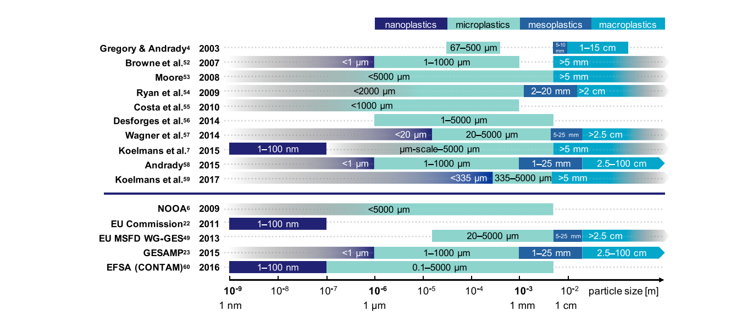
Figure 2. Examples of differences in the categorization of plastic debris according to size as applied (an/or defined) in scientific literature and in institutional reports (not exhaustive). From Hartmann et al 2019.
Primary microplastics are often produced with discreet sizes to fulfil a specified purpose. Nurdles, the pelletized plastics used by manufacturers, have been reported as 5mm in diameter with a weight of 20 mg each (Hammer et al. 2012). Microplastics used in cosmetics are much smaller but are being phased out of production and use in many products including rinse-off cosmetics and toothpaste (Moore 2008, Duis and Coors 2016, Wardrop et al. 2016). However, upon entry into the environment, primary plastics break down to smaller becoming secondary plastics. Even with the decreased production of certain primary microplastics, those previously released are likely to persist in the environment (Besseling et al. 2017).
Size classification efforts of plastic fragments generally fall into three categories, influenced by the desire to capture 1) biological relevance of plastic pieces; 2) limitations of sampling or analytical detection capabilities; 3) a consistent naming framework.
The outcome of an international research workshop organized by NOAA defined microplastics as pieces of plastic less than 5mm in length, with the rationale that 5mm and smaller are those most likely to be ingested by animals and potentially cause adverse biological effects beyond physical blockage of the gastrointestinal tract (Arthur et al. 2009). It was agreed that setting a lower boundary for microplastic size was not appropriate but acknowledged that 333 µm was a practical lower boundary due to sampling equipment limitations. Mesh neuston nets with size of 333 µm are commonly employed in the collection of plankton and floating debris, thus plastics smaller than that mesh size are not necessarily captured during sampling (Hidalgo-Ruz et al. 2012). The use of sampling equipment with this lower limit is illustrated by two studies that quantified microplastics in the Chesapeake Bay and four estuarine river tributaries. In both cases, researchers used manta trawl nets to capture and reported microplastic fragments as those ranging from 0.3-5.0 mm (Yonkos et al. 2014, Bikker et al. 2020).
The Joint Group of Experts on the Scientific Aspects of Marine Environmental Protection (GESAMP) recommended a system of size classification that encompasses the range of mega to nanoplastics (Table 1) (GESAMP 2015). In two global assessment reports (GESAMP 2015, 2016), they recommended that all particles <5mm should be included in an assessment of sources along with fate and effects of microplastics because using a different cutoff could exclude data from some pertinent published studies.
Table 1. Size classification as recommended by GESAMP.
Terminology | Size Classification
Megaplastics | >1 m
Macroplastics | 25-1000 mm
Mesoplatics | 5-25 mm
Microplastics | <5 mm
Nanoplastics | <1 µm

Frias and Nash, 2019 reviewed current and previous methods for describing microplastics and proposed a definition that includes size and origin along with other chemical and physical properties. The authors define microplastics as “synthetic solid particle of polymeric matrix, with regular or irregular shape and with size ranging from 1 µm to 5 mm of either primary or secondary manufacturing origin, which are insoluble in water” (Frias and Nash 2019).
Hartmann et al. (2019) also reviewed current studies and provided recommendation for a framework of unified terminology for size but cautioned that categorizing plastic debris using one component, such as size, may result in oversimplification and suggest similarity between microplastics when it may not exist. The authors note that plastics within the same category may still differ widely because of their differences in hazardous properties or environmental behavior. However, their recommended size classification is shown in Table 2, and reflect consistent use of SI prefixes in the size designation of micro and nanoplastics.
Table 2. Size classification terminology recommended by Hartmann et al. (2019)
Terminology | Size Classification
Macroplastics | 1 cm and larger
Mesoplatics | 1 to 10 mm
Microplastics | 1 to <1000 µm
Nanoplastics | 1 to <1000 nm

The definition of nanoplastics is debated but has most often been described as <1000 nm (Browne 2007, Andrady 2011, Cole et al. 2011) or <100 nm (in at least one of its dimensions) as defined for non-polymer nanomaterials in the field of engineered nanoparticles (Koelmans et al. 2015).
One proposed system suggests that using a strict classification based on size is not a satisfactory approach since it does not capture the continuous nature of mixtures of environmental plastics or predict the fate of particles (Kooi and Koelmans 2019). Instead the study proposes a three-dimensional probability distribution that considers size, shape, and density. A discreet size classification system is not easily extracted from this study and is beyond the current scope of discussion.

Other Methods of Classification
This section briefly outlines other considerations that are presumably meaningful elements necessary to illustrate the relationship between microplastics and adverse ecological effects. The discussion is not intended to be exhaustive but rather serve as a point of consideration for inclusion of alternative classification methodologies that influence future ERA and monitoring activities.

Chemical composition
Chemical composition is an important identifying characteristic of microplastics. Chemical and physical properties associated with different materials influence the fate, transport, exposure, and toxicity of fragments. Common polymers described in the marine environment include the following (GESAMP 2016). Future ERA or monitoring efforts may focus on one or several types of parent materials if evidence suggests a potential for greater exposure or risk in particular organisms or ecosystems.
- ABS - Acrylonitrile butadiene styrene
- AC - Acrylic
- EP - Epoxy resin
- PA - Polyamide
- PCL - polycaprolactone
- PE (LD - low density, LLD - linear low density, HD - high density) - Polyethylene
- PET - Polyethylene terepthalate
- PGA - Polyglycolic acid
- PLA - Polylactide
- PP - Polypropylene
- PS - Polystyrene
- EPS (PSE) - Expanded polystyrene
- PU (PUR) - Polyurethane
- PVA - Polyvinyl alcohol
- PCV - Polyvinyl chloride
- PU (PUR) - Polyurethane
- SBR - Styrene-butadiene rubber

Shape or Structure
The identity of primary or secondary microplastics and their susceptibility to environmental degradation influence the ultimate shape or structure of resultant microplastics found in aquatic environments. Shape and structure also influence the fate, transport, exposure, and potential toxicity of fragments. Future ERA or monitoring efforts may focus on one or several types of shapes or structures if evidence suggests a potential for greater exposure or risk in organisms or ecosystems of interest. Those morphologies commonly described in literature include the following:
- Fibers and lines
- Fragments
- Films
- Foam
- Beads, spheres, pellets
- Spheroid
- Cylindrical

Color
Plastic is produced in all colors, including clear and translucent variations, which means that a variety of colors are observed in environmental microplastics. Color may be important in a biological context if certain colors are more likely to be mistaken for the food source of an organism. In such case, color could be considered for closer study in a future ERA or monitoring effort.

Units of Concentration
Microplastics research report measurements in a variety of media including water, sediment, fish, invertebrates, phytoplankton, and plants along with different concentration units (Figure 3). Quantification of microplastics is necessary to understand abundance in environmental matrices and develop a better correlation between exposure and effects including potential dose-response relationships in exposed organisms.
Reported microplastic units tend to vary by study and media type, causing challenges for monitoring or identification of comparisons, correlations, or trends between studies with different objectives. The 2019 Microplastics in the Chesapeake Bay and its Watershed: State of the Knowledge, Data Gaps, and Relationship to Management Goals workshop proceedings noted that inconsistencies such as the tendency to report mass/unit volume or particles/unit area in similar studies. Mixed unit estimates like these pose problems as # particles m⁻³ cannot directly correspond to aquatic surface area since the volume of water in one area may be more or less than in another of the same area (Bikker et al. 2020). Consistency in estimation of particles per unit area or volume is critical since organisms respond differentially depending on the impact measured. For example, number of particles per unit area is appropriate when measuring impact on respiration since gill area is the important factor for gas exchange. However, volumetric estimates are more appropriate for gastrointestinal studies since ingested “food” is more biologically relevant when measured by volume (although number of particles can also be relevant when assessing ingestion effects). Most microplastic analysis methods lack standardization and continue to update as new analytical technologies become available. Thus, the sampling, identification, and quantification of microplastics in different media remains inconsistent.

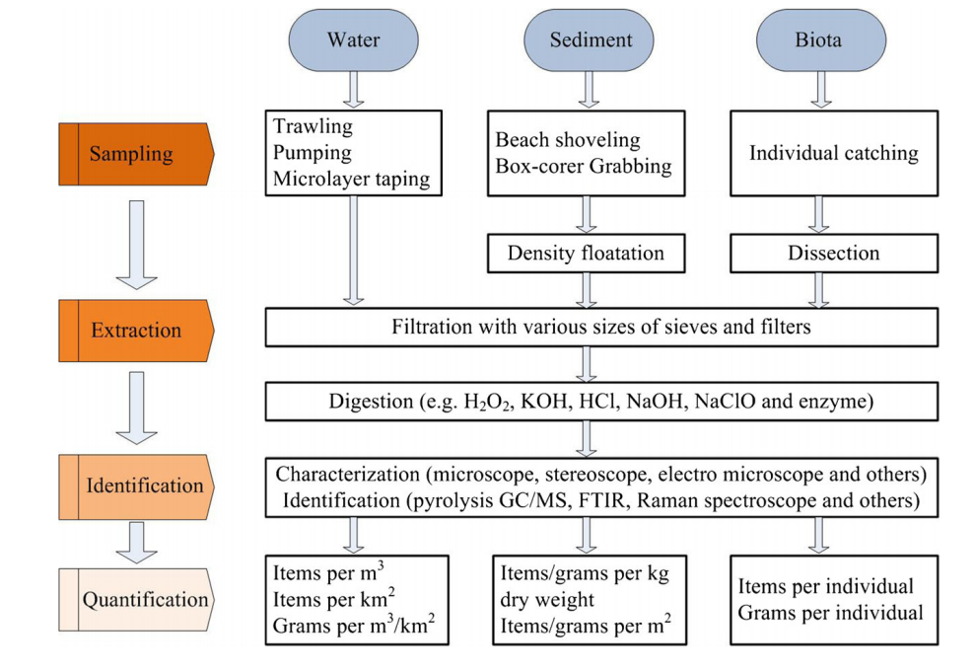
Figure 3. Analytical processes and example quantification processes in water, sediment, and biota (Mai et al., 2018)

Water Column
Surface water studies commonly measure microplastics at either a single depth profile or throughout a larger portion of the water column. Collection of plastic fragments for quantification is performed via surface water collection/filtration or by a trawl net in open water. For example, Bikker et al (2020) characterized plastic fragments from 30 water samples collected throughout the Chesapeake Bay by using a surface manta trawl with 330 µm mesh net, and reported amount as particles/m³ as a volume-based estimate and particles/km² as an area-based estimation of particles. Units used to describe the amount of microplastics in water include:
Number of particles per volume of water
- Number of particles m⁻³ ; Number of particles l⁻¹
Quantifies number of plastic particles in water by volume
This unit of measurement potentially accounts for particles throughout the water column.
Number of particles per area of water
- Number of particles m-²
Quantifies number of plastic particles on the surface area of water.
Since water, is more than area (I.e. not two-dimensional), this metric is less informative for understanding the overall amount of microplastics and may exclude particles that are lower density and not at the surface of the water column .

Sediments
Plastic fragment quantification in sediment is typically evaluated based on surface area of a specified quadrat or a volume of bulk collected sediment. Units used to describe the amount of microplastics in sediment include:
Number of particles per volume of sediment
- Number of particles l⁻¹
Quantifies number of plastic particles in sediment samples and based on a liquid volume of sediment.
- Number of particles kg⁻¹ dry weight
Quantifies number of plastic particles in sediment samples and based on dry weight of sediment.
- Number of particles kg⁻¹ wet weight
Quantifies number of plastic particles in sediment samples and based on wet weight of sediment.
Number of particles per area of sediment
- Number of particles m⁻² sediment surface
Quantifies number of plastic particles on the surface of a quadrate area of sediment.
- Mass m⁻² sediment surface
Quantifies mass of plastic particles on the surface of a quadrate area of sediment

Organisms
Microplastic uptake ingestion or gill uptake in aquatic organisms can be used to monitor microplastic contamination. Commonly monitored biota include fish, sea turtles, sea birds, bivalves and other invertebrates, and plankton. Microplastics are most frequently evaluated in the digestive tract or gills. Units used to describe the amount of microplastics in animals or their tissues include:
Number of particles per individual
The number of particles per individual is a general measurement that does not discriminate between organ or tissue as site of accumulation. It can be a useful measurement for general exposure estimates.
- Number of particles/individual
Quantifies abundance of plastic particles within a whole individual. Mass of plastics per stomach or gastrointestinal tract
- Mass of plastics in stomach
Quantifies abundance of plastic particles within stomach contents.
- Mass of plastics in GI tract
Quantifies mass of plastic particles within the entire gastrointestinal tract
Number of stomachs with particles
- Number of organisms within a study in which plastics were found
Quantifies abundance of individual stomachs in which plastic particles were observed. A very useful metric that serves as an index to selectivity of fish (Hyslop 1980, Chesson 1983, Deudero and Morales-Nin 2001, Liao et al. 2001)
Number of particles per wet or dry tissue weight
The measurement of the number or mass of microplastic relative to body mass of an organism is intrinsically useful as it provides a standardized assessment per individual. Additionally, it allows for comparisons between studies.
- Number of particles g⁻¹ wet weight
Quantifies number of plastic particles in tissue samples and based on wet weight of tissue.
- Number of particles g⁻¹ dry weight
Quantifies number of plastic particles in tissue samples and based on dry weight of tissue.
Total mass per unit of tissue
- Mass of plastics/g wet weight
Quantifies mass of plastic particles in tissue samples and based on wet weight of tissue.
- Mass of plastics/g dry weight
Quantifies mass of plastic particles in tissue samples and based on dry weight of tissue.
Number of particles in stomach or gastrointestinal tract
- Number of particles in stomach
Quantifies the number of plastic particles in the stomach of an animal.
This measurement provides insight to available plastics for ingestion and perhaps selectivity of plastic types by fish. However, it may not yield an ideal relative measure of impact given variability in size, whereby total microplastic mass may be more informative.
- Number of particles in GI tract
Quantifies the number of plastic particles in the GI tract of an animal.
This measurement shares many of the same issues as those previously described for number of particles in stomach or GI tract.
Number of particles on gill surfaces
- Number of particles/gill surface
Quantifies the number of plastic particles on or in the gill surfaces of an animal.
This methodology can potentially serve as a proxy for area of gill surface covered (and may be easier to measure than particle area)
Mass of particles on gill surfaces
- Mass of plastics/ gill surface
Quantifies the mass of plastic particles on or in the gill surfaces of an animal.
This is biologically informative measurement as gill surface area is critical for sufficient respiration (Avio et al. 2015)

Submerged Aquatic Vegetation Habitat
Number of Particles per Area of Blade/volume of plant canopy
- Number of particles cm⁻² of plant surface area
Quantifies the number of particles attached to plant surface.
Can be used to assess impacts directly to plant health or as pathway for organisms feeding on plant tissue or surface (Goss et al. 2018)
- Number of particles l⁻¹ of samples SAV canopy
If comparing the canopy filtration of particles, then a volumetric approach is more robust as one would be comparing # particles per volume of canopy sampled vs nearby similar volume of unvegetated water column (Murphy 2019).

Summary
- Microplastic classification remains complex and a unified classification/ descriptive system is still young and it may be necessary to reconsider size and concentration units as research needs develop.
- It is not possible to exhaustively consider all chemical and physical properties in the current effort because microplastics encompass a diverse group of materials with different physical/chemical properties along with fate, transport, and bioavailability characteristics.
- The upper cutoff for microplastics in most contemporary literature or recommendations is either 5mm or 1mm. The use of 5mm has been acknowledged for its biological relevance in terms of potential uptake and is also the upper limit reported by two Chesapeake Bay studies. The designation of 1mm (1000 µm) is convention driven and consistent with SI prefix “micro” but not necessarily consistent with results of current research. Constraining the definition to 1mm potentially leaves out biologically/ecologically relevant sizes that can be termed conceptually as “micro”.
- Concentration units tend to vary by type of media investigated but are most generally reported (ex. water, sediment, tissue, etc) as mass/unit volume or particles/unit. The use of standardized terminology is necessary for the Chesapeake Bay Program and its partners to implement consistent monitoring and research in the bay and its watershed.

Recommendations

5.1. Size Classification for ERA and Future Research and Monitoring
- For the purposes of the ERA we recommend defining a microplastic as <5mm, as consistent with the recommendations of NOAA and the GESAMP observation that all particles <5mm should be included in an assessment to ensure that data from pertinent published studies are not excluded. Two microplastic monitoring studies in the Chesapeake Bay and tributaries were consistent in reporting results with 5 mm as the upper cutoff (Bikker et al. 2020, Yonkos et al., 2014). Thus, using a 1 mm cutoff would mean that two highly relevant studies might be excluded or cause a point of uncertainty. While 1 mm is a more clear-cut representation of the SI prefix “micro,” and arguably more appropriate in the sense of a naming convention, 1 mm and 5 mm represent the same order of magnitude. The inclusion of plastic particles up to 5mm does not represent an order of magnitude change compared to 1 mm, is noted for biological relevance, and if included is unlikely to cause a significant change in the overall outcome of the ERA.
- The lower limit of microplastics research is often functionally constrained by limitations of sampling technology. In the case of Chesapeake Bay and tributary studies, researchers used manta trawl nets to capture and report microplastic fragments with a lower limit of 333 µm (Bikker et al. 2020, Yonkos et al., 2014). However, this field sampling limit should not prohibit the inclusion of laboratory data in the ERA that include microplastic particles smaller than 333 µm but greater than the defined size of nanoplastics.
- The lower limit of microplastic monitoring in the Chesapeake Bay would likely be limited to existing sampling equipment, i.e. 330um. For the purposes of this assessment, the definition of nanoplastics is recommended as 1 to <1000 nm, which is consistent with the SI naming convention and also inclusive of the alternative definition of <100 nm as defined for non-polymer nanomaterials in the field of engineered nanoparticles (Koelmans et al. 2015, Besseling et al. 2017). These compounds are not yet monitored in the Chesapeake Bay, tidal Potomac or in many species of interest, which leaves uncertainty about their ecological relevance.

Classification | Size | Rationale
Microplastic | 5 mm - 1000 nm (1µm) | --NOAA and GESAMP precedence  --Upper size limit is consistent with previous monitoring studies in Chesapeake Bay and tributaries  --Use of 333 µm as a lower bound potentially excludes the inclusion of laboratory or monitoring studies that include data below that value  -- The lower size limit is consistent with the SI naming convention.
Nanoplastic | 1 nm - <1000 nm (1µm) | --The upper limit is consistent with the SI naming convention.  --Limit is inclusive of particles <100 nm as defined for non-polymer nanomaterials in the field of engineered nanoparticles  -- The lower size limit is consistent with the SI naming convention.

5.1. Units of Measurement for Future Research and Monitoring
- Water: Number of particles m⁻³ ; Number of particles l⁻¹ which quantifies number of plastic particles in water by volume is recommended for standardized monitoring strategies in the Chesapeake Bay and watershed. This unit of measurement potentially accounts for particles throughout the water column, including those at the surface.
- Sediment: The number of particles in sediment should be measured volumetrically since organisms exist in a three-dimensional environment within the sediment. The exception to this would be to assess abundances of microplastics on the sediment surface as this region is exploited by a variety of errant polychaetes, crustaceans, and benthic fish.
- Organism: The mass of particles per individual is a general measurement that does not discriminate between organ or tissue as site of accumulation and accounts for an organism’s total exposure to microplastics. This measurement may serve as an informative tool for monitoring the prevalence of microplastic accumulation in organisms. This approach has advantages from a toxicology/risk standpoint.

- SAV: Measuring microplastics within SAV beds mostly depends on the research objectives. The most common measurement would assess the area covered on blades of plants. Goss et al (2018) reported # particles blade ⁻¹ which provides insight to loadings. However, area covered by microplastic particles is more biologically relevant because a) area of microplastics will block the surface of blades from sunlight, and b) larger particles can potentially be consumed by grazers, therefore area estimates can serve as a proxy for mass (as recommended above). One exception to this recommendation is in the case of studies that are comparing SAV bed metrics (e.g. canopy capture of microplastics) to similar conditions elsewhere, which would entail measuring # particles unit volume⁻¹.

References

Andrady, A. L. 2011. Microplastics in the marine environment. Marine Pollution Bulletin 62:1596-1605.
Arthur, C. D., J. Baker, and H. Bamford. 2009. Proceedings of the International Research Workshop on the Occurrence, Effects, and Fate of Microplastic Marine Debris. September 9-11, 2008, University of Washington Tacoma, Tacoma, WA, USA. U.S. Department of Commerce, National Oceanic and Atmospheric Administration, NOAA Marine Debris Program, Silver Spring, MD.
Avio, C. G., S. Gorbi, M. Milan, M. Benedetti, D. Fattorini, G. d'Errico, M. Pauletto, L. Bargelloni, and F. Regoli. 2015. Pollutants bioavailability and toxicological risk from microplastics to marine mussels. Environmental Pollution 198:211-222.
Besseling, E., J. T. K. Quik, M. Sun, and B. Koelmans. 2017. Fate of nano- and microplastic in freshwater systems: A modeling study. Environmental Pollution 220:540-548.
Bikker, J., J. Lawson, S. Wilson, and C. Rochman. 2020. Microplastics and other anthropogenic particles in the surface waters of the Chesapeake Bay. Marine Pollution Bulletin 156:111257.
Browne, M. A. 2007. Environmental and biological consequences of microplastic within marine habitats.
Chesson, J. 1983. The estimation and analysis of preference and its relationship to foraging models. Ecology 64:1297-1304.
Cole, M., P. Lindeque, C. Halsband, and T. S. Galloway. 2011. Microplastics as contaminants in the marine environment: A review. Marine Pollution Bulletin 62:2588-2597.
Deudero, S., and B. Morales-Nin. 2001. Prey selectivity in planktivorous juvenile fishes associated with floating objects in the western Mediterranean. Aquaculture Research 32:481-490.
Duis, K., and A. Coors. 2016. Microplastics in the aquatic and terrestrial environment: sources (with a specific focus on personal care products), fate and effects. Environmental Sciences Europe 28:1-25.
EPA, U. S. 2017. Microplastics Expert Workshop Report.
Frias, J., and R. Nash. 2019. Microplastics: finding a consensus on the definition. Marine Pollution Bulletin 138:145-147.
GESAMP. 2015. Sources, Fate and Effects of Microplastics in the Marine Environment: A Global Assessment. International Maritime Organization, London, UK.
GESAMP. 2016. Sources, Fate and Effects of Microplastics in the Marine Environment: Part 2 of a Global Assessment. International Maritime Organization, London, UK.
Goss, H., J. Jaskiel, and R. Rotjan. 2018. Thalassia testudinum as a potential vector for incorporating microplastics into benthic marine food webs. Marine Pollution Bulletin 135:1085-1089.
Gregory, M. R., and A. L. Andrady. 2003. Plastics in the marine environment. Plastics and the Environment 379:389-390.
Hammer, J., M. Kraak, and J. Parsons. 2012. Plastics in the Marine Environment: The Dark Side of a Modern Gift. Reviews of Environmental Contamination and Toxicology 220:1-44.
Hartmann, N. B., T. Hüffer, R. C. Thompson, M. Hassellöv, A. Verschoor, A. E. Daugaard, S. Rist, T. Karlsson, N. Brennholt, and M. Cole. 2019. Are we speaking the same language? Recommendations for a definition and categorization framework for plastic debris. ACS Publications.
Hidalgo-Ruz, V., L. Gutow, R. C. Thompson, and M. Thiel. 2012. Microplastics in the Marine Environment: A Review of the Methods Used for Identification and Quantification. Environmental Science & Technology 46:3060-3075.
Hyslop, E. J. 1980. Stomach contents analysis- A review of methods and their application. Journal of Fish Biology 17:411-429.
Koelmans, A. A., E. Besseling, and W. J. Shim. 2015. Nanoplastics in the aquatic environment. Critical review. Pages 325-340 Marine anthropogenic litter. Springer, Cham.
Kooi, M., and A. A. Koelmans. 2019. Simplifying microplastic via continuous probability distributions for size, shape, and density. Environmental Science & Technology Letters 6:551-557.
Liao, H., C. L. Pierce, and J. G. Larscheid. 2001. Empirical assessment of indices of prey importance in the diets of predacious fish. Transactions of the American Fisheries Society 130:583-591.
Moore, C. J. 2008. Synthetic polymers in the marine environment: A rapidly increasing, long-term threat. Environmental Research 108:131-139.
Murphy, R. F. 2019. Microplastic Occurrence in Aquatic Vegetation Beds in Tidal Waters of Washington, D.C., Tetra Tech, Owings Mills, MD.
Thompson, R. C., Y. Olsen, R. P. Mitchell, A. Davis, S. J. Rowland, A. W. John, D. McGonigle, and A. E. Russell. 2004. Lost at sea: where is all the plastic? Science(Washington) 304:838.
Wardrop, P., J. Shimeta, D. Nugegoda, P. D. Morrison, A. Miranda, M. Tang, and B. O. Clarke. 2016. Chemical pollutants sorbed to ingested microbeads from personal care products accumulate in fish. Environmental Science & Technology 50:4037-4044.
Yonkos, L. T., E. A. Friedel, A. C. Perez-Reyes, S. Ghosal, and C. D. Arthur. 2014. Microplastics in four estuarine rivers in the Chesapeake Bay, USA. Environmental Science and Technology 48:14195-14202.

