Chesapeake Bay Program
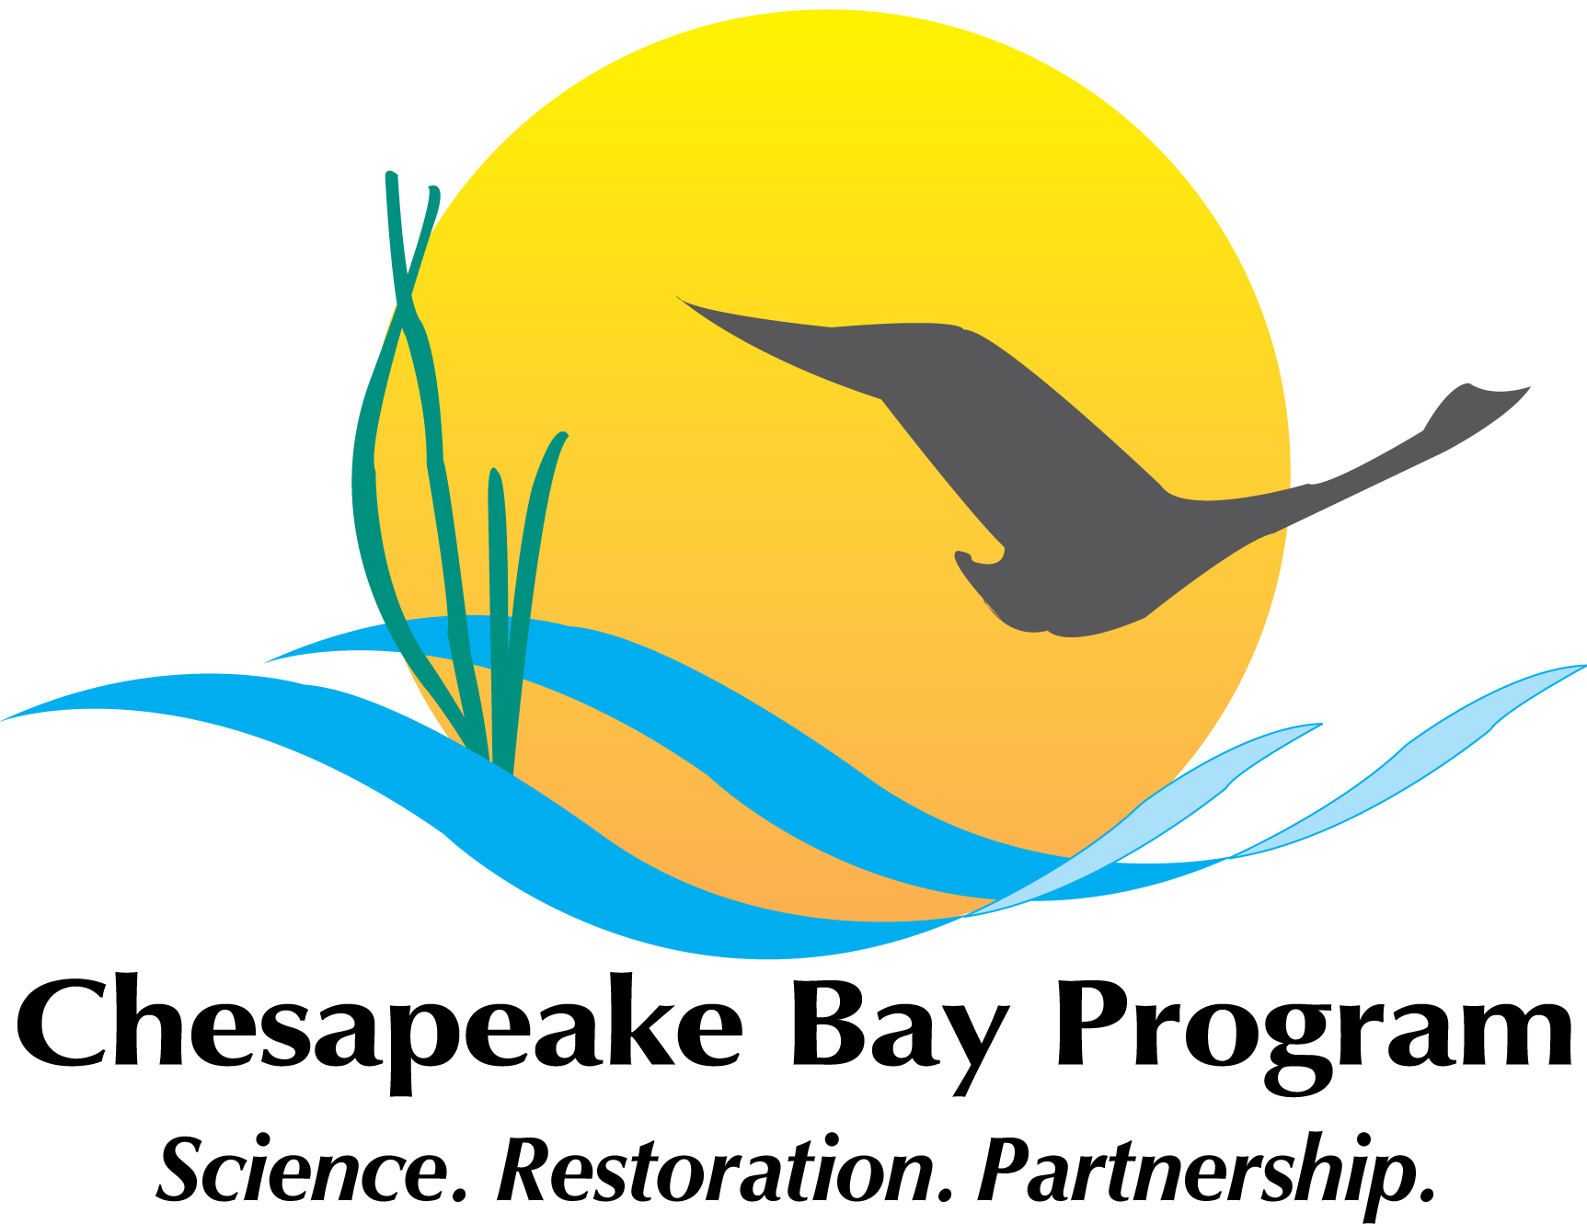
Plastic Pollution Action Team
Monitoring Workgroup Meeting #1
January 4, 2022
10:00am – 11:00 am

Join with Google Meet
meet.google.com/kau-mqdi-jfq
Join by phone
(US) +1 347-708-3191 (PIN: 457871625)
*New to GoToMeeting? Get the app now and be ready when your first meeting starts:
https://global.gotomeeting.com/install/989295277
**************************

AGENDA

010:00 Introductions
Matt Robinson (DOEE) – PPAT Chair

10:05 Review of December 2021 PPAT Meeting Action Items
Matt Robinson (DOEE) - PPAT Chair

10:15 Discussion on monitoring program designs and needs (including analytical equipment)
Kelly Somers (EPA) – PPAT Vice-Chair, and Matt Robinson (DOEE), PPAT Chair

10:55 Next Steps
Kelly Somers (EPA) – PPAT Vice Chair
11:00 Adjourn
Kelly Somers (EPA Region III)

