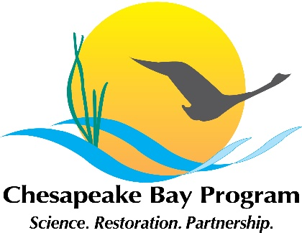
Diversity Workgroup Meeting
November 19, 2021
9:00 am-12:00 pm
Webex

Webinar Information

Link: https://umces.webex.com/umces/j.php?MTID=m198d8aca5491390a4ff51a85114cf1cf

Meeting number: (access code): 2623 323 6607
Meeting password: DWGnov2021

Phone: +1-408-418-9388 United States Toll

Please join by either computer audio or your phone, not both. Viewing the webinar in the desktop app is recommended over the web browser. If you experience bandwidth issues, we recommend turning off your video when not speaking. Note: This meeting will be recorded for internal use to ensure the accuracy of meeting notes.

Meeting Objectives
- Engage participants in reflection that will help prepare for the biennial progress review, through the CBP’s Strategy Review System process. Review and provide feedback on what the Diversity Workgroup plans to present to the Management Board
- Learn how different entities are implementing DEIJ by sharing current, past, or future projects.
- Identify how we can personally contribute to the success of the Diversity Workgroup, and how the Diversity Workgroup can help us achieve success in our own endeavors.

9:00 -9:20 | Welcome & Introductions, Kevin Newman, Diversity Workgroup Chair, and Wendy O’Sullivan, Diversity Workgroup CoChair
9:20-9:25 | Strategy Review System (SRS) Overview, Sherry Witt
9:25-9:50 | The Changing Landscape of Environmental Justice Samantha Beers, Director, Office of Communities, Tribes, and Environmental Assessment at US EPA Region 3
9:50-10:35 | SRS discussion Kevin Newman, Wendy O’Sullivan, Sherry Witt  Workgroup members are encouraged to provide feedback on the questions to be addressed as part of this process.
Break

10:45-11:15 | Sharing Successes TBD
11:15-11:45 | Networking Opportunity All
11:45-12:00 | Way Forward & Closing Comments Kevin Newman and Wendy O’Sullivan

