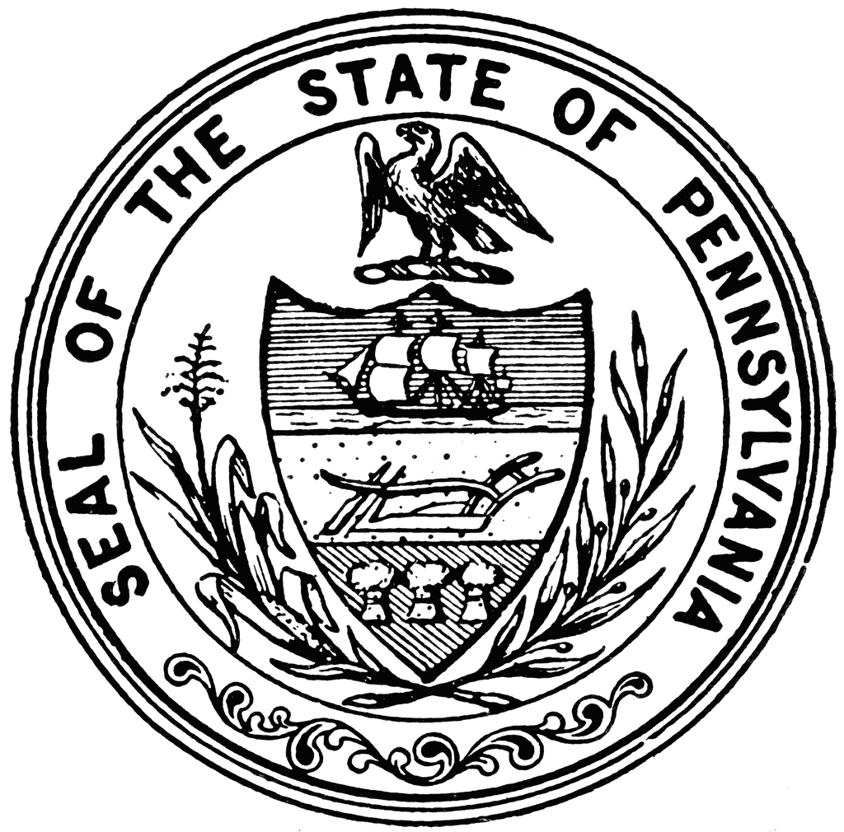
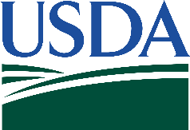
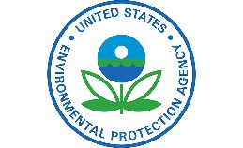

October 11, 2016

A Joint State-Federal Strategy to
Accelerate Nutrient Load Reductions in Pennsylvania’s Chesapeake Bay Watershed

The Challenge

Accelerated agricultural nutrient reductions are needed to help achieve local water quality goals and Pennsylvania’s comprehensive efforts to support the Chesapeake Bay restoration.

The Strategy

This strategy to accelerate Pennsylvania’s nutrient reductions was developed jointly by the Commonwealth of Pennsylvania, the U.S. Department of Agriculture (USDA), and the U.S. Environmental Protection Agency (EPA). This strategy uses science and local expertise to target effective voluntary conservation; builds on-the-ground technical capacity; and builds and leverages partnerships and private capital and markets to increase total conservation investments.

In addition to the annual state and Federal investments, Pennsylvania, USDA, and EPA identified supplemental resources in 2016 to accelerate progress toward the nutrient reduction goals in Pennsylvania’s Chesapeake Bay Watershed Implementation Plan. Pennsylvania and the federal partners are looking forward to working collaboratively with Chesapeake Bay stakeholders to further the strategy in 2017. This short-term strategy will accelerate nutrient reductions in Pennsylvania and serve as a stepping stone to the Commonwealth’s longer-term plan for meeting its 2025 goals. The strategy is designed to reduce nutrient loadings to local waters and the Chesapeake Bay by:

- Targeting more agricultural conservation practices in priority watersheds to reduce nutrient losses from farm fields in south-central Pennsylvania. EPA, USDA, and Pennsylvania will continue to coordinate program opportunities to meet local needs. They will review and refine as necessary the list of watersheds being prioritized for federal assistance and promote conservation systems that are economically and environmentally effective for nutrient reduction.
- Building more technical assistance to help farmers implement agricultural conservation practices that are effective at reducing nutrients. USDA and EPA will coordinate with Pennsylvania agencies, Conservation Districts, supply chain entities and agri-business, and other partners to address producers’ demand for technical assistance to implement agricultural conservation practices.
- Leveraging innovative partnerships, private capital, and markets to supplement the benefits of state and federal investments. EPA and NRCS will coordinate their respective innovation grant programs in FY17 and create a special emphasis joint Request for Proposals focused on Pennsylvania agricultural nutrient reductions.

The Additional Investments

Pennsylvania, USDA, and EPA have committed an additional $28.8 million.

PA State Investments: A total of $11.8 million

- An additional $4.3 million to implement high priority agricultural conservation practices and BMPs through programs such as the Adaptive Toolbox for Conservation Saturation, Dirt and Gravel Roads Program, and the Growing Greener Program, provided by PA Department of Agriculture and PA Department of Environmental Protection.

- An increase of almost $2.5 million for riparian forest buffer funding to work with producers to implement riparian forest buffers to reduce nutrients entering local streams, provided by the PA Department of Conservation and Natural Resources and the Pennsylvania Infrastructure Investment Authority (PENNVEST).

- An additional $1 million to producers through County Conservation Districts to implement priority agricultural practices in the highest nutrient loading counties, provided by the PA Department of Agriculture and State Conservation Commission.

- An additional $1.5 million to help farmers finance the development of the state-required nutrient/manure management or agricultural erosion and sediment control plans through the Conservation Plan Reimbursement Program, provided by Pennsylvania Department of Environmental Protection.

- New funding of $2.5 million to support Pennsylvania’s Agricultural Easement Program, provided by PA Department of Agriculture.

EPA Investments: A total of $4.2 million

- Up to $1 million of additional funding to the National Fish and Wildlife Foundation (NFWF) Innovative Nutrient and Sediment Reduction Grants Program to promote market-based and ag-lead efforts in Pennsylvania. This investment will be used to leverage additional contributions from federal, state, and private partners to advance creative, sustainable solutions that result in agricultural nutrient reductions that go beyond what government can do alone.

- $3 million to NFWF to implement priority agricultural conservation practices in priority Pennsylvania watersheds – project awards announced August 2016.

- An additional $200,000 to implement effective agricultural conservation practices in the highest nutrient loading watersheds in south-central Pennsylvania through additional funding from EPA 319 Nonpoint Source Management Program and contractor support.

USDA Investments: A total of $12.7 million

USDA provided additional, targeted funding to Pennsylvania to support the Chesapeake Bay during the last few months of Fiscal Year 2016. NRCS provided $12.7M in funding to accelerate conservation, in addition to the initial allocation for the state, including:

- $8.1M in additional funding for priority conservation practices and easements through conservation programs, including the Environmental Quality Incentive Program, Conservation Stewardship Program, Wetlands Reserve Easements and Conservation Innovation Grants, and Rural Development’s Rural Energy for America Program;

- $4.6M in additional technical assistance funding to support priorities like increasing producer adoption of riparian forested buffers; growing technical assistance capacity for producers through professional trainings and funding to local partners who work with farmers; and funding innovation through Conservation Innovation Grants.

History of Investments

These amplified investments build off a history of significant state and Federal commitments made towards the Chesapeake Bay restoration in Pennsylvania.
- PA has invested approximately $180.5 million in all sectors for Chesapeake Bay restoration activities over the past three years.
- EPA has invested approximately $72.5 million in Pennsylvania for Chesapeake Bay restoration activities from 2009 to 2015.
- NRCS has invested more than $267 million in technical and financial assistance to assist producers in the Pennsylvania portion of the Chesapeake Bay watershed from 2009 to 2015. USDA/NRCS Chesapeake Bay Watershed Efforts Webpage

