T
he 2010 Chesapeake Bay Total Maximum Daily Load (Bay TMDL) outlines the reductions in nitrogen, phosphorus and sediment that are needed to ensure the Bay can meet water quality standards. To collectively achieve these Bay-wide reductions, each watershed jurisdiction is assigned specific nitrogen and phosphorus reduction targets to meet. New planning targets for the Phase III Watershed Implementation Plans (WIPs) have now been developed.

How do the WIPs relate to planning targets?
The 2010 Bay TMDL required reductions of nitrogen, phosphorus and sediment to meet water quality standards. To collectively meet the Bay-wide reductions, each watershed jurisdiction (Delaware, the District of Columbia, Maryland, New York, Pennsylvania, Virginia and West Virginia) were assigned different nitrogen and phosphorus reduction targets to achieve individually.
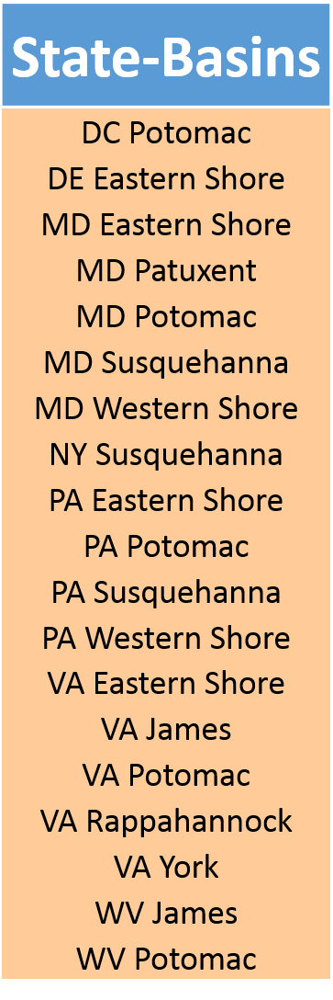
To help meet these pollution reduction targets, the jurisdictions develop WIPs that include detailed, specific steps that they each will implement. The jurisdictions are currently developing their third (Phase III) WIP since the Bay TMDL was established in 2010. As part of the Phase III WIP development process, the jurisdictions have received draft planning targets that reflect refinements to the model using the most up-to-date science and monitoring data available. Although the planning targets are different from the 2010 Bay TMDL limits, these planning targets establish new goals for the jurisdictions to achieve to meet water quality standards.
How are the target pollution loads determined?
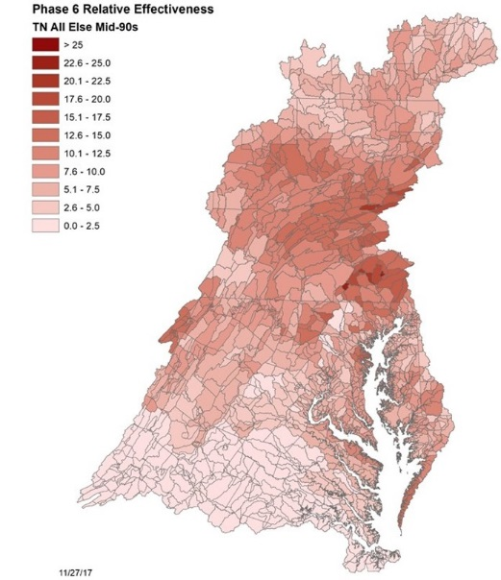
The development of the Phase III WIP planning targets used similar methodology that was employed for the Bay TMDL. The targets were set using the updated Phase 6 Chesapeake Bay suite of modeling tools, which contains significantly more data and information than the previous version. The modeling tools underwent improved calibration, which yields more precise estimates of how much pollution the Bay can handle while still meeting water quality standards.
The targets are not established on a statewide basis, but rather on a state-basin scale. The water quality effects of conservation practices varies by watershed, so implementing the same controls in different watersheds has different levels of effectiveness (i.e., a pound of nitrogen in the James River may not have the same level of impact as a pound of nitrogen in the Potomac River). To account for the differing levels of effectiveness, the planning targets are set depending upon the overall level of impact. Graphics to the left and on the next page demonstrate the most impactful nonpoint source areas in the watershed (defined as the effect on oxygen in the Bay per pound of nitrogen or phosphorus released in the watershed).

Why isn’t sediment specifically given a target?
Planning targets only account for nitrogen and phosphorus—not sediment. This is because:
- Conservation practices implemented to reduce pollution from agricultural sources will help decrease sediment flowing into the Bay.
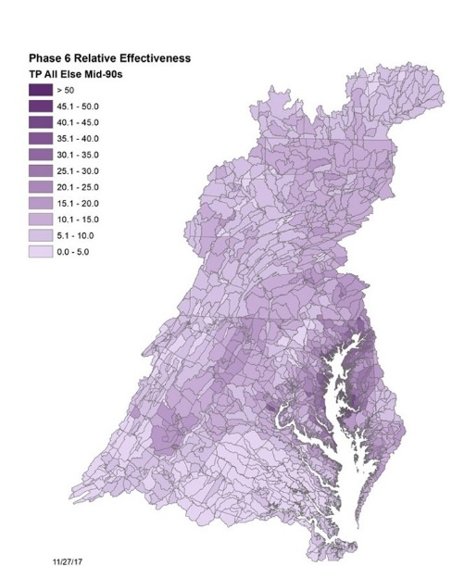
- Dissolved oxygen levels in the Bay are more dependent on nitrogen and phosphorus reductions than sediment because nutrients can cause algal blooms that die off and decompose, leading to areas of hypoxia, or “dead zones”.

May jurisdictions exchange pollution loads?
Pollution controls in some watershed areas will be more effective and have a greater impact than those same controls might have in other areas. To improve effectiveness and better allocate resources, states can exchange nitrogen loads for phosphorus loads, phosphorus loads for phosphorus loads and nitrogen loads for nitrogen loads within the same state basin, as well as with other state basins within the same jurisdiction. Exchange ratios are set based on extensive modeling and vary from basin to basin and jurisdiction to jurisdiction. Even though targets are set on a basin, not a state scale, jurisdictions may only exchange pollution loads within the same state.

What happens if the pollution loads are not reduced by 2025?
The Chesapeake Bay Program will provide as many resources as possible to help the jurisdictions meet their Phase III WIP planning targets. Potential federal actions may occur if jurisdictions do not meet their targeted pollution reductions; however, any federal actions will be guided by common sense, the best available information and a shared goal to restore the Chesapeake Bay.

