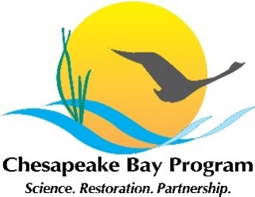
AGENDA
Spring 2021 Public Access Workgroup Meeting

Wed May 19, 2021
9:00 – 10:00

Meeting Location: Virtual

Zoom Join Info: https://umces-edu.zoom.us/j/96113014027?pwd=cjZHdWtvMVBkektnMUF4VzNkMmJYdz09
Phone Line: +1 301 715 8592, Meeting ID: 961 1301 4027
Password: 175643

9:00 am Welcome & Opening Comments
- Welcoming Remarks
- Introductions
9:05 am Report on 2020 Call for Public Access Data
- Review the Analysis and Methods document
9:05 am GIT Funding, Benefits and Barriers Across the Chesapeake Bay Watershed
Steve Raabe, OpinionWorks
- Overview of Scope
- Discussion of Objectives
  - What is the definition of underserved populations?
  - How much emphasis should we put on it in the scope?
- Volunteers
9:50 am Updates from Workgroup Members
10:00 am Adjourn – Thank you for your time, effort and participation!

