
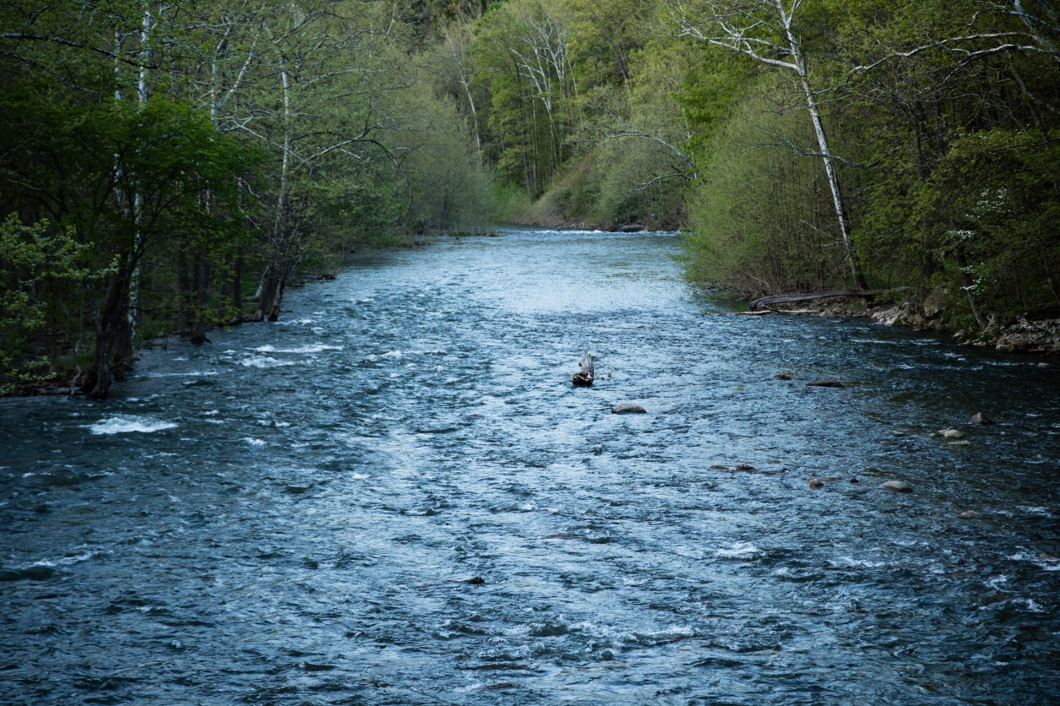

Riparian Forest Buffer

Outcome

Management Strategy

2015–2025, v.2
The North Fork South Branch Potomac River flows past Seneca Rocks in Monongahela National Forest in Pendleton County, W.Va., on April 28, 2017. (Photo by Will Parson/Chesapeake Bay Program)

Introduction
Of the many best management practices (BMP) that improve water quality and habitat in the Chesapeake Bay watershed, the most effective may be the restoration of riparian forest buffers. Woody vegetation historically occurred along most streams in the Chesapeake Bay watershed prior to European settlement, except where conditions were too wet, frequently disturbed, or salty. This condition is considered the optimal natural condition for streamside vegetation of the watershed and sets the target condition for buffer restoration, as well as for water quality. Riparian forest buffers (RFB) provide critical barriers between polluting landscapes and receiving waterways using relatively little land. Forest buffers reduce the adverse effect of excessive nitrogen, phosphorus and suspended sediment inputs. Per acre, they likely provide more benefits and are more cost-effective than any other BMP, especially when considering the added value of habitat at the critical juncture of land and water.
Forest buffers have been part of the fabric of Bay restoration since 1994 when the Chesapeake Executive Council first called upon the Chesapeake Bay Program (CBP) to develop a policy to “enhance riparian stewardship and efforts to conserve and restore riparian forest buffers (Directive 94-1).” Since then, many goals and plans have been put into place, that have met with varying degrees of success. The current effort, the 2014 Riparian Forest Buffer Initiative (hereafter, the Initiative), is the biggest, most concerted effort by state and federal agencies to increase riparian forest buffers in the watershed to date. The Initiative was started in 2014 by the U.S. Department of Agriculture (USDA), the Environmental Protection Agency (EPA) and the Alliance for the Chesapeake Bay. Much of their work helped to inform the first Management Strategy.
New high-resolution mapping of land use in the Chesapeake watershed has shown that as much as 69 percent of the riparian area is in a natural condition (primarily forest or wetland). Previous estimates for riparian forests before this new imagery were about 58 percent. The goal to have a minimum of 70 percent of the riparian area in forests is now within reach. Furthermore, through the high-resolution mapping, we learned there are approximately1.4 million acres of bufferable (currently without a forest or natural buffer) area available on which that forests or wetlands could be placed. Because Bay water quality is still impaired, and there is still a great need for this habitat, the target for this goal may shift once the new Watershed Implementation Plans (WIPs) are completed. Tools associated with high-resolution mapping product will be helpful to restoring RFB and should be incorporated in trainings for Technical Service Providers (TSPs).
The rate of new riparian forest restoration continued to decline despite a jump in 2016 due to a landowner survey in Pennsylvania that identified many acres of voluntary buffers that had previously been unreported. The pace of restoration needs to accelerate to meet 2025 water quality goals under the Chesapeake Bay Total Maximum Daily Load (Bay TMDL). Furthermore, with the new Phase 6 modeling tools, the number of riparian forest buffer BMP acres in some states decreased because they were over ten years old and had not been verified. The states will therefore need to begin a verification process to recapture those acres of buffer that are extant.
The federal-state Conservation Reserve Program/Conservation Reserve Enhancement Program (CRP/CREP) has long been the best program for restoring RFB in the watershed. However, because of program design and inconsistency, states are realizing that new and different programs are needed to help reach their goals. In recent years, at least three states (NY, PA, VA) have created programs and grants focused on the riparian area, but these do not take advantage of federal assistance, nor do they always prioritize forest buffers.
Finally, there is a buffer design and maintenance issue. As a result of new data from Penn State and the Agriculture Research Service, we now have a better understanding that many (as much as one-third) of our riparian buffers have concentrated flow cutting through them. This flow, also called buffer by-pass, prevents the buffer from filtering runoff before it reaches the stream. There are actions that can be taken upland of the buffer and also some buffer design elements that could be used to reduce the likelihood of buffer-bypass.

Goal, Outcome and Baseline
This management strategy identifies approaches for achieving the following goal and outcome:
Vital Habitats Goal
Restore, enhance and protect a network of land and water habitats to support fish and wildlife, and to afford other public benefits, including water quality, recreational uses and scenic value across the watershed.
Riparian Forest Buffer Outcome
Continually increase the capacity of forest buffers to provide water quality and habitat benefits throughout the watershed. Restore 900 miles per year of riparian forest buffer and conserve existing buffers until at least 70 percent of riparian areas throughout the watershed are forested.

Baseline and Current Condition
As much as 69 percent of the roughly 288,000 total riparian miles in the Bay watershed has a forest or natural buffer in place. A buffer restoration goal of 900 miles/year was first set by the states in 2007. Since that time, this goal has never been reached. The current rate of restoration/tree planting, is shown in Figure 1. Buffer width is not prescribed but is between 35 and 300’ wide, with an average 100’ wide to achieve the benefits credited. Average width currently is ~95’.
Figure 1. Miles of new riparian forest buffer reported by states to CBP.

Participating Partners
The following partners have participated in the development of this strategy. Most participation has occurred as part of a State Task Force.
Chesapeake Bay Watershed Agreement Signatories
- Commonwealth of Pennsylvania
- State of Delaware
- State of West Virginia
- Chesapeake Bay Commission
- Commonwealth of Virginia
- State of New York
- State of Maryland
Other Key Participants
- Federal: Farm Service Agency, Natural Resource Conservation Service, Forest Service, US Geologic Service, US Fish and Wildlife Service, Department of Defense, Environmental Protection Agency, National Park Service, Army Corps of Engineers, Smithsonian Institution
- Non-Governmental: Alliance for the Chesapeake Bay, Chesapeake Bay Foundation, Trout Unlimited, The Nature Conservancy, Cacapon Institute, Casey Trees, Parks and People (Baltimore and Washington, D.C.), Delaware Center for Horticulture, Baltimore Greenspace, Pennsylvania Conservation Districts, Stroud Water Research Center, Pheasants Forever, Ducks Unlimited, Potomac Conservancy, Virginia Farm Bureau, Virginia Grain Producers, Virginia Agribusiness Council, Virginia Cattlemen’s Association, Virginia Dairymen’s Association, Maryland Farm Bureau Federation
- Local: Local Government Advisory Committee; Soil and Water Conservation Districts; Anne Arundel County; Arlington County; Prince Georges County; Cumberland, MD; Fairfax County; Annapolis, MD; Baltimore County

Factors Influencing Success
The following are natural and human factors that influence the partnership’s ability to attain the riparian forest buffer outcome. Because the restoration of riparian forest buffers is predominantly an agricultural practice, many of the factors influencing this outcome are common to agriculture. These are not readily within our control, and will not be ranked as part of this Management Strategy:
- Fluctuation in commodity crop values
- Inter-generational transfer of agricultural lands
- Loss of agricultural lands
- Lack of congressional authorization of a new Farm Bill, which caused Conservation Reserve Program to close in 2013 and 2014.
Note: Urban riparian buffers are included in the urban tree canopy and are addressed as part of the Tree Canopy Management Strategy along with related stormwater issues.
Other factors are more technical or relate to management/leadership. All of these factors have been identified to be of the highest order of priority from the various groups that have been assembled as part of the Initiative (specifically, the Steering Committee, State Task Forces, and the Innovators’ Roundtable). In working through the logic table for the revision of this Management Strategy, the following factors were determined to be most important:
- Partner Coordination
- Science and Technical Understanding
- Improved Technical Assistance
- Government Agency Engagement
- Legislative Engagement
- Landowner Engagement
- Funding or Financial Resources
- Non-governmental Engagement
- Public Engagement

Current Efforts and Gaps
CBP partners have been working on the RFB outcome for over 24 years. In 2014, USDA, EPA and the Alliance for the Chesapeake Bay began the Riparian Forest Buffer Initiative. It was clear that the agriculture and water quality experts should have more ownership of this Outcome which is primarily placed on agricultural land. The CBP Forestry Workgroup can help and provide technical leadership in tree reforestation, but should not continue to be the sole lead for the RFP practice at the regional level. The Initiative developed a list of gaps/barriers which was heavily used in the first Management Strategy. There have been some positive new efforts in the last 2-3 years, such as the RFB leadership in Pennsylvania. Most of the successes are localized and need to expand to other parts of the watershed. An analysis of buffer restoration information mapped out clearly that there were counties in every state with a high success in working with farmers to install forest buffers. This map is shown in Figure 2. This is significant in that each state can distribute lessons from those successful counties to other counties that have good opportunity to place more forested buffers, but have not done so in recent years.

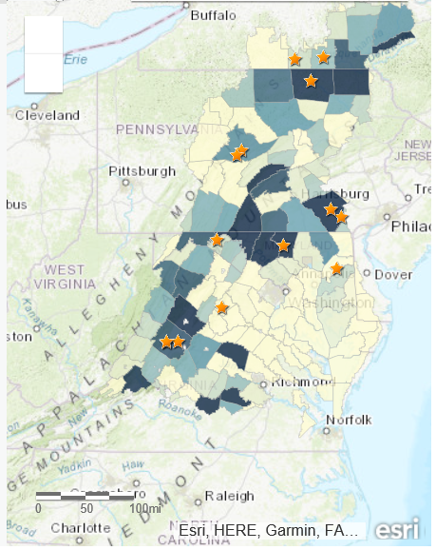
Figure 2. Map of Chesapeake watershed showing forest buffer establishment by county for 2017 (Source: www.chesapeakeforestbuffers.net). Darker blue counties installed more buffers.

- Leadership. While the Phase III of the WIPs have not been completed, all indications are that the rate of RFBs restoration will have to greatly accelerate to meet 2025 goals for water quality under the Bay TMDL. There are approximately1.4 million acres of opportunity, that is at once a lot and a limited number. Greater leadership at multiple points along a continuum – federal (DC), state (state agency leads, State ag leaders), and local (County NRCS or SWCD) – is needed. There needs to be a clear, coordinated response from all of these leaders to the need for RFB. Currently, a RFB leader has been appointed in each watershed state, however this person needs to be empowered and recognized by other leaders. Also, the state RFB and water quality leads should meet regularly with the NRCS State Conservationist and solicit that person’s assistance in implementing state priority ag practices.
It is not sufficient for leadership to be identified and actively convene stakeholders – leadership must ensure there are efficient and dedicated programs to deliver in their state. This may involve developing new policies or tweaking old policies to ensure their stability and efficiency in getting RFB on the ground. Many programmatic changes – such as buffer maintenance programs that complement existing Farm Bill programs – can be most efficiently made at the state level. For example, strong state leadership could direct Technical Assistance to geographic areas that are underserved, and otherwise make changes in eligibilities or administrative practice to expedite buffer sign-up.
- Need efficient, regularly-funded programs. Both federal and state agencies have been guilty of lapses in CRP funding. This creates trust issues – landowners need consistent, dependable programs or they can’t be sold. From the federal side, the lapse in funding is indicative of the need for legislative action such as in the form of a new Farm Bill. But lapses in state funding can be avoided with better planning for implementation of this priority practice (and keeping in mind that every dollar the state spends, is matched with 4 federal dollars under CRP).
Inefficiencies in program delivery – where multiple people and agencies work back and forth to get a single contract out – can be very discouraging to farmers and restrict RFB enrollment. A more streamlined team approach could be identified through a Lean-type system.
State programs should be developed to address buffer maintenance issues using an economy of scale. A dedicated group of trained buffer maintenance personnel would ease the maintenance burden to landowners and facilitate enrollment. Additional funding is needed from federal, state and private entities to take the risk out of enrollment and help sell forest buffers.
- Federal Policy. CBP partners would benefit from Farm Bill language supporting RFB efforts. To a large degree, RFB progress has depended on CRP/CREP, but this program has been beleaguered with acreage caps, time lags and shutdowns. Partners have been in favor of quicker, more flexible programs. Partners are calling for a higher acreage cap for CRP in the Farm Bill, adding more flexibility in program delivery, increasing maintenance and incentive funding, and including something separate and new that would be specific to RFB. The Forest Buffer Action Team (referred to below) is working on this recommendation and what the CBP Principals Staff Committee (PSC) could do to help.
- Improved technical assistance and staffing. More technical assistance (TA) is needed in the Chesapeake for RFB and across the board as outlined in the recent report by the Chesapeake Bay Commission report, Boots on the Ground. Existing staff at the county level and consultants could be better trained to reinforce the TA staff delivering RFB well. Technical Service Providers (TSP) have access to new tools and need training to use them. One of these tools is a Decision Support dashboard to determine the multiple benefits of placing a forest buffer in a particular location.
The new information on farm hydrology and buffer by-pass indicate the need for specialists to address this issue where it begins (often in farm fields) so buffers can do their job. In most cases, by following the upland hydrologic issues from their source, a series of farm practices, including a forest buffer, could be better designed to address hydrologic issues. This is referred to here as whole farm planning for hydrology.
- Enhanced engagement at multiple levels (landowner, TSP and leadership). Partners have been reaching out to landowners, TSPs and other partners on the importance of RFBs to various degrees of success. A comprehensive communications and outreach plan is proposed to provide guidance for future efforts. The CBP Communications team will be leading this effort.
Actions, Tools and Support to Empower Local Government and Others
- The Local Government Advisory Council (LGAC) has been engaged in the process of developing this Management Strategy.
- Targeting tools from federal and state government are available and will be better disseminated, with training, to local partners. These tools, along with high-resolution land cover imagery can help partners see how much opportunity exists in their area and where RFB program delivery should be targeted.
- Other programs, tools and support have been identified in the State Task Force reports and are partially reflected in the summary of them provided in the Appendix of this Management Strategy.

Management Approaches
The following Management Approaches have been refined since the first Management Strategy to be more focused on high priority partnership actions.
The partnership will work together on these approaches to address the factors affecting our ability to meet the goal and to fill the gaps previously identified. The RFB management approaches were summarized from strategies identified in the Innovators’ Roundtable in 2014 and through the draft State Task Force reports. These are still relevant. The following are the newly honed and reorganized management approaches – also reflected in the biennial workplan.

- Renew leadership to achieve an “all hands” approach
  - State RFB lead has been appointed in all Bay jurisdictions. There is a need to bolster this position with state water quality support. In Pennsylvania, there are regular coordinating meetings that are directly supported and often attended by cabinet-level leadership. The RFB lead should communicate regularly with the WIP lead and NRCS State Conservationist.
  - CBP’s Management Board asked for the formation of a Forest Buffer Action Team. This Team will report back to the Management Board with suggested leadership actions which they will share with the PSC in October 2018.
  - Work on policies to advance RFB. Improved Farm Bill language is needed that increases the acreage cap of CRP/CREP and makes it more flexible for RFB. Because of the high priority and unique challenges of RFB, some have suggested starting over with a program devoted to doing them effectively.
- Improve existing Ag programs and continue to develop new ones
  - This “all hands” leadership should flow to the local level where SWCD, NRCS, and Farm Service Agency (FSA) could improve coordination in RFB enrollment in counties showing up as light colored
  - Develop programs to assist landowners with maintenance, for example, with specialized cost-effective multi-farm area maintenance teams.
  - Amend state Conservation Reserve Enhancement Program (CREP) agreements to increase flexibility and incentives and support verification
  - Conduct strategic, coordinated, and cost-effective RFB outreach across the watershed
  - Compile and disseminate information on what it takes to properly establish and maintain healthy multi-functional RFBs
  - Look broadly to align related projects/funding (e.g. state preservation programs, stream restoration, etc.)
  - Use federal funding as leverage to get more RFB
  - Integrate RFB as part of state stormwater programs (also see Tree Canopy Management Strategy)
- Improve and Increase Technical Assistance
  - Maintain existing trained Riparian Foresters
  - Increase TSPs by working with NRCS, SWCDs and other agricultural consultants
  - Increase state and local funding for CRP (or similar RFB program)
  - Find ways to make existing program more efficient
  - Provide more training for TSPs incorporating new tools and science, including climate science
  - Address whole farm hydrologic planning to reduce buffer by-pass
- Outreach and Communications
  - Produce an Outreach and Communications Plan for RFB. This will help coordinate and hone outreach and communications efforts across the watershed, and help engage landowners and the general public.
- Non-agricultural programs
  - Develop RFB and tree planting restoration program targeted to MS4s and local governments and institutions that may include private investment and charitable foundation support
  - Analyze current spending on grant programs (e.g. Chesapeake Bay Implementation Grants, Section 319, and State Revolving Funds) to determine what might be available for implementation of RFB programs on non-ag lands
  - Look into Pay for Success conservation finance opportunities
  - Ensure there are trained citizens through Master Naturalists or Tree Steward programs who can help localities establish non-agricultural buffers
  - Develop more state and private grant programs to help localities and other land managers who want to improve their riparian forest buffers (these exist in PA and NY)
  - Partner with NGO’s to share in training and decision support tools to get more forest buffers in developed areas

Approaches Targeted to Local Participation
- Many of the identified management approaches are critically important at the local level. For example, local leadership promoting RFB as an essential practice to achieve their water quality goals. Local officials should be involved with SWCD, RC&Ds, county offices of NRCS and FSA, and others working with landowners to ensure that the actions identified in this strategy are taking root and having an effect.
- Protect RFBs in local land use regulation. Local government has authority over conversion of agricultural land to other land uses and loss of RFBs on agricultural lands will have a negative impact on water quality. This loss is being tracked through the Chesapeake Bay Program modeling tools and other tools to identify loss and opportunity of RFB will be made available.
- More programs for RFB on non-agricultural land need to be developed and promoted by local authorities. “Backyard Buffers” and “Buffer in a Bay” are two such programs for suburban areas. RFB should be incorporated into State Stormwater Plans as a priority practice. (Note: Non-agricultural buffers are treated in more depth as part of the Tree Canopy Management Strategy).
- Local governments are also landowners and should make it a priority to restore and protect riparian areas to forests wherever possible on public land.
Cross-Outcome Collaboration and Multiple Benefits
Riparian forest buffers provide multiple benefits – their restoration supports many of the outcomes of the 2014 Chesapeake Bay Watershed Agreement, most notably: water quality, brook trout, wetlands, tree canopy, and land protection. Management approaches that specifically benefit these other outcomes are:
- Add coordinators and technical assistance (TA) staff (e.g. wetlands, brook trout, water quality)
- Expand use of RFB teams – turnkey operations that help with everything from enrollment to maintenance (e.g. water quality, brook trout)
- Conduct more training for TA providers (e.g. water quality, wetlands, brook trout)
- Increase incentives for TA providers (e.g. water quality)
- Create GIS maps for targeting practices (e.g. brook trout, wetland, tree canopy, water quality)
- Expand RFB easement options through state and local policies/programs – specifically at agricultural preservation programs (e.g. land conservation)
- Refine tracking and monitoring programs through technology transfer (e.g. wetland, tree canopy, brook trout, water quality)

Monitoring Progress
Current monitoring programs
State implementation of CBP BMP verification, which recommends additional site visits, will strengthen monitoring and spur correction of maintenance issues associated with RFB. In most places, nearly 100 percent of plantings are visited by a professional, but new emphasis on maintenance combined with verification will increase survival and make buffers more visually attractive.
Other forms of monitoring are based on tracking through annual progress reporting from the following sources:
- Contracted acres from FSA (these data can also be reported monthly and at the county level)
- Number of acres reported by states to Chesapeake Bay Watershed Model
- Miles reported from Forestry Workgroup
New or proposed monitoring approaches
- Data derived from high-resolution satellite imagery are becoming more common and help monitor gain, loss, and survival of riparian forest buffers. These may be able to supplement one or more of the reports mentioned above. Resources to detect change in the amount of buffers using this imagery will be provided.
- Reports from partners on progress on actions in this Management Strategy.
- Feedback on webinars and training that are proposed as part of the communications and outreach strategy.

Assessing Progress
The biennial workplan will be the main tool for focusing collaboration across federal, state, local, and nongovernmental partners on the riparian forest buffer outcome. In addition to looking at program changes made at the regional level, we will track our progress in meeting the state actions set out in the State Task Force reports. Assessment of progress will be aligned with the cycle of state reporting for two-year milestones for the TMDL, because riparian forest buffer data are critical to meeting these milestones. Examining the alignment of the three sources of RFB data listed above will also indicate progress. As the first biennial workplan is nearing its end, another assessment process will be triggered to look at progress, challenges and lessons learned from the first workplan.

Adaptively Manage
The partnership will use the following approaches to ensure adaptive management:
- Tracking progress toward the annual 900-mile goal, as well as identifying trends and priority areas.
- The Riparian Forest Buffer Initiative provides a means to engage additional partners in helping make progress on actions in the Management Strategy and Workplan.
- CBP partners involved in related goals, i.e., conservation, brook trout, wetlands, healthy watersheds and others, provide an important source of mutual feedback on what works well and what does not.
- Throughout the year, the partnership’s communication tools, including websites, webinars and special announcements, will inform progress toward the RFB goal and highlight needs or opportunities for partnership members to engage.
- Monthly Forestry Workgroup meetings provide a regular venue for evaluating and adjusting particular strategies that support the annual 900-mile goal.
- Annual reporting by the partnership and its members of best practices, success stories and other qualitative and quantitative successes is another means to recognize the impacts of existing programs, reflect on and adapt existing and new strategies, and grow the capacity and stewardship required to increase the amount of riparian forest buffers in the watershed.

Biennial Workplan
A workplan to accompany this management strategy will be completed six months after this document is finalized. It will identify specific partner commitments for implementing the strategy and include the following information:
- Each key action
- Timeline for the action
- Expected outcome
- Partners responsible for each action
- Estimated resources

