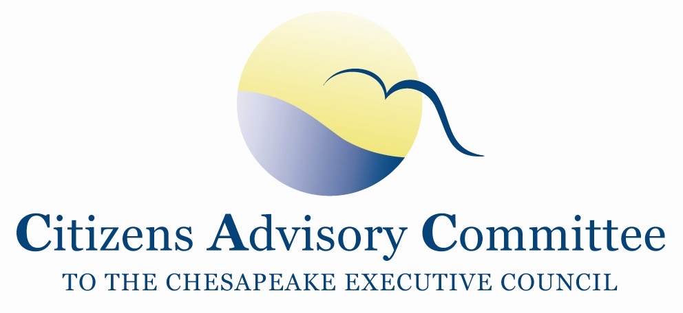
Citizens Advisory Committee
Meeting Agenda
September 16-17, 2020

______________________________________________________________________________________________________________________________________

Virtual Meeting
This meeting will be recorded for internal use to assure the accuracy of the meeting notes.

Meeting Goal: Foster a deeper understanding of the connections between environmental quality and public health. The panel will help us to discover opportunities for professionals and stakeholders in both fields to bridge the gaps and inform each other’s efforts for positive change.

Wednesday, September 16- From Your Remote Office

10:00 a.m. Call to Order and Welcome…………………….………………….…..Matt Ehrhart, Chair

10:10 a.m. Housekeeping, Engagement Rules and Roll Call

10:15 a.m. Business Meeting
- Approval of May Meeting Minutes
- December CAC Officers Elections
- Proposed 2021 CAC Meeting Dates
  - Feb 25-26 (Th/F); May 19-20 (W/Th); Sept 16-17 (Th/F); Dec 1-2 (W/Th)
- Briefing on the Executive Council Meeting
- Updates on the BMP Verification ad hoc workgroup
- Member Updates

11:00 a.m. Chesapeake Bay Program’s DEIJ Strategy and PSC Action Plan…..……Wendy O’Sullivan
Vice-Chair, Diversity Workgroup, National Park Service
Jim Edward,
Chair, Diversity Workgroup, EPA Chesapeake Bay Program
- Highlights of the Diversity, Equity, Inclusion and Justice (DEIJ) Strategy, EC Statement and PSC Action Plan
- Updates and Discussion on options to create a Community Advisory Board

11:45 a.m. Overview of Public Panel and What to Expect

12:00 p.m. Lunch Break

1:00 p.m. Panel: Bridging the Gaps Between Environmental Quality and Public Health
Co-Moderators:
- Surili Patel, American Public Health Association
- Julie Lawson, CAC Vice-Chair
Panelists:
- Doug Farquhar, Esq, Environmental Health Program at the National Conference of State Legislatures
- Dr. Sacoby Wilson Maryland Institute for Applied Environmental Health
- Nsedu Obott Witherspoon, Executive Director, Children’s Environmental Health Network
- Liz Perera Director, Climate Policy, Sierra Club
- Adrienne Hollis, Union of Concerned Scientists

3:00 p.m. Panel Concludes
CAC Meeting Recess

5:00 p.m. Optional Virtual Reception (panelists invited)

Thursday, September 17- From Your Remote Office

1:00 p.m. Reflections on the Panel Discussion
(10 min Break-out Rooms with Discussion Guide)
Reports to the full group

1:30 p.m. Chesapeake Bay Program Updates………………………………………………..Jim Edward,
Associate Director, EPA Chesapeake Bay Program

- Conowingo Watershed Implementation Plan and Financing Strategy
- Updates on Jurisdictions’ Progress
- Most effective basins for allocating funding
  - How EPA determines targeted tributaries for additional funding

2:00 p.m. Wastewater Epidemiology and COVID-19………………………….....…Dr. Raul Gonzalez
Environmental Scientist
Hampton Roads Sanitation District
2:45 p.m. Break

3:00 p.m. Reflection, Discussion and Action Items
- DEIJ Action Plan and new Advisory Board
- Public Health and Environmental Protection Panel
- CBP Updates
- COVID-19 tracking in wastewater
- Intermittent CAC Webinars and Learning Sessions
- September 23 Virtual Meeting with Governor Northam

Discussion on December 3-4 Meeting Topics
- Briefings from LGAC and STAC leadership
- CAC Officer Elections

4:00 p.m. Adjourn

