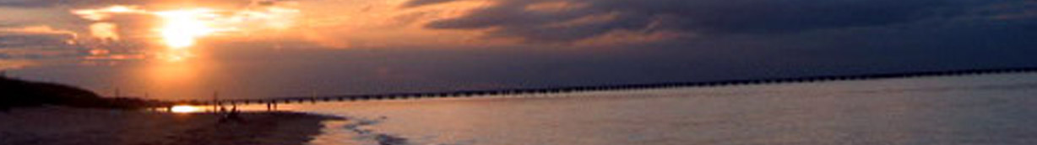
Chesapeake Bay Program Sustainable Fisheries
Goal Implementation Team
September 2013 Update
Chesapeake Bay New Agreement
- The Fisheries GIT has been involved in the drafting process of the Chesapeake Bay Program’s New Agreement, which will articulate the Bay Program’s restoration goals through the year 2025.
- The Bay Program’s Management Board tasked the Fisheries GIT with developing fisheries outcomes for the New Agreement.
- Discussions at the June full GIT meeting, the monthly Executive Committee meetings, and input from other stakeholder were utilized to develop fisheries outcomes.
- Five fisheries outcomes under the Sustainable Fisheries Goal are currently proposed for the New Agreement: blue crab abundance, blue crab management, oysters, forage fish, and fish habitat.
- A full draft of the New Agreement will be available for public comment for a 30-day period in October.
- The Agreement is set to be signed in December by the Bay jurisdictions, Chesapeake Bay Commission, and EPA representing the federal government.
Executive Committee Meeting Science Presentations
At monthly Fisheries GIT Executive Committee meetings, attendees hear from Bay scientists and policy administrators on topics including:
- Fisheries Protection, Restoration, and Prioritization GIS
  - Sean Corson (NCBO)
  - NOAA and TNC are developing a new criteria driven GIS tool to assess habitat restoration and protection efforts. This tool can specifically help prioritize fisheries habitat protection efforts by identifying the relative value of habitats for fish species.
- Oyster Decision Support Tool
  - Peter Bergstrom (NCBO)
  - This tool provides a visual representation of oyster monitoring and restoration data, as well as related physical data. This tool can be used to track oyster restoration activity and progress.
December 2013 - Full GIT Meeting
December 3-4th at Chesapeake Biological Lab in Solomons, MD
SAVE THE DATES!
Our Vision: The Sustainable Fisheries Goal Implementation Team (Fisheries GIT) brings a wide group of managers and scientists together to improve management and maintain the sustainability of commercially and ecologically important Chesapeake Bay fisheries. The Fisheries GIT is working across jurisdictional boundaries and applying the best available science to support ecosystem-based decisions.
Spring/Summer 2013 Accomplishments
The Fisheries GITs Executive Committee has continued to collaborate on science and policy issues to support sustainable Chesapeake Bay fisheries. Recent highlights include:
Blue Crabs
- CBSAC released the 2013 Blue Crab Advisory Report, endorsed by the Executive Committee. The report introduced new male conservation triggers developed by CBSAC. These conservation triggers are specific conditions that will signal managers to consider male-specific regulations.
- CBSAC is working to prioritize the critical research and analysis needs presented in the 2013 report. These research needs are critical to ensuring the best the most accurate analysis of WDS data and abundance estimates.
Invasive Catfish
  - The Invasive Catfish Task Force is working to finalize their report entitled “Chesapeake Bay Invasive Catfish Response Plan”.
  - The report will include management recommendations to minimize the spread of invasive catfish and mitigate their potential impacts on the ecosystem. It also focuses on increasing public awareness and developing consistent messaging to inform watermen and the general public.
  - The Task Force has developed a work plan for this fall, and plans to meet in person to work on the report.
Oysters
  - Draft restoration blueprints have been developed for the Little Choptank and Tred Avon.
  - Reef construction and seed planting in Harris Creek are fifty percent complete.
  - There are several research projects in progress throughout the Bay looking at oyster reef ecosystem services.
American Shad
- The American Shad Indicator Action Team has developed a revised Baywide indicator for shad abundance, and updated data for Virginia tributaries.
- The Shad Team will be presenting the revised indicator to the Fisheries GIT Executive Committee and the Management Board. Once approved, the indicator will be updated on the Bay Program’s website.
- This new indicator will incorporates more tributaries, and also links to information on American shad restoration and stocking efforts throughout the Bay.
Meetings, Presentations, and other Fisheries GIT information can be found at: http://www.chesapeakebay.net/groups/group/sustainable_fisheries

