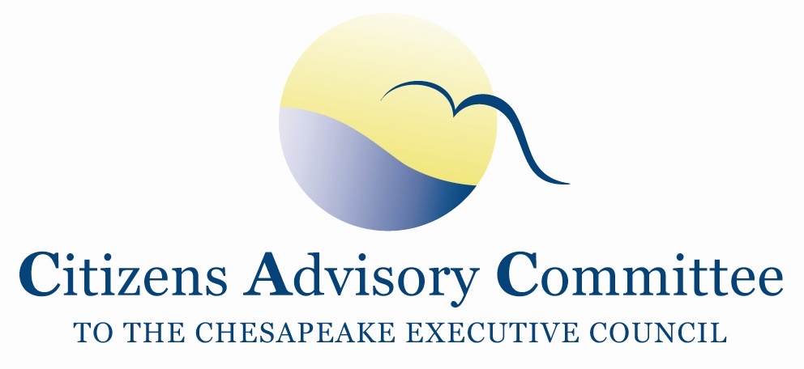
Citizens Advisory Committee
Meeting Agenda
September 18-19, 2019

______________________________________________________________________________________________________________________________________

Stroud Water Research Center
970 Spencer Road
Avondale, PA

Meeting Goal:
- Receive updates on CAC priority topics: Watershed Implementation Plans and Agricultural Conservation Practice Targeting, Monitoring and Tracking.
- Learn about the region’s successful restoration partnerships.

Wednesday, September 18

11:00 a.m. Call to Order and Welcome……………………….………………….…..Matt Ehrhart, Chair
- Introduction of Members and Guests
- Opening Remarks about the Stroud Water Research Center and Meeting Agenda

11:15 a.m. Updates from the Chesapeake Bay Program…………………………..…………Jim Edward,
Deputy Director, EPA Chesapeake Bay Program Office
- Overviews of EPA Assessments of the Draft Jurisdictions’ Watershed Implementation Plans
- Conowingo Dam WIP awardees and workplans
- Land Policy BMPs
- EPA Funding

12:00 p.m. Working Lunch
Presentation: Private Businesses and Nonprofits Accelerating Conservation Practices
Turkey Hill and the Alliance for the Chesapeake Bay Clean Water Partnership
Jenna Mitchell, PA State Director, Alliance for the Chesapeake Bay

1:00 p.m. CAC Priority: Watershed Implementation Plans
Updates from PA DEP……………………………………………………………...Kristin Wolf
Chesapeake Bay Program Coordinator,
PA Department of Environmental Protection
- PA Watershed Implementation Plan
  - Funding
  - Addressing CAC’s comments on PA’s draft WIP
- County implementation plans

1:45 p.m. Delaware River Watershed Initiative……………………………...….Andy Johnson, Director
Watershed Protection Program, William Penn Foundation

John Jackson, Senior Research Scientist, Stroud Water Research Center

3:00 p.m. Onsite Tour: Stroud Water Research Center
- LEED platinum building and onsite stormwater infrastructure
- Education Facilities
- Restoration research on the White Clay Creek

5:00 p.m. Meeting Recess

6:30 p.m. Dinner- Mendenhall Restaurant
Members continue to discuss local river and Chesapeake Bay issues in an informal setting

Inn at Mendenhall
323 Kennett Pike, Route 52
Chadds Ford, PA 19317

Thursday, September 19- Mendenhall Meeting Room
Hot Breakfast buffet available off the lobby starting at 6:30am.
(Check out of the hotel before the meeting begins.)

8:30 a.m. Call to Order………………………...………………………..….…….…..Matt Ehrhart, Chair
- Approve May 2019 Meeting Minutes
- CAC Member Updates and Announcements
  - EC Meeting debrief, discussion lead Matt Ehrhart
  - Environmental Literacy Summit, discussion lead Chuck Herrick
- Staff Updates
- Set Dates for 2020 CAC Meetings

9:15 a.m. CAC Priority: Agricultural Conservation Practice Targeting, Monitoring and Tracking
Presentation on the role the Chesapeake Conservancy plays at the Chesapeake Bay Program on BMP mapping and tracking
Louis Keddell
Senior Geospatial Project Manager, Chesapeake Conservancy
The Chesapeake Conservancy has a 6-year agreement with the CBP. Objectives Include:
- Land Cover and Land Use Data (2) Hydrology and Ditches (3) BMP mapping and Tracking and, (4) General Geospatial Support. Chesapeake Conservancy CBP Objectives Pre-Recorded Webinar

This presentation will focus on Objective 3) in partnership with Chesapeake Commons and Drexel University, the Chesapeake Conservancy will to create a BMP opportunity data blueprint for the entire Chesapeake Bay watershed and a streamlined platform for project identification/prioritization, tracking and standardized reporting.

10:15 a.m. Break

10:30 a.m. CAC Discussion, Final Thoughts and Action Items
- Reflections on the Meeting Topics
- Discuss Action Items and Next Steps
- Ideas for November 2019 CAC meeting agenda in Washington, DC

12:00 p.m. Adjourn
Remaining 2019 CAC Meeting Dates:
November 21-22 in DC

