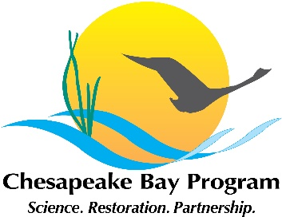
Stream Health Workgroup meeting
Friday, August 21 10:00-12:00
Microsoft Teams Meeting
Link to Join Microsoft Teams Meeting
+1 202-991-0477 Conference ID: 415 867 272#

Time | Topic and Presenter | Action Items and Points of Discussion
10:00 | Updates and Announcements – Neely Law (Fairfax County) and Julianna Greenberg (CRC) | - Updates on Co-chair search  - Reminder that next meeting will be in October  - 2020 GIT funding  - Updates to stream restoration protocol guidance  - Feedback from ChesCRS20 summit
10:15 | Chessie BIBI updates – Claire Buchanan
10:20 | USGS Stressor white paper updates – Rosemary Fanelli (USGS) and Matthew Cashman (USGS) | - Workgroup will have opportunity to provide feedback and then approve changes
10:50 | Incorporating Mussels into Bay Restoration – Joe Wood (Chesapeake Bay Foundation)
11:15 | Open discussion | - Discussion of meeting topics for October and December meetings
11:30 | Adjourn

