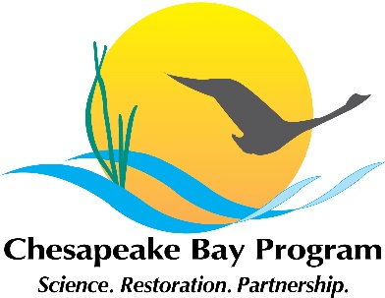
Stream Health Workgroup Meeting
April 16, 2021, 11:00-12:00
Click here to join the meeting
Or call in (audio only) +1 202-991-0477, ID: 305 023 455#

11:00 | Introductions and Announcements –Sara Weglein (MD DNR)
11:15 | Maryland Water Monitoring Council Stream Restoration Monitoring Committee – Bill Stack and Lisa Fraley McNeal (CWP)
11:25 | How to incorporate DEIJ (Diversity, Equity, Inclusion, and Justice) in to our workplan – Tuana Phillips (EPA) and Briana Yancy (CRC)
11:45 | Overview of the SRS (Strategy Review System) process – Neely Law (Fairfax County)
11:55 | Upcoming events and news (All)
12:00 | Adjourn

