Quarterly Progress Meeting Template
To be prepared by an Outcome’s lead GIT in advance of its Quarterly Progress Meeting

Step 1: Summarize your outcome.

Outcome: Riparian Forest Buffer

Continually increase the capacity of forest buffers to provide water quality and habitat benefits throughout the watershed. Restore 900 miles per year of riparian forest buffer and conserve existing buffers until at least 70 percent of riparian areas throughout the watershed are forested.

Lead and Supporting Goal Implementation Teams (GITs):

Water Quality GIT; supported by Maintain Healthy Watersheds and Vital Habitat GITs

Participating Partners:

List the partners participating in your Management Strategy and Two-Year Work Plan. Include specific federal agencies, state agencies, academic institutions, and nongovernmental organizations, where possible. If limited participation is an issue for your GIT or Workgroup, you may wish to provide the names of those individuals that represent partner agencies and organizations on your GIT or Workgroup in order to facilitate a review of membership.

- State of Delaware
- State of Maryland
- State of New York
- Commonwealth of Pennsylvania
- Commonwealth of Virginia
- State of West Virginia
- Chesapeake Bay Commission
- Farm Service Agency (U.S. Department of Agriculture)
- National Park Service
- Natural Resources Conservation Service (U.S. Department of Agriculture)
- U.S. Army Corps of Engineers
- U.S. Department of Defense
- U.S. Environmental Protection Agency
- U.S. Fish and Wildlife Service
- U.S. Forest Service
- U.S. Geological Survey
- Alliance for the Chesapeake Bay
- Baltimore Greenspace
- Cacapon Institute
- Casey Trees
- Chesapeake Bay Foundation
- Delaware Center for Horticulture
- Ducks Unlimited
- Maryland Farm Bureau Federation
- The Nature Conservancy
- Parks and People Foundation
- Pennsylvania Conservation Districts
- Pheasants Forever
- Potomac Conservancy
- Smithsonian Institution
- Stroud Water Research Center
- Tree Baltimore
- Trout Unlimited
- Virginia Agribusiness Council
- Virginia Cattlemen’s Association
- Virginia Dairymen’s Association
- Virginia Farm Bureau
- Virginia Grain Producers

Progress:

Insert a brief summary of your progress toward the Outcome. Indicate whether we are on track to achieve the Outcome, based on your expected trajectory or response.

If appropriate, your summary can include text, chart(s) and/or map(s) from ChesapeakeProgress.com and/or be communicated through an adapted version of the graphic below.

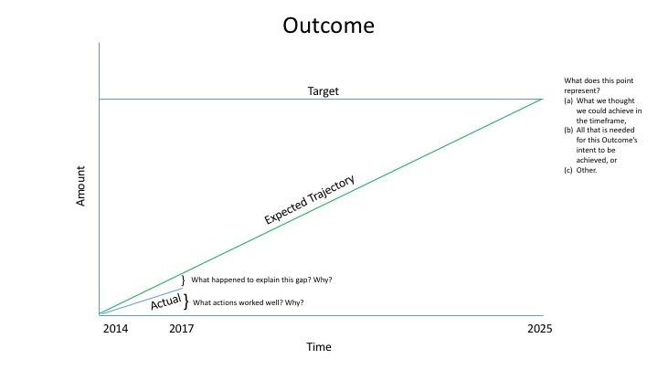

Step 2: Explain the logic behind your work toward an Outcome.

See the logic table template under “Projects and Resources” on the GIT 6 page of Chesapeakebay.net for instructions and format for documenting and explaining how your actions relate back to elements of the decision framework (see Appendix A) included in your Management Strategies.

Step 3: Craft a compelling narrative.

While the information included in Steps 1 and 2 is meant to explain the work you are doing and support the analysis that is needed to adaptively manage, the presentation you bring to your Quarterly Progress Meeting should be summarized in a compelling narrative. This narrative will allow you to:

- Summarize your Outcome, the progress you have made thus far, and whether we are on track to achieve this Outcome by the identified date.
- Explain the logic behind your work toward an Outcome, indicate the status of your management actions, and denote which actions have or will play the biggest role in making progress.
- Outline your current understanding of your management approach, the challenges you may face, the adaptations you may recommend, and the requests you may have of the Management Board for action, support, or assistance.

We recommend answering the following Adaptive Management-inspired questions in writing and using the “And, But, Therefore” story structure to present these points to the Management Board. Our Discussion and Analysis Presentation Template (.PPT) should be adapted to fit your style and needs.

What are our assumptions?

- What original assumptions did we make in our Management Strategy that we felt were important to our success?
  - What “Factors Influencing Success” were originally identified in your Management Strategy?
  - What programmatic gaps that fail to address those factors did you originally identify in your Management Strategy?
  - What were the “Management Approaches” you chose to include in your Management Strategy and Two-Year Work Plan in order to address those gaps?

Are we doing what we said we would do?

- Are you on track to achieve your Outcome by the identified date?
  - What is your target? What does this target represent (e.g., the achievement we believed could be made within a particular timeframe; the achievement we believed would be necessary for an Outcome’s intent to be satisfied; etc.)?
  - What is your anticipated deadline? What is your anticipated trajectory?
  - What actual progress has been made thus far?
  - What could explain any existing gap(s) between your actual progress and anticipated trajectory?

- Which of your management actions have been the most critical to your progress thus far? Why? Indicate which influencing factors these actions were meant to manage.

- Which of your management actions will be the most critical to your progress in the future? Why? What barriers must be removed—and how, and by whom—to allow these actions to be taken? Indicate which influencing factors these actions will be meant to manage.

Are our actions having the expected effect?

- What scientific, fiscal, or policy-related developments or lessons learned (if any) have changed your logic or assumptions (e.g., your recommended measure of progress; the factors you believe influence your ability to succeed; or the management actions you recommend taking) about your Outcome?

How should we adapt?

- What (if anything) would you recommend changing about your management approach at this time? Will these changes lead you to add, edit, or remove content in your Work Plan? Explain.

- What opportunities exist to collaborate across GITs? Can we target conservation or restoration work to yield co-benefits that would address multiple factors or support multiple actions across Outcomes?

- What is needed from the Management Board to continue or accelerate your progress? Multiple requests for action, support or assistance from the Management Board should be prioritized, where possible, and all requests should be “traceable” to the factors influencing progress toward your Outcome. Because a limited number of agencies and organizations are represented in the Management Board’s membership, we recommend naming those agencies and/or organizations that may play a key role in fulfilling your request for action, support, or assistance, in order to guide the Management Board in its work to contact, consult, or coordinate with partners.

Appendix A | Item 1: Adaptive Management Decision Framework Diagram
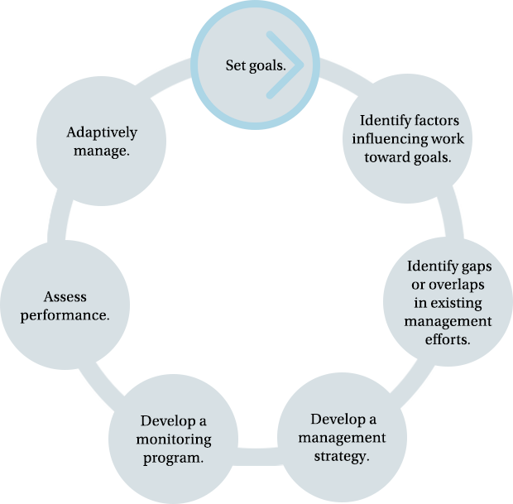

Appendix A | Item 2: Modified Decision Framework Diagram to Explain the Role of Three Indicator Types in Adaptive Management
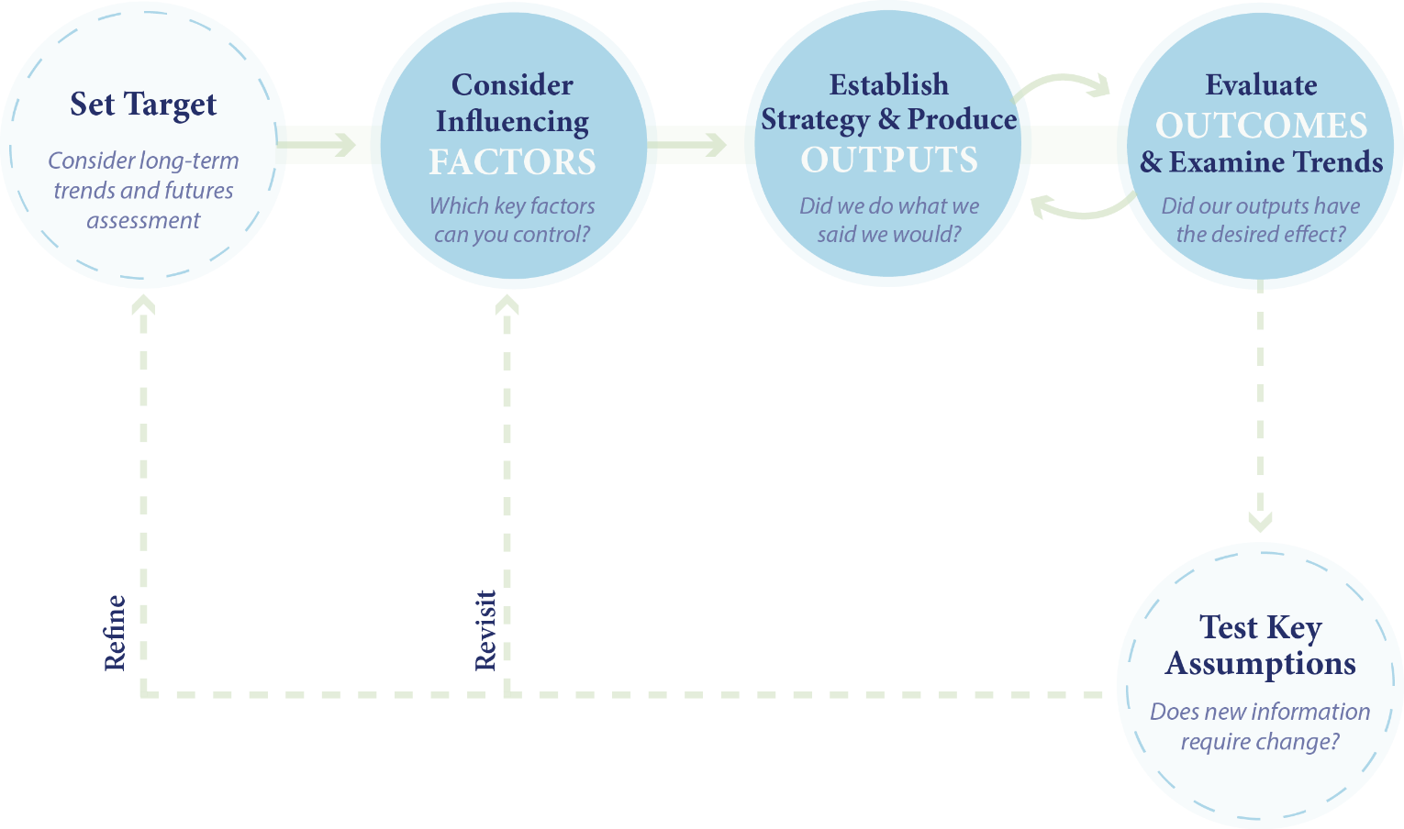
Appendix B: Guide to Influencing Factors
Use this appendix to consider factors that influence your outcome, and include significant factors in your logic table. Note: These are broad categories of possible factors. The factors you list in your Logic Table may be more specific.

Factor | Description
Public Engagement | Public comprehension of an issue and commitment to take action (which is often the basis for public pressure on legislators and resource managers).
Landowner Engagement | Landowner comprehension of an issue and commitment to take action (which is often the basis for individual actions affecting land use and best management practice implementation).
Legislative Engagement at the Federal, State and/or Local Levels | Legislative comprehension of an issue and commitment to take action (which is often the basis for actions that are necessary to set policies and commit resources to achieve a desired outcome).
Government Agency Engagement at the Federal, State and/or Local Levels | Are agency priorities and resources aligned with the Chesapeake Bay Program’s strategy to achieve a desired outcome? These are often the conditions that are necessary for Chesapeake Bay Program partners to implement work plans.
Nongovernmental Organization Engagement | Organization comprehension of an issue and commitment to take action (which is often the basis for targeted action by the group to achieve a desired outcome).
Partner Coordination | Effective collaboration and integration of federal, state, and nongovernmental organization activities to achieve a desired outcome.
Use Conflict | Competing demands or expectations for resource use (natural resources, public funds, etc.) that compromise desired outcome attainment.
Population Growth | Often marked by changing land use, increased pollution loads, and/or increased use of resources.
Scientific and Technical Understanding | Sufficient information and adequate technical tools to support informed decisions and effective action. Can be needed to support research, monitoring, modeling, or decision-guidance development.
Biota (Flora and Fauna)  e.g., Population dynamics, disease, invasive species, or range shifts | Characteristics of plant and animal populations or communities that affect the achievement of a desired outcome.
Habitat Condition  e.g., Water quality or habitat fragmentation | Changes in the quality, quantity, or distribution of the parameters that make an area suitable for a population or community.
Climate Change | Changes in temperature, precipitation, and sea level that can affect the implementation of a management actions or the achievement of a desired outcome.
Funding or Financial Resources  e.g., Funding or appropriations, external revenue, human capital, etc. | If you have identified a lack of financial resources as a factor influencing progress toward your Outcome, please review and answer the questions in Appendix B.1: Guiding Finance Questions.

Appendix B.1: Guiding Finance Questions

If you have identified Funding or Financial Resources as a factor influencing progress toward your Outcome and are requesting assistance from the Management Board in addressing this factor, please answer the following questions as part of the materials you submit before your Quarterly Progress Meeting. The answers to these questions will form the foundation of a finance system for your Outcome.

- What are the anticipated sources of revenue from outside traditional or existing revenue streams that you believe would support this work? In other words, who else cares and how do/did you identify them?
- How can existing resources work more in concert to ensure that your work is most efficient and effective? In other words, are there strategies or processes for making each dollar go further in accomplishing your goals?
- How would you know if the financial effort is successful in achieving your specific Outcome?

Appendix C: Quarterly Progress Meeting Schedule

Date | Cohort
May 10, 2018  June 14, 2018: Subsequent Management Board Meeting | Water Quality  - Toxics Contaminants Research  - Toxic Contaminants Policy and Prevention  - 2017 and 2025 Watershed Implementation Plans  - Water Quality Standards Attainment and Monitoring  - Forest Buffers
August 9, 2018  September 13, 2018: Subsequent Management Board Meeting | Climate Change and Resiliency  - Wetlands  - Black Duck  - Climate Adaptation  - Climate Monitoring and Assessment
November 15, 2018  December 6, 2018: Subsequent Management Board Meeting | Local Action  - Tree Canopy  - Local Leadership  - Land Use Methods and Metrics Development  - Land Use Options Evaluation
January 2019 | Two-Day Biennial Strategy Review System Meeting

Appendix D: Quarterly Progress Meeting Preparation and Follow-Up Timeline
Information about specific dates for specific cohorts can be found under “Projects and Resources” on the GIT 6 page of Chesapeakebay.net.

Timeframe | Activity
Before Quarterly Progress Meeting

5 weeks before Quarterly Progress Meeting | The SRS Planning Team (which is part of GIT 6) meets with the GITs and/or Workgroups in a Quarterly Progress Meeting Cohort to address issues and answer questions.
3 weeks before Quarterly Progress Meeting | Outcome Leads submit draft meeting materials to the SRS Planning Team. The SRS Planning Team and GIT 6 will provide feedback on these materials in advance of the Outcome Leads’ meeting with STAR. These materials include:  - Logic Table  - Outcome Summaries (Quarterly Progress Meeting Discussion Questions)  - PowerPoint Presentation
2 weeks before Quarterly Progress Meeting | Outcome Leads present "dry runs" of their presentations at a STAR meeting (with members of the SRS Planning Team in attendance) for review and feedback. The SRS Planning Team works with Outcome Leads to refine similar requests for action, support, or assistance from the Management Board into shared requests, where appropriate.
2 weeks before Quarterly Progress Meeting | Based on the meeting materials submitted by the Outcome Leads, the discussion at the STAR meeting, and any subsequent meeting material refinement, the SRS Planning Team prepares a "Consolidated Requests" document that presents all asks of the Management Board in a single document and highlights the shared requests that have come from multiple Outcome Leads.
2 weeks before Quarterly Progress Meeting | The Management Board Coordinator or Staffer sends the following materials to the Management Board:  - Logic Tables  - Outcome Summaries (Quarterly Progress Meeting Discussion Questions)  - PowerPoint Presentations  - Consolidated Requests Document
During Quarterly Progress Meeting

During Quarterly Progress Meeting | GIT or Workgroup Chair introduces the presenting Outcome Lead to the Management Board.  After each presentation, the Chairs of the Management Board and GIT 6 lead a discussion based on the following four questions:  - What are our assumptions?  - Are we doing what we said we would do?  - Are our actions having the expected effect?  - How should we adapt?

After Quarterly Progress Meeting

3 days after Quarterly Progress Meeting | The SRS Planning Team holds a debrief with the GITs and/or Workgroups in a Quarterly Progress Meeting Cohort.
2 weeks after Quarterly Progress Meeting | Using the Consolidated Requests document, GIT 6 further refines requests for action, support, or assistance from the Management Board, where appropriate.
4 weeks before next Management Board meeting | Management Board Coordinator or Staffer sends the following materials to the Management Board:  - Actions and Decisions from the Quarterly Progress Meeting  - Refined Consolidated Requests Document
Subsequent Management Board Meeting
A follow-up to requests and recommended actions presented at previous Quarterly Progress Meeting.

2 weeks after “Subsequent Management Board” meeting | Management Board Coordinator or Staffer sends the Management Board and the GITs and Workgroups in a Quarterly Progress Meeting Cohort a final summary of all decisions made at the two meetings.
90 days after “Subsequent Management Board” meeting | GITs submit revised Management Strategies and Two-Year Work Plans (if appropriate) based on decisions made.

Appendix E: Guidance on Updating Management Strategies and Two-Year Work Plans

Management Strategies

If it is determined during a Quarterly Progress Meeting that (a) new factors influencing the Partnership’s progress toward an Outcome should be considered or (b) management approaches should be discarded, modified, or added, changes to an Outcome’s Management Strategy may be necessary. GITs should not focus on editing the entire document, but should instead focus on editing the following sections with the following information:

- Participating Partners: Have previously unidentified agencies or organizations committed to your management approaches or actions? Are previously identified agencies or organizations no longer involved in your management approaches or actions?
- Factors Influencing Success: Have you identified new factors influencing your progress toward an Outcome? Do previously identified factors no longer impact your work?
- Current Efforts and Gaps: Have previously identified management efforts that support progress toward an Outcome—taking place within or outside of the Partnership—been modified or stopped? Have previously identified gaps been addressed?
- Management Approaches: Your management approaches should serve as high-level descriptions of the management actions that fall beneath them. Because management approaches and actions should seek to address the factors identified above, it is likely your management approaches and actions will change if you have identified new factors influencing your progress toward an Outcome or have determined that previously identified factors no longer impact your work. When describing a management approach, you are encouraged to explicitly link the approach to the factor(s) it is meant to address, in order to make your adaptive management-based logic clear (e.g., “In order to improve our understanding of SAV science and restoration techniques, build our knowledge of the impact climate change will have on SAV beds, and foster public engagement in SAV restoration and monitoring, we will enhance research and citizen involvement and education around SAV in the Chesapeake Bay watershed.”)
- Monitoring Progress: Edit this section if you have added new management approaches to this document or if your monitoring methods have changed.
- Assessing Progress: Edit this section if you have added new management approaches to this document or if your assessment methods have changed.
- Adaptively Managing: Edit this section as needed.

Two-Year Work Plans

If it is determined during a Quarterly Progress Meeting that (a) new factors influencing your progress toward an Outcome should be considered or (b) actions that support management approaches should be discarded, modified, or added, changes to an Outcome’s Two-Year Work Plan may be necessary. The Two-Year Work Plan should be linked to the Logic Table and appear in the Logic Table Appendix.

