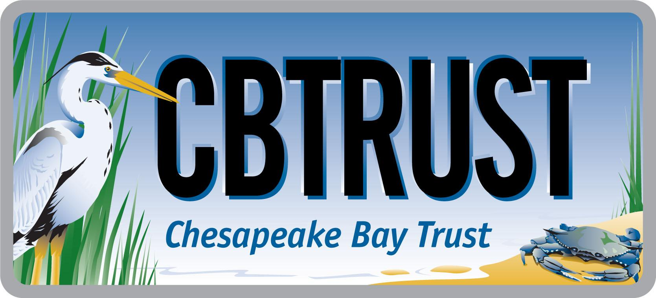
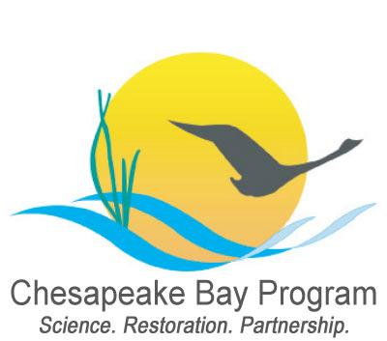

2018 Goal Implementation Team Projects Process for Project Funding and

Request for Ideas

aProposal #14a
Goal Implementation Team (GIT) | Stewardship Goal Implementation Team (GIT)
Preparer Name(s) (name(s) and email(s)) | Shannon Sprague (NOAA), Lorna Rosenberg (EPA), Britt Slattery (MD DNR), Frank Rogers (Cacapon Institute)
Proposed Project Title (10 words or less) | Quantify and support BMP installation and restoration at schools to contribute directly to Bay restoration goals
Project Type | Work Plan Implementation Project &  Metric Development and Tracking
Proposed Outcomes | Measurable increase in CBP indicators/metrics that school facilities and student projects are contributing  Increase in school district sustainability plans that reference CBP indicators/metrics; Increase in number of schools contributing to local WIP and restoration goals  Increase in BMP installation at schools  Increase student and teacher participation in watershed restoration on school grounds
Justification (500 words or less) | There are approximately 4,400 public and charter schools in the Chesapeake Bay watershed that represent hundreds of thousands of acres. However, schools are often overlooked as viable options for BMP implementation, and even when BMPs are installed this data is not often captured for Chesapeake Bay Program indicators and metrics. To better connect schools with the restoration and protection goals of the Watershed Agreement, a contractor will work with select GIT representatives and sustainable schools practitioners to compile information and geospatial data to identify the potential for BMPs on school grounds, how these projects can quantifiably contribute to water quality goals and other CBP indicators and metrics, and how school districts can work this information into planning and operations.  This will involve the contractor using information and data from existing state and national sustainable schools recognition programs, GITs and working groups of the Chesapeake Bay Program, and existing datasets along with the expertise of the Education Workgroup to better understand existing and potential opportunities for projects; work with school districts to identify barriers, best practices, needs, and challenges for implementing projects; and process this information into a set of recommendations and guidance documents for stakeholders, including state and local resource managers, GIT and workgroup staff, and school district personnel. The project will take into consideration BMP projects and resources from the National Wildlife Federation (under previous CBP funding), the Chesapeake Stormwater Network, and Prince George’s county  At the conclusion of this project, the Education Workgroup will work with the Communications Workgroup to develop an outreach strategy that builds on this work.  Specific deliverables will include:  - Data about building square footage, acreage, impervious surface, forest cover, linear feet of streams, and other relevant information  - Guidance document for state and local resource managers on how BMPs at schools can be used by states to meet Total Maximum Daily Load requirements  - Plan and methodology to account for school data in Chesapeake Bay Program metrics and indicators, including specific targets for school contributions to these metrics and indicators  - Guidelines for school district personnel on how to include BMPs in school district sustainability plans, including a discussion of the barriers to the installation, maintenance, and long-term sustainability of BMPs  - Findings report that details important data, existing gaps, and future opportunities to be used by GIT chairs and coordinators to inform their work with schools
Proposed Project Steps and Timeline | Meet with Task Lead, Education Workgroup chairs, and project team to discuss project design (January 2019)  Meet with Status and Trends Workgroup to introduce project and establish a procedure for engaging with GIT representatives (January/February 2019)  Interview GIT representatives to identify opportunities for schools to contribute to indicators and/or metrics, e.g., advance Forestry Workgroup’s Urban Tree Canopy expansion goals by planting “urban trees” and “urban forests” on school grounds (Water Quality GIT-3) (March 2019)  Identify any school district level data to be included in the 2019 Environmental Literacy Indicator Tool (a survey for all school districts) (March 2019)  Review and document existing school and land use data to determine building square footage, acreage, impervious surface, forest cover, linear feet of streams, and other relevant information as identified by the GIT representatives and Education Workgroup (March/April 2019)  Interview representatives and review data from existing state and national sustainable schools recognition programs to better understand how they are tracking related restoration/BMP data (April/May 2019)  Interview a representative sample of school districts to identify barriers, best practices, needs, and challenges for implementing projects (April/May 2019)  Develop a findings report that details important data, existing gaps, and future opportunities to be used by GIT chairs and coordinators (including Education Workgroup) to inform their work with schools (May 2019)  Present findings and recommendations to the Education Workgroup leadership team (early June 2019)  Present findings and recommendations at the mid-year Education Workgroup meeting for initial discussion about setting realistic targets for schools and tool development (June/July 2019)  Produce a plan and methodology to account for school data in Chesapeake Bay Program metrics and indicators, including specific targets for school contributions to these metrics and indicators (August/September 2019)  Produce guidance document for state and local resource managers on how BMPs at schools can be used by states to meet Total Maximum Daily Load requirements (September/October 2019)  Work with relevant GIT representatives and Education Workgroup members to develop guidelines for school district personnel on how to include BMPs in school district sustainability plans, including a discussion of barriers to BMP installation (October/November 2019)
Estimated Costs | $69,600
Cross-Goal Benefits | Increase in school contributions to indicators/metrics across the program;  Increase opportunities for students to participate in real-world restoration/stewardship practices (improves educational value and student’s sense of contribution);  Improve public understanding of BMPs that they can implement;  Meaningful opportunities for GITs to engage with students.  In addition to the Stewardship GIT, the following groups have indicated strong support for this project: Status and Trends Workgroup; Forestry Workgroup
Proposed GIT Technical Project Lead (name and email) | Lorna Rosenberg  rosenberg.lorna@epa.gov

