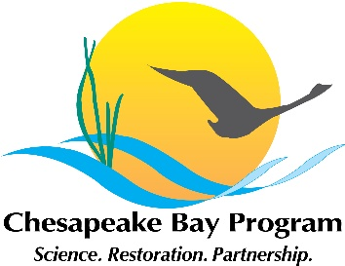
Chesapeake Bay Program Stream Health Workgroup meeting
February 2, 2020 10am-12:00pm
Fish Shack Conference Room, 410 Severn Ave, Annapolis, MD 21401
Call: +1-929-205-6099, ID: 693-871-927
Zoom URL: https://zoom.us/j/693871927

 | Topic and presenter | Action items and points of decision
10:00 | Introductions and announcements – Co-chairs Neely Law (Center for Watershed Protection) and Matt Meyers (Fairfax County)
10:05 | Stream Restoration Permitting – Josh Burch (DC DOEE) | - Final comments to Julianna by March 2  - Identify points of contact in your agency or firm who can complete the survey
10:35 | USGS Stressor updates – Rosemary Fanelli (USGS), Neely Law Matt Meyers | - Provide Rosemary with papers and documents relevant to stressor literature review  - Provide points of contact with in State /District agency for Interview/survey
11:05 | Stream Health Indicator Discussion – Claire Buchanan (ICPRB), Kelly Maloney (USGS) | - Does the workgroup agree to evaluate the metric used to measure progress? (Affirming previous decision by workgroup)  - Decision to form an Action Team to provide recommendations to the SHWG and Partnership to change or keep the SH indicator
11:45 | Chessie BIBI status update – Claire Buchanan | - Send Claire information for the Chessie BIBI
11:55 | Wrap up and next steps – Neely Law and Matt Meyers

