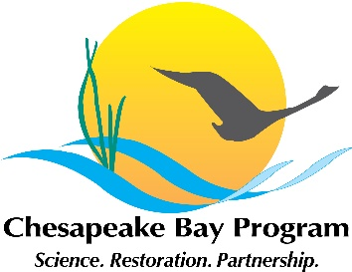
Chesapeake Bay Program Stream Health Workgroup meeting
May 15, 2020 10am-12:00pm
Microsoft Teams Meeting
Link to join Webinar
+1 202-991-0477 United States, Washington DC (Toll)
Conference ID: 428 300 847#

 | Topic and presenter | Action Items and points of decision
10:00 | Introductions and announcements – Neely Law (Fairfax County)  - Vacant Co-chair position
10:15 | Chessie BIBI Updates and Action Team - Claire Buchanan (Interstate Commission on the Potomac River Basin) | Will provide another update at the February Meeting
10:20 | Stream Permitting Survey Updates – Julianna Greenberg (Chesapeake Research Consortium) | Continue to send Julianna the correct point of contact for your agency or group.
10:25 | USGS Stressor Update – Rosemary Fanelli (USGS)  - Progress update
10:55 | Stream Health Metric Discussion – Neely Law  - Initiating ideas and discussion for GIT funding and to advance 2021 Workplan ideas
11:25 | GIT Funding Ideas – Neely Law  - Stream Health Metrics  - Riparian Corridors | Submit ideas for GIT funded projects to the Habitat Goal Team for approval by June 15
12:00 | Adjourn

