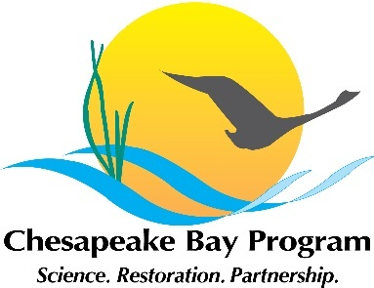
Stream Health Work Group Meeting
October 25, 2019 10am-12:00pm
Conference room 305, 410 Severn Avenue, Annapolis, MD 21401
https://www.chesapeakebay.net/what/event/stream_health_workgroup_meeting6
Meeting url: https://zoom.us/j/332689614
Dial: +1 929 205 6099, Meeting ID: 332 689 614

 | Topic of Discussion | Actions needed
10:00 | Introductions and announcements – Co-chairs Neely Law and Matt Meyers  - November 6-7 Habitat GIT meeting
10:05 | Overview of changes to the stream health Logic and action table and management strategy | - Approval of/comments on management strategy  - Approval of/ comments on logic and action table
10:45 | Chessie BIBI  - Claire Buchanan will provide an update on the data call and the timeframe for this work  - Analysis of regional stream conditions – Kelly Maloney
11:00 | Stressors and Stream Health  - Overview of proposed scope of work - Rosemary Fanelli  - Current research on response of streams to management actions - Greg Noe | - Approval of the scope of work
11:45 | Update on stream restoration permitting  Matt Meyers and Josh Burch will present an overview of the stream restoration permitting survey and request that the membership identify participants to complete the survey | - Feedback on survey content from membership  - Identify which members and interested parties will complete the stream restoration permit survey
12:00 | Next steps and Adjourn | - Date for next quarterly meeting

