
Toxic Contaminants
Principles for Phase III Watershed Implementation Plans

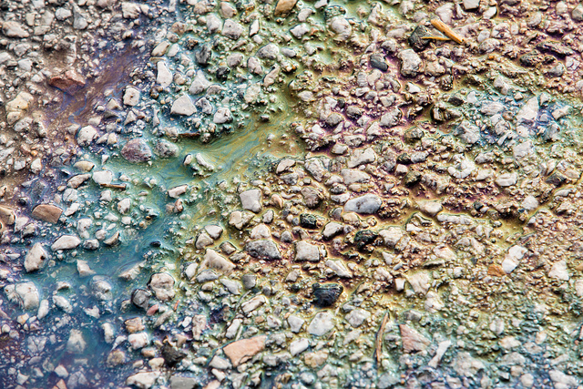
An oily sheen colors asphalt at a commercial complex in northwest Baltimore on Jan 24, 2017. When it rains, chemical contaminants and trash that have collected on pavement and other impervious surfaces can get washed into local streams.

Vicki Blazer of the U.S. Geological Survey leads a field survey of smallmouth bass from the Shenandoah River. Blazer's team has observed the effects of pesticides, pharmaceuticals or other chemicals that disrupt the hormonal systems of smallmouth bass.
Managing Toxic Contaminants to Protect Fish,
Wildlife and People
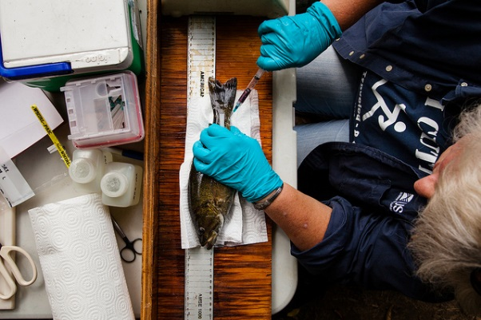
Toxic Contaminants are a Public Health Risk to People and Harm Fish and Wildlife. Toxic contaminants, primarily high levels of polychlorinated biphenyls (PCBs) and mercury, lead to advisories on the amount of fish people should consume from the Chesapeake Bay and its tributaries. Some contaminants can increase cancer risk (PCBs, polycyclic aromatic hydrocarbons (PAHs)). Other contaminants (e.g., mercury) can cause developmental and neurological damage in humans, especially children. Toxic contaminants have shown to cause health and reproductive problems in fish and wildlife. Because of these concerns the Chesapeake Bay Program Partnership developed a goal to reduce the impacts of toxic contaminants.
Urban Toxic Contaminants (UTCs), Ecological and Human Health: UTCs such as PCBs, PAHs, and mercury can negatively impact living resources and affect human health through consumption of contaminated fish and seafood and exposure to airborne contaminants. These UTCs are often related to industrial, commercial and transportation-related sources. The contaminants impact aquatic ecosystems through association with urban runoff, atmospheric deposition and previously contaminated sediment.
Stormwater Management and Sediment Control: Many toxic contaminants, especially UTCs (PCBs, PAHs, mercury) tend to associate with sediment and originate in urban and industrial areas where they are transported into the ecosystem through contaminated sediment in stormwater. Thus, any best management practice (BMP) that controls or traps sediment and prevents stormwater runoff can aid in preventing release of UTCs into waterways and aquatic ecosystems.
Agriculture-associated Contaminants and Ecological Health: Chemical contaminants associated with agricultural crop lands and animal production, include biogenic hormones (from animal manure), veterinary pharmaceuticals and antibiotics, herbicides and other pesticides. Mixtures of these chemicals have been shown to harm stream conditions, fish health and local biodiversity.
Agriculture Practices: BMPs on agricultural land that control nutrients and sediment also trap herbicides, pesticides, biogenic hormones, and pharmaceuticals from crop land and animal operations and prevent them from entering the Bay and its tributaries.

Best Management Practices for Toxic Contaminants Management*
Best Management Practice | Urban Pollutants | Agricultural Pollutants | Additional Co-Benefits
Best Management Practice | Urban Pollutants | Agricultural Pollutants | Stream Health** | Forage Fish** | Citizen Stewardship**
Ag Forest Buffer |  | 4 | 2 | 2 | 0
Streamside Forest Buffers |  | 3 | 2 | 2 | 0
Narrow Forest Buffer | 3 | 3 | 2 | 2 | 0
Runoff Reduction | 2.5 |  | 3 | 2.5 | 0.5
Wet Ponds | 2.5 |  | 1.5 | 2.5 | 1
Urban Forest Buffers | 2.5 |  | 4 | 3 | 2
Filtering Practices | 2 |  | 2 | 3 | 1.5
Infiltration Practices | 2 |  | 2.5 | 3 | 2
Dry Ponds | 2 |  | 1 | 1 | 1.5
Bioretention | 1.5 |  | 3 | 2.5 | 4.5
*Values were taken from a Tetra Tech study evaluating BMP effects on outcomes on a scale of +5 (very beneficial) to -5 (very harmful). Values were averaged estimates from various Chesapeake Bay Program Partnership workgroups and reports, based on best professional judgement. Scores are not based on empirical research on BMP performance related to co-benefits.
*Recent research indicates that upgrades to municipal wastewater treatment plants (WWTPs) can significantly reduce PCB loads in wastewater effluent. In addition to the nonpoint source BMPs above, enhanced nutrient removal upgrades to WWTPs may have significant co-benefits for toxic contaminants management.
**Stream Health, Forage Fish were selected for inclusion in the co-benefits table due to recognized effects of contaminants on fish health and fish habitat. Citizen Stewardship was selected for inclusion because raising stakeholder awareness is important to gain public support for managing toxic contaminants.

Guiding Principles for Incorporating Contaminants Management into Phase III WIPs
WIP Development
- Target areas with known legacy contaminants, often historically urban and industrial sites. One primary focus is PCBs, which were banned from production in the 1970s. However, PCBs are very environmentally stable and persist in sediments associated with contaminated land.
- Emphasize BMPs that trap sediments and associated contaminants, particularly in areas that flood or erode.
- Consider practices to reduce agriculture-associated contaminants. Contaminants, associated with pesticides and manure can enter waterways through agricultural runoff and contaminate drinking water.
- Consider toxic contaminants management in a local area planning goal. To reduce the impacts of toxic contaminants, consider inclusion of activities to mitigate that risk in your jurisdiction’s phase III WIP.
- Target waste water treatment plant upgrades for both significant and nonsignificant municipal treatment plants. PCBs, pharmaceuticals and contaminants related to personal care products enter local waters from treatment plant effluent.

Tools and Resources
WIP Implementation
    - Environmental justice is an important consideration for toxic contaminants management. It has been established that many UTCs are concentrated in historically diverse and underserved communities. Members of these communities should be engaged in the planning and implementation of practices to manage toxic contamination.
    - When implementing cover crop BMPs and other agricultural practices that use herbicides, use practices that minimize the risk of runoff and groundwater contamination, such as buffers and proper application rates and procedures.
    - Combine BMP implementation efforts with traditional contaminant regulatory measures where there are local TMDLs and permits for toxic contaminant reduction.
    - Partner with local governments, NGOs and local stakeholders on approaches that provide co-benefits for reduction of contaminants, nutrients and sediment.
    - Plan for effects of climate change: Consider impacts of climate change-related phenomena such as flooding and increased storm frequency and severity when siting, designing, and maintaining BMPs.

- Toxic Contaminants Workgroup Chesapeake Bay Program page
- Report: Quantification of BMP Impact on Chesapeake Bay Program Management Strategies and Link to Co-benefits scoring
- Chesapeake Stormwater Network Report: Part One (Urban Contaminants) and Part Two (Agriculture and Wastewater Contaminants)
- Interactive Maps:
  - Tidal Chesapeake Bay Chemical Contaminants Indicator Map (2016 update)
  - PCB TMDL Map (2015 update)
- Link to Chesapeake Assessment Scenario Tool (CAST)
  - Resources for PCB TMDLs: Maryland | Virginia | Washington, DC
Contacts for More Information about Toxic Contaminants in Your Jurisdiction
Jurisdiction | Website | Lead | Email
Delaware | Division of Water | John Hayes, DNREC | John.hayes@state.de.us
D.C. | Chesapeake TMDL and Toxic Substances page | Aaron Waters, DOEE | aaron.waters@dc.gov
Maryland | MDE Chesapeake Bay TMDL Center and WIP Development Resources | Len Schugam, MDE | leonard.schugam@maryland.gov
New York | Water Pollution Management | Jackie Lendrum, NYS DEC | Jacqueline.lendrum@dec.ny.gov
Pennsylvania | Bay TMDL and WIP Resources | Amy Williams  Tom Barron | amywilli@pa.gov
Virginia | Bay TMDL page | Mark Richards, VA DEQ | Mark.Richards@deq.virginia.gov
West Virginia | Bay TMDL Resources | John Wirts | John.C.Wirts@wv.gov
Delaware River Basin Commission | Water Quality and Toxic Pollutants | Greg Cavallo, DRBC | Greg.Cavallo@drbc.nj.gov
CBP | Toxic Contaminants Workgroup | Greg Allen, EPA | Allen.greg@epa.gov

