Release Date: NOVEMBER 16, 2016
A new USGS study shows non-native Brown Trout can place a burden on native Brook Trout under the increased water temperatures climate change can cause.
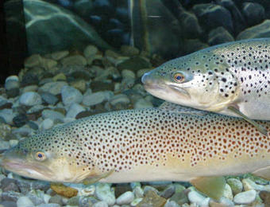
Two Brown Trout swiming through a stream. Photo by U.S. Fish and Wildlife Service.
A U.S. Geological Survey study published today combines climate change and invasive species research by examining how native Brook Trout interact with non-native Brown Trout under rising stream temperatures.
During the study, which is one of the first experimental studies linking climate change and invasive species biology, researchers found that non-native Brown Trout limited the ability of Brook Trout to utilize warmer stream temperatures. In contrast, removal of Brown Trout expanded Brook Trout’s reach into warmer waters.
Brook Trout is a freshwater fish species native to eastern North America and threatened by climate change because of its requirement for cold stream temperatures. Brown Trout are native to Europe and have been introduced throughout much of the territory of native Brook Trout.
“We know streams are warming due to climate change and non-native species are becoming increasingly abundant in many places,” said Nathaniel Hitt, U. S. Geological Survey research fish biologist. “We wanted to understand how these changes may synergistically affect native Brook Trout, a species of cultural and economic importance in eastern North America.”
Through the research, it was discovered that native Brook Trout were less resilient to climate change compared to the invasive Brown Trout because the native fish has less tolerance to higher water temperatures. Since the food sources were located in the warmer waters during the study, the Brook Trout’s ability to feed was reduced while in the presence of the Brown Trout.
However, researchers found that when the Brown Trout were removed from the experiments, the Brook Trout were able to regularly enter the warmer waters to forage for food. This indicated to scientists that Brook Trout can utilize the warmer waters climate change is likely to produce, but that ability is limited when Brook Trout share habitat with Brown Trout.
“Our research indicates that reducing Brown Trout numbers can benefit native Brook Trout where the species co-occur,” Hitt said. “Moreover, Brown Trout management could help Brook Trout be more resilient to anticipated effects of climate change.”
The study was conducted at the USGS Experimental Stream Laboratory at the Leetown Science Center in Kearneysville, West Virginia. This facility enabled researchers to control stream temperature and Brown Trout presence in a series of replicated stream channels. Using underwater video sampling, scientists were able to evaluate Brook Trout responses to water temperature change in the presence and absence of Brown Trout.
“Our study shows that climate change and non-native species should be considered in tandem when evaluating effects on native fish,” Hitt said. “In many cases these changes are happening simultaneously, so we need interdisciplinary research such as this study to anticipate how these changes will interact in the future.”
This study was published in the Canadian Journal of Fisheries and Aquatic Sciences and can be accessed here: http://www.nrcresearchpress.com/doi/abs/10.1139/cjfas-2016-0255.
The study was supported by the USGS Fisheries and Environments Programs. The USGS provides science to inform restoration of the Chesapeake Bay and its watershed. For more information visit http://chesapeake.usgs.gov.

