Wastewater Projection for 2025
In the past, we have used the most recent year as the baseline to project future wastewater loads with the scheduled upgrades and the future population forecasts. Following are two charts showing the wastewater TN and TP EOS loads by year with the trend lines pointing down. When most of the TMDL permit limits have become effective in recent years, we expect that most of the significant facilities have completed their upgrades and the down trends of wastewater loads will soon stop and the population growth impact will take over as the major factor on the future projection.
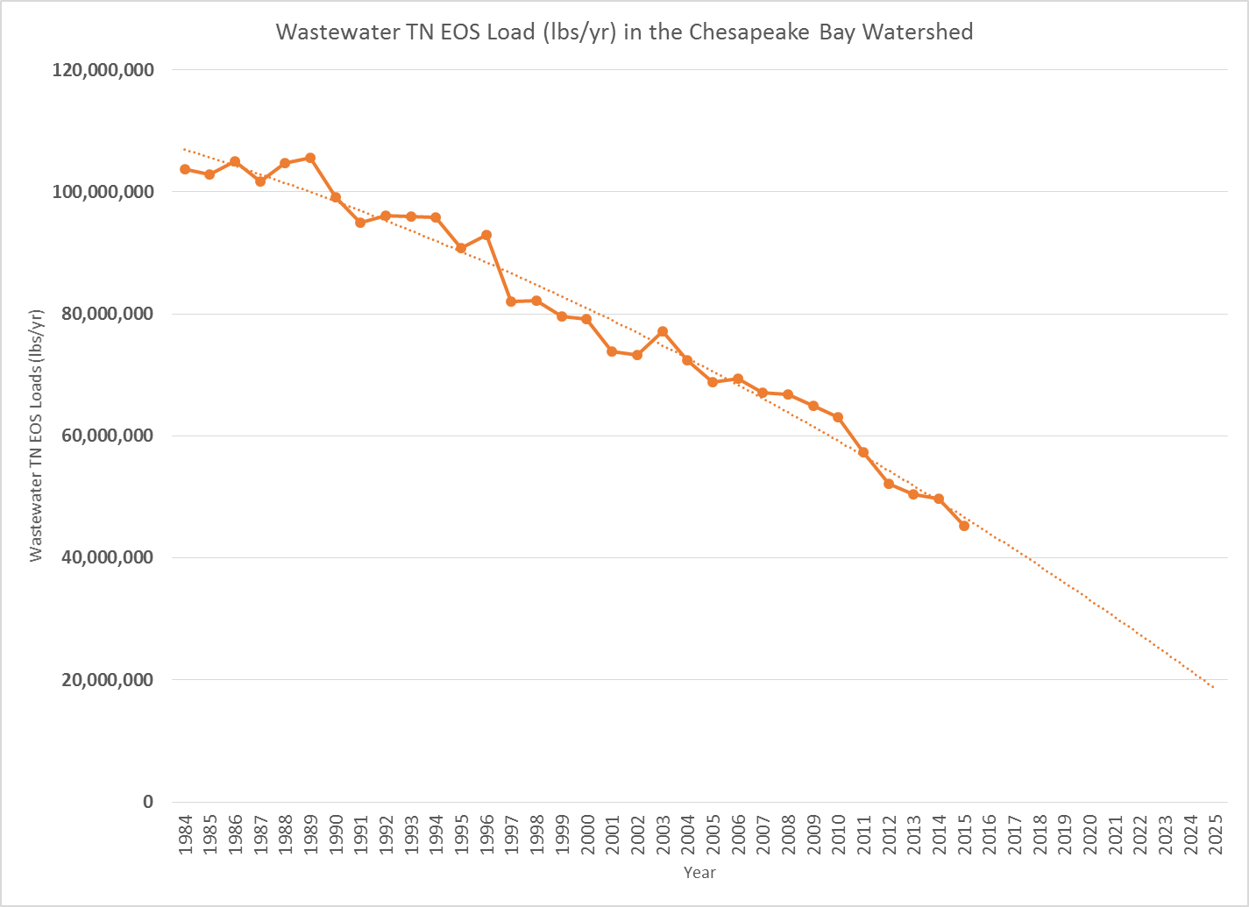
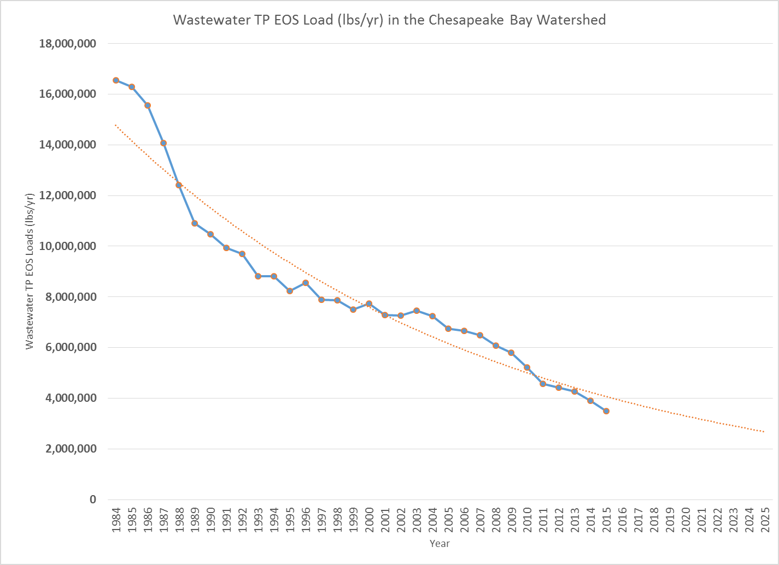
Assumptions:
Since we are still on a down trend, it is reasonably safe to use the most recent year as our projection baseline for treatment level. We can assume that there will be no changes in treatment from the baseline unless there are scheduled upgrades in the future. Flow baseline is based on the average flow of recent three years. Growth impact will be reflected in the flow projection that increases or decreases by the same ratios as population changes from the baseline year. We assume that there is no growth impact on industrial plant loads. Industrial plants will use the average loads of recent three years as baselines with no changes into the future unless there are planned upgrades.
Municipal plants
- Concentration:
The projected concentrations will be the baseline concentrations or base on the upgraded treatment levels if there are scheduled upgrades in the future.
- Flow:
  - The future wastewater flow is assumed to increase or decrease from the recent three year average in the same ratios as the population projection changes from the baseline year. The population data is by the counties that the plants serve.
  - If some plants are expanding, their future flows will be their new design flows because we do not have the baselines for expanding plants.

- New Plants: The permit limits and design flows will be used for new facilities planned to be built.

Industrial Plants

- We will use the average loads of recent three years as baselines with no changes into the future unless there are scheduled upgrades.
- If there are scheduled upgrades in the future, the upgraded levels will be the projections.
- The permit limits will be used for new industrial plants planned to be built.

The WIP loads are the projection ceilings

