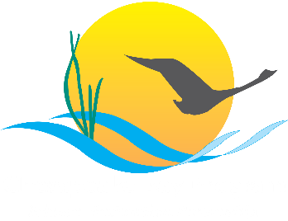

Diversity Outcome

Management Strategy

2015–2025, v.1

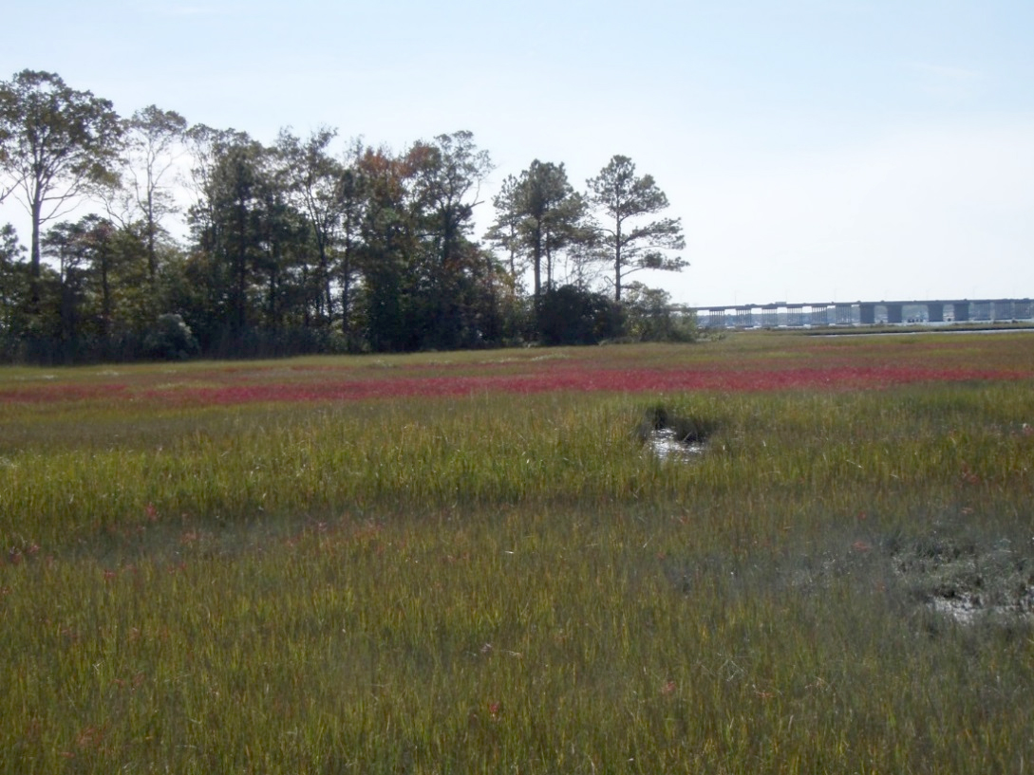

Wetlands Outcome

Management Strategy

2015–2025, v.1

Introduction
Wetlands provide a wealth of functions and services to support a healthy Chesapeake Bay ecosystem and support the needs of people in the watershed. They are thriving habitats for a diversity of species including birds that migrate along the Atlantic Flyway and fish and juvenile blue crabs that spawn and take shelter in coastal wetlands. Chesapeake wetlands provide world-class hunting, kayaking, and bird watching opportunities that greatly contribute to the regional economy and quality of life. Tidal wetlands can help stabilize shorelines, control erosion and buffer inland and coastal communities from the costly damages associated with floods and storm surge. Wetlands act as natural filters by absorbing nutrients and sediment from overland flow and shallow groundwater before it enters the Bay, and some also provide groundwater recharge. Over the long-term, organic, saturated wetland soils store carbon from the atmosphere and help offset greenhouse gas emissions.
Wetland restoration is a credited best management practice (BMP) in the Chesapeake Bay Program’s watershed model (16.75 average percent reduction/acre for nitrogen, 32.18 average percent reduction/acre for phosphorus, and 9.82 average percent reduction/acre for sediment). Both restoration and enhancement are intended to provide a range of benefits (including both habitat and water quality improvements) that are dependent on wetland type and landscape position. For purposes of clarity and accuracy, restoration, which results in an actual gain of wetland acreage, is tracked separately from enhancement, which results in gains in function of existing wetlands. Wetland restoration where wetlands historically existed is typically more successful than wetland creation where wetlands never existed

Goal, Outcome and Baseline
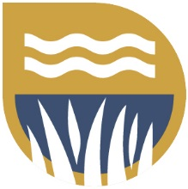
This management strategy identifies approaches for achieving the following goal and outcome:
Vital Habitats Goal
Restore, enhance and protect a network of land and water habitats to support fish and wildlife, and to afford other public benefits, including water quality, recreational uses and scenic value across the watershed.
Wetlands Outcome
Continually increase the capacity of wetlands to provide water quality and habitat benefits throughout the watershed. Create or reestablish 85,000 acres of tidal and nontidal wetlands and enhance the function of an additional 150,000 acres of degraded wetlands by 2025. These activities may occur in any land use (including urban) but primarily occur in agricultural or natural landscapes.

Baseline and Current Condition
The progress of the Wetlands Outcome is measured from zero acres starting in 2010 when Watershed Implementation Plans (WIPs) were adopted by the states. Between 2010 and 2013, 6,098 acres of wetlands were established, rehabilitated or reestablished on agricultural lands (including cropland, pasture, fallow fields, and forests) in the Chesapeake Bay watershed.

Participating Partners
Team Lead: Habitat Goal Implementation Team
Workgroup Lead: Wetland Workgroup
Opportunities for Cross-Goal Team Collaboration:
Habitat Goal Implementation Team
  - Black Duck Action Team
Maintain Healthy Watersheds Goal Implementation Team
  - Healthy Watersheds Outcome Team
  - Land Use Options and Evaluation Outcome Team
Water Quality Goal Team
  - Forestry Workgroup (Riparian Forest Buffer Outcome)
Fostering Chesapeake Stewardship Goal Implementation Team
  - Protected Lands Outcome Team
  - Environmental Literacy Outcome Team
Enhancing Partnering, Leadership and Management Goal Implementation Team
  - Local Leadership Outcome Team. Local governments, watershed associations, county conservation districts, nonprofits, and the private sector all play a role in this strategy. Specifically, they provide outreach to landowners, identify and work with interested landowners, and provide technical expertise and resources
Active Current Participation and Role (Signatory Agencies in Bold):
Level of Participation: High (actively involved in drafting the Management Strategy)
  - Maryland Department of Natural Resources (MD DNR)
  - The Nature Conservancy
  - Maryland Department of the Environment (MDE)
  - U.S. Fish and Wildlife Service (USFWS)
  - Natural Resources Conservation Service, Maryland
  - U.S. Army Corps of Engineers (USACE)
Level of Participation: Medium (actively involved in reviewing the draft documents)
  - Delaware Department of Natural Resources and Environmental Control
  - Pennsylvania Department of Environmental Protection
  - Virginia Department of Conservation and Recreation
  - Virginia Department of Environmental Quality
  - West Virginia Division of Natural Resources
  - Upper Susquehanna Coalition
  - U.S. Environmental Protection Agency (EPA), Region III
  - U.S. Geological Survey (USGS)
  - Virginia Institute of Marine Science
  - Biohabitats, Inc.
Level of Participation: Low (generally interested in the development of the Management Strategy)
  - District of Columbia Department of the Environment
  - Virginia Governor’s Office
  - Chesapeake Bay Commission
  - Chesapeake Bay Program
  - U.S. Department of Agriculture
Delaware
Maryland
Pennsylvania
Virginia
  - West Virginia
  - Chesapeake Bay Foundation
  - Troutman Sanders
  - Virginia Agribusiness Council

Factors Influencing Success
There are many social, political, and programmatic factors that influence the rate and success of implementing wetland restoration projects. Understanding the following factors will help conservation and agency partners to formulate key policy, technical, and socioeconomic solutions and to target restoration efforts where they provide the greatest benefit:
- Funding
Funding must be dedicated for wetland restoration and enhancement implementation, and technical staff to manage these projects, if the Wetlands Outcome is to be met.
- Landowner Willingness/Marketing and Outreach
Increasing and incentivizing landowner willingness is essential to the success of wetland restoration and enhancement. There is a strong need to better understand the obstacles to landowner participation, including interest and eligibility to enroll in existing programs, economic implications, the effectiveness of current outreach efforts, and other social and political factors to restoring wetlands. A few states are experiencing competition for wetland restoration from mitigation banks.
- Inaccurate and Incomplete Reporting
The Wetland Workgroup is not confident that all wetland restoration projects are being reported to the Chesapeake Bay Program and that some of the reported information may be inaccurately categorized.
- Understanding of Importance of Restoration among Decision-Makers
Conflicting state priorities can impede restoration efforts. Wetland restoration needs to be elevated as a consistent priority to meet multiple environmental and societal problems such as water quality, reduced wildlife habitat, flood resiliency, and climate change. Decision-makers should emphasize the ecosystem services provided by these wetlands and the need to protect and restore wetlands to increase these services.
- Technical Understanding among Restoration Practitioners
Funding does not always exist for technical training or for sufficient technical staff to deliver wetland restoration projects. A series of technical publications specific to wetland restoration on the Chesapeake Bay and/ or a series of workshops would be useful to train practitioners on wetland pollutant removal rates for different wetland landscape scenarios, new and innovative design criteria, effective outreach efforts, and how to integrate multiple programs to provide multiple benefits (e.g., tree plantings to meet afforestation goals, grass buffers and wetland restoration for habitat and water-quality benefits).
- Climate Change
Changing weather patterns and storm intensity result in increased overland flow that must be absorbed by wetlands. One of the more significant impacts from climate change is wetlands loss due to sea level rise. Sea level rise threatens to inundate many coastal wetlands. Tidal wetland losses will be greater if no migration corridor exists due to development or other barriers.

Current Efforts and Gaps
Partners in the Chesapeake Bay Program’s Wetland Workgroup have been working together to protect and restore the watershed’s wetlands for more than 30 years. Following are primary programmatic efforts being taken by partners to achieve the Wetland Outcome:
Current efforts:
- NRCS Wetland Easement Program (WRE) - The NRCS Agricultural Conservation Easement Program, Wetlands Reserve Easement (WRE) component is a voluntary program that provides an opportunity for landowners to receive financial assistance to enhance wetlands in exchange for retiring marginal land from agricultural. WRE provides technical and financial assistance to eligible landowners to address wetland, wildlife habitat, soil, water, and related natural resource concerns on private lands in an environmentally beneficial and cost-effective manner.
- Farm Service Agency Conservation Reserve Enhancement Program (CREP) - CREP is an offshoot of the Conservation Reserve Program (CRP), the country’s largest private-land conservation program. Administered by the Farm Service Agency (FSA), CREP targets high-priority conservation issues identified by local, state, or tribal governments or non-governmental organizations. In exchange for removing environmentally sensitive land from production and introducing conservation practices, farmers, ranchers, and agricultural land owners are paid an annual rental rate. Participation is voluntary, and the contract period is typically 10–15 years, along with other federal and state incentives as applicable per each CREP agreement.
- USFWS Partners for Fish and Wildlife Program - The Partners for Fish and Wildlife Program was established in 1987 with a core group of biologists and a small budget for on-the-ground wetland restoration projects on private lands. This successful, results-oriented program has garnered support through the years and has grown into a larger and more diversified habitat restoration program assisting thousands of private landowners across the Nation. Click here for a history of the Partners for Fish and Wildlife Program.
- North American Wetland Conservation Act (NAWCA) grants - The North American Wetlands Conservation Act (Act, or NAWCA) of 1989 provides matching grants to organizations and individuals who have developed partnerships to carry out wetlands conservation projects in the United States, Canada, and Mexico for the benefit of wetlands-associated migratory birds and other wildlife.
- National Oceanographic and Atmospheric Administration (NOAA) - The Nature Conservancy (TNC) and NOAA have developed a Habitat Prioritization Tool for coastal areas. The Chesapeake Bay Habitat Tool provides spatial context for multi-habitat conservation opportunities in the Bay. Features of the tool include: A web map with Bay-wide data for important near shore habitats, new benthic data layers to better describe the habitat on the Bay floor, and an interactive tool to prioritize wetland protection and restoration. Potential applications of the Habitat tool include developing place-based habitat conservation plans to meet multiple objectives, and identifying locations where natural infrastructure can support coastal resiliency
- US Army Corps of Engineers - Under its ecosystem restoration mission, USACE restores wetlands, riparian and other floodplain, and aquatic habitats with an emphasis on native species. USACE undertakes ecosystem restoration as single purpose projects or as components of multiple purpose projects that may include navigation, flood damage reduction, coastal storm damage reduction, and other purposes. USACE wetlands restoration projects are cost-shared between the federal government and a nonfederal sponsor (state, municipal government, port authority, etc.). Cost capability is a function of the nonfederal sponsor fiscal resources and the program or authority limit. The Chesapeake Bay watershed is a national priority for USACE restoration efforts. USACE wetlands restoration projects constructed and in-construction in the Chesapeake Bay watershed range in size from several acres, such as in Upper Marlboro, to hundreds of acres, such as at Poplar Island, with costs of these examples ranging from millions to hundreds of millions of dollars, respectively. USACE undertakes wetland restoration projects for the purpose of habitat restoration and does not cost share projects that focus solely on water quality.
- US Geological Survey - USGS has existing studies of the effects of climate change on coastal wetlands. USGS has employed equipment at over 200 sites to accurately measure relative sea-level rise near Blackwater Refuge and other coastal wetlands. USGS studies are 1) assessing long-term changes in wetlands due to climate change, 2) modeling marsh migration due to sea-level rise and land-use change; and 3) assessing near-shore habitats for waterbird use to determine the optimal shoreline type (part of a joint project with NOAA). USGS is also involved in studies of freshwater wetlands with a research on the natural water-quality functions of wetlands, and on the level of performance and optimization of design for water-quality benefits. This research on both natural and created/restored wetlands helps with targeting management actions in the watershed. USGS can provide technical support, using the Chesapeake Land Change Model, to forecast areas where development may cause loss of wetlands. In support of the Wetlands and Black Duck Outcomes, USGS is also starting an investigation to assess potential loss/migration of marshes due to sea-level rise.
- The Nature Conservancy – Through our state chapters in each of the Bay states, TNC restores and protects wetlands on our preserves and private lands. TNC uses a science-based approach to assess restoration opportunities across the different landscapes, prioritize locations that will achieve the greatest water quality and habitat benefits, and then perform targeted outreach to priority landowners to offer a suite of restoration options through public and private programs.
- Ducks Unlimited - DU is a non-profit organization working toward the goal of wetland habitat sufficient to support sustainable North American waterfowl populations. Founded in 1937, DU delivers wetland conservation projects on private and public lands across the entire North American continent, including all six Chesapeake Bay Watershed states. DU's priorities within the watershed include high use waterfowl areas such as the tidal portions of the Western Shore of Virginia and Maryland, the Lower Susquehanna River, and the Delmarva Peninsula. DU achieves its conservation mission through diverse partnerships with other non-profits, government agencies, foundations, corporations, individuals and others. Specific DU conservation programs vary within each state and are dependent upon funding sources and scientific guidance.
- Maryland Department of the Environment - MDE implements regulatory programs for waterways, tidal and nontidal wetlands and authorizes restoration projects in regulated waters and wetlands. MDE has undertaken numerous actions to expedite review of restoration projects. MDE offers pre-application consultation and field visits to help expedite review of restoration projects in regulated resources. In addition, MDE has sample drawings and siting guidance for “living shoreline” tidal wetland projects. MDE requires living shorelines, typically tidal marsh creation, for shoreline stabilization unless applicants demonstrate through a waiver process that a living shoreline would be unsuitable or ineffective. MDE has worked with the U.S. Army Corps of Engineers (USACE) and the Natural Resources Conservation Service (NRCS) to develop a streamlined application form for NRCS restoration projects. MDE and the USACE are currently revising their joint application to include special sections and instructions for non-NRCS restoration projects. MDE is hiring additional staff to focus on restoration projects to provide more efficient review of restoration proposals. MDE also provides review and comments on proposed Chesapeake Bay Trust Fund projects to identify and potentially resolve regulatory issues early in the project planning process.
Gaps:
Tracking Wetland Restoration and Enhancement
There is a clear need to streamline wetland restoration and enhancement tracking and to improve the accuracy of the data reported. The Wetland Workgroup is working with National Environmental Information Exchange Network (NEIEN) contacts in each state to develop a clear and transparent process of how information flows from practitioners to the NEIEN database and to improve the accuracy of wetland restoration practice reporting. Another concern is that NEIEN is not currently adequate for certain functional gains which are not BMP’s, such as nutria eradication or Phragmites removal (enhancement projects). Trainings for state NEIEN contacts and restoration practitioners will be included in the biennial workplan to be developed in association with this strategy.
In many nontidal wetland situations, uplands and wetlands exist in a mosaic. Restoration of wetland/upland complexes could potentially be credited as a block. This would remove the arduous task of teasing out hydric and nonhydric soils. However, this may prove difficult due to code requirements.
Funding
Dedicated funding for restoration and enhancement implementation is not sufficient to meet the Wetland Outcome goals. A great example of a state funding source that can be used to leverage existing funds and supplement ongoing efforts is the Chesapeake and Atlantic Coastal Bays Trust Fund in Maryland. The Trust Fund was created to support the implementation of projects that reduce non-point source pollution and reach Total Maximum Daily Load (TMDL) and local WIP goals. The source of funding is Maryland’s motor fuel tax and rental car tax. The Trust Fund represents an innovative approach to leverage resources, focus funds to the most cost-effective, efficient locations and practices, engage the community and hold everyone accountable. Guided by the BayStat Agencies and the Scientific Advisory Panel, the Trust Fund continually adapts to incorporate new scientific advances and knowledge. Some projects include, but are not limited to, stream and floodplain restoration, wetland restoration and creation, bioremediation, tidal marsh restoration, urban stormwater management, forested buffers and reforestation as well as some agricultural and residential BMPs.
Staffing
There is a need for more coordinated outreach and technical personnel to engage landowners and to increase staff capacity to develop design plans for restoration projects and perform project management (permitting, contracting construction etc.). It is imperative these professionals are connected with interested landowners.
Data
Some states lack a comprehensive map of wetland resources in their state. Maps that would be useful in identifying potential wetland restoration opportunities include:
- Regularly updated National Wetland Inventory or equivalent maps for each state
- Accumulated sediment in riparian wetlands from historic land clearing and/or dams (legacy sediments)
- Ditches and channelized streams
- Incised stream channels that are disconnected from floodplains
- Historic anthropogenic wetland loss areas
Targeting/Prioritization Tools
While there is currently no overall wetland restoration and enhancement targeting and prioritization tool for the entire Chesapeake Bay watershed, several tools are available to help decision-makers prioritize wetland restoration and protection projects (see details below in local engagement section).
Actions, Tools and Support to Empower Local Government and Others
The following tools have proven useful in empowering local governments and others to pursue wetlands restoration and enhancement projects. If not already underway, consideration should be given to expanding the use of these tools in other jurisdictions.
As part of two EPA State Wetland Program Development grants, MDE completed projects to prioritize areas for wetland restoration, preservation and mitigation in Maryland’s Coastal Bays in 2004 and throughout Maryland in 2006. The resulting documents, sorted by county and watershed, characterize the aquatic resources in each watershed and identify the highest-priority areas for protection and restoration. These documents also identify and summarize pertinent existing documents and resources, including local watershed plans, Watershed Restoration Action Strategies, Maryland Biological Stream Surveys (MBSS), Stream Corridor Assessments, state plans, local water-quality monitoring reports, 303(d) lists, 305(b) reports, and Total Maximum Daily Load calculations. Based on this information, Geographic Information System (GIS) and desktop data were used to identify desirable and undesirable locations for wetland restoration, preservation and mitigation. (http://www.mde.state.md.us/programs/Water/WetlandsandWaterways/AboutWetlands/Pages/Programs/WaterPrograms/Wetlands_Waterways/about_wetlands/prioritizingareas.aspx)
The Watershed Resources Registry (WRR) is a GIS-based watershed planning tool developed through several years of extensive coordination between the Technical Advisory Committee (TAC) that included numerous federal, state, local, and nongovernmental organizations, such as MDE, USACE, USFWS, EPA, MD DNR, Maryland Environmental Services and Maryland State Highway Administration. This GIS-based tool provides a watershed-based planning framework for aquatic resources throughout Maryland. The WRR includes the most-pertinent conservation models available in the state, which will be maintained and revised periodically, as new and updated data is acquired. These GIS layers were carefully selected by the TAC to represent the most important resources to protect and restore throughout the State. This initiative is now expanding to other states (http://watershedresourcesregistry.com).
Additional actions, tools and support needed to empower local government and others will be identified during development of the work plan.

Management Approaches
The Partnership will work together to carry out the following actions and strategies to achieve the Wetland Outcome goal. These approaches seek to address the factors affecting the ability to meet the goal and the gaps identified above.
Reporting
- The Wetland Workgroup will work with NEIEN contacts for each Bay state to develop a flow chart of how wetland restoration projects are reported from all organizations performing restoration to the state NEIEN contact. Pending recommendations from the Wetlands Expert Panel on how best to credit wetland enhancement in the model, the workgroup will recommend addition of field(s) to NEIEN to allow for reporting and tracking of enhanced wetland acreage, if such a practice is approved by the partnership.
Prioritization
Wetland Workgroup members will work to identify outcomes and criteria to prioritize areas for wetland restoration in each state, considering the impacts of development and climate change. The U.S. Geological Survey will provide technical support, using the Chesapeake Land Change Model, to forecast areas where development may cause loss of wetlands, as well as potential loss of marsh habitat due to projected sea-level rise.
Focus restoration efforts on projects that benefit species requiring high-quality wetland habitats, and incorporate water quality benefits where possible.
Maximize limited resources by focusing efforts on projects that help Chesapeake Bay Program partners meet multiple goals.
Work with experts in black duck ecology to help provide the habitat needed in the Chesapeake Bay watershed to meet the black duck outcome and support other wintering and breeding waterfowl populations.
Identify areas where wetlands can be restored without taking agricultural land out of production, such as
  - Historic wetlands that have been buried by legacy sediments (extend analysis to include both Piedmont and Coastal Plain physiographic regions)
  - Severely incised stream channels that are disconnected from floodplain wetlands
  - Channelized and deepened streams and artificial levees that disconnect streams from floodplain wetlands
- Water quality and habitat priorities rarely overlap. For water-quality projects, practitioners should work to maximize habitat improvements.
- Identify opportunities for large acreage gains.
Identify and Develop Solutions to Barriers to Accelerating Wetland Restoration
- Identify barriers that the workgroup can mitigate and develop actions plans to address.
- Increase understanding of the need for restoration among decision-makers.
Increase Technical Understanding of Factors that Influence Restoration Project Success
- Identify tools, models and other science needs for improving wetland restoration enhancement activities and correlating water quality and wildlife habitat accomplishments.
- Engage other Chesapeake Bay Program teams, such as the Land Conservation Workgroup and Healthy Watershed GIT, on mutual issues such as wetland protection.
Local Engagement
- Local government involvement is crucial to meeting the wetland outcomes. The Wetland Workgroup will strive to include representation from local governments, county conservation districts, watershed associations, and other nonprofit organizations. In addition, the Wetland Workgroup will track progress and seek continual feedback from local stakeholders. The Wetland Workgroup will provide annual reports to the Habitat GIT and stakeholders including local governments.
Approaches Targeted to Local Participation
To facilitate greater local participation, including participation from underserved and underrepresented communities, the Habitat Goal Implementation Team, in partnership with the LGAC, CAC and the Diversity Action Team, will actively seek representatives from local governments, county conservation districts, watershed associations, and other nonprofit organizations to serve on the Wetland Workgroup. In addition, the Wetland Workgroup will track progress and seek continual feedback from local stakeholders. The Wetland Workgroup will provide annual reports to the Habitat GIT and stakeholders including local governments.

Monitoring Progress
To track progress toward the goal, representatives from each watershed state compile all state, federal, and nongovernmental wetland restoration and enhancement accomplishments that take place in their states. Data are submitted to the Chesapeake Bay Program’s watershed model scenario input deck through state submissions reported via NEIEN.
The Wetland Workgroup has uncovered inconsistencies in reporting. One of the priorities of the Workgroup is to streamline wetland restoration tracking and improve reporting overall, as well as the accuracy of the reported practices and acreages.

Assessing Progress
Wetland restoration acreages will be tracked through NEIEN. By improving the degree and accuracy of reporting, NEIEN should be a fairly accurate tracking tool.

Adaptively Managing
The partnership will use the following approaches to ensure adaptive management:
- The Wetland Workgroup will meet in the fall of each year to share progress and discuss any new challenges or opportunities. The workgroup will use this time to review performance assessment information and adjust management strategies if appropriate. As new issues are identified, the workgroup will collectively develop strategies to overcome barriers to restoration and identify future science needs.

Biennial Workplan
Biennial workplans for each management strategy will be developed by April 2016. They will include the following information:
- Each key action
- Timeline for the action
- Expected outcome
- Partners responsible for each action
- Estimated resources

