
Principles for Phase III Watershed Implementation Plans

Public Access:
Protecting public access for economic development, human health, and infrastructure
Public access is a significant contributor to the economy of the Bay watershed. According to the 2006 study The Active Outdoor Recreation Economy, paddle-based recreation and fishing alone have a total national economic value of $97.5 billion. The 2011 report, The Economics Associated with Outdoor Recreation, Natural Resources Conservation, and Historic Preservation in the United States, found that recreational power boating generated $32.5 billion in sales and services. Power boating, particularly on the Bay and its major tributaries, contributes about $5 billion to the area’s economy. Water-based recreational activities make important economic contributions to states and localities across the Bay region.
Public access also plays an integral role in the development of water trails which have become an important part of many localities’ eco-tourism initiatives. Depending on waterway size, trails can include facilities to support paddle craft, trailerable power boats, and larger cruising vessels. Partnerships aimed at increasing access and recreational opportunities are developed with state agencies, local governments, non-profits, outfitters, and the food and lodging industry.
Open, green spaces and waterways with ample public access bolster public health and quality of life. People rely on these special places to exercise, relax, and recharge their spirits. Outdoor time strengthens family bonds and nurtures fit, creative children, while building personal connections with the very places that have shaped life in the region for centuries—especially its streams, rivers, and bays.
A key component of local government’s infrastructure is their system of parks and open space. Public access to water for recreational pursuits is a key component of that system. Designing and developing these access sites in harmony with other major infrastructure needs such as roads, utilities and even schools can help to maximize benefits of dollars spent. Appropriate BMP’s developed as part of other infrastructure needs close to an access site may reduce the potential development impact of the access facility. Since public access facilities are by nature at the interface of land and water, infrastructure development that maximizes appropriate site use and limits impacts to the adjacent waters is sound planning.
Best Management Practices with Public Access in Mind
BMPs for Public Access were taken from Tetra Tech study’s Recreation and Protected Lands Tables as there was no independent evaluation of Public Access. Protected lands are often good locations for public access and enhance the recreational benefits. Scores with a value of >3.0 indicated significant BMPs that should remain priorities for restoration.
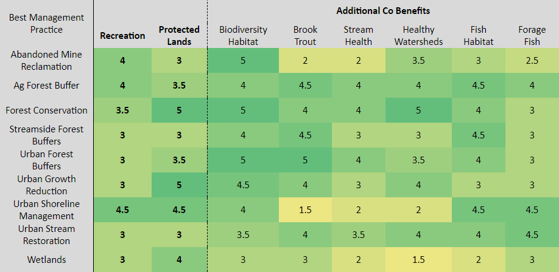
Guiding Principles for Phase III Watershed Implementation Plan and Public Access
WIP Implementation Principles
- Know where waterways generally acceptable for primary contact recreation are located; public access sites are best located on such waters.
- Capitalize on co-benefits. As public access sites are developed, utilize appropriate BMPs and look for opportunities to enhance public access on conserved lands. Sites could be used for BMP educational opportunities through appropriate signage.
- Consider the capacity of the resource on which the site is located and the site’s capacity to meet its projected use.
- Align with existing climate resiliency plans. Consider site sustainability related to sea level rise and storm events.
- Engage Partners. Work with government agencies, local citizen groups, elected officials, and NGOs to develop needed public access facilities.

Tools and Resources
- Public Access Site Development Outcome information page on chesapeakebay.net.
- Map of Public Access Sites, Progress Charts, Management Strategy, Workplan, and Participating Partners on Chesapeake Progress.
- Recreation activities and public access site specific information at Find Your Chesapeake.

Contacts for More Information
Jurisdiction | Website | Lead | Email
CBP | Public Access Site Development | Amy Handen | amy_handen@nps.gov
Delaware | DE Division of Parks and Recreation | Michael Krumrine | Michael.Krumrine@state.de.us
D.C. | District Department of the Environment | Diane Davis | diane.davis2@dc.gov
Maryland | MD Department of Natural Resources - Boating Services | Lisa Gutierrez | lisa.gutierrez@maryland.gov
New York | NY State Parks | Mark Hohengasser | Mark.Hohengasser@oprhp.state.ny.us
Pennsylvania | PA DCNR - Bureau of Recreation and Conservation | Kelly Rossiter | krossiter@pa.gov
Virginia | VA DCR – Division of Planning and Recreation Resources | Danette Poole | Danette.Poole@dcr.virginia.gov
West Virginia | WV Division of Natural Resources - Fisheries | Brandon Keplinger | Brandon.j.keplinger@wv.gov

