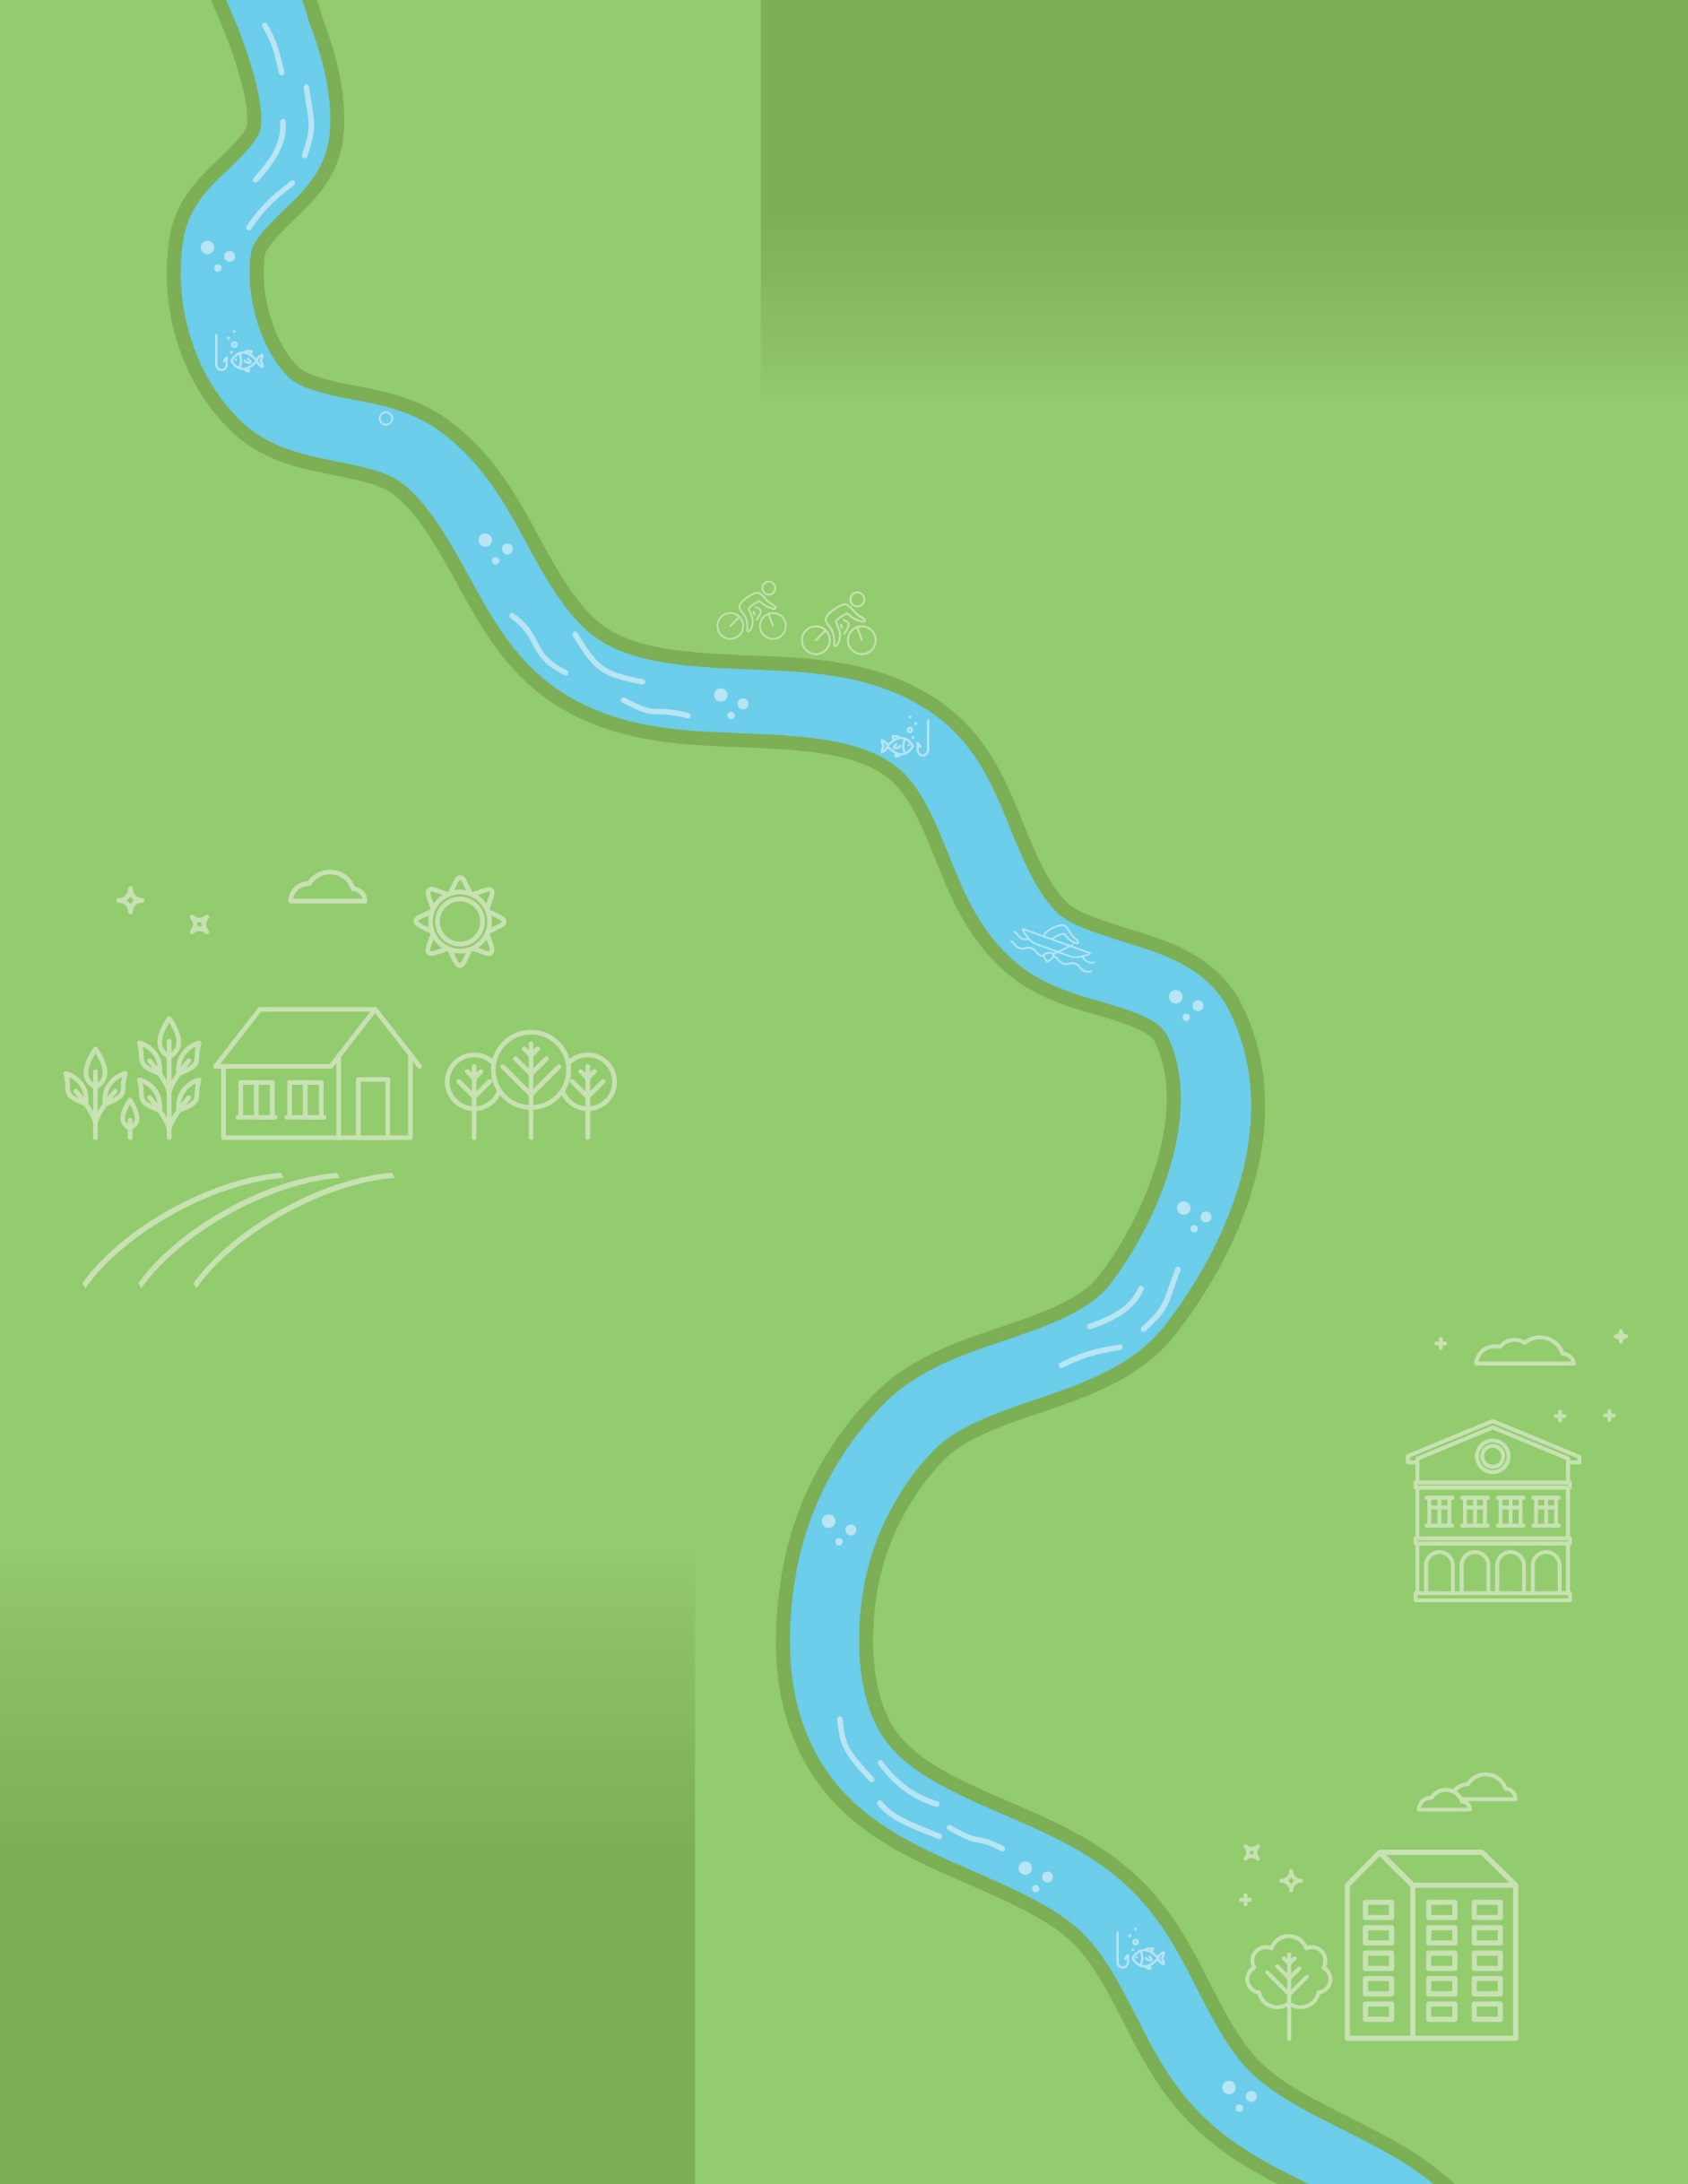

2010
Chesapeake Bay TMDL established and Phase I WIPs submitted
2011-2012
Phase II WIPs submitted

Local Government Engagement

and Communication during the

Chesapeake Bay Midpoint Assessment

and Phase III WIP Development
(April 2016 – June 2019)
Version 3, October 2017 (DRAFT)







December 2017
States report annual BMP progress; begin scenario runs using CAST
Spring 2018
Midpoint Assessment complete
May 2018
Partnership finalizes Phase III WIP planning targets
November 2017
Water quality monitoring trends released

October 2017
States present local engagement Strategy to CBP leadership/LGAC
January 2018
States begin developing local planning goals
December 2017
Partnership finalizes modeling tools and releases Phase III WIP Planning Targets

January 2018
Two-year Milestone Commitments Due; solicit local input September – October 2017
January 2018
EPA finalizes Phase III WIP Expectations
Spring 2017
States finalize initial local engagement strategy; Milestone Evaluation complete

December 2018
States report annual BMP progress; Verification programs in place
February 8, 2019
Draft Phase III WIPs due to EPA
December 2016
States report annual
BMP progress; Launch BMP Verification Program
April 2016
Phase III WIP development planning begins
June 7 2019
Final Phase III WIPs due to EPA
January 2017
EPA releases Interim
Phase III WIP Expectations
2025
100% of practices in place to meet Bay restoration goals set by TMDL
Key dates in Bay TMDL process
Key activities or information that needs to be communicated to local governments or others
Key activities requiring local government engagement
Guidance for Phase III WIP development released

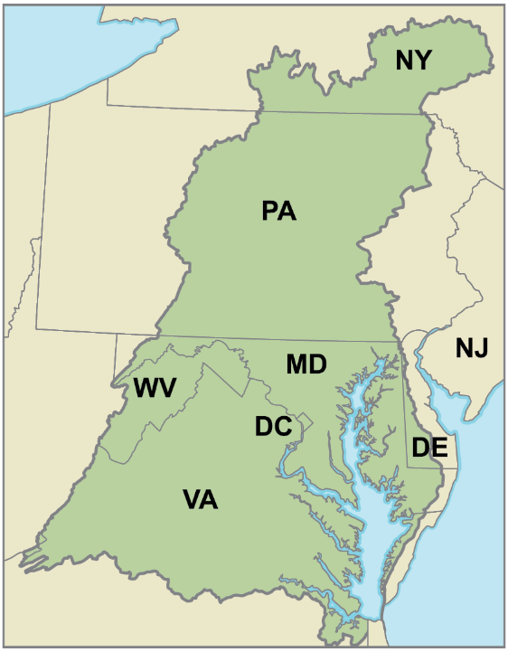
Definitions
Watershed Implementation Plans (WIPs) are created by each state and serve as a guide for meeting the pollution-reduction targets in the Chesapeake Bay TMDL. Phase I WIPs, developed in 2010, describe actions the states need to take by 2017 and 2025. Phase II WIPs, developed by the states in 2012, build on the initial Phase I WIPs by identifying specific activities that need to be implemented locally. The Draft Phase III WIPs, due February 2019, will detail actions to be implemented between 2018 and 2025 to meet the Bay TMDL restoration goals. The final Phase III WIPs are due June 2019.
Two-year Milestones are short-term, two-year goals that states set for themselves to increase restoration work and ensure progress for the Bay cleanup targets. They also guide implementation by describing specific actions to be taken by the state or others during the next two-year period.
The Chesapeake Bay Watershed spans 64,000 square miles and includes the District of Columbia and portions of New York, Pennsylvania, Delaware, Maryland, Virginia and West Virginia (commonly referred to as “Bay jurisdictions”).
Best Management Practices (BMPs) are restoration activities and projects (planned and implemented) to improve local water quality and meet pollution reduction targets established in the Bay TMDL.
Midpoint Assessment is the mid-term evaluation of overall progress toward the 2017 goal of having practices in place to meet 60 percent of the overall nitrogen, phosphorus and sediment reductions necessary to achieve the 2025 Bay TMDL goals.
Chesapeake Bay Watershed Model or “Model” is a suite of computer analysis models that is being enhanced. The revised Model, which informs the actions of those working to restore the Bay, will allow reporting of newly approved pollution-reduction practices. In addition, updated high-resolution land cover and land use data have been incorporated to more accurately represent what’s happening on the ground. The Model has been calibrated using almost three decades’ worth (1985 to 2013) of water quality monitoring data from a network of more than 200 monitoring stations (tidal and non-tidal) throughout the watershed.
Local Government Engagement and Communication during the
Chesapeake Bay Midpoint Assessment and Phase III WIP Development

