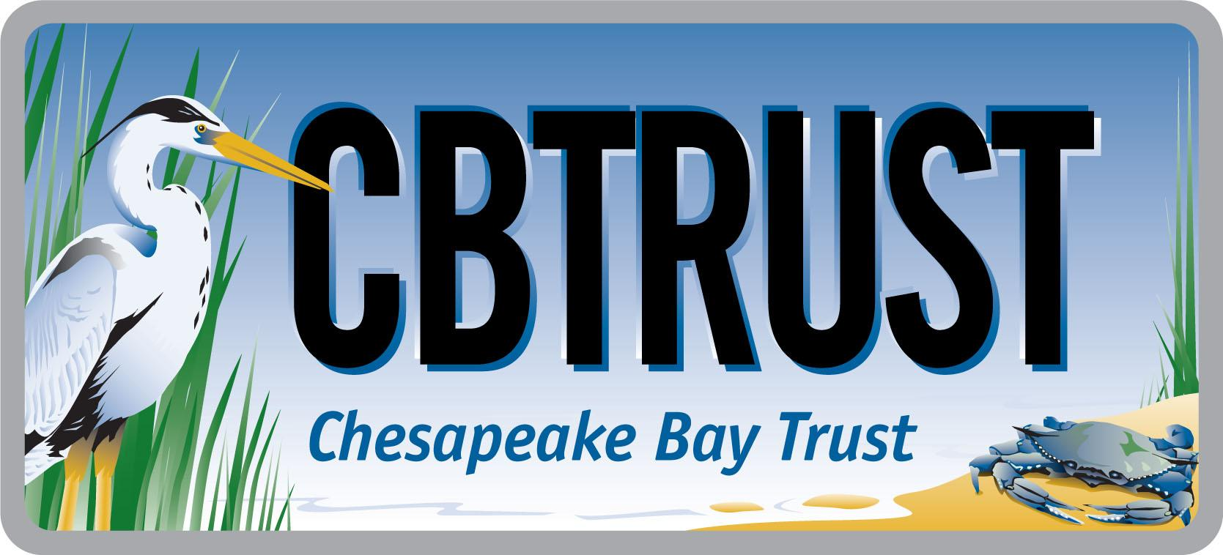


2018 Goal Implementation Team Projects Process for Project Funding and

Request for Ideas

aProposal #a
Goal Implementation Team (GIT) | Water Quality Goal Implementation Team (GIT)
Preparer Name(s) (name(s) and email(s)) | Barbara White (Virginia Department of Forestry, Barbara.White@dof.virginia.gov), Judy Okay (Forestry Workgroup member, judyannokay@gmail.com, Julie Mawhorter (US Forest Service, jmawhorter@fs.fed.us)
Proposed Project Title (10 words or less) | Turf to Buffers Stewardship Campaign for Bay Counties
Project Type | Work Plan Implementation
Proposed Outcomes | The project develops a new model for riparian forest buffer restoration in non-agricultural areas, addressing a key barrier to implementation of the Riparian Forest Buffer workplan and outcome, while also directly supporting the Tree Canopy and Citizen Stewardship outcomes. This project will provide a new resource for technical assistance, outreach, and funding to non-agricultural land owners and local governments.  The training package for outreach to and by citizens will be shared across Bay counties and Bay states; The Project planning guide will meet standards for CBP TMDL expectations with a follow up monitoring protocol. Using lessons learned from this project partnership, other counties can be considered for project opportunities.  Through this pilot/demonstration program, which will serve as a model for replication throughout the state and region, 50 acres of riparian buffers and/or tree planting will be established in Virginia Bay Counties through the training and engagement of at least 20 citizen stewards (Master Naturalists/Tree Stewards).
Justification (500 words or less) | This partnership proposal by the Virginia Department of Forestry (DOF) and Virginia Cooperative Extension Master Naturalist and Virginia Tree Stewards Programs is an opportunity to develop a strong effort to support riparian forest buffer restoration in more developed, non-agricultural areas. One of the strongest barriers to outreach in non-agricultural areas is a lack of state agency and local government staffing to initiate efforts needed to improve local and regional participation in environmental efforts. There is also a lack of program funding to support these non-agricultural tree planting efforts. This project builds buffer restoration capacity through Virginia’s Master Naturalist and Tree Steward Programs, which are established partnerships between Virginia Department of Forestry, Virginia Tech University Cooperative Extension and the Virginia Urban Forestry Council designed to train citizen volunteers to lead environmental projects and education in their communities.  Riparian forest buffers are ranked #2 in the list of important best management practices (BMPs) that are key to achievement of the Chesapeake Bay clean up goals. In the beginning efforts to clean up the Bay, riparian forest buffer restoration tracked evenly or above the set goals. In the past 10 years there has been a drastic reduction in the rate of forest buffer restoration and tree planting. Much of the restoration accomplished has been implemented with federal and state agricultural cost-share funds. Commodity prices have increased making every acre of agricultural land more valuable. Enthusiasm and interest in RFB restoration by agricultural land owners has waned.  There are other land uses that also have serious impacts on the Chesapeake Bay and its tributary waters. Land use changes from forest to development of various types (roads, housing, and commercial uses, parks and turf areas) increase sediment loads and polluted surface flow to Bay feeder streams. A new focus to restore forest buffers along streams adjacent to non-agricultural land uses can help to reverse the unrealized goals in tributaries of the Chesapeake Bay. This project implements key Riparian Forest Buffer Workplan actions: 1.5 Develop non-traditional buffer projects, 2.1 Work buffers into planning and zoning in counties, 3.3 Increase landowner education on RFB establishment and maintenance, 8.4 Integrate RFBs in local green space, and 9.1 Broaden awareness of non-ag landowners about tree planting, RFBs, and benefits of reduced mowing.  The geographic focus areas are the rapidly developing Virginia Bay Counties. This effort to train the Master Naturalists and Tree Stewards to promote and implement riparian forest buffer restoration, particularly on turf areas in their communities, should have positive repercussions on streams and waterways. Although many Master Naturalists and Tree Stewards have planted trees in their communities, planting riparian forest buffers that will stand up to the standards of those planted in agricultural land settings is somewhat complex. Planning riparian projects with the correct number of trees, the right species in the right place, and appropriate site preparation is not necessarily intuitive. There are natural barriers to success that need to be overcome in the planning stages.
Proposed Project Steps and Timeline | Virginia Department of Forestry staff has been involved in planning, planting and monitoring riparian forest buffers for decades. Guidelines based on experience have been developed. The Hardwood Planting Guide and Form 84 are two documents that will be assessed and modified to use as training guides for the Master Naturalists volunteers. There is a wealth of information on the importance and benefits of planting trees in a watershed that can also be mined from the Chesapeake Riparian Network website. A well rounded training program will be assembled and transferred to the Master Naturalists and Tree Stewards. This will be planned and acted on over a two year period.  Phase One It is expected that recruitment of Master Naturalists and Tree Stewards will take place in the first three months of the grant period. In the latter six months of the first grant period Master Naturalists will attend training by DOF staff involved in planning and planting riparian forest buffers.  Phase Two Trained Master Naturalists will be expected to develop a list of potential planting sites in their counties. The sites and groups they are expected to work with are: Watershed Friends Groups, Home Owner Associations (HOAs) with common property. County Parks and Recreation staff, County Planning and Zone Dept., School Systems.  Planting plans and site preparation should be done in winter of Year Two. Site prep and planting should take place in Spring of Year Two. Monitoring should occur in the latter months of Year Two.  Deliverables  - A minimum of 20 Master Naturalists or Tree Stewards receive and apply training.  - 50 new acres of newly planted riparian buffer and tree planting demonstration projects.  - The projects are checked for 2 years to be sure of establishment.  - A training program for citizen volunteers will be available for Bay wide use.
Estimated Costs | $65,000
Cross-Goal Benefits | This project supports outcomes of the Water Quality and Habitat GITs (Water Quality, Riparian Forest Buffers, Tree Canopy), Healthy Watersheds GIT, and Stewardship GIT (Citizen Stewardship).
Proposed GIT Technical Project Lead (name and email) | Julie Mawhorter (US Forest Service, Tree Canopy Outcome Coordinator)  jmawhorter@fs.fed.us

