Wetland Workgroup Meeting
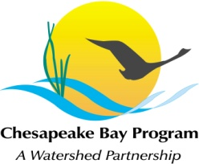
Chesapeake Bay Program
Conference Room 305
410 Severn Ave
Annapolis, MD 21403

Thursday, January 26th, 2017
1:00 - 3:00PM

Conference Line: 866-299-3188 Code: 267-985-6222
Adobe Connect: https://epawebconferencing.acms.com/wetlandworkgroup
(Note: Enter as Guest with your name and affiliation)

1:00 Introductions from Wetland Workgroup members / Review of goals and agenda
- Input from Wetland Workgroup – At least one cool wetland update from your state or organization.

1:15 Wetland Expert Panel Report Update – Kyle Runion, CRC

1:20 Landowner Outreach Project & Workshop Update – Amy Jacobs, TNC

1:30 Habitat & Fisheries Goal Team Collaboration, Shoreline and Tidal Wetland Habitats for Fish – Kara Skipper & Paige Hobaugh, CRC

2:00 Coastal Planning Tools: Mapping Natural Solutions for Resilient Maryland Communities –
Nicole Carlozo, MD DNR

2:30 Request speakers for future meetings

3:00 Adjourn

Tentative 2017 Meeting dates
March 16
May 18
July 20
Sept 14
Nov 16
Each of these meetings will take place in CBP Conference Room 305, conference line: 866-299-3188, code: 267-985-6222.

