Wetland Workgroup Meeting
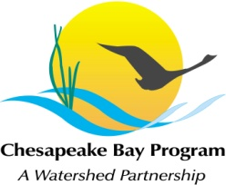
Chesapeake Bay Program Office
Conference Room 305A

Thursday, November 19th, 2015
1:00-3:00PM

Conference Line: 866-299-3188 Code: 410-267-5731
Adobe Connect: https://epawebconferencing.acms.com/wetlandworkgroup/ (Note: Enter as Guest with your name and affiliation)

1:00 Welcome and Introductions
- Please provide your name, affiliation, and one exciting piece of news on a wetland related issue.
1:15 September Field Meeting Recap
1:20 Wetland Expert Panel Update and Next Steps
- We have been tasked with providing the Expert Panel a list of wetland restoration practices. Please review the attached list and send Erin any wetland restoration practices not on this list by 11/19.
1:35 Wetland Workgroup 2-year Workplan
- Please review and be prepared to provide comments.
2:00 Landowner Attitudes toward Wetland Restoration Survey Update
2:15 Guest Presentation: Updating Wetland Maps to Improve the Chesapeake Bay Model (Patrick Raney, Upper Susquehanna Coalition)
2:45 Wrap-Up and Next Meeting
3:00 Adjourn

